
www.nuvusoftware.com

Technical Reference

Version 4.5

Table of Contents

1 - NuVu Configuration 4
1.1 Introduction 4
1.2 Welcome Page 6
1.3 Compulsory Information Page 7
1.4 Services Page 13
1.5 Poll Page 16
1.6 Fax Page 20
1.7 Email Settings 23
1.8 Finish Page 26
2 - NuVu Engine Components 27
2.1 Introduction 27
2.2 The NuVu report Preparation tool 28
2.3 The NuVu Auto-Find utility 38
2.4 The NuVu Preview utility 41
3 - NuVu Servers/Services 42
3.1 Introduction 42
3.2 The NuVu Licence Service 43
3.3 The NuVu POLL Server 44
3.4 The NuVu POLL Service 52
3.5 The NuVu FAX Service 54
3.6 Testing the NuVu Servers 58
4 - ‘Fax Any Document’ 62
4.1 Introduction 62
4.2 Considerations 62
4.3 Steps to ensure Document delivery 63
5 - NuVu Licencing 65
5.1 Introduction 65
5.2 NuVu Licencing Overview 66
5.3 The ‘rbd_lic’ Licence utility 69
6 - Network Installation 70
6.1 Client Network Installation 70

- NuVu Configuration

Introduction
This section covers all settings that need to be advised before the NuVu Reporting Suite can be used in a Server environment. This section can be ignored when installing individual client PC’s. It is most important that this section be read by your system administrator in order to avoid problems when attempting to integrate your application with the NuVu Reporting Suite. Of particular importance is the setting up of the LICENCE, FAX and POLL services to run correctly on the Server machine.

The NuVu Configuration Wizard (installed into the default root installation folder, with a filename of ‘NuVuConfigWizard.Exe’) is used to advise the various NuVu properties which are used by the NuVu Reporting Suite in order for it to function effectively in a Server environment.

It is IMPORTANT to note that the NuVu Configuration Wizard must be run by a user that has the required administrator privileges in order to install windows services, write to the registry, and install printer drivers (if the NuVuFaxServer or NuVuFaxService is to be installed).

The NuVu Configuration Wizard has a number of pages which are optionally displayed depending on the values advised on the 'Compulsory Information' page. The pages that are displayed by the configuration wizard include:

- Welcome Page (always shown)

- Compulsory Information Page (always shown)

- Services Page (only shown if the FTP, Poll or Fax service has been chosen)

- Fax Page (only shown if the fax Server or Service has been chosen)

- Poll Page (only shown if the Poll Server or Service has been chosen)

- Email Page (always shown)

- Finish Page (always shown)

In Addition, certain information is hidden from the user depending on the advised settings on the relevant pages.

The NuVu Configuration wizard is automatically invoked after the successful installation of the NuVu Reporting Suite, but may also be invoked by navigating to the NuVu program group (from the Windows Start button).

When the Wizard is invoked, the Windows Registry is interrogated for the current settings of the various properties, and these are displayed to the user, for modification. The title of the configuration window will also show the identified operating system category (Windows 98/Me, or Windows 2000, Xp, NT 4 or NT Server 2003).

Clicking the 'Finish' button on the last screen of the wizard will save the advised configuration settings into the Windows Registry.

Depending on if the NuVu FTP Service or NuVu FTP Server has been chosen to be configured, the utility will then attempt to install (or re-install) the appropriate NuVu FTP Service/Server and restart it.
The same procedure will apply to the NuVu POLL Service/Server and NuVu FAX Service/Server appropriately.
NO reboot is necessary before beginning to utilise the NuVu Server/Service after the installation process has completed, unless you are instructed to do so. The only reason why this may happen, is that during a re-installation of the software, the NuVu Configuration Wizard is unable to shut down existing NuVu Servers/Services. In this case a reboot will be required in order to update these respective servers/services.

Validation of each page displayed is performed BEFORE the next page is displayed. Any errors detected will be reported back to the user, and the cursor will be positioned on the field in error.

Clicking the 'Finish' button on the last page will save the advised configuration settings into the Windows Registry. The Servers / Services will also either be stopped and restarted, or completely re-installed, depending on the settings chosen by the user.

The utility will also take care of removing any previous server/service. For example, if the NuVu FTP Server was the installation choice before the utility was invoked, and then the user decides to install the NuVu FTP Service instead, the original NuVu FTP Server will be uninstalled before the new NuVu FTP Service is installed.

Clicking the 'Cancel' button will exit the utility WITHOUT saving any of the advised options. The user will be warned before the wizard is closed, allowing the user to cancel the closing of the wizard if so desired.

WARNING: (Windows 2000, XP, NT4 or NT Server 2003)

When invoking this Wizard, the user must ensure that proper network connections are in place if any Services (Fax, Poll or FTP) are to be installed (or re-installed). For example, if the user was previously connected to a certain domain, and is now unplugged from the network when attempting a re-install, it is likely that the previously installed services will NOT be able to be uninstalled, due to the configuration utility not being able to shut down the relevant Services due to permissions problems.

The contents of each Wizard Page will now be shown, and explained.

Welcome Page

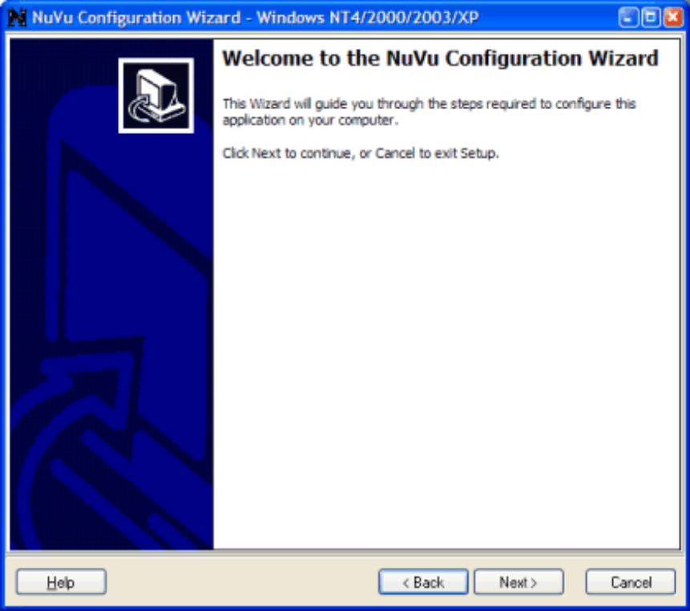

This page is shown upon invoking the NuVu configuration wizard, and simply explains to the user that the wizard has been invoked. The user is given the opportunity to invoke this help (by pressing the HELP button), or alternatively clicking the 'Next' button to proceed to the 'Compulsory Information' page. The wizard can be cancelled at any time by clicking the CANCEL button.

Compulsory Information Page
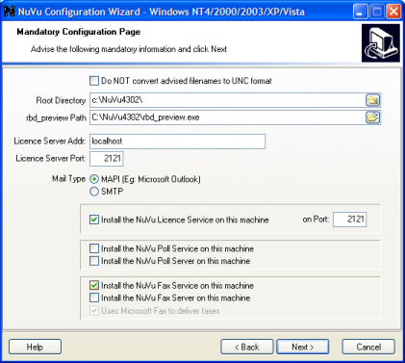

This section is used to advise the following details -

Do NOT convert filenames to UNC format

As a default, the NuVu Configuration Wizard will convert ALL advised filenames and folder names into universal naming convention format (UNC). This is normally desirable to prevent errors occuring when a folder share is sometimes lost in a network environment. However, in a Citrix (or other) environment, folder shares are often dynamically allocated to users. The same share can in fact point to a different location on disk. This is typical when assigning a working folder to a Citrix user. In this scenario, it is advisable to TICK this option to ensure that all advised shared folder/file names remain unconverted.

Root Directory

In a team development environment, it is common practice to store all the report definitions (designs), plus their associated graphic files and sample reports in a central directory. This option allows the user to advise the central root directory for the sharing of these files. The report definitions (with extention .rbd) and Graphic files will default to the Docs sub-directory of this root directory. The sample reports will default to the Samples sub-directory of this root directory. In both cases, these are just the defaults, and may be overridden during the design process.

The advised (or browsed) Root Directory is converted into UNC format when this page is completed.

This Directory will be validated to ensure that a valid (existing) directory has been advised.

This option is also available to be changed from the 'Designer Properties' dialog window which can be invoked from the Tools menu within the NuVu Report Designer tool.

rbd_preview path

Advise the full pathname of the NuVu 'rbd_preview.exe' utility here, or alternatively click the browse button to browse the network or local file system for this file. This utility is the executable that performs the actual rendering of the graphical report to printer, pdf, email etc. By default, the browse will start in the default 'c:\nuvu' directory, which is the normal location for this file.

This option will be validated to ensure that the rbd_preview.exe can be found at the advised location.

The advised (or browsed) rbd_preview path is converted into UNC format when this page is completed.

Licence Server Addr

The licencing section describes which Windows server is interrogated at run-time whenever the NuVu preparation tool (rbd_prepare.exe) or Poll Server is executing a request. The licencing configuration does not apply when the application is being run on a UNIX platform that is not calling the Windows Poll Server, or a Windows application server that is connected via a character terminal client and who is not using the Windows Poll server.

The Licence server is useful in setting up a central licence repository that can be accessed from either the Poll Server, or individual windows client PC's during preparation and rendering of NuVu reports.

Advise either a TCP/IP address (in the format nnn.nnn.nnn.nnn - example 192.6.31.2) or a resolvable hostname that will be interrogated at run-time to establish the valid licence for the current request. If the Licence server is on the same machine as that being configured, then 'localhost' can be advised here.

Licence Server Port

Advise a valid TCP/IP port number (from 1 to 65535) here. The NuVu processing engine will use this port number to communicate with the Licence server at run-time when servicing a request. The standard FTP port is '21', but this may be changed if another FTP Server is being used on this port.

Please refer to the NuVu Technical reference for more information regarding the Licence server.

Mail Type

Here the user must select which email protocol will be used when sending emails out to clients.

Each protocol has its own advantages and disadvantages. Generally speaking, if the user is doing ad-hoc emailing of displayed reports, and is using a MAPI email system (Microsoft Outlook for example) as a default for other emails, then the MAPI email protocol would be the obvious choice. However, if the user is doing numerous email blasts to many recipients, and the latest MAPI security patches have been applied to the MAPI software, then the SMTP protocol might be more appropriate, because this protocol does not do any security checking before sending emails out to the email server. Disadvantages of the SMTP protocol, is that the email configuration has to be manually advised (the Hostname, Port Number etc. needs to be manually advised on this dialog window) before the emailing via the SMTP protocol will be successful. Also note that a current internet or permanent email server connection is required before issuing an SMTP email send, as opposed to the MAPI protocol, which will prompt to auto-connect if appropriate.

Server/Service options:

The remaining fields on this page refer to the various NuVu server/services that can be installed on this machine, namely the Licence Service, the NuVu Poll Server / Service and the NuVu Fax Service.

At this stage, we should explain a little how your application can interact with the NuVu Reporting Suite.

Self-Service

This method involves installing the full NuVu Reporting Suite on each individual Windows PC. The application would be running in client/server mode, where the client requests a report from the application. The report is processed on the client, and the resulting report file (text printfile) is stored somewhere on the local PC (or a mapped network drive). The local PC would then invoke the optional 'rbd_find' utility to locate the associated NuVu design template for the current report, and then invoke the 'rbd_prepare' utility to prepare the report, whereafter the NuVu report previewer/processor would be invoked to generate the graphical report, rendering it directly to a local or network printer, or viewing the results in the NuVu report viewer.

In the Self-Service scenario, the only applicable settings are the Fax Service option.

Directory Polling

This method is normally deployed in a true Windows Client/Server environment (where Windows PC's are running a graphical application connected via TCPIP to a back-end application server), but may also be deployed in a character client environment. The back-end application server (Windows/Unix or Mainframe) would process the report requested by the client, storing the temporary report printfile (or prepared report) somewhere on the application server (NOT the client PC).

The 'Directory Polling' mechanism can either drop unprepared (raw printfiles) or prepared (files that have been through the NuVu 'rbd_prepare' utility). It is imperitive that the nominated Windows PC (that is running the NuVu polling service) be able to access this directory (via Samba or some other file sharing mechanism).

If this mechanism is deployed, then the nominated directory will be polled (interrogated) intermittantly to see if there are any files present in the directory to process. Any found files will be processed and delivered to the nominated printer or alternatively viewed by the Windows PC.

In this scenario, the Poll settings on this page may apply.

Spooler Polling

This method is normally deployed in a true Windows Client/Server environment (where Windows PC's are running a graphical application connected via TCPIP to a back-end application server). The back-end application server (Windows/Unix or Mainframe) would process the report requested by the client and direct the raw printfile directly to a Windows spool queue, residing on a nominated Windows PC.

The 'Spooler Polling' mechanism will poll the standard Windows spool queue intermittantly to see if there are any new spool entries to process. Any found spool entries (that have completed their spooling process) will be processed (the associated NuVu template will be automatically found, and the report prepared for graphical output), and then delivered to the nominated printer or alternatively viewed by the Windows PC.

In this scenario, the Poll settings on this page may apply.

Install the NuVu Licence Service

This tick-box is used to identify whether the NuVu Licence Service must be installed onto this machine. It is only necessary to tick this option on the machine which is going to act as the Licence server. The NuVu Licence server is the machine that will listen on the advised port (see below) for received NuVu licence requests. These requests are then validated by the licence server and an appropriate pass/fail message is returned to the calling process.

Is this option is unticked, and the NuVu Licence service is currently installed on this machine, it will be removed when the FINISH button is clicked to save the configuration settings.

Please note, if the current operating system of this machine is identified as being either Windows 98 or Windows Me, then this option is also disabled, as these operating systems do not support Windows Services natively.

Port

Like any TCP/IP service, a port number must be advised, which will be used to listen for client licence requests on. It is important to note that the advised port number must not be allocated to any other service. This can be determined by examining the services file, located in your Windows\System32 directory (if running under Windows98/Me) or your Windows\System32\drivers\etc directory if running on Windows 2000, XP or 2003 Server). If the advised port number is being used by another service, you will encounter error messages once the FINISH button is clicked, when the NuVu Licence Service is installed.

The default port number is 2121, and should be used unless you encounter conflicts with other services.

Install the NuVu Poll Service

This tick-box is used to identify whether the POLL Service will be installed onto this machine. It is only necessary to tick this option on the machine which is going to act as the POLL server. The POLL server is the machine that will monitor the Poll Directory or Windows spool queue for new files to process. When found, these reports will be automatically processed by the NuVu report rendering engine (rbd_preview.exe) and delivered to the appropriate destination (printer, fax, email, spool etc.).

If this option is not ticked and the 'Install the NuVu Poll Server' option is also unticked, then the 'Poll' page of the Nuvu configuration wizard will be bypassed.

If this option is unticked, and there is currently a POLL Service installed on this machine, it will be removed when the FINISH button is clicked to save the configuration settings.

Please note, if the current operating system of this machine is identified as being either Windows 98 or Windows Me, then this option is also disabled, as these operating systems do not support Windows Services natively.

Install the NuVu Poll Server

This tick-box is used to identify whether the POLL Server will be installed onto this machine. It is only necessary to tick this option on the machine which is going to act as the POLL server. The POLL server is the machine that will monitor the Poll Directory or Windows spool queue for new files to process. When found, these files will be automatically processed by the NuVu report rendering engine (rbd_preview.exe) and delivered to the appropriate destination (printer, fax, email, spool etc.).

If this option is not ticked and the 'Install the NuVu Poll Service' option is also unticked, then the 'Poll' page of the Nuvu configuration wizard will be bypassed.

If this option is unticked, and there is currently a POLL Server installed on this machine, it will be removed when the FINISH button is clicked to save the configuration settings.

The Poll server has one additional attribute over the NuVu Poll service, and that is the ability to VIEW reports. This feature can be used when the Poll Server is installed on individual client PC’s, allowing rendered reports to be immediately viewed after being processed by the Poll server.

Install the NuVu Fax Service

This tick-box is used to identify whether the NuVu Fax Service will be installed onto this machine. It is only necessary to tick this option on the machine which is going to act as the Fax server. The Fax server is the machine that will deliver outward-bound faxes of rendered NuVu reports to the desired recipients.

If this option is not ticked, then the 'Fax' page of the Nuvu configuration wizard will be bypassed.

If this option is unticked and the 'Install the NuVu Fax Server' option is also unticked, and there is currently a Fax Service installed on this machine, it will be removed when the FINISH button is clicked to save the configuration settings.

Please note, if the current operating system of this machine is identified as being either Windows 98 or Windows Me, then this option is also disabled, as these operating systems do not support Windows Services natively.

Install the NuVu Fax Server

This tick-box is used to identify whether the NuVu Fax Server will be installed onto this machine. It is only necessary to tick this option on the machine which is going to act as the Fax server. The Fax server is the machine that will deliver outward-bound faxes of rendered NuVu reports to the desired recipients.

The NuVu Fax Server is functionally identical to the NuVu Fax Service – except the Fax Server runs in interactive mode, whereas the fax services runs as a silent service.

If this option is not ticked and the 'Install the NuVu Fax ServicePoll Server' option is also unticked, then the 'Fax' page of the Nuvu configuration wizard will be bypassed.

If this option is unticked and the 'Install the NuVu Fax Server' option is also unticked, and there is currently a Fax Service installed on this machine, it will be removed when the FINISH button is clicked to save the configuration settings.

The Fax Server (if initiated from a user session) will be minimized to the system tray. There is additional functionality provided by the Fax Server by right-clicking on the tray icon – providing access to the Fax Monitor, amongst other things.

Use Microsoft Fax to deliver faxes (Recommended)

This tick-box should be ticked if the Microsoft Fax Service is going to be utilised for the actual rendering and delivery of NuVu faxes. This is the recommended option, especially on Vista machines. Note that this option is disabled and cleared out if the current machine on which the Configuration Wizard is running has an operating system lower than XP/Windows Server 2003.
Please ensure that you have installed Microsoft Fax and configured that software correctly before attempting to use the NuVu Fax Server/Service

Services Page
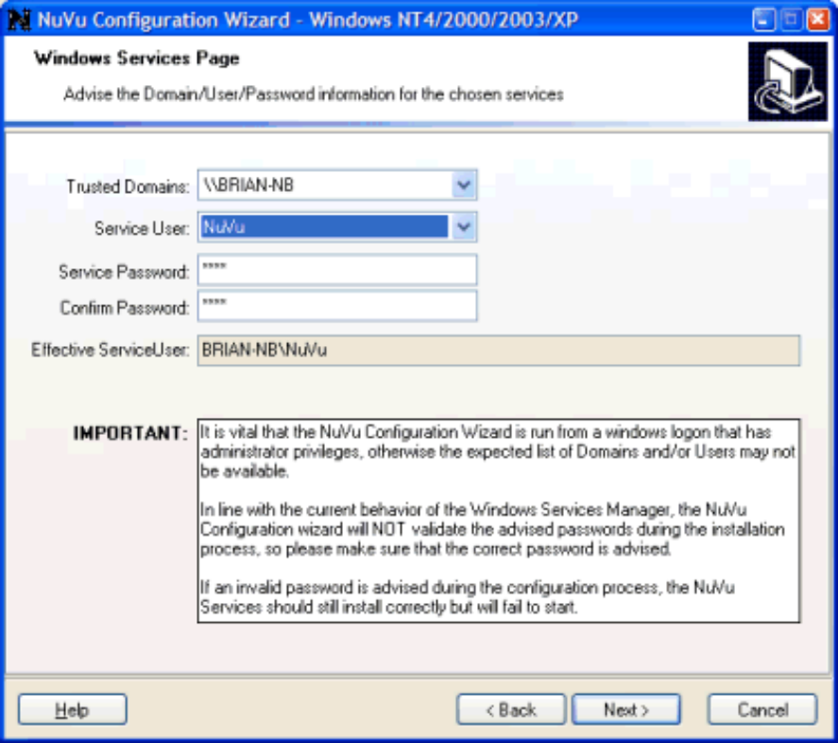

This page is only displayed if the user has clicked on the 'Install Licence Service', 'Install Poll Service' or 'Install Fax Service' options on the 'Compulsory Information' page. Windows services are automatically started when the server PC is booted, unlike other processes which are only started when a user logs into the server. Therefore, all windows services require the service to start using an advised user and password. This information is gathered on this page.

Trusted Domains

This read-only combo-box displays all the identified domains that can be connected to (including the local machine if available). The advised domain will be used to determine the validity of the advised Service User, so it is important when running the NuVu Configuration Wizard to ensure that you are logged on to the Domain that Service User will also be logging in to when the various NuVu Services are started by the Windows services manager.

Service User

This read-only combo-box displays all the available users in the selected Domain (see Trusted Domains above). The various NuVu Services (Licence, Fax and Poll) are required to log into the Server machine (ie: this machine) during system startup. Advise the user which will be used to log into the server machine here. This user should have administrator rights, and also able to utilise the installed printers (local and network), Directory services, email and fax servers. The advised user should NOT be the administrator itself (for security reasons). We suggest that a new user be created for the NuVu Reporting Suite, with a usercode of 'nuvu'. After creating this new user, you should log out of the server, and then log back in using THIS newly created user ('nuvu' for example). Then ensure that the user has access to the required directory services (mapped drives etc), as well as ensuring that this user is also able to print to the required local and network printers. This is achieved by calling up any application that can print (WordPad for example) and choosing the print option, then examining the list of available printers to ensure that it includes all required printers. If any printers are missing, these should be added at this stage.

IMPORTANT:

In order for the NuVu Services to operate correctly, you must ensure that you have created a user that has 'Log on as a Batch Job' and 'Log on as a Service' authorities. To set (or check) this, invoke the Control Panel, and choose the 'Administrative Tasks -> Local Security Policy' option. The following dialog window will be presented:

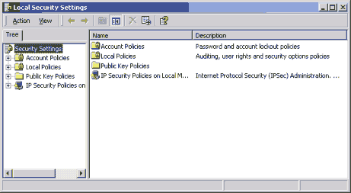

Select the 'Local Policies' group from the left-hand panel, and then scroll down the right-hand panel until you find the 'Log on as a Batch Job' option and double-click it. A dialog window showing all users currently assigned to this authority will be shown, similar to the example below:

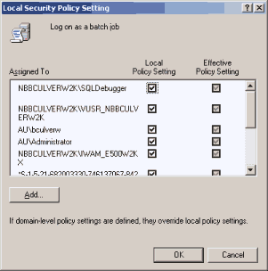

If your nominated user is not in this list, click the 'Add' button, and select the user from the displayed list, and finally click the OK button to add this user to the authority.

Repeat these steps for the 'Log on as a Service' authority.

It is also important to realise that when a service is running under the advised user/password, only printers and network drives that have been assigned to this user will be able to be utilised. This is common issue raised with customer support - "why does my report not print to the printer when I run the Poll service? Everything works perfectly when I run the Poll server....". This is exactly the problem - the user who has been advised as the service user does not have access to the printer that is being printed to - so the service silently aborts the job.

Service Password

During the installation step of the NuVu services (and during the login process of these services at system startup), the password for the advised user is interrogated in order to authenticate the service. Advise the known password of the advised Service User into this field. This field is protected so that asterisks are shown in place of actual characters typed. Should the actual user change their password at any time, this utility will have to be re-invoked to advise the new password details.

It is worth noting that the advised password is NOT used to authenticate the NuVu service(s) during installation of these services, but will be used when the service is started.

Confirm Password

This field is used to verify that the correct password has been advised into the Password field (described above). As with the Password field, this field is protected so that asterisks are shown in place of actual characters typed. If the contents of this field do not exactly match the 'Service Password' field advised above, then an appropriate error message will be issued, and the user will be directed back to the 'Service Password' field in order to correct this error.

Effective ServiceUser

This read-only field displays the actual domain\user prefix that will be used to start the appropriate NuVu services, and is displayed for information/troubleshooting purposes only.

Poll Page
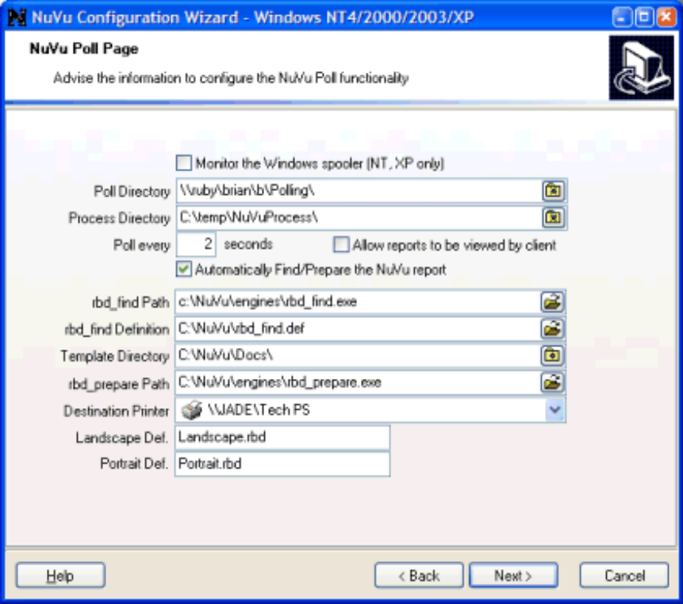

This page is only displayed if the user has chosen the 'Install Poll Service' or 'Install Poll Server' options on the 'Compulsory Information' page. The NuVu poll server/service can either monitor the contents of a nominated directory (normally a shared folder that is able to be written to directly by the application server) or alternatively a nominated Windows print queue. In either case, any files that are written to the nominated folder or spool queue are processed by NuVu and rendered to the nominated destination.

Please refer to the Nuvu technical reference manual for more information in this regard.

This page allows for the advice of the following information:

Monitor the Windows Spooler?

This tick-box is used to identify whether the POLL Service/Server is going to monitor an advised Windows spool queue or alternatively a nominated directory (folder).

If this option is ticked, then the 'Poll Directory' is replaced with a 'Poll Printer' option, and the 'Automatically Find/Prepare' tick-box is ticked and disabled, because in this scenario, the Windows PC is going to be responsible for the finding of the associated Nuvu template, and the preparation of the NuVu report prior to printing.

Poll Directory

This option is only visible if the Monitor Spooler tick-box (described previously) has been left un-ticked.

Advise (or browse to) the directory that will be monitored for any new files (either raw printfiles, or NuVu report instance files (files ending with a .rbi extention) depending on the 'Automatically Find/Prepare the NuVu report' setting (described later in this section). The browse tool provides a mechanism to explore the network and optionally create a new directory at the selected root directory.

This directory is validated to ensure of it's existence before moving to the next page.

Poll Printer

This option is only visible if the Monitor Spooler tick-box (described previously) has been ticked.

Select the appropriate printer that is going to process the raw printfiles here.

NOTE: The selected printer must be setup (via the Printer Properties window) so that entries are saved to disk after spooling, otherwise the entries will simply disappear after printing, and the NuVu Poll service will not have a chance to process them. The NuVu Poll service will automatically remove printed entries from the spool queue after processing.

Process Directory

Advise (or browse to) the directory that will be used as the processing directory. At run-time, any .rbi files (or raw printfiles - if the 'Automatically Find/Prepare the NuVu report' setting has been ticked) that are discovered in the Poll Directory (see previous) will be moved to this directory, whereafter the NuVu rendering engine (rbd_preview.exe) will be invoked to deliver the graphical report to the appropriate destination (printer, fax, email, spool etc.).

The browse tool provides a mechanism to explore the network and optionally create a new directory at the selected root directory.

This directory will be validated to ensure of it's existence before moving to the next page.

This directory MUST be different to the Poll Directory.

Poll every ... seconds

This setting determines the number of seconds that the Poll Server/Service will wait before re-checking the contents of the Poll directory or Windows spool queue.

Setting this value too low (1 second, for example) will result in extra disk and CPU activity on a busy server.

A typical value for this setting is 3. If the Poll Service/Server is being run on local PC's with the viewing option (see below) enabled, then this value should be set as low as possible (to 1 second for example), to ensure that the report delivery is as instantaneous as possible.

Allow Viewing

The Poll Server/Service is normally installed on a central server, that will process all reports for all users. In this scenario, the 'Allow Viewing' tick-box should be left UNTICKED so as to avoid invoking the NuVu report viewer (or PDF viewer) because the server in this case would be possibly unmanned. However, if the Poll Server/Service is installed on individual client PC's, in order to allow users to view their own reports produced by the application server, then this option should be ticked.

NOTE: This option can be used when the 'Monitor the Windows Spool queue' tick-box is ticked, in order to preview reports (ie: debug this whole process) rather than sending them to the nominated Windows printer.

Auto Find/Prepare

This tick-box is used to determine if the processed printfiles need to be Prepared for NuVu graphical printing or not. If the 'Monitor the Windows Spool queue' option has been ticked, then this option is automatically ticked (and not able to be unticked), because the contents of the Windows Spool queue are always in raw printfile format.

Ticking this option will result in the 'rbd_find' and 'rbd_prepare' utilities being invoked to prepare the NuVu report for printing. More information can be found in the 'Integration' section of the User Reference manual.

If this option is ticked, then the remaining input fields on this tab folder must be advised, as described below.

rbd_find Path

Advise the full pathname of the NuVu 'rbd_find.exe' utility here, or alternatively click the browse button to browse the network or local file system for this file. By default, the browse will start in the default 'c:\nuvu\engines' directory, which is the normal location for this file.

More information can be found in the 'Integration' section of the User Reference manual.

rbd_find Def.

Advise the full pathname of the NuVu 'rbd_find definition' file. This text file contains information that is used by the 'rbd_find' utility to automatically locate the required NuVu template for a raw printfile. An alternative to typing the full pathname is to click the browse button to browse the network or local file system for this file. By default, the browse will start in the default 'c:\nuvu' directory, which is the normal location for this file.

More information can be found in the 'Integration' section of the User Reference manual.

Template Dir.

Advise the full pathname of the directory that holds the designed NuVu templates (files ending with a .rbd or .rbc entension). This location is used by the 'rbd_find' utility to retrieve the required NuVu template for a raw printfile. An alternative to typing the full pathname is to click the browse button to browse the network or local file system for this directory. By default, the browse will start in the default 'c:\nuvu\docs' directory, which is the normal location for this directory.

More information can be found in the 'Integration' section of the User Reference manual.

rbd_prepare Path

Advise the full pathname of the NuVu 'rbd_prepare.exe' utility here, or alternatively click the browse button to browse the network or local file system for this file. By default, the browse will start in the default 'c:\nuvu\engines' directory, which is the normal location for this file.

More information can be found in the 'Integration' section of the User Reference manual.

Dest. Printer

Select the appropriate printer that is going to actually produce the graphical NuVu reports here. Any local or network printer can be selected here.

Landscape Def.

Advise the name of the standard Landscape NuVu template that will be used to render the report if no template can be found for the current report. This template is used if the length of the longest line in the first 100 lines of the spooled report is >= 90 characters. As part of the standard NuVu installation, the default 'landscape.rbd' is installed to the installation 'docs' folder, so advising 'Landscape.rbd' here will suffice.

This field is validated to ensure that the advised template (which must reside in the Template Dir) exists.

Portrait Def.

Advise the name of the standard Portrait NuVu template that will be used to render the report if no template can be found for the current report. This template is used if the length of the longest line in the first 100 lines of the spooled report is < 90 characters. As part of the standard NuVu installation, the default 'portrait.rbd' is installed to the installation 'docs' folder, so advising 'Portrait.rbd' here will suffice.

This field is validated to ensure that the advised template (which must reside in the Template Dir) exists.

Fax Page

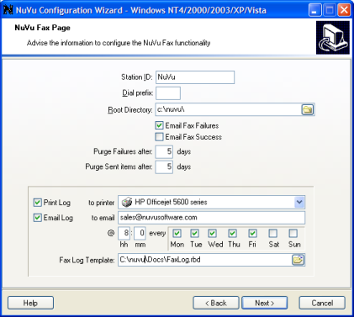

This page is only displayed if the user has chosen the 'Install Fax Service' or ‘Install Fax Server’ option on the 'Compulsory Information' page. The NuVu Fax server/service is a fully-fledged fax server that can deliver rendered NuVu reports via the advised TAPI modem to the appropriate fax recipient. The actual delivery of the faxes is performed by Microsoft Fax – so please ensure that this component has been installed and configured on the same server as the NuVu Fax Service.

This page allows for the advice of the following information:

Station ID

This setting is used to uniquely identify this machine. If this machine is the only one sending out NuVu reports, then it is appropriate to advise your Company Name here, otherwise perhaps the name of the Company plus a unique number or name will be appropriate. This setting can be included in the Header line of the fax, and is substituted for the $I parameter in the header, which is explained below.

Dial Prefix

If this machine requires a dial prefix to obtain a dialling tone, then this should be advised into this setting. A common dial prefix is '0,', which indicates dial zero for a line, and pause a few milliseconds before starting to dial the actual fax number.

Root Directory

The NuVu fax service will move faxes into three different sub-directories of the advised root directory during the sending of faxes from the NuVu Report Previewer. When a fax is initiated from the report previewer, the fax is copied to the root directory. The NuVu Fax Server/Service monitors the root directory for any new faxes. When a new fax is detected, it is copied to the Pending directory (a sub-directory automatically created by this configuration process). Any fax which has reached its send date/time in the Pending directory will attempt to be transmitted. Any fax which is successfully sent is then automatically copied to the Sent sub-folder (also automatically created by this configuration process). Any fax which is unsuccessfully transmitted will be moved to the Failed sub-directory, created automatically by this configuration process.

There is a separate NuVu Fax Monitor available from the NuVu Program Group, which visually displays the contents of each of these sub-directories, and allows the user to move fax items between these directories using drag-and-drop.

Email Fax Failures

If this option is ticked, then a notification message will be emailed for all faxes that cannot be delivered for whatever reason. An optional email address can be advised within the Fax configuration file that is created at run-time before faxing a NuVu document. If no optional address is advised, then the email address advised on the 'Email' tab of the configuration utility will be used instead.

Email Fax Success
If this option is ticked, then a notification message will be emailed for all faxes that are successfully transmitted. The email address advised on the 'Email' tab of the configuration utility will be used. This email will NOT have the actual fax attached to it.

Purge Failures after [x] days

Instructs the NuVu Fax Server/Service to remove all Failed fax entries after the designated number of days.

Purge Sent Items after [x] days

Instructs the NuVu Fax Server/Service to remove all Sent fax entries after the designated number of days.

Print Log

If this option is ticked, the the NuVu Fax Server/Service will automatically print a copy of the Fax Log (the same log that is displayed in the bottom right-hand pane of the NuVu Fax Monitor utility) to the advised printer whenever the advised scheduled time and dates are reached. At most, the fax log can be printed every day (monday to sunday) at a specified time. As part of the Print/Email log process, the log file will also be purged (after a backup copy is made, in the same folder as the NuVu Fax server/service executable).

To Printer

This option only applies if the 'Print Log' tick-box has been ticked, and is used to advise the appropriate Windows printer onto which the Fax Log will be printed.

Email Log

If this option is ticked, the the NuVu Fax Server/Service will automatically email a copy of the Fax Log (the same log that is displayed in the bottom right-hand pane of the NuVu Fax Monitor utility) to the advised email address whenever the advised scheduled time and dates are reached. At most, the fax log can be emailed every day (monday to sunday) at a specified time. As part of the Print/Email log process, the log file will also be purged (after a backup copy is made, in the same folder as the NuVu Fax server/service executable). The Fax Log will be converted into a PDF document and attached to the sent email.

To Email

This option only applies if the 'Email Log' tick-box has been ticked, and is used to advise the appropriate email address to which the email will be sent.

@ hh mm & days

This section only applies if either (or both) of the 'Print Log' or 'Email Log' tick-boxes have been ticked. It allows the user to specify the time (in hours and minutes) at which to process the Fax Log, as well as an array of days that can be selected. Obviously if all days are left unticked, then no log will be emailed or printed, irrespective of other settings.

Fax Log Template

This field is only enabled if either (or both) of the 'Print Log' or 'Email Log' tick-boxes have been ticked. The user must advise the NuVu design template that will be used to process the Fax Log to produce the printed or emailed Fax Log. The default of 'FaxLog.rbd' can be used for most purposes.

Email Settings
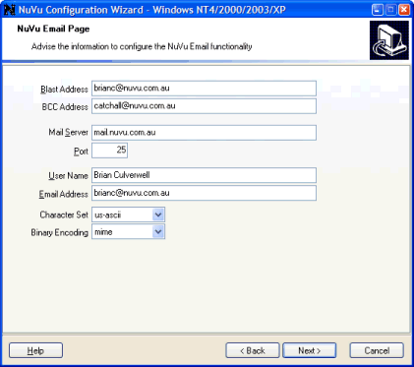

This section is used to advise the following details -

Blast Address

This field is applicable to both MAPI and SMTP email, and is used during an Email Blast to direct all email that does not have an email address back to an internal email address, so that further action can be applied to these emails (for example, manual printing of these reports for snail mail submission to the client).

BCC Address

This field (Blind Copy email address) is applicable to both MAPI and SMTP email, and if advised, is used during all email sent via NuVu. In the case of clicking the 'email' button on the report viewer, the BCC address is automatically filled in with this address. In the case of all other command-line options passed to the NuVu processing engine that will result in email output ('E:', 'EB:' and 'B:'), then this BCC address will be APPENDED to any other BCC address advised within the associated configuration file.

Mail Server

This field is only applicable if the selected email protocol is MAPI (because this setting is automatically determined by the MAPI software). If the SMTP protocol has been chosen, then the appropriate host name of the email server must be advised here. This information will probably need to be obtained from your network administrator.

Port

This field is only applicable if the selected email protocol is MAPI (because this setting is automatically determined by the MAPI software). If the SMTP protocol has been chosen, then the appropriate port number on which to communicate between this PC and the host email server must be advised here. In 99% of cases, the normal smtp port of 25 can be used here. This will probably need to be confirmed with your network administrator.

User ID

This field is not currently used, but will be used when SSL user validation is introduced into the product at a later point in time.

Password

This field is not currently used, but will be used when SSL user validation is introduced into the product at a later point in time.

Confirm Password

This field is not currently used, but will be used when SSL user validation is introduced into the product at a later point in time.

User Name

This field is only available if the selected email protocol is MAPI (because this setting is automatically determined by the MAPI software). If the SMTP protocol has been chosen, then the appropriate user name (sign-in name) might need to be advised here. In 99% of cases, this field can be left blank. This will probably need to be confirmed with your network administrator.

Email Address

This field is only available if the selected email protocol is MAPI (because this setting is automatically determined by the MAPI software). If the SMTP protocol has been chosen, then an appropriate email address (normally your own) must be advised here. This email address will be included with the email message, so that recipients can reply back to the sender (or in the case of undelivered email messages, the email server will send the email back to this recipient address, marked as UNDELIVERED).

Character Set

This drop-down list contains the available character sets that can be chosen whenever an SMTP email is sent. The first item in the list (iso-8959-1) is the default, but of recent times, utf-8 is becoming a standard character set when sending emails. This setting may need to be changed if the recipients of any emails sent complain that the email is either unreadable, or that the attachments are missing.

Binary Encoding

This drop-down list contains the available Binary Encoding methods that can be chosen whenever an SMTP email is sent (with attachments). The first item in the list (mime) is the default, but of recent times, yenc is becoming a standard character set when sending emails. This setting may need to be changed if the recipients of any emails sent complain that the email is either unreadable, or that the attachments are missing.

Finish Page

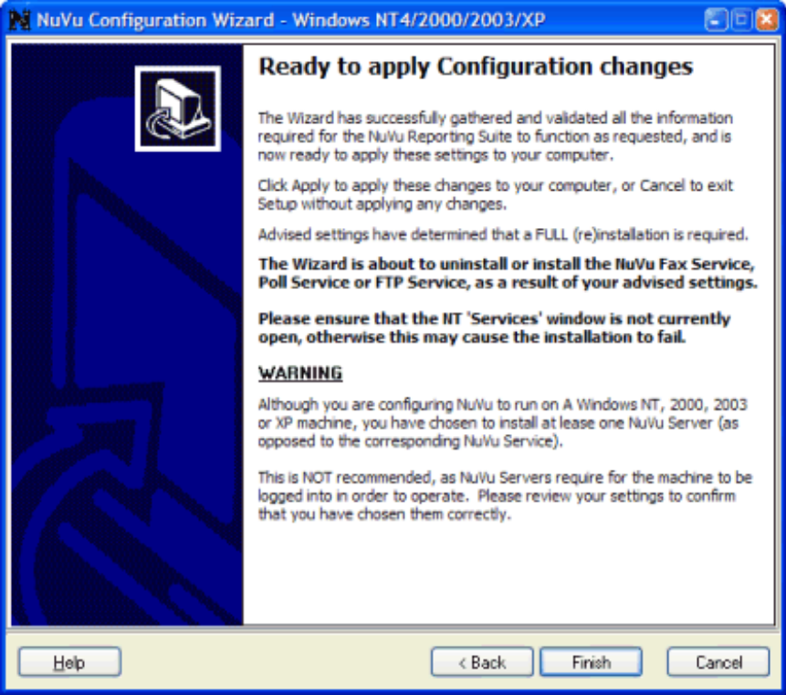
This page is the final page of the NuVu configuration wizard, and allows the user to pause before appying the advised settings to the machine on which this wizard has been run.

This page will also show a warning in bold (as shown in the sample above) if the user has decided to install any of the NuVu services - this warning is to ensure that the user closes down the 'Services' window before commencing the install.

The page may also display a warning (as shown in the sample above) if the user has decided to install the NuVu Poll Server onto a machine that supports Windows services.

- NuVu Engine Components

Introduction
This section of the Technical Reference Manual describes the function of the various engine components used by the NuVu Reporting Suite.

In essence, the process required to transform a legacy text-based report into a NuVu graphical report and render it to the desired destination involves the calling of these engine components.

The NuVu Engine components will now be briefly described, with full explanations following :

The NuVu report Preparation tool
The supplied executable ‘rbd_prepare’ is used to pre-process the legacy report, NuVu definition and other run-time parameters into a single NuVu report instance file, which may be then graphically rendered by the NuVu viewer software (rbd_preview.exe) that resides on a Windows server.

Starting with Version 4 of the NuVu Reporting Suite, there is only a Windows operating system version of the ‘rbd_prepare’ utility, located in the ‘Engines’ sub-folder of the advised NuVu installation folder.
The syntax of the call to this utility is detailed below :

[installdir]\rbd_prepare.exe P1 P2 P3 P4 P5 P6 P7 P8 P9

Where :

P1 = The legacy report full pathname. For example : c:\spool\100333.rpt. This report must exist and be able to be opened, otherwise an error message will be generated, and the rbd_prepare.exe will return with error code 101.

P2 = The full pathname of the NuVu report definition. For example: c:\rbd\docs\invoice.rbd. This definition must exist and be able to be opened, otherwise an error message will be generated, and the rbd_prepare.exe will return with error code 201.

P3 = The NuVu reporting instance that will be created on disk. For example: c:\temp\brian.rbi. If a file already exists with this name, it will be overwritten. If permissions do not allow this file to be overwritten (or written to in the first place), then an error message will be generated, and the rbd_prepare.exe will return with error code 301.

P4 = The destination, which may be :
D[,PDF] – View the report in either the NuVu viewer (if no optional ‘,PDF’ is advised), or alternatively view the report using the default PDF viewer (Eg : Adobe Acrobat) if the optional ‘,PDF’ is appended to this parameter.
E:[emailaddress|configfilename][,PDF] – This will indicate the email recipient(s) who will receive the resulting reporting instance when the NuVu viewer is invoked. Note that when the NuVu viewer is invoked, the viewer will NOT be displayed at all, and the report will be automatically emailed to the advised recipient(s). The email addresses are advised with semi-colons seperating them (for example: bpc@nuvu.com;dec@nuvu.com).
If the optional ‘,PDF’ is appended to this argument, then the report will be converted to PDF format before being attached to the individual emails, otherwise the report will be output in NuVu format, and will require that the email recipients install the free NuVu viewer before the reports may be displayed.

PLEASE NOTE : The setting that can be advised when the report is designed that prevents a report from being emailed is ONLY effective when a report is attempted to be emailed from the supplied NuVu viewer. This setting is currently ignored when run from the command-line email option.

There is an alternative to advising the actual email address (or addresses) after the E: parameter. An Email configuration filename can be advised instead of the email address. This will automatically email the list of recipients and copied recipients as read from the contents of this file. The contents of this advised file will be read in by the rbd_prepare utility and the contents embedded into the report instance (.rbi file). The filename advised here is a configuration file (an example of which can be located in the installion NuVu directory, called ‘EmailConfig.txt’) which may contain any of the following settings :
To= a list of email addresses, separated with semi-colons (Eg : bculverw@tpg.com.au; sales@nuvusoftware.com).

CC= a list of email copy addresses, separated with semi-colons (Eg : bculverw@tpg.com.au; sales@nuvusoftware.com).

BCC= a list of email blind copy addresses, separated with semi-colons (Eg : bculverw@tpg.com.au; sales@nuvusoftware.com).

EmailFromAddr= Optional ‘From’ email address. If not advised, then the email address that was advised on the ‘Email’ page of the NuVu Configuration screen will be used instead.

EmailSubject= Description to be displayed in the subject line of each email.
As of Version 4.00 of the product, there is now support for replaceable tokens within the subject of the email message. These tokens are identified by a leading ‘@[‘ followed by the name of the required field that is defined within the associated NuVu report, and ending with a trailing ‘]’. These field tokens are replaced prior to emailing with the actual contents of the field from the report at run-time. This functionality is shown in the subject line of the example below.
The ‘EmailSubject’ keyword has replaced the ‘Subject=’ keyword, but the ‘Subject=’ keyword is still recognised for backward compatibility.

EmailBody= optional text to display in the body of the email. Please note, there is a special syntax that must be chosen when advising this parameter. The ‘Message=’ must appear on its own line, with nothing following it. The line after this must contain a single left-square bracket ([) only. The message for the body of the email is then advised on as many lines as required, and finally the end of the message is signified by a single right-square bracket (]) on its own line.
As of Version 4.00 of the product, there is now support for replaceable tokens within the body of the email message. These tokens are identified by a leading ‘@[‘ followed by the name of the required field that is defined within the associated NuVu report, and ending with a trailing ‘]’. These field tokens are replaced prior to emailing with the actual contents of the field from the report at run-time. This functionality is shown in the subject line of the example below, but applies equally to the Message body.
The ‘Message’ keyword has replaced the ‘EmailBody=’ keyword, but the ‘Message=’ keyword is still recognised for backward compatibility.

AttachMain=[True|False] optional setting that governs if the actual NuVu Report that is generated is also attached to the email. In absence of this setting, a setting of ‘AttachMain=True’ will be assumed. This setting is useful if NuVu Reports is just being used as an Email delivery system, and all that is required is to email receipients and attach the files specified in the ‘Attachments=’ parameter (explained below this).

Attachments= optional files to attach to the email,separated with semi-colons. At run-time, the NuVu processing engine will verify the existance of all supplied files. Any files that are not able to be located on disk will be simply ignored.
Example :
# EmailConfig.txt - Email configuration file for the NuVu Print Engine automatic email
#
# Copyright (c) NuVu (Pty) Ltd
#
# lines starting with '#' are treated as comments

To=brianc@tpg.com.au
CC=brianc@tpg.com.au
Subject=This is an automated email from NuVu : Purchase Order # @[PONumber]
EmailFromAddr=support@nuvu.com.au
Message=
[
Advise details for the body of the Email here....

This is the second paragraph. Blah Blah Blah....
]

P:printername[,printquality,printcolor,dithering,duplex,bin] – This will indicate which printer (windows UNC name) to direct the printing to when the NuVu viewer is invoked. Note that when the NuVu viewer is invoked, the viewer will NOT be displayed at all, and the report will simply be directed to this Windows printer directly. There are five optional parameters (comma-delimited) that may be advised, being the printquality (draft, low, medium or high), printcolor (grayscale or color), dithering (none, course, fine, lineart or grayscale), duplex (singlesided, horizontalduplex or verticalduplex) and bin (an integer relating to the required bin number (1=first bin, 2=2nd bin etc). Please note, that if the printername contains spaces, this whole string should be enclosed in double quotes (for example : “P:hp deskjet 890C”).

It is worthy to note that the printername can be any substring of the printer names that are available on the Windows network (as seen from the Windows PC on which the report is to be rendered (processed)). For example, assuming that the following printers are installed on your system (visible by clicking on the ‘Print’ button within the NuVu Preview window) :

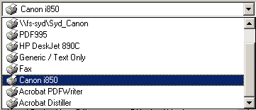
Advising ‘Canon’ or ‘i850’ will select the ‘Canon i850’ printer. Advising ‘890C’ will select the ‘HP Deskjet 850C’ printer. In this example, if the full name of the ‘HP Deskjet 890C’ printer is to be passed as a runtime parameter, enclose the full printer name in double-quotes (because there is spaces in the printername), including the ‘P:’ parameter, as follows : “ P:HP Deskjet 890C ”. Although in this example, the printer name is advised in Upper and Lower case (as per the drop-down list), it is not necessary, as printer names are converted to lowercase automatically by the system.

F:filename – This will automatically save the current RBI (report instance) to the designated filename.
X:filename – This will automatically export the contents of the report in comma-seperated format (.csv) for subsequent loading into a spreadsheet or other application.
PDF:filename – This will save the report in standard PDF format, to the advised filename (which should end with a .pdf extention).
Fax:filename – This will automatically fax the report (either using the supplied NuVu Fax Server or installed WinFax 10.0 onwards). The filename advised here will be read in by the rbd_prepare utility and the contents embedded into the report instance (.rbi file). The filename advised here is a configuration file (an example of which can be located in the installion NuVu directory, called ‘FaxConfig.txt’) which contains the following settings :
FaxNumber= desired fax number to dial, including any dialling prefixes (Eg : 0,98947373).

Recipient= Name to be displayed on the cover sheet (if a cover sheet is output).

FaxSubject= Description to be displayed on the cover sheet (if a cover sheet is output). If this option is left blank, then the name of the report as advised in the ‘Report Options’ dialog window will be used.
As of Version 4.00 of the product, there is now support for replaceable tokens within the subject of the fax. These tokens are identified by a leading ‘@[‘ followed by the name of the required field that is defined within the associated NuVu report, and ending with a trailing ‘]’. These field tokens are replaced prior to faxing with the actual contents of the field from the report at run-time. This functionality is shown in the subject line of the example below.
The ‘Subject=’ keyword has replaced the ‘FaxSubject=’ keyword, but the ‘Subject=’ keyword is still recognised for backward compatibility. If the ‘Subject=’ is advised WITHOUT the ‘FaxSubject=’ keyword, then this text will be used instead of the ‘FaxSubject=’ text.

FaxFrom= The Name of the sender that will be shown on the fax (and email sent to the ‘EmailToAddr’ when a fax cannot be successfully transmitted due to some error).

EmailFromAddr= The email address that will be shown on the email sent to the ‘EmailToAddr’ when a fax cannot be successfully transmitted due to some error.

EmailToAddr= The email address to which an email will be posted in the event that this fax cannot be successfully transmitted due to some error.

Date= The date on which this fax will be transmitted. If omitted, then this fax will be sent immediately. The format for the advised date is YYYY/MM/DD. (Example : 2002/03/31 would schedule this fax to be sent on the 31st March 2002. If this date is already passed, then the fax will be sent immediately).

Time= The time at which this fax will be transmitted. If the date parameter is advised (above), then the time parameter MUST be advised. The format for the advised time is HH:MM:SS. (Example : 23:59 :00 will schedule the fax to be transmitted at 59 minutes after 11pm).
BillingCode= Optional billing code for billing of this fax to the customer.

CoverPage= optional filename of the WinFax cover page template to use for the cover page. If this option is omitted (or is blank), then no cover page will be output with the fax. If the standard Quick Cover Page is to be output, advise ‘Quick Cover Page’ here.

CoverText= optional text to display in the body of the cover page (if the cover page is output). Please note, there is a special syntax that must be chosen when advising this parameter. The ‘CoverText=’ must appear on its own line, with nothing following it. The line after this must contain a single left-square bracket ([) only. The message for the body of the cover page is then advised on as many lines as required, and finally the end of the message is signified by a single right-square bracket (]) on its own line.
As of Version 4.00 of the product, there is now support for replaceable tokens within the cover text. These tokens are identified by a leading ‘@[‘ followed by the name of the required field that is defined within the associated NuVu report, and ending with a trailing ‘]’. These field tokens are replaced prior to faxing with the actual contents of the field from the report at run-time. This functionality is shown in the subject line of the example below, but applies equally to the Cover Text.
The ‘Message’ keyword has replaced the ‘CoverText=’ keyword, but the ‘Message=’ keyword is still recognised for backward compatibility. If the ‘Message=’ is advised WITHOUT the ‘CoverText=’ keyword, then this message text will be used instead of the ‘CoverText=’ message.

Example :
# FaxConfig.txt - Fax configuration file for the NuVu Print Engine automatic fax
#
# Copyright (c) NuVu (Pty) Ltd
#
# lines starting with '#' are treated as comments

FaxNumber=55555555
Recipient=Advise Recipient Name here...
FaxFrom=NuVu Support
Subject=This is an automated Fax from NuVu : Purchase Order # @[PONumber]
EmailFromAddr=nuvusupport@nuvusoftware.com
EmailToAddr=failed@nuvusoftware.com
#Date=2003/02/05
#Time=23:59:30
BillingCode=
CoverPage=c:\nuvu\docs\QuickCoverPage.rbc
CoverText=
[
Advise details for the body of the Cover Page here....

This is the second paragraph. Blah Blah Blah......
]
ShowDialog – if this option is in the configuration file, then the fax preview window will be displayed before the fax is sent, allowing the user to manually change any details before the fax is sent.

B:configname,[RBI|PDF],otherdestination – This will invoke the report blast facility, which will automatically seperate the various pages of the processed report into three different sets, one for email recipients, one for fax recipients and the third for recipients who are not identified as either email or fax.

In order for this function to operate, there MUST be a field in the report with a name of ‘blastinfo’, which will contain either blanks (neither email nor fax), otherwise a pipe delimited string containing three parameters, the first being the destination (E = email, F = Fax), the second being either the email address or the fax number, and the third being the recipient name. For example, page 1 could have a blastinfo field containing E|fredbloggs@freddy.com.au|Fred Bloggs, and page 2 could have a blastinfo field containing F|99225563|Ginger Rogers, and page 3 could have a blank blastinfo field. When this report is processed, page 1 will automatically be emailed to fredbloggs@freddy.com.au (attention of Fred Bloggs), page 2 will automatically be faxed to Ginger Rogers on fax number 99225563 and the third page will be sent to the advised otherdestination (which could be display, save, export or any of the other methods available). Note, that the automatic emails will use the standard email options advised when producing an email blast (covered earlier in this help document).

PLEASE NOTE : The setting that can be advised when the report is designed that prevents a report from being emailed is ONLY effective when a report is attempted to be emailed from the supplied NuVu viewer. This setting is currently ignored when run from the command-line email option.

The configname parameter is the filename of the fax/email configuration file. Refer to the Fax: and E: options above for a detailed explanation of this configuration file. The configuration file should contain information required for both the faxing and emailing of documents, and therefore should be a combination of both the previously documented Fax and Email configuration files.

The [RBI|PDF] option is used to specify in which format the email recipients will receive their report. Advising RBI will output the report in the standard NuVu display format. Advising PDF will output the report in Adobe PDF format.

The last parameter is the destination for the remaining recipients who are neither email nor fax. Any valid destination (Display, Save to File, Export, Print etc.) may be advised here, in the same format as specified for that destination.

Examples :
P:printer5,low,grayscale – would send the results directly to printer5, and print the output in low resolution and shades of gray.
P:printer5 – would send the results directly to printer5 on the network, in high quality (the default) and in color (the default).
P - would view the report using the report viewer, but automatically display the print dialog window, allowing the user to select the destination printer, print quality, range of pages etc.
B:c:\NuVu\FaxConfig.txt,PDF,P:printer5 – would perform a report blast of the current report, emailing email recipients in PDF format, and faxing fax recipients using the settings within the c:\NuVu\FaxConfig.txt configuration file, while sending all non email or fax recipients to printer5 on the network.

D – would view the report using the report viewer.
E:bpc@email.com.au – would automatically email the report to the recipient (bpc@email.com.au)
E:bpc@email.com.au,freeda@email.com.au – would automatically email the report to the recipients (bpc@email.com.au and freeda@email.com.au)
F:c:\temp\myrbi.rbi – would automatically copy the current report instance (.rbi file) to the designated filename (c:\temp\myrbi.rbi).
X:c:\temp\myreport.csv – would automatically export the current report contents (.rbi file) to the designated filename (c:\temp\myreport.csv).
PDF:c:\temp\myreport.pdf – would create a PDF format output file (myreport.pdf) in the c:\temp directory.
Fax:c:\NuVu\FaxConfig.txt – would fax the report to the recipient and fax number contained within the FaxConfig.txt configuration file.
P5 = Number of Copies, only applicable if the Destination is ‘ P :…’ (see P4 parameter)

P6 = Starting Page number. This will ensure that all pages of the legacy report before the advised starting page number are EXCLUDED from the resulting report instance created by this program.

P7 = Ending Page number. This will ensure that all pages of the legacy report after the advised ending page number are EXCLUDED from the resulting report instance created by this program.

P8 = Number of Logical Lines per page. This parameter is important if the legacy report does NOT contain physical page breaks (ctrl-L) within it. The processing engine will use this parameter to break the report into logical pages.

P9 = Delete (Y/N). This parameter indicates if the created reporting instance file created by the processing engine will be automatically deleted when the NuVu viewer is closed.
Error Processing

The ‘rbd_prepare’ utility, being a command-line utility (can be run from a UNIX script or Windows batch file), returns an error status upon completion. This error status can be used in the scripts to output error messages, or direct processing according to the error returned. The following error numbers can be returned by the utility :

0 - No error, utility completed successfully.
1 - Incorrect number of parameters passed (expected 9).
This could either be a result of having spaces within pathnames and other parameters, that are NOT double-quoted, or else an invalid number of parameters have indeed been passed to the utility.
2 - Unable to open the NuVu report template file (parameter 2).
Either the advised NuVu report template (a file with an extension of ‘.rbd’) does not exist at the advised location, or else the current user does not have permission to access this file, or the file is opened in exclusive-mode by some other user or process.
3 - Unable to open the report file (parameter 1).
Either the advised raw text report file does not exist at the advised location, or else the current user does not have permission to access this file, or the file is opened in exclusive-mode by some other user or process.
4 - Unable to write to the output rbi file (parameter 3).
The full pathname advised in parameter 3 either contains illegal characters (for the current operating system), or the advised pathname is invalid (does not exist).
5 - Unable to open the Fax Configuration file (Mode=Fax:filename).
If the advised destination for the rendered report is a Fax (or Fax Blast), then the utility has been unable to open the advised fax configuration file (see ‘FAX :’ option above for the syntax required for this report destination). Either the advised fax configuration file does not exist at the advised location, or else the current user does not have permission to access this file, or the file is opened in exclusive-mode by some other user or process.
6 - Unable to extract current user.
This utility requires authentication against the supplied NuVu licence file in order to determine if the current user is licenced to use the NuVu rendering engine or not. This error is reported if the operating system cannot determine who the current user is. This is a rare error, and should be directed at your system administrator.

7 - Unable to locate the NuVu Licence file.
This utility requires authentication against the supplied NuVu licence file in order to determine if the current user is licenced to use the NuVu rendering engine or not. This error is reported if the supplied licence file (nuvu.lic) cannot be located in the installation folder of NuVu (Eg : c:\nuvu on Windows operating systems).

8 - The NuVu Licence file is unregistered.
This utility requires authentication against the supplied NuVu licence file in order to determine if the current user is licenced to use the NuVu rendering engine or not. This error is reported if the supplied licence file is unregistered. Please contact Sterland Software (the distributor of this software) for more information and solution to this problem.

9 - Maximum licence count has been exceeded.
This utility requires authentication against the supplied NuVu licence file in order to determine if the current user is licenced to use the NuVu rendering engine or not. This error is reported if the current user was not previously licenced to use the NuVu engine, and there are NO more empty licences to automatically allocate. Please contact Sterland Software (the distributor of this software) for more information and solution to this problem.

10 - Product has expired.
This error is reported if the supplied NuVu licence file has now expired. This may be due to a limited ‘trial’ version of the software passing its expiry date. Please contact Sterland Software (the distributor of this software) for more information and solution to this problem.

11 - Registration period has expired.
This utility requires authentication against the supplied NuVu licence file in order to determine if the current user is licenced to use the NuVu rendering engine or not. When the NuVu licence file is initially supplied, you are given a pre-determined number of days in order to install this file. If this period is passed without registering the licence file, then this error is issued. Please contact Sterland Software (the distributor of this software) for more information and solution to this problem.

12 - Checksum is invalid (NuVu Licence file).
This rare error is reported if the supplied and installed NuVu licence file has become corrupted. Please do NOT attempt to manually edit the licence file with a text (or other) editor, as this will surely corrupt the file. Please contact Sterland Software (the distributor of this software) for more information and solution to this problem.

13 - Incorrect platform (NuVu Licence file).
During the Licence registration process, you are required to supply the desired platform on which the NuVu engines will be running (Unix or Windows). This error is reported if the current operating system platform is DIFFERENT to what was advised during the registration process. Please contact Sterland Software (the distributor of this software) for more information and solution to this problem.

14 - Fax CoverPage definition not found.
If the advised destination for the rendered report is a Fax (or Fax Blast), and a fax cover page has been requested (inside the Fax Configuration file), the utility has been unable to locate (or open) the advised fax cover page (see ‘FAX :’ option above for more information in this regard). Either the advised fax cover page file (normally a file with an extension of ‘.rbc’) does not exist at the advised location, or else the current user does not have permission to access this file, or the file is opened in exclusive-mode by some other user or process.

The NuVu Auto-Find utility
The executable, ‘rbd_find’, is used to automatically find the associated report template for the processed legacy report. This utility is useful when the application which is outputting the legacy report does not know the contents (or unique identifier) of the report. The utility searches the first 50 lines of the legacy report and comparing the text found there with the list of text in the associated find-definition file. When an entry is found in this file, the utility will automatically copy the actual report definition (.rbd file) which is listed in the find-definition file to the advised filename (parameter P3). This template will be searched for in the advised path (parameter P4). If there are any errors while processing the rbd_find utility (or no corresponding definitions are found in the find-definition file) then a non-zero return value is returned from the utility.

From Version 4 of the NuVu Reporting Suite, there is only a Windows version of the ‘rbd_find’ utility program, installed into the NuVu installation folder.

The default location (and filename) of this definition file can be changed to any user-defined preferrance. The NuVu report designer has a ‘Designer Properties’ window where the actual location and name of this file can be advised.

Layout of the ‘Find Definition File’.

The Find Definition File is a text file that can be edited with any text editor (although this file is also automatically edited from within the NuVu Designer tool). An example of this file is included in the standard NuVu installation, and is named ‘rbd_find.def’ in the root installation folder of NuVu.

This text file contains a line for each report that needs to be automatically identified when the ‘rbd_find’ utility program is executed. The first 2 lines of this file contain column headings, therefore the definitions should start on line 3.

Each line contains 7 fields that are in FIXED positions in the line. It is MOST IMPORTANT that the fixed positions are maintained, and that that spaces and NOT tabs are used to fill the empty gaps between the fields. Failing to ensure these rules may result in the ‘rbd_find’ utility failing to find the appropriate template at runtime.

Column 1 – 1 : ID Wildcard

The advised character (& by default) will be used as a wildcard character, replacing the word in the ID string. For example, if an ID string of ‘Customer Listing for Rep: &’, then any string in the legacy report which contains ‘Customer Listing for Rep: <any string>’ will be identified as the ID string.

Column 4 – 43 : ID String

The advised text string will be searched for at run-time by the 'rbd_find' utility program in order to determine which report definition to associate with the advised legacy report. This string is CASE SENSITIVE.

Column 45 - 47 : ID Row

This numeric right-justified field is used to determine in which row of the legacy text report to search for the ID String (see above). If a non-zero value is advised here, then the ID string will only be searched for in the specified row of the legacy report. Leaving this option at zero, will search the legacy report for the ID string in any row (up to row 100 of the report).

Column 49 – 51 : ID Column

This numeric right-justified field is used to determine in which column of the legacy text report to search for the ID String (see above). If a non-zero value is advised here, then the ID string will only be searched for in the specified column of the legacy report. Leaving this option at zero will search the legacy report for the ID string in any column of each searched line (up to line 100).

Column 53 - 104 : NuVu Template name

This field is used to advise the actual template name (the NuVu Design with a file extention of .rbd). Please note, only the filename must be advised here, EXCLUDING the path. The path is advised as a separate parameter to the ‘rbd_find’ utility.

Column 106 - 108 : AND/OR Condition

As of version 4.1 of this utility, there is now an ability to search for two strings within the processed legacy report. The primary search string is advised as before, but if this column contains an AND or OR, then the line following the current definition line will also be used to search the legacy report. Therefore it is now possible to search for a certain string in a defined row, as well as (or either) another string in a completely different row/column.

Column 110 - 200 : Optional Destination
This field is optional (ie: can be left blank), but if a non-blank string is advised here, then this will result in the ‘Destination’ being set automatically to this value at run-time. This is a very handy mechanism to ensure that certain reports are always printed to a particular printer (especially when using the NuVu POLL engine to deliver graphical reports. Any valid Destination string can be advised here, as outlined in the ‘NuVu Report Preparation Tool’ section which precedes this section in the manual. For example, ‘P:hp1100’ could be advised here (WITHOUT THE QUOTES) against a definition so that each time this report definition is chosen by the ‘rbd_find’ utility, the destination will automatically be changed to print to the ‘hp1100’ printer.
Please note, there is also a capability (when printing) to print to the current DEFAULT printer. If you wish to use this feature, advise a printer name of <default>, eg: P:<default>.

Calling Syntax

The syntax of the call to this utility is detailed below :

[install directory]\rbd_find.exe P1 P2 P3 P4

Where :

P1 = The legacy report full pathname. For example : c:\spool\100333.rpt. This report must exist and be able to be opened, otherwise the rbd_find.exe will return with error code 1.

P2 = The find-definition full pathname. For example : c:\rbd\rbd_find.def. This file must exist and be able to be opened, otherwise the rbd_find.exe will return with error code 2. See the ‘Layout of the Find Definition File’ section above for more information.

P3 = The output report definition full pathname. For example : c:\temp\brian.rbd. This file must be able to be written to, otherwise the rbd_find.exe will return with error code 3. If the legacy report does not satisfy any definitions within this file, then the rbd_find.exe will return with error code 4.

P4 = The pathname where the templates (.rbd) reside. For example : c:\nuvu\docs\. The trailing slash (back or forward depending on operating system) is required.
Error Processing

The ‘rbd_find’ utility, being a command-line utility (can be run from a Windows batch file), returns an error status upon completion. This error status can be used in the scripts to output error messages, or direct processing according to the error returned. The following error numbers can be returned by the utility :

0 - No error, utility completed successfully.
1 - Incorrect number of parameters passed (expected 4).
This could either be a result of having spaces within pathnames that are NOT double-quoted, or else an invalid number of parameters have indeed been passed to the utility.
2 - Unable to open the definitions file (parameter 2).
Either the advised definitions file (normally c:\nuvu\rbd_find.def on Windows, or /nuvu/rbd_find.def on Unix) does not exist at the advised location, or else the current user does not have permission to access this file, or the file is opened in exclusive-mode by some other user or process.
3 - Unable to open the report file (parameter 1).
Either the advised raw text report file does not exist at the advised location, or else the current user does not have permission to access this file, or the file is opened in exclusive-mode by some other user or process.
4 - No template found for this report.
The utility has processed through all the definitions in the passed definition file (parameter 2), and has been unable to locate a template that matches the advised raw text report file (parameter 1). This return error can be used within scripts to assign a ‘default’ NuVu report template to use with the report.
5 - Unable to write to the output rbd definition file (parameter 3).
The utility HAS successfully found a template within the advised definition file (parameter 2), and this template file is valid (can be located in the directory advised in parameter 4), but the utility has failed when attempting to COPY the found template from the advised directory to the advised full pathname advised in parameter 3. This is normally due to an invalid filename (illegal characters in filename) or an unknown directory path.
6 - Unable to open the found template file (for copying).
The utility HAS successfully found a template within the advised definition file (parameter 2), but the actual NuVu template cannot be located in the directory advised in parameter 4.

The NuVu Preview utility
The windows executable, rbd_preview.exe, is used to view, print, email, fax or spool a pre-processed legacy report. The preview utility is only able to be run on Windows 98, 2000, 2003, Me, XP or NT.

The Syntax of calling the previewer is detailed below :

[install directory]\rbd_preview.exe P1 [-silent]

Where :

P1 The reporting instance full pathname, normally created by the rbd_prepare.exe utility. For example : c:\temp\brian.rbi. This reporting instance must exist and be able to be opened, otherwise an error message will be generated, and the rbd_preview.exe will return with error code 101.

-silent This optional parameter will ensure that the rbd_preview utility is run in ‘silent’ mode. This is the only way that the utility is called when run from the NuVu FTP Server/Service, or the NuVu POLL Server/Service, and ensures that the utility does not attempt to display any messages (or view the rendered report). All error messages are re-directed to a log-file (named ‘rbd_preview.log’, and residing in the same folder as the invoked ‘rbd_preview’ utility). This log-file acts as a useful debugging tool when analysing any application integration problems.

Error Processing

Each time the ‘rbd_preview.exe’ utility is invoked (either directly from your application, or within a Unix/Windows script), the full command-line that is passed to the utility is first written to a logfile, that resides in the ‘log’ sub-folder of the advised NuVu installation folder, and with a name of ‘rbd_preview.log’. The destination for the report (and any other useful information) is also written to this log file.

In addition, if the utility is being run with the ‘-silent’ option, then any other errors that are detected during the processing of a report will be written to this log file. If the ‘-silent’ option has not been advised, then error messages are displayed in standard windows dialog boxes (because the utility is assumed to be running from a visible Windows client application).

- NuVu Servers/Services

Introduction
This section of the Technical Reference Manual describes the various Servers and Services that ship with the full copy of the NuVu Reporting Suite. These Servers/Services are described briefly below, with full explanations following :

- NuVu Licence Service
Handles the validation and assignment of all licences. Each time the ‘rbd_prepare.exe’ utility or the NuVu Poll Server/Service begins processing a request, a call is made to the NuVu Licence server to determine if the current user is licenced to use the NuVu Reporting Suite.

- NuVu Poll Server
The Poll Server is able to monitor either a nominated windows shared folder, or alternatively a Windows print queue for new entries arriving from the application process. The Poll Server will then attempt to locate the NuVu Template for the found entry (text report) and render it graphically and deliver it to the desired destination.
- NuVu Poll Service
Identical in function to the NuVu Poll Server (described previously), the Poll Service is able to monitor either a nominated windows shared folder, or alternatively a Windows print queue for new entries arriving from the application process. The Poll Server will then attempt to locate the NuVu Template for the found entry (text report) and render it graphically and deliver it to the desired destination.
The only difference between the Poll Service and Poll Server is that the Poll Service is implemented as a true Windows service and therefore does not require a user to be logged into the machine on which the service is running.
- NuVu Fax Service
The NuVu Fax Service is a fully-fledged fax delivery service that is tightly integrated with the other NuVu components, and allows for the seamless faxing of graphically rendered documents to the nominated recipients.

The NuVu Licence Service
The Windows executable, NuVuService.exe, is is fully-featured FTP Service, capable of receiving licence requests from any client PC on the network. The licence is validated on the Licence Server machine and a pass/fail status is passed back to the calling process (the rbd_prepare.exe and Poll Server processes). The NuVu Licence Server is installed as a Windows Service, and is therefore only able to be run on Windows 2000, 2003, XP or NT.

When the NuVu reporting suite is installed, the NuVu Configuration tool is used to configure the NuVu Licence Server (if applicable). If the Licence Server option is chosen, the NuVu Licence Server will automatically start each time the PC on which it is installed is booted into the Windows operating system.

The NuVu Licence Server is multi-threaded, in that it is able to process multiple licence requests simultaneously (as is normally the case in a multi-user environment).

The NuVu Licence Server has a built-in logging mechanism which records all activity between the NuVu Licence Server and the processes that call it (rbd_prepare.exe and the NuVu Poll Server/Service). This comprises a log-file (standard text-file) that is written to each time there is activity between the application server and the NuVu Licence Service. This file is located in the ‘log’ sub-folder of the advised NuVu installation folder (normally in the default c:\nuvu\log folder) and is named ‘NuVuLicenceServer.log’. This file may be interrogated using a standard text file editor like Notepad or Wordpad to display the contents of the log-file, or alternatively the ‘View NuVu Server Logs’ option can be chosen from the ‘NuVu’ program group. This option displays the various log files produced by the NuVu Reporting Suite.

The NuVu Configuration utility (available from the NuVu application folder) allows the user to specify the various configuration options for the NuVu Licence Service. Please refer to the on-line help available from this utility to find out more on these configuration options, or alternatively refer to the ‘NuVu Configuration’ section of this manual for more information regarding the configuration of the NuVu Licence Server.

The NuVu POLL Server
The Windows executable, NuVuPollServer.exe, is is fully-featured Polling Server, capable of interrogating and processing the files within a nominated folder, or alternatively the contents of the Windows Spool queue for a nominated printer, depending on the configured options. It is important to re-iterate that the NuVu POLL Server is a WINDOWS executable, and therefore can only be installed on a Windows operating system. Therefore in order for a back-end application to integrate to the Nuvu Poll Server, there is a requirement that the back-end application and NuVu Poll Server machine are able to reference the same (shared) folder or windows spool queue.

To illustrate how the Poll Server works, examine the following schematic diagram that shows an application integrated with the NuVu Poll Server via means of a shared folder:
Windows Environment

❶


❺





❻

❸

❹

❷

❶ Application drops raw text report into a folder ❷ that is accessible from the Windows Poll Server (A shared folder in this case). Optionally, a configuration file is also dropped into the same folder (before the raw text report is dropped there).
❸ The associated NuVu template is determined from the associated ‘rbd_find.def’ file, by calling the ‘rbd_find.exe’ utility program.
❹ The ‘BeforePoll.exe’ utility will be called at this stage, if the executable exists. The primary task for the ‘BeforePoll.exe’ utility is to create a NuVu Configuration file by examining details within the raw text report.
❺ The NuVu Poll Server automatically prepares the report, merging it with the appropriate template that was identified in step ❸.
❻ Prepared report is directed to the appropriate output destination (Print, Email, Fax etc). If no configuration file was sent along with the raw text report, then the only option here is to Print the document to the printer advised in the NuVu Configuration tool.

The above diagram only illustrates the situation where the NuVu Poll server is monitoring a shared folder for new entries to process. The Poll server can also be configured so that a nominated Windows printer queue is monitored instead of a normal folder. When the NuVu Poll server is monitoring a print queue, then there is no way to create a configuration file and associate it with entries written to the print queue, so in this scenario, the only available destination for the rendered report is to print it to the nominated printer as advised within the NuVu Configuration tool.

In addition to the above diagram, the Poll Server is able to either AutoProcess raw text files (ie: files that have not yet been associated with a NuVu design template), or else can render previously processed NuVu report instance files (files ending in an extention of .rbi).

As of Version 4.00 of the NuVu Reporting Suite, there is now a ‘hook’ that can be placed inside the NuVu Polling process, that is of particular use when the Poll Server is monitoring a windows spool queue. In previous versions of the NuVu Reporting Suite, there was little control over the ultimate destination of a report that was processed from the nominated print queue. The ‘rbd_find.def’ definitions file could be used to direct the rendered graphical report to an alternate printer (refer to the technical reference manual for more details regarding this option) at run-time, but this was a little restrictive. This new hook provides an additional step that can be inserted into the processing stream that can be used to create an alternate NuVu configuration file before the report is actually prepared and processed by the engine. This is an unrestricted configuration file, and is thus able to advise email, fax and any other valid destination as specified in the NuVu technical reference manual.
This hook is implemented via a call to a Windows executable with the name ‘BeforePoll.exe’ that MUST reside in the same folder as the ‘NuVuPollServer.exe’ (or ‘NuVuPollService.exe’ if the service has been chosen). This executable must be written to accept a single string parameter, being the full pathname of the entry that is about to be processed. The NuVu Configuration file is a file that has the same name (and resides in the same folder) as the filename that is passed in as the input parameter, except the extention of the file must be ‘.rbx’.
This new feature requires a separate executable to be created for your implementation, please contact your support contact at Sterland Software for more information on this advanced option.

The NuVu Poll Server is only able to be run on Windows 2000, 2003 or XP operating systems, and can be run as an executable program that is invoked automatically upon system login.

When the NuVu reporting suite is installed, the NuVu Configuration tool is used to configure the NuVu Poll Server. If the Server option is chosen, the NuVu Poll Server is automatically placed into the Startup folder for the applicable operating system, and will therefore be loaded into memory whenever the user logs into Windows. The Poll Server will be represented by an icon in the system tray. Please note that in order to invoke the NuVu Poll Server, it is neccessary for the nominated Windows PC to be logged in to the system. An alternative (preferred) configuration is to install this option as a service (available on Windows 2000, 2003 and XP machines). Using this option, the service will be automatically started each time the nominated PC is BOOTED and therefore does not require that a user be logged in to the PC. The NuVu Poll service is described in detail in the next section.

The optional Configuration file

When the NuVu Poll Server is configured to monitor an advised folder, an optional configuration file can be dropped into the advised folder in order to assist the Poll Server further. This condifuration file MUST be be saved into the advised folder BEFORE the raw report is saved there, to ensure that when the raw report is processed, that the config file is already resident. Also this configuration file must have an identical filename to the original raw report, but with a .rbx extention.

Currently there are two different settings that can be advised within the configuration file, namely the ‘Template=’ and the ‘Destination=’ keywords.

The ‘Template=’ keyword can be used to bypass the auto-finding of the required NuVu Template that normally occurs within the processing loop of the Poll Server. This keyword must be followed with either a fully qualified pathname to the NuVu Template (eg : Template=c:\nuvu\docs\InvoiceTemplate.rbd), otherwise just the template name (eg : Template=InvoiceTemplate.rbd). In the latter case, the Poll Server will interrogate the ‘NuVu Template Folder’ in order to derive a fully qualified template name. Please note, if the fully qualified template name cannot be found on disk, then the Poll Server will revert to using either the standard Landscape or Portrait template for the report.

The ‘Destination=’ keyword may also be advised, and must be followed by any valid destination string, as specified in the ‘NuVu Preparation Tool’ secion of this manual.

Poll Server Options

As explained previously, the NuVu Poll Server automatically installs itself in the system tray upon user login to the Poll Server machine. It is important to note that the Server machine MUST be logged in by a user to automatically invoke the NuVu Poll Server.

The NuVu Poll Server has a logging mechanism which records all activity performed by it. To invoke this dialog window, the user must then double-click the ‘N’ icon in the task-bar (or alternatively right-clicks on the icon and chooses the ‘Details’ menu option from the subsequent pop-up menu), then the following dialog window will be displayed (centered on the screen).

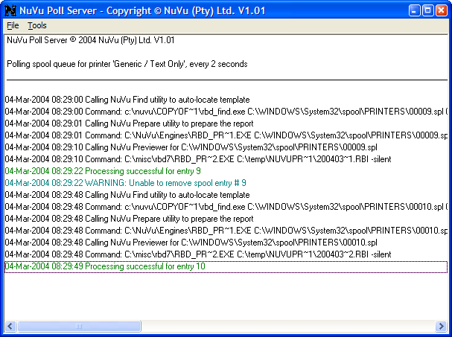

The main purpose for displaying the details is to monitor the activity between the Application Server and the Poll Server. There are menu options which allow the manual shutting down and starting up of the server process, as well as the ability to change the various options for the Poll Server.

To view or change the various Poll Server options, select the Tools⇨Options menu items from the NuVu Poll Server Menubar. The following dialog window will then be displayed :
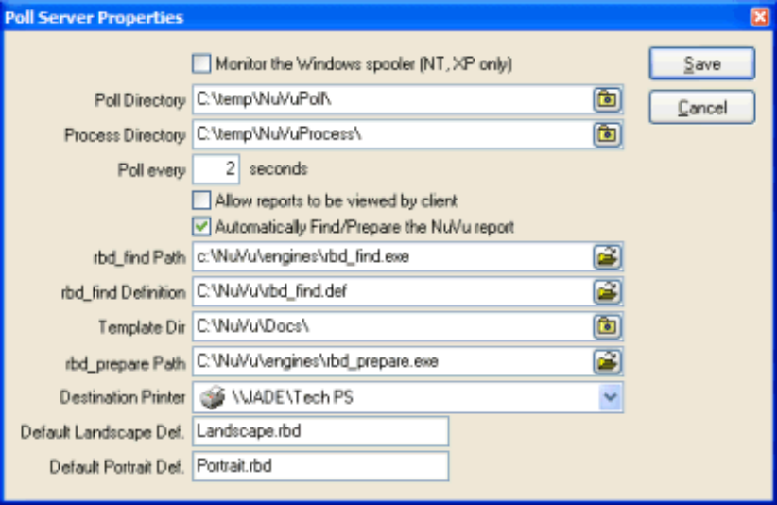

Please note that the Poll Server will be temporarily STOPPED while the options are being viewed or modified. When this dialog window is saved or closed, the Poll Server will be automatically re-started.

Please refer to the ‘NuVu Configuration’ chapter for more details of each of these settings.

The NuVu Poll Server can only be shut down (removed from memory) by right-clicking the ‘N’ icon in the system tray, and choosing the Shut Down menu item from the pop-up menu which is subsequently displayed. Please note, that it is not advisable to shut down the NuVu Poll Server during normal operations.

Polling a nominated Folder

The NuVu Configuration utility is used to advise the various settings for this option. The actual folder (directory) must be advised as well as the number of seconds between re-examining the nominated folder. There are optional settings that allow for the automatic preparation (running the rbd_find and rbd_prepare utilities (described earlier)) of reports after they have been located in this folder.

All the application needs to do is create a text report and drop it into the same nominated folder that the NuVu Poll server is monitoring. Obviously when the application server is running in a UNIX/LINUX environment, the folder must be able to be visible from the Windows NuVu Server machine. This is normally achieved via directory software such as Samba, which is available on most Unix or Linux distributables. When the NuVu Poll Server detects new files in the nominated folder, it will pick these files up, and transfer them to the ‘Process’ folder (as advised on the NuVu configuration window). Once the files have been transferred to the ‘Process’ folder, they are optionally prepared and then passed through to the ‘rbd_preview’ utility in order to deliver the reports graphically to the advised printer.

Polling a Windows Spool Queue

The NuVu Configuration utility is used to advise the various settings for this option. The actual Windows printer must be advised as well as the number of seconds between re-examining the spool queue of this nominated printer. There are optional settings that allow for the automatic preparation (running the rbd_find and rbd_prepare utilities (described earlier)) of reports after they have been located in this folder.

All the application needs to do is to print a text report to the nominated poll printer. This printer MUST be setup using the standard windows ‘Generic / Text Only’ printer driver. When the NuVu Poll Server detects new spool entries for the nominated printer, it will pick these entries up, and transfer them to the ‘Process’ folder (as advised on the NuVu configuration window). Once the entries have been transferred to the ‘Process’ folder, they are prepared and then passed through to the ‘rbd_preview’ utility in order to deliver the reports graphically to the advised printer.

An example of a working Unix script (named ‘nuvu_poll.sh’) is shown below, and may be customised to your specific requirements. This script is installed by default to the ‘Scripts’ directory of the NuVu installation folder, and is shown below :
#!/bin/sh
#
#==============================================================================
# nuvu_poll.sh
#
# A script that automatically finds the correct template for a passed raw text
# report, prepares it report for nuVu processing, and then drops the file
# into a shared folder (shared with Windows via Samba etc). The NuVu Poll
# server (running on a defined Windows Server somewhere on the network) will
# monitor this folder, detect any new files dropped into it, and call the
# NuVu rendering engine (rbd_preview.exe) in order to render and deliver the
# report to its desired destination (Fax, Email, Print etc).
#
# Input Parameters:
#
# $1 = full pathname of the report (eg: /tmp/myreport.txt)
# $2 = full pathname of the nuvu installation (eg: /nuvu)
# $3 = destination string required for rbd_prepare (eg: Fax:c:/temp/wombat.cfg)
# NOTE: any pathnames can be advised with forward-slashes - these will
# be auto-converted to backslashes by the NuVu Previewer.
# $4 = destination folder (UNIX folder, but shared by Windows)
# $5 = a temporary folder (eg: /tmp/nuvu)
# $6 = a temporary filename (should be unique and without path or extention)
# (eg: 12345678)
#
# Assumptions:
#
# 1. The rbd_find.def file must reside in the passed nuvu install path ($2).
# 2. The rbd_prepare and rbd_find utilities must reside in the passed nuvu
# install path ($2).
# 3. The design templates (.rbd) are located in the 'docs' folder of the nuvu
# install path ($2/docs).
#
# Copyright (c) 2004, NuVu (Pty) Ltd.
# =============================================================================

REPORT=$1 # legacy report file (including path) to process
NUVU=$2 # full path of the nuvu installation (Eg: /nuvu)
FIND=$NUVU/rbd_find.aix # full path to your O/S rbd_find program
PREP=$NUVU/rbd_prepare.aix # full path to your O/S rbd_prepare program
MODE="$3" # Destination option as per User Manual (P4 option)
DEST=$4 # legacy report spool path (excluding file)
DEFFILE=$NUVU/rbd_find.def # full pathname to the report definitions file
RBDP=$NUVU/docs/ # path to directory where .rbd files are stored
TP=$5 # path to a temp work directory (eg: /tmp/nuvu)
TF=$6 # a temporary file to use (no extension)

# Ensure Temporary folder is valid, and temporary file advised

if test ! -d "$TP"
then
echo Temporary folder \"$TP\" cannot be located... aborting
exit 90
fi
if test "$TF" = ""
then
echo Temporary file not advised... aborting
exit 91
fi

# Output header info to the logfile

echo Processing \"$REPORT\" using script "nuvu_poll.sh" >$TP/$TF.log
date >>$TP/$TF.log
echo >>$TP/$TF.log

# Verify that advised parameters are valid

if test ! -f "$REPORT"
then
echo Report \"$REPORT\" not found... aborting >>$TP/$TF.log
exit 92
fi
if test ! -d "$NUVU"
then
echo NuVu folder \"$NUVU\" not found... aborting >>$TP/$TF.log
exit 93
fi
if test ! -f "$FIND"
then
echo NuVu find utility \"$FIND\" not found >>$TP/$TF.log
exit 94
fi
if test ! -f "$PREP"
then
echo NuVu prepare utility \"$PREP\" not found >>$TP/$TF.log
exit 95
fi

# Step 1 - Find the report template for the raw report (or return error)
#
# Parameters:
# 1: legacy report generated by server
# 2: full pathname of the NuVu definition index file
# 3: full pathname of the copy of the found NuVu Definition file
# 4: directory name where the NuVu definitions are stored

echo Command: $FIND $DEFFILE $TP/$TF.rbd $RBDP >>$TP/$TF.log
$FIND $REPORT $DEFFILE $TP/$TF.rbd $RBDP
ERR=$?

# if the rbd_find utility reported an error, then output to log and exit

if test "$ERR" != "0"
then
echo $FIND reported error $ERR .... aborting >>$TP/$TF.log
exit $ERR
fi

# A valid template has been found (and copied to $TP/$TF.rbd).
# Invoke the NuVu preparation tool to prepare a NuVu report instance file
# (with extension .rbi), ready to be passed to the NuVu Print Server.
#
# rbd_prepare parameters:
# 1: legacy report generated by server
# 2: the NuVu definition file (output by thre #RBDFIND utility)
# 3: the full pathname of the .rbi file which will be created by this utility
# 4: the required destination string, as outlined in the Technical manual
# 5: no. of copies of the generated graphical report to produce (set to 1)
# 6: first page to render within the graphical report (zero = N/A)
# 7: last page to render within the graphical report (zero = N/A)
# 8: the no. of lines per logical page of the legacy report (zero = N/A)
# 9: Y = Delete .rbi after report is rendered and delivered, N = don't delete

echo Command: $PREP $REPORT $TP$TF.rbd $TP$TF.rbi $MODE 1 0 0 0 Y >>$TP/$TF.log
$PREP $REPORT $TP/$TF.rbd $TP/$TF.rbi $MODE 1 0 0 0 Y
ERR=$?

# if the rbd_prepare utility reported an error, add to the logfile and exit

if test "$ERR" != "0"
then
echo $PREP reported error $ERR .... aborting >>$TP/$TF.log
exit $ERR
fi

rm $TP/$TF.rbd # remove temporary .rbd file - we have finished with it

# Now drop the prepared .rbi file into the advised Windows destination folder

echo Command: cp $TP/$TF.rbi $DEST/$TF.rbi >>$TP/$TF.log
cp $TP/$TF.rbi $DEST/$TF.rbi
rm $TP/$TF.rbi # remove temporary .rbd file - we have finished with it

echo Processing successful for \"$REPORT\" >>$TP/$TF.log
exit 0 # processing was successful (assuming the ftp was successful)

/nuvu/nuvu_poll.sh /myreports/sports001.rep ./ pdf:c:/temp/aix.pdf /nuvu/Polling /tmp 12345678
This example (nuvu_poll.sh) would be called directly from your application, as follows :
Cmd = ‘/nuvu/scripts/nuvu_poll.sh ‘ + MyReport + ‘ /nuvu ‘ + ‘PDF:c:/temp/mypdf.pdf ‘ + ‘/nuvu/Polling ’ +
‘/tmp ‘ + string(time,’hhmmss’).
UNIX SILENT VALUE(Cmd).

The ‘UNIX SILENT’ is an example of the calling syntax for invoking a UNIX shell from within the PROGRESS 4GL environment and would have to be replaced with the syntax required for your application.

Here is a similar script for the Windows operating system (Nuvu_Poll.bat) :

@echo off
goto start

==============================================================================
NuVu_poll.bat

A script that automatically finds the correct template for the passed raw text
report, prepares the report for nuVu processing, and then drops the prepared
file into a folder that the NuVu poll engine is monitoring. From there, the
Poll engine will pick the file up, render it and deliver it to the required
destination (Fax, Email, Printer etc).

Input Parameters:

%1 = full pathname of the report (eg: c:\temp\wombat.txt)
%2 = full pathname of the nuvu installation (eg: c:\nuvu)
%3 = destination string required for rbd_prepare (eg: Fax:c:\temp\wombat.cfg)
%4 = destination folder
%5 = a temporary folder (eg: c:\temp)
%6 = a temporary filename (should be unique and without path or extention)
(eg: 123456)
%7 = an optional string 'debug', which if advised will output verbose messages
to a logfile with a filename of the unique filename advised as %6, with
an extention of .log.

Assumptions:

1. The rbd_find.def file must reside in the passed nuvu install path (%2).
2. The rbd_prepare.exe and rbd_find.exe must reside in the 'engines' folder of
the nuvu install path (%2).
3. The design templates (.rbd) are located in the 'docs' folder of the nuvu
install path (%2\docs).

Copyright (c) 2004, NuVu (Pty) Ltd.
==============================================================================

:start

set report=%~s1
set nuvu=%~s2
set mode=%~3
set dest=%~s4
set tempd=%~s5
set uniqf=%6
set debug=%7
set engines=%nuvu%\engines

echo Processing file %report% using NuVu_Poll.bat >%tempd%\%uniqf%.log
echo. >>%tempd%\%uniqf%.log

rem --------- Validate folders etc

if exist %tempd%\nul goto next
echo temporary folder '%tempd%' is invalid
set errorlevel=96
goto BadExit
:next

if exist %nuvu%\nul goto next
echo NuVu folder '%nuvu%' is invalid
set errorlevel=95
goto BadExit
:next

rem --------- Prepare the report for NuVu Processing

call %nuvu%\scripts\NuVu_AutoPrepare.bat %report% %nuvu% %mode% %tempd% %uniqf% %debug%
if errorlevel 1 goto BadExit

rem --------- Copy created .rbi to the destination folder (then delete it)

if exist %dest%\%uniqf%.rbi del %dest%\%uniqf%.rbi
copy %tempd%\%uniqf%.rbi %dest%\%uniqf%.rbi
if not "%debug%" == "" goto next
if exist %tempd%\%uniqf%.rbi del %tempd%\%uniqf%.rbi
:next

:GoodExit
echo Processing successful for %report% >>%tempd%\%uniqf%.log
exit 0

:BadExit
echo Processing failed for %report% >>%tempd%\%uniqf%.log
exit %errorlevel%

:end

This example (NuVu_Poll.bat) would be called directly from your application, as follows :
Cmd = ‘c:\nuvu\scripts\nuvu_poll.bat ‘ + MyReport + ‘ c:\NuVu ‘ + ‘PDF:c:\temp\mypdf.pdf ‘ +
‘c:\NuVuPoll ’ + ‘c:\temp ‘ + string(time,’hhmmss’).
DOS SILENT VALUE(Cmd).

The ‘DOS SILENT’ is an example of the calling syntax for invoking a DOS shell from within the PROGRESS 4GL environment and would have to be replaced with the syntax required for your application. For example, the DELPHI equivalent would be ‘WinExec(Pchar(Cmd),SW_HIDE) ;’.

The NuVu POLL Service
The Windows executable, NuVuPollService.exe, is is fully-featured Polling Service, capable of interrogating the contents of either a nominated folder, or alternatively the contents of the Windows Spool queue for a nominated printer, depending on the configured options.

The NuVu Poll Service is only able to be run on Windows 2000, 2003 or XP, and is installed and run as a Windows Service application (automatically started when the Server PC is booted).

When new entries are found, the NuVu Poll Service will process these entries, optionally also preparing the report for NuVu Graphical output, and then also perform the actual delivery of the reports to the required destination.

Please refer to the on-line documentation regarding the Nuvu Poll Service (under the ‘Delivery Options’ tab) in the NuVu Configuration tool for more information regarding this utility.

When the NuVu reporting suite is installed, the NuVu Configuration tool is used to configure the NuVu Poll Service. The NuVu Poll Service is identical in functionality to the NuVu Poll Server, so reference should be made to the NuVu Poll Server for more information regarding the functionality of this service. If the Service option is chosen, the NuVu Poll Service is automatically started whenever the PC on which the service is installed is booted. There is no need for any users to be logged into the Server PC in order for the NuVu Poll Service to perform it’s operations.

The NuVu Poll Service has a built-in logging mechanism which records all activity performed by the service. This comprises a log-file (standard text-file) that is written to each time there is any activity performed by the NuVu Poll Service. This file is located in the ‘log’ sub-folder of the advised NuVu installation folder (c:\nuvu\log by default) and is named ‘NuVuPollServer.log’. This file may be interrogated using a standard text file editor like Notepad or Wordpad to display the contents of the log-file, or alternatively the ‘View NuVu Server Logs’ option can be chosen from the ‘NuVu’ program group. This option displays the various log files produced by the NuVu Reporting Suite.

The optional Configuration file

When the NuVu Poll Server is configured to monitor an advised folder, an optional configuration file can be dropped into the advised folder in order to assist the Poll Server further. This condifuration file MUST be be saved into the advised folder BEFORE the raw report is saved there, to ensure that when the raw report is processed, that the config file is already resident. Also this configuration file must have an identical filename to the original raw report, but with a .rbx extention.

Currently there are two different settings that can be advised within the configuration file, namely the ‘Template=’ and the ‘Destination=’ keywords.

The ‘Template=’ keyword can be used to bypass the auto-finding of the required NuVu Template that normally occurs within the processing loop of the Poll Server. This keyword must be followed with either a fully qualified pathname to the NuVu Template (eg : Template=c:\nuvu\docs\InvoiceTemplate.rbd), otherwise just the template name (eg : Template=InvoiceTemplate.rbd). In the latter case, the Poll Server will interrogate the ‘NuVu Template Folder’ in order to derive a fully qualified template name. Please note, if the fully qualified template name cannot be found on disk, then the Poll Server will revert to using either the standard Landscape or Portrait template for the report.

The ‘Destination=’ keyword may also be advised, and must be followed by any valid destination string, as specified in the ‘NuVu Preparation Tool’ secion of this manual.

Polling a nominated Folder

The NuVu Configuration utility is used to advise the various settings for this option. The actual folder (directory) must be advised as well as the number of seconds between re-examining the nominated folder. There are optional settings that allow for the automatic preparation (running the rbd_find and rbd_prepare utilities (described earlier)) of reports after they have been located in this folder.

All the application needs to do is create a text report and drop it into the same nominated folder that the NuVu Poll service is monitoring. Obviously when the application server is running in a UNIX/LINUX environment, the folder must be able to be visible from the Windows NuVu Server machine. This is normally achieved via directory software such as Samba, which is available on most Unix or Linux distributables. When the NuVu Poll Service detects new files in the nominated folder, it will pick these files up, and transfer them to the ‘Process’ folder (as advised on the NuVu configuration window). Once the files have been transferred to the ‘Process’ folder, they are optionally prepared and then passed through to the ‘rbd_preview’ utility in order to deliver the reports graphically to the advised printer.

Polling a Windows Spool Queue

The NuVu Configuration utility is used to advise the various settings for this option. The actual Windows printer must be advised as well as the number of seconds between re-examining the spool queue of this nominated printer. There are optional settings that allow for the automatic preparation (running the rbd_find and rbd_prepare utilities (described earlier)) of reports after they have been located in this folder.

All the application needs to do is to print a text report to the nominated poll printer. This printer MUST be setup using the standard windows ‘Generic / Text Only’ printer driver. When the NuVu Poll Service detects new spool entries for the nominated printer, it will pick these entries up, and transfer them to the ‘Process’ folder (as advised on the NuVu configuration window). Once the entries have been transferred to the ‘Process’ folder, they are prepared and then passed through to the ‘rbd_preview’ utility in order to deliver the reports graphically to the advised printer.

The NuVu FAX Service
The Windows executable, NuVuFaxService.exe, is is fully-featured Fax Service, capable of delivering your Nuvu reports to clients via standard Fax.

The NuVu Fax Service is only able to be run on Windows 2000, 2003, XP or NT, and is installed and run as a Windows Service application (automatically started when the Server PC is booted).

In order for the NuVu Fax Service to operate, TAPI (Microsoft Telephone Application Processing Interface) must be installed on the nominated Windows PC Server. This PC Server must also have a Fax Modem installed and this must be correctly configured.

As of Version 4.3 of NuVu, the original Faxing Engine utilised internally by the NuVu Faxing Service has been replaced with the Microsoft Fax Service – so please ensure that you also install and configure the Microsoft Fax Service before attempting to utilise the NuVu Fax Service.

When the NuVu Fax Service is started, the Windows TAPI component will also be started, if it is not already running.

The NuVu Fax Service also has a complimentary utility, the ‘NuVu Fax Monitor’. This interactive tool is available from the NuVu application folder, and displays a window showing Pending, Failed and Sent faxes, as well as the contents of the Fax log. An example of the Fax Monitor window is shown below :
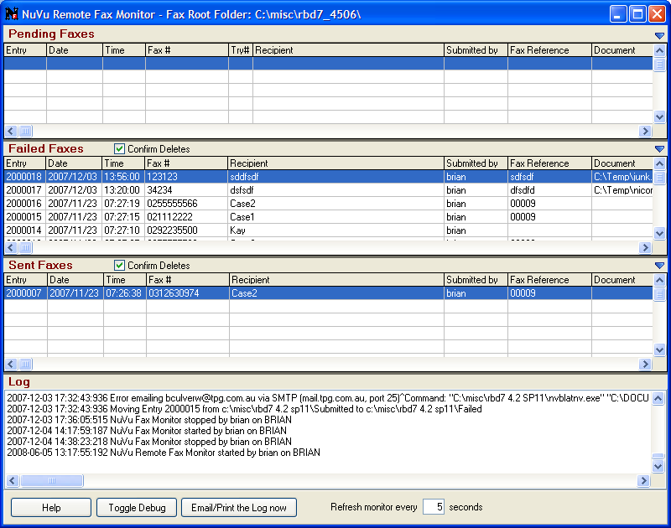
Items can be dragged from one folder to another, as well as the details amended for any fax. Please refer to the on-line help manual available from the ‘NuVu Fax Monitor’ application for more details.

When the NuVu reporting suite is installed, the NuVu Configuration tool is used to configure the NuVu Fax Server/Service. The NuVu Fax Service is identical in functionality to the NuVu Fax Server, except that it runs as a Windows Service as opposed to a normal application program that runs on the task bar.

The NuVu Fax Service has a built-in logging mechanism which records all activity performed by the service. This comprises a log-file (standard text-file) that is written to each time there is any activity performed by the NuVu Fax Service. This file is located in the ‘log’ sub-folder of the advised NuVu installation folder (default of c:\nuvu\log) and is named ‘NuVuFaxServer.log’. This file may be interrogated using a standard text file editor like Notepad or Wordpad to display the contents of the log-file, or alternatively the ‘View NuVu Server Logs’ option can be chosen from the ‘NuVu’ program group. This option displays the various log files produced by the NuVu Reporting Suite.

Depending on the advised configuration settings, the contents of this logfile is also able to be automatically emailed and/or printed at a nominated time of the day, on any selected day(s) of the week – see the ‘NuVu Configuration’ section of this manual for more information regarding faxing capabilities.

The NuVu Fax Service is invoked whenever a report is chosen to be faxed, either from the viewed report, or via the command-line to the ‘rbd_preview’ utility program.

Installing and Configuring the NuVu Fax Server/Service

- Nominate a server (PC) on your network that is going to be the NuVu Fax Server.
- Ensure the nominated server has a TAPI-Compliant Fax Modem installed onto it, and ensure that the most recent driver has been installed for it.
- Ensure that the Microsoft Fax component is correctly installed and configured, and is running on the nominated server.
- Login to this nominated server using a user/password that has ADMINSTRATIVE RIGHTS on the machine – as this is required to write the required registry settings when the NuVu Configuration Wizard is run.
- If not already installed, install the NuVu Reporting Suite onto the server, as nominated in step 1 above. At the end of the installation the NuVu Configuration Wizard will be automatically invoked.
- If the NuVu Reporting Suite is already installed – invoke the NuVu Configuration Wizard from the NuVu Program group on the nominated server.
- Click ‘Next’ until the ‘Mandatory Configuration Page’ is displayed, as shown below :
Ensure that either the NuVu Fax Service or NuVu Fax Server is ticked, as shown above. It is recommended that you install the NuVu Fax Service – as this service starts automatically when the server machine boots.
- Click ‘Next’ until the ‘Fax’ page is displayed, as shown below :
Advise the appropriate options on this screen – as explained in detail in Section 1 of this reference manual.
- Click ‘Next’ until to get to the ‘Finalisation’ page – then click the ‘Finish’ button. This will install and start the NuVu Fax Service / Server with the advised settings – and you are now ready to Fax.
- To configure the individual client PC’s that will be running the rbd_preview.exe (the report viewer) there is only one thing to setup – that is the ‘NuVuFax.ini’ file that must reside in the same folder as the rbd_preview.exe that the user is running. Typically an installation will have a shared folder on the network where the nuvu executables will reside for ALL clients – lets assume this to be a shared folder P:\NuVu.
Use any text editor to create the NuVuFax.ini file in this same folder, with the following entries :
[Overrides]
FaxRoot=\\MyNuVuFaxServer\NuVu\
This will be interrogated by the rbd_preview.exe when a user is viewing a report and clicks on the ‘Fax’ toolbutton. What this should be set to, is the root folder on the server (machine) that is running the NuVu Fax Server/Service (ie : the same folder that was advised when the Fax Service was installed and configured).
For example :
Lets assume you installed the NuVu Fax Service on machine \\OurFaxServer, in a folder called NuVu. You shared that folder (full permissions). On the NuVu Configuration Wizard Fax Page, you would have specified a Fax Root folder of C:\NuVu (but could have specified \\OurFaxServer\NuVu).
What needs to be advised into the shared NuVuFax.ini file for all user is :
[Overrides]
FaxRoot=\\OurFaxServer\NuVu\
Of course if you created a share on the NuVu install folder – lets say P: , this could also be specified as :
FaxRoot=P:\
The trailing backslash is desired, but not essential.

Testing the NuVu Servers
The various configurations of Poll Server/Service and Fax Service can be quite daunting for a system administrator to configure and ensure that they are working together with the correct configuration settings.
As part of the full NuVu installation, a ‘TestServer’ utility program is installed into your NuVu install folder, and available as an option from the NuVu program group.
This ‘TestServer’ utility runs on the Windows operating system, and is thus only able to test the installation from this platform. However, in a UNIX (or other) environment, the tool is still very useful to determine that all the Windows components are installed, configured and working properly before looking at issues relating to the operating system that is delivering the report to the servers.
To invoke this utility to test the configuration, simply click ‘Start’ and select the ‘NuVu Reporting Suite’ program group, and then click on the ‘Test Servers’ option. The following window will be displayed in the centre of your screen :
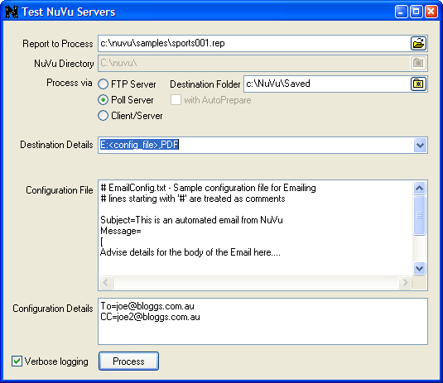
If any of the NuVu Servers (Fax, Poll or FTP) are not currently running when this utility begins, you will be prompted whether or not you would like them started for you automatically. It is advisable to answer yes to this confirmation, otherwise the testing of these servers will be problematic.
Advise the details as follows :

Report to Process Select the raw text report that you wish to process here. Use the browse button at the end of this field to explore and choose any text file on the network.

NuVu Directory This field is read-only, and simply shows you the current setting for the installation folder for the NuVu reporting suite.

Process Via Reports can be processed via the FTP Server or POLL Server, or via Self-Service, where the PC does all the work in preparing and rendering a report via the NuVu reporting suite. If the FTP Server option is chosen, then you should advise an existing folder in the Destination Folder field. The FTP server will deliver the .rbi reports into this folder. This utility uses three standard Windows scripts, depending on the selected ‘Process Via’, as follows :
’FTP Server’ NuVu_Ftp.bat (that also calls NuVu_AutoPrepare.bat)
’Poll Server’ NuVu_Poll.bat (that also calls NuVu_AutoPrepare.bat), but only if the Poll Server is NOT oing AutoPreparing of reports.
’Client/Server’ NuVu_SelfServe.bat (that also calls NuVu_AutoPrepare.bat).

Destination This drop down box contains common destination examples that can be chosen from. The last item in the list allows you to advise the complete Destination string manually (into the ‘Configuration Details’ field described below).

Configuration File Depending on the ‘Destination’ option chosen earlier, this editor box will display the standard configuration information required. For example, if you choose the ‘E :<config_file>,PDF’ option from the ‘Destination’ drop-down list, then the contents of the ‘EmailConfig.txt’ file will be copied into this box, for examination purposes. No changes can be advised here.

Configuration Details This editor box is used to advise additional information that is required by the various servers to correctly render the report. The information here can be automatically filled in depending on the selected ‘Destination’ option described earlier. In the case where the <advise manual...> ‘Destination’ option has been advised, then it is your responsibility to type in a valid destination string here. For valid destination strings, please refer to the ‘NuVu Prepare’ utility documentation earlier in this document.

Verbose Logging If this option is ticked, then the contents of the generated logfile will contain debugging information which will assist in eliminating integration problems.

Click the ‘Process’ button in order to test the servers using the advised settings. When processing is complete, the following dialog window will be displayed, containing the error status from the process (if any), together with the contents of the created logfile, as shown below :
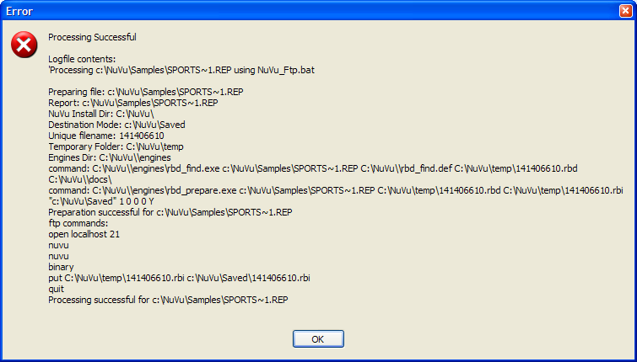

Test Example
The following example assumes that you have started the required servers (you will be prompted to do this then the utility starts up). The example will take the sample report ‘sports001.rep’ which is shipped with the NuVu reporting suite, and use the FTP server to deliver the report to the ‘c:\nuvu\saved’ folder, after which the FTP server will invoke the rbd_preview utility to render the report to a saved PDF file, which we will choose to display after the processing is completed.
Step 1 : Advise the details as per the screen-shot below :
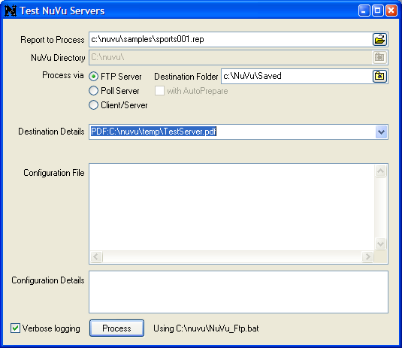

Step 2 : Process the report by clicking the ‘Process’ button. After a second or two, the following dialog window should be displayed :
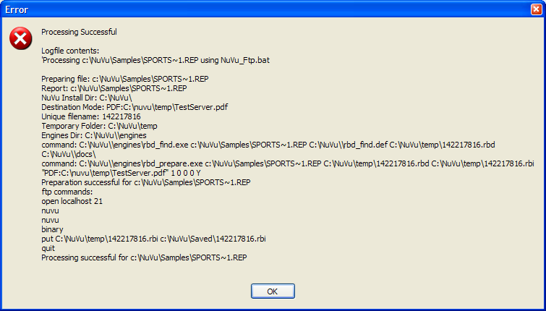
Step 3 : Click the OK button after examining the various processes that have occurred during the rendering process. You will notice that the report was first prepared (by invoking the NuVu_AutoPrepare.bat script), then some FTP commands were issued to the NuVu FTP server.
Step 4 : Because we chose the ‘PDF :’ option, the utility will now ask us if we want to view the created PDF file (that was created as c:\nuvu\temp\TestServer.pdf). Choose YES, and the Acrobat Reader will be invoked to display the resulting report, as shown below :
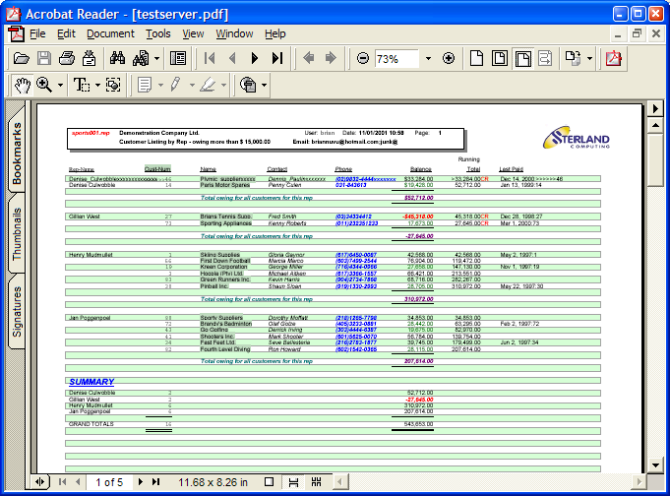

- ‘Fax Any Document’

Introduction
This version of the NuVu Reporting Suite contains a tool that allows individual users (clients) to submit non-NuVu documents through to the NuVu Fax Server for processing. These documents include Adobe Acrobat PDF documents, Text documents, Microsoft Word documents, Microsoft Excel documents and any other documents that have the ability to be ‘printed’ from the windows explorer.

This section of the document describes the steps that must be taken in order to fully utilise this ability.

Considerations
It is important to remember that the remote clients are distinct from the back-end Fax Server. The NuVu Fax Server is implemented via a service process (NuVuFaxService.exe) that continually monitors a nominated folder for new entries that are required to be faxed. The Fax Service is run under a nominated user (normally ‘NuVu’), therefore the associated applications (Adobe Acrobat, Microsoft Word etc.) are required to be installed and available to this user, otherwise requests that are made by remote clients will be rejected by the NuVu Fax Server process.

The client-side ‘Fax via NuVu’ function invokes the NuVuFaxFile.exe utility that is run on the client PC. This is implemented via the Context menu that appears when a user right-clicks on any document when using the Windows Explorer tool. If the remote user selects the ‘Fax Via NuVu’ option, then the NuVuFaxFile tool is invoked and requests fax information from the remote user. An example of the ‘Fax any Document’ dialog windows is shown below:

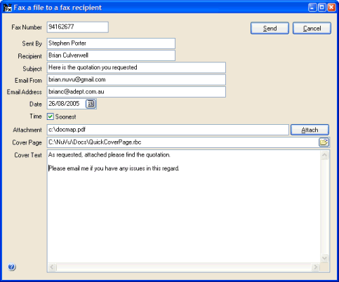
When the remote user clicks the ‘Send’ button, validation is performed to ensure that the document requested to be faxed does indeed have an associated program that has exposed the ‘print’ functionality. If this validation fails, the remote user will be informed that the selected document CANNOT be faxed via the NuVu Fax Server, otherwise the request is dropped into the same folder that the back-end NuVu Fax Server is monitoring, and is subsequenty processed by the NuVu Fax Server. This validation does NOT ensure that the document will be faxed however – because the user that the NuVu Fax Server is running under must also have the same associations for each document. If this is n the case, the NuVu Fax Server will automatically reject the fax request, emailing the failure notification to the appropriate email address (if enabled).

Steps to ensure Document delivery
The following steps should be followed to ensure that documents submitted by remote client users are serviced correctly by the NuVu Fax Server:

- The NuVu folder on the remote Server PC should be installed so that ALL users have FULL permissions on this folder, and all sub-folders of this folder. This will ensure that users can submit fax requests to the ‘FaxRoot\Pending’ folder when the ‘Send’ button is clicked after advising the required fax details.
- The user under which the NuVu Fax Server (Service) is running under MUST be able to set the installed ‘APF Fax Printer’ as the default printer. This process is automatically performed during fax preparation of an external document. The NuVu Fax Service will identify a new fax entry that has been dropped into the ‘Pending’ folder of the fax queue, then attempt to set the default printer to the NuVu Fax Printer, then print the advised document via it’s native application (Microsoft Word for example) to the NuVu Fax Printer. If the NuVu Fax service is unable to set the default printer to the NuVu Fax Printer, then the fax will be aborted.
To verify this ability, it is best to log into the server on which the NuVu Fax Server has been configured to run on, using the user under which the NuVu Fax Service will run, and invoke the ‘Printers and Faxes’ setting from the ‘Start’ menu of the windows operating system, and then attempt to set the default printer to the ‘APF Fax Printer’. If a small tick is not present against this printer after selecting it as the default printer, then you will need to liase with your System Administrator to grant the necessary permissions to ensure that this step can be performed.
NOTE: It is desirable for set the ‘APF Fax Printer’ as the default printer for the user that is running the NuVu Fax Service, as this will increase performance of the NuVu Fax Service, as the default printer will NOT need to be set to the ‘APF Fax Printer’ each time a request is performed. The setting of the default printer is CPU intensive, and can take anything upwards of half a second to perform.
- Ensure appropriate applications have been installed and are available to the user that the NuVu Fax Server (Service) is running under. For example, if a user requests a Microsoft Word document to be faxed to an advised recipient, the remote PC will first verify that the user has Microsoft Word installed on their PC. If this check is passed, then the entry will be submitted to the back-end NuVu Fax Server for processing. The back-end NuVu Fax Server will then pick up this request and attempt to call the application associated with the submitted document (in this case, a Microsoft Word document) and print it to the NuVu Fax Printer. Therefore if Microsoft Word is not installed and correctly configured for the user that is running the NuVu Fax Service, this request is going to be rejected by the NuVu Fax Server.
- It is recommended that the ‘Fax’ page of the NuVuConfigurationWizard is set to ‘Email Failures’. This setting will allow notification of failed faxes to be submitted back to the user that requested the fax in the first place. The email address is requested during the submission of the fax by the remote client.

- NuVu Licencing

Introduction
This section of the Technical Reference Manual describes the Licence mechanism employed by the NuVu Reporting Suite. This section is important to understand, as without the correct licencing in place, the NuVu Reporting Suite will not function.

NuVu Licencing Overview

The NuVu reporting solution is a multi-user application. As such, the product is registered for the number of licenced (named) users. Before the NuVu Reporting Suite can be used in a live environment, the required number of licences will have to be purchased. This step involves indicating the required number of named useds required, and paying the associated licence fee. The instruction for the required licence count is normally achieved via email. When emailing, please ensure that the indicated Serial# is included in the email.

Licencing is checked in only one place, when the NuVu preparation utility (‘rbd_prepare.exe’) is invoked on a Windows platform, or the NuVu Poll Server is about to process a found entry in the monitored folder or print queue. For more information please refer to the ‘NuVu Deployment Scenarios’ section of this manual.

When the licence is checked on a Windows platform, the ‘rbd_prepare’ utility (or NuVu Poll Server/Service) will call the running NuVu Licence Server to determine if the current user is licenced, or there is an available empty licence ready to be allocated to this user. If neither condition is met, the calling process will fail with an appropriate error-code.
Therefore, in all cases, you must ensure that the NuVu Licence Server is always running (on a Windows Server somewhere on the network), and that the NuVu Configuration Wizard has been properly configured to access the Licence Server. In addition, the Licence Server must be separately registered. This is achieved by invoking the ‘Register NuVu Licence Server’ menu option from the ‘NuVu’ program group. The control code required for this would have been supplied by Sterland Software, in the same email that contained the supplied NuVu licence file (‘nuvu.lic’).

For more details, please refer to the ‘NuVu Configuration’ section of this manual, or the on-line help available from the NuVu Configuration Wizard itself.

Sterland Software, the global distributer of the NuVu product, will issue instructions and a licence file (nuvu.lic) which needs to be copied from the received email to the root directory of your Server NuVu install machine (normally ‘c:\nuvu’). This is the same folder as which contains the ‘nuvuservice.exe’ executable. This licence file is encrypted, and any attempt to modify its contents will render your licences invalid. When ordering your licences, it is important to first determine your deployment strategy (ie : where will the graphical reports be prepared – on the Unix Server, or a Windows Server) – the supplied licence file will only be valid for the operating system indicated when the licences are ordered.

As a default, the licence file is delivered with ‘Auto-Expiry’ enabled. This means that users who have not used the NuVu reporting suite for a default number of days will automatically be marked as ‘Expired’, and their licence will be able to be reused by the system. With this default setting enabled, licences are allocated on a first-come-first-served bases, which will allocate licences until the licenced user-count is reached, whereafter no new users will be able to utilize the NuVu reporting software until one or more of the licences automatically expire, or more user licences are purchased.

If a more controlled access to the NuVu reporting product is desired, there is a Windows utility program that is able to allocate the actual users able to run NuVu reports. In this case, the ‘Auto-Expiry’ option is normally turned OFF, so that these allocated users are never de-allocated by the system.
The next section of this reference manual describes the Windows utility program that is available to maintain the supplied licence file.
Steps in preparing for issuing of a Licence

- The nominated Windows server that is going to run the NuVu Licence Server must be registered individually. In order for this registration to be successful, Sterland Software requires that the client supplies the serial number on the machine that is going to run the NuVu Licence Server, which is normally the same machine that runs the NuVu Poll server. To determine this serial number, install the full NuVu Reporting Suite onto the machine that is going to run the NuVu Licence Server, and then select the ‘Register NuVu Licence Server’ menu option from the NuVu program group. A dialog window will be displayed, similar to the following:
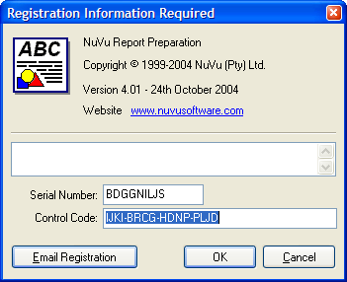
- On a new registration, the ’Control Code’ field is normally blank. To apply for registration, you can either manually write down (carefully) the displayed ‘Serial Number’ field shown on this screen (‘BDGGNILJS’ in the example above), and then either phone or email the request through to your Sterland Software sales representative. Remember, you must also include the name of the business and contact, the required licence type (Designer and/or runtime), and number of required licences (named users) that is to be associated with the required licence details. Alternatively (and the preferred mechanism), you can click on the ‘Email Registration’ button at the bottom of the screen. If this is done, the following dialog window will be presented :
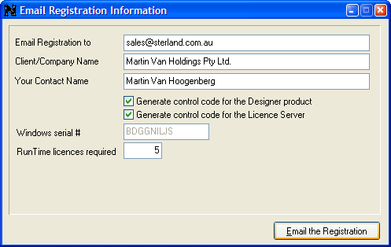
Advise (carefully) the required ‘Email Registration to’, ‘Client/Company Name’, ‘Your Contact Name’, the required licence type(s) and the required number of users in the fields provided, and then click on the ‘Email the Registration’ button. After clicking this button, the following information dialog window will be presented to you :
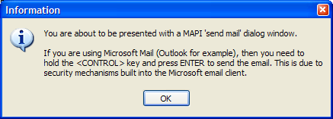
Click OK after reading the contents of the information dialog window. This will then present you with a standard ‘Send Mail’ screen (normally a Microsoft Outlook/Outlook Express dialog) as shown below :
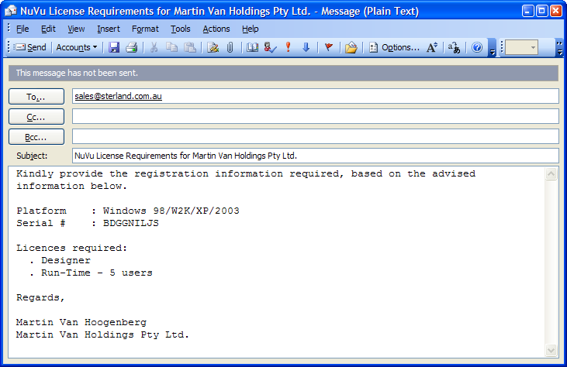
All that is left to do is hold the <CONTROL> key down and then click the ‘Send’ button. If the <CONTROL> key is not held down, it may take several attempts at clicking the ‘Send’ button before the email is sent.
- Wait for the confirmation email from Sterland Software, indicating the successful registration for your company, and containing the licence Control Code and licence file (attached to the email). This email will also contain instructions on how to successfully complete the registration.
PLEASE NOTE : There are currently two different installations of the NuVu Reporting Suite, one containing MAPI support and the other that does not. The version that does NOT contain MAPI support may need to be installed on servers that have Windows 2003, or Windows XP Service Pack 2 or greater, and that are running Microsoft Exchange Server. There is a known problem with applications that attempt to access the Windows MAPI API on these platforms. The ‘No MAPI’ version of the installation will therefore NOT have the ‘Email Registration’ button described above. If registration needs to be emailed using the ‘No MAPI’ version, then this will have to be performed manually.

The ‘rbd_lic’ Licence utility

As described in the previous section, the NuVu reporting solution is a multi-user application, which is registered for the number of licenced users (‘named’ users). Licences are automatically allocated on a ‘first-come-first-serve’ basis (unless the named users have been manually advised using this ‘rbd_lic’ utility program).

If the required users are NOT manually advised into the supplied licence file, then situations could arise where users that should not be using the NuVu Reporting Suite have done so, and have used up an available licence slot.

This utility overcomes this problem, and allows the System Administrator to maintain the users (add or remove) within the licence file, as well as enabling or disabling the ‘Auto-Expiry’ of users.

The ‘rbd_lic’ utility program is installed into the ‘Engines’ directory during the automatic installation of the product. This directory contains various flavours of Windows operating systems.

The ‘rbd_lic’ utility program is a command-line utility, with the following syntax :
<path>/rbd_lic.exe licence_file options

Where ‘licence_file’ is the supplied ‘nuvu.lic’ supplied via email during the registration process, and the options are explained below :
-add username Adds the advised username to the licence file, as long as there is an available (or expired) slot in the licence file.
-remove username Removes the advised username (if found) from the licence file. This therefore allows a new user to use this de-allocated licence.
-list Produces a list of all users currently assigned within the licence file. If the user has been inactive for more than the designated number of days (normally 58), then an ‘(Expired)’ message is displayed alongside the associated user.
-expiry on Enables the ‘Auto-Expiry’ of uses within the licence file. When this option is enabled, users are allocated on a ‘first-come-first-served’ basis, and will automatically expire after the default number of inactive days (normally 58).
-expiry off Disables the ‘Auto-Expiry’ of uses within the licence file. When this option is disabled, users NEVER expire, and must be manually removed in order to re-allocated the licence to another user.

If no run-time parameters are advised to the ‘rbd_lic’ utility program, a usage statement will be displayed, showing the available options, as described above.

- Network Installation

Client Network Installation

In a large Windows application with many users, installing each client PC that is going to require the NuVu reporting ability can be a labourious task, involving installing each client via an installation CD, then configuring that client to access the central licence server and other settings required for the correct operation of the NuVu software on the client PC – for example : pointing the client PC to a central document repository that contains the NuVu design templates that will be associated with the raw text reports at run-time.

Fortunately, there is a solution for Client PC installation, in the form of the ‘NetSetup’ executable program that is automatically installed when a full install (from CD or otherwise) is performed somewhere on the network.

Before starting individual client PC installs over the network, a configuration file (‘Netsetup.ini’) should be manually changed to reflect your environment. This configuration file can be edited with any text editor (NotePad for example). Here is an example of the contents of the standard NetSetup.ini file shipped with the NuVu reporting suite (and residing in the same folder as where NuVu has been installed) :

[Executables]
engines\rbd_find.exe
engines\rbd_prepare.exe
engines\rbd_lib.dll
rbd_preview.exe
rbd_lib.dll
NuVuPollServer.exe
NuVuFaxFile.exe
Docs\Landscape.rbd
Docs\Portrait.rbd

[Batch Files]
NuVu_Poll.bat
NuVu_Ftp.bat
Nuvu_SelfServe.bat
NuVu_AutoPrepare.bat

[Constants]

# $RootDir contains the folder from which the NetSetup has been run, so only
# change this if installing the files from a different server
# $RootDir=NuVu

# $LicenceServer already contains the IP address (or network name) of the
# machine on which the NetSetup has been run, so only change this if installing
# from a different server
# $LicenceServer=brian-nb

$InstallTo=C:\NuVu
$FaxServer=$LicenceServer
$EmailHost=[prompt:Mail Server Address,Please advise your mail server address (eg: mail.nuvu.com)]
$EmailAddress=[prompt:Your Email Address,Please advise your email address (eg: brian@nuvu.com)]
$YourName=[prompt:Your Name,Please your full name here (eg: Brian Culverwell)]
$PollPrinter=[prompt:Default Destination Printer,Please advise a valid printer name to be used as a default by the NuVu Poll Server]

[Registry]
InstallDirectory=$InstallTo
ServerAddress=$LicenceServer
EmailHost=$EmailHost
FaxRoot=\\$FaxServer\NuVu\
TemplateDirectory=\\$LicenceServer\$RootDir\Docs\
RbdFindDefPath=\\$LicenceServer\$RootDir\rbd_find.def
EmailUserName=$YourName
EmailAddress=$EmailAddress
InternalEmail=$EmailAddress
NuVuPollDestPrinter=$PollPrinter

# Standard Settings

ServerPort=2121
ServicePort=2121
EmailPort=25
EmailType=SMTP
EmailCharSet=us-ascii
EmailEncoding=mime
NuVuPollDirectory=$InstallTo\Poll\
NuVuProcessDirectory=$InstallTo\Process\
NuVuPollSeconds=0
NuVuPollType=Server
NuVuPollAllowView=yes
PollMonitorSpooler=False
NuVuPollPrinter=
RbdFindPath=$InstallTo\Engines\rbd_find.exe
RbdPreparePath=$InstallTo\rbd_prepare.exe
PollAutoPrepare=True
DefaultLandscapeDef=Landscape.rbd
DefaultPortraitDef=Portrait.rbd
NuVuPreviewPath=$InstallTo\rbd_preview.exe
PollInstalled=True
ColumnOffset=0

Any entry in the advised ‘netsetup.ini’ file that begins with a ‘#’ is deemed to be a comment, and is ignored.

There are four different sections in this file. Each section-name is surrounded with square brackets. The sections are :
- Executables
- Batch Files
- Constants
- Registry

The Executables section describes all files that should be copied from the server machine to the client PC. The files will be copied from the install folder of the server machine to the install folder of the client PC. The install folder of the server machine is determined as the same folder in which the ‘NetSetup.exe’ utility program is run from. The install folder of the client PC is determined from the ‘InstallDirectory’ setting wihtin the Registry section of this configuration file. The settings here are complete and should not be tampered with.

NOTE : If the ‘NuVuFaxFile.exe’ is included in this section, the registry will automatically be set for each client on which the NetSetup utility is run, so that the ‘Fax Via NuVu’ option is automatically available.
The Batch Files section describes the Windows batch files that will be copied from the server machine to the client PC. The files will be copied from the install folder of the server machine to the install folder of the client PC. The install folder of the server machine is determined as the same folder in which the ‘NetSetup.exe’ utility program is run from. The install folder of the client PC is determined from the ‘InstallDirectory’ setting wihtin the Registry section of this configuration file. The settings here are complete and should not be tampered with.
The Constants section is used to advise the various constants that will be used during the Network installation process. These constants must begin with a ‘$’ sign and be given a meaningful name (for example ‘$FaxServer’. The name is NOT case-sensitive.

This section can also be used to advise up to 6 prompted values that can be retrieved from the user when the Network Setup utility is running. To advise a prompt value, the following syntax must be used :

$ConstantName=[prompt :PromptLabel,Hint], where the ‘PromptLabel’ will be used to prefix the required field on the NetSetup screen, and the ‘Hint’ field will display in a balloon help message when the user hovers over the input field. Please ensure that the ‘PromptLabel’ can fit into the available space before the field in question.

The Registry section describes the various registry settings that will be created within the registry of the client PC. Basically any entry that is installed into the HKLM/Software/BpcSoft/Beautifier registry key can be advised here. The most popular registry keys are described as follows :

- InstallDirectory= Advise the appropriate folder that will be automatically created on the client PC. The entries within the Executables and Batch Files sections will be copied to this folder (and sub-folders) by the NetSetup utility. Ensure that there is NO trailing back-slash on the end of the value. Example : c:\NuVu. This entry can also contain a constant-name as advised within the constants section. If so, ensure that the constant-name is prepended with the ‘$’ symbol. For example : InstallDirectory=$InstallTo.
- TemplateDirectory= Advise a UNC name of the machine and folder structure that contains the defined NuVu templates (designs) that will be interrogated at run-time by the software running on the client PC. Ensure that there IS a trailing back-slash on the end of the value. Example : \\brian-nb\NuVu\Docs\. This entry can also contain a constant-name as advised within the constants section. If so, ensure that the constant-name is prepended with the ‘$’ symbol. For example : TemplateDirectory=$TemplateFolder.
- FaxRoot= Advise a UNC name of the machine and folder structure that will be used as the root folder for the NuVu Faxing engine. By default, three folders will automatically be created under the advised folder name, being ‘Failed’, ‘Sent’ and ‘Pending’. Ensure that there IS a trailing back-slash on the end of the value. This entry can also contain a constant-name as advised within the constants section. If so, ensure that the constant-name is prepended with the ‘$’ symbol. For example : FaxRoot=$FaxServer\NuVu\
- RbdFindDefPath= Advise a UNC name of the machine and full pathname of the NuVu Find configuration file that will be interrogated at run-time by the ‘rbd_find.exe’ software running on the client PC, in order to determine the appropriate template to use with the current raw report. This entry can also contain a constant-name as advised within the constants section. If so, ensure that the constant-name is prepended with the ‘$’ symbol.
For example : RbdFindDefPath=\\$LicenceServer\$RootDir\rbd_find.def
- EmailUserName= Advise the appropriate user name that will be shown on all emails sent from the client. This is NOT an email address, but rather a physical user name. This entry can also contain a constant-name as advised within the constants section. If so, ensure that the constant-name is prepended with the ‘$’ symbol.
For example : EmailUserName=$YourName
- EmailAddress= Advise the appropriate email address that will be used to process all emails sent from the client. This entry can also contain a constant-name as advised within the constants section. If so, ensure that the constant-name is prepended with the ‘$’ symbol.
For example : EmailAddress=$EmailAddress
- InternalEmail= Advise the appropriate email address that will be used to process all email blasts sent from the client. As a default, set this value to the SAME value as advised in the ‘EmailAddress’ entry described above. This entry can also contain a constant-name as advised within the constants section. If so, ensure that the constant-name is prepended with the ‘$’ symbol.
For example : InternalEmail=$EmailAddress

- ServerAddress= This setting is probably the most important of the lot, as signifies the TCP/IP address of the NuVu Licence server. This setting is read before beginning the rendering of any reports on the Client PC, and the Licence server is then called to verify that the current user is licenced to use the product. Without this setting (or if this setting is incorrectly advised), NO reports will be able to be processed via the NuVu reporting engine. Either a raw IP address or a name that is defined in your ‘Hosts’ table can be advised here. Examples : 192.6.31.3, NuVuLicenceServer, localhost.
- ServerPort= This setting is optional, and if omitted will default to the standard NuVu FTP port of ‘2121’. This setting need only be advised if the Licence server has been configured to listen on a TCP/IP port other than 2121. Example : 2500.
- ServicePort= This setting is optional, and if omitted will default to the standard NuVu FTP port of ‘2121’. This setting need only be advised if the Licence service has been configured to listen on a TCP/IP port other than 2121. In general, just advise the same value as the advised ‘ServerPort’ entry described above. Example : 2500.
- EmailHost= This setting is used to advise the address of your default mail server, and is only necessary if the client PC is going to use SMTP in order to send emails via the NuVu processing engines. Example : mail.tpg.com.au
- EmailPort= This setting is used to advise the port that is used by your default mail server, and is only necessary if the client PC is going to use SMTP in order to send emails via the NuVu processing engines. If not advised, the default SMTP port number 25 will be used. Example : 262.
- EmailType= This setting is used to advise the email type that is going to be used by the client PC. Values allowed here are MAPI and SMTP. MAPI is common on client PC’s, as emails sent will interface directly with your desktop mail system (Microsoft Outlook for example), but suffers from the security restrictions imposed recently that requires manual confirmation before each email is sent. SMTP is common when you want to bypass the security confirmation for each email. Example : SMTP.
- NuVuPollDestPrinter= Advise a valid printer name that will be used as the default destination printer to sent NuVu processed reports to when processed by the NuVu Poll Server/Service. This entry can be ignored if the user will not be using the NuVu Poll Server/Service. Unlike the ‘P:’ command-line option available to the rbd_preview utility, the advised name must match EXACTLY the name of a valid and installed windows printer. This entry can also contain a constant-name as advised within the constants section. If so, ensure that the constant-name is prepended with the ‘$’ symbol.
For example : NuVuPollDestPrinter=$PollPrinter
- NuVuPollDirectory= Advise a valid NuVu Poll folder that the NuVu Poll engine is to interrogate at run-time. This entry can be ignored if the user will not be using the NuVu Poll Server/Service. This folder should end with a back-slash. This entry can also contain a constant-name as advised within the constants section. If so, ensure that the constant-name is prepended with the ‘$’ symbol.
For example : NuVuPollDirectory=$InstallTo\Poll\
- NuVuProcessDirectory= Advise a valid NuVu Process folder that the NuVu Poll engine is to use during the processing of reports at run-time. This entry can be ignored if the user will not be using the NuVu Poll Server/Service. This folder should end with a back-slash. This entry can also contain a constant-name as advised within the constants section. If so, ensure that the constant-name is prepended with the ‘$’ symbol.
For example : NuVuProcessDirectory=$InstallTo\Process\
- NuVuPollSeconds= Advise a valid integer value here that will govern how often the NuVu Poll Server/Service will interrogate the advised ‘NuVuPollDirectory’ (or ‘NuVuPollPrinter’) at run-time to check for new entries. This entry can be ignored if the user will not be using the NuVu Poll Server/Service. A value of zero will ensure that the Poll Server/Service will continually check for new entries. This entry can also contain a constant-name as advised within the constants section. If so, ensure that the constant-name is prepended with the ‘$’ symbol.
For example : NuVuPollSeconds=0
- NuVuPollType= Advise the type of NuVu Poll engine that will be installed. Options include ‘Server’ or ‘Service’. If the NuVu Poll server is to be installed on a client PC, the typical entry here is ‘Server’. This ensures that the client will be able to view reports generated via the NuVu Poll engine. This entry can be ignored if the user will not be using the NuVu Poll Server/Service. This entry can also contain a constant-name as advised within the constants section. If so, ensure that the constant-name is prepended with the ‘$’ symbol.
For example : NuVuPollType=Server
- NuVuPollAllowView= Advise either ‘yes’ or ‘no here. This entry will determine if the client is able to view reports that are generated via the NuVu Poll engine. This entry can be ignored if the user will not be using the NuVu Poll Server/Service. This entry can also contain a constant-name as advised within the constants section. If so, ensure that the constant-name is prepended with the ‘$’ symbol.
For example : NuVuPollAllowView=yes
- PollMonitorSpooler= Advise either ‘True’ or ‘False’ here. This entry will determine if the NuVu Poll engine is going to monitor new entries in the advised NuVuPollPrinter or advised NuVuPollFolder. This entry can be ignored if the user will not be using the NuVu Poll Server/Service. This entry can also contain a constant-name as advised within the constants section. If so, ensure that the constant-name is prepended with the ‘$’ symbol.
For example : PollMonitorSpooler=False
- NuVuPollPrinter= Advise a valid and installed Windows printer that will be interrogated at run-time by the NuVu Poll engine. This entry can be ignored if the user will not be using the NuVu Poll Server/Service, or has chosen to process a folder instead of a spool queue (see previous entry). This entry can also contain a constant-name as advised within the constants section. If so, ensure that the constant-name is prepended with the ‘$’ symbol.
For example : NuVuPollPrinter=
- RbdFindPath= Advise the full pathname of the ‘rbd_find.exe’ utility program (that is used to determine what NuVu report template to associate with the raw text report). This entry can also contain a constant-name as advised within the constants section. If so, ensure that the constant-name is prepended with the ‘$’ symbol.
For example : RbdFindPath=$InstallTo\Engines\rbd_find.exe
- RbdPreparePath= Advise the full pathname of the ‘rbd_prepare.exe’ utility program (that is used to render the graphical version of the NuVu report). This entry can also contain a constant-name as advised within the constants section. If so, ensure that the constant-name is prepended with the ‘$’ symbol.
For example : RbdPreparePath=$InstallTo\rbd_prepare.exe
- PollAutoPrepare= Advise a value of ‘True’ or ‘False’ here. This entry will determine if the NuVu Poll engine is going to monitor pre-generated NuVu Report instances (.rbi files) or not. Advise a value of ‘True’ if the NuVu Poll engine is going to be responsible to finding and preparing the NuVu report instances. Advise ‘False’ if the NuVu Poll engine is going to pick up pre-generated NuVu report instance files (.rbi extension). This entry can be ignored if the NuVu Poll engine is not going to be utilised. This entry can also contain a constant-name as advised within the constants section. If so, ensure that the constant-name is prepended with the ‘$’ symbol.
For example : PollAutoPrepare=True
- DefaultLandscapeDef= Advise a value of the NuVu template that will be used if no appropriate NuVu report definition can be found at run-time, and the current raw report is deemed to be a landscape report (based on the width of the widest field). This entry can be ignored if the NuVu Poll engine is not going to be utilised. The advised entry should correspond to a definition contained within the ‘TemplateDirectory’ entry described previously. The advised value can also contain a constant-name as advised within the constants section. If so, ensure that the constant-name is prepended with the ‘$’ symbol.
For example : DefaultLandscapeDef=Landscape.rbd
- DefaultPortraitDef= Advise a value of the NuVu template that will be used if no appropriate NuVu report definition can be found at run-time, and the current raw report is deemed to be a portrait report (based on the width of the widest field). This entry can be ignored if the NuVu Poll engine is not going to be utilised. The advised entry should correspond to a definition contained within the ‘TemplateDirectory’ entry described previously. The advised value can also contain a constant-name as advised within the constants section. If so, ensure that the constant-name is prepended with the ‘$’ symbol.
For example : DefaultPortraitDef=Portrait.rbd
- RbdPreviewPath= Advise the full pathname of the ‘rbd_preview.exe’ utility program (that is used to process a prepared NuVu Report Definition (.rbi extension). This entry can also contain a constant-name as advised within the constants section. If so, ensure that the constant-name is prepended with the ‘$’ symbol.
For example : NuVuPreviewPath=$InstallTo\rbd_preview.exe
- PollInstalled= Advise a value of either ‘True’ or ‘False’. A value of ‘True’ indicates that the user will be utilising (and installing) the NuVu Poll engine to process reports. A value of ‘False’ indicates that the user will not be using the NuVu Poll engine to process reports. This entry can also contain a constant-name as advised within the constants section. If so, ensure that the constant-name is prepended with the ‘$’ symbol.
For example : PollInstalled=True

Invoking the NetSetup utility

Before invoking the NetSetup utility program, a few steps need to be performed. There are :
- Perform a full installation onto a server that has been nominated as the FTP/Licence server.
- Configure the system for the required NuVu Servers (FTP, Poll, Fax etc).
- Run the ‘Register the NuVu Licence Server’ option from the ‘NuVu’ program group. A registration screen similar to the one shown below will be displayed :
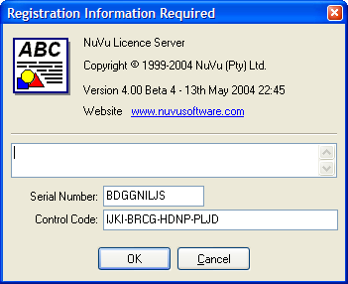
Convey the ‘Serial Number’ to Sterland Software, together with your payment for the required number of users you require licences for. A return email will be sent to you that will contain the required Control Code that needs to be typed into the ‘Control Code’ field on this screen. In addition, the email will contain a ‘NuVu.lic’ licence file which must be extracted and saved into the NuVu installation folder on the Licence Server machine. For more information on registration, please see details in the previous section of this manual.

- Edit the ‘NetSetup.ini’ file as outlined in the previous section.
Once the above steps have been completed, login to a client PC and explore to the shared NuVu installation folder on the licence server (example : \\brian-nb\NuVu). Simply double-click the ‘NetSetup.exe’ item, and the a screen similar to the following will be displayed :
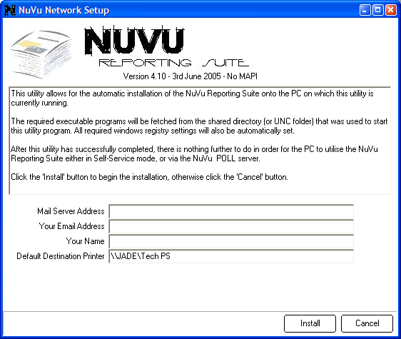

If the supplied ‘NetSetup.ini’ contains any ‘prompt :’ values inside the ‘Constants’ section, then these values will be shown on the screen, and the user will be able to advise the values for these prompts. In the sample NetSetup screen above, there are four prompt fields that need to be advised by the user. Any prompted fields are MANDATORY (and therefore cannot be left blank).
Simply click the ‘Install’ button at the bottom of this screen to begin the installation process. After a few seconds the window will close and you will be presented with a small dialog window signifying that the process has successfully completed – it is as easy as that. Repeat this step on each client Pc required to utilise the NuVu reporting suite.

To make the individual client PC installations even easier, simply compose an email that contains a UNC name of the netsetup.exe on the server, and distribute this email to all eligible NuVu users. Most modern email systems will automatically convert the advised UNC name into a link, that the user can simply click on to automatically install the software on that clients PC.

For Example, the body of your email could contain something similar to this :
Snip ---------------------------------------------------------------------------------------------------------------------------------------
The NuVu Reporting Suite has been installed on our server, and is now available for immediate installation on your PC. In order to perform the automatic installation process, simply click the following link :
\\brian-nb\nuvu\netsetup.exe (Replace this with the actual link)
You will be prompted with the following screen before the installation starts :
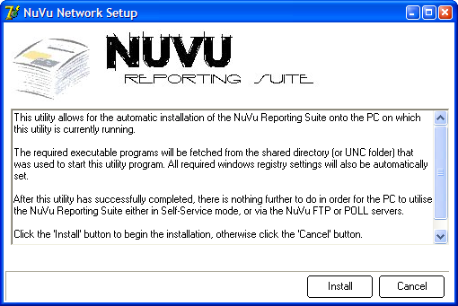
Simply click the ‘Install’ button to begin the installtion.

Regards
Joe Bloggs
System Administrator
Snip ---------------------------------------------------------------------------------------------------------------------------------------

