
www.nuvusoftware.com

User Reference
Version 4.5

Table of Contents

1 - The Report Designer 8
1.1 Introduction 8
1.2 Trigger-Based Processing 9
1.3 Designer Objects 10
1.3.1 Text Objects 11
1.3.2 Field Objects 14
1.3.3 DownField Objects 36
1.3.4 TextBox Objects 56
1.3.5 Rectangle Objects 66
1.3.6 Picture Objects 69
1.3.7 Chart Objects 74
1.4 Changing multiple object properties 77
1.5 Designer Properties 78
1.6 Start a New Report Definition 83
1.7 Open an existing Report Definition 83
1.8 Save changes to the Report Definition 84
1.9 Preview the current Report Definition 85
1.10 Change the current mode to 'Pointer' 85
1.11 Change current mode to 'Text Fields' (Ctrl-T) 85
1.12 Change the current mode to 'Field' (Ctrl-F) 86
1.13 Change current mode to 'DownField' (Ctrl-D) 87
1.14 Change the current mode to 'Rectangle' 88
1.15 Change the current mode to 'Pictures' 89
1.16 Change current mode to 'TextBox' (Ctrl-B) 90
1.17 Change current mode to 'Chart' (Ctrl-H) 91
1.18 Change the current mode to 'Lasoo' (F5) 92
1.19 Change the Font Name 92
1.20 Change the Font Size 93
1.21 Change the Font ‘Bold’ Attribute 93
1.22 Change the Font ‘Italic’ Attribute 93
1.23 Change the Font ‘Underline’ Attribute 94
1.24 Left-Align the selected objects 94
1.25 Right-Align the selected objects 94
1.26 Center-Align the selected objects 95
1.27 Change the Foreground Color 95
1.28 Change the Background Color 96
1.29 Move the selected object in front of others 97
1.30 Move the selected object behind all others 97
1.31 Align all selected objects Horizontally 98
1.32 Align all selected objects Vertically 98
1.33 Select a new current Trigger 98
1.34 Move Trigger above previous Trigger 99
1.35 Move Trigger below next Trigger 99
1.36 Add a new Trigger to the report definition 99
1.37 Delete the currently selected Trigger 99
1.38 Create a new trigger as a copy of another 100
1.39 Edit the current Trigger Properties 100
1.40 Edit the properties of the Report 114
1.41 Invoke the Wizard to build the report 123
1.42 Undo changes to objects on the canvas 128
1.43 Redo changes to objects on the canvas 129
1.44 Cut the selected objects to the clipboard 129
1.45 Copy the selected objects to the clipboard 130
1.46 Paste objects on the clipboard to the canvas 130
1.47 Automatically select all downfields 131
1.48 Select the Zoom Factor for the Canvas 131
1.49 Editing the sample legacy report 131

2 - The Report Previewer 133
2.1 Introduction 133
2.2 Open a previously saved report instance 135
2.3 Save report instance for later retrieval 135
2.4 Print the current report instance 136
2.5 Email displayed report instance 138
2.6 Send the report to multiple Recipients (Blast) 144
2.7 Fax the report to a recipient 145
2.8 Adjust display to show page width 147
2.9 Adjust display to show page height 147
2.10 Adjust display to show whole page 148
2.11 Zoom in (Magnify) 148
2.12 Zoom Out (Reduce magnification) 148
2.13 Display the first page of the report 149
2.14 Display the previous page of the report 149
2.15 Display the next page of the report 149
2.16 Display the last page of the report 149
2.17 Export current report directly into Excel 149
2.18 Export current report to .csv file 150
2.19 Export current report as raw text 150
2.20 Begin searching for text 150
2.21 Search for the next occurance of text 151
2.22 Search for previous occurances of text 151
2.23 Advise Preview Options 151

3 - Designer Tutorial (simple) 156
3.1 Introduction 156
3.2 Step 1 : Starting a new Report Definition 157
3.3 Step 2: Specifying Options for the report 158
3.4 Step 3: Adding a Trigger to the Definition 166
3.5 Step 4: Adding static text and shapes 178
3.6 Step 5: Linking Fields to the Definition 181
3.7 Step 6: Linking Down Fields 183
3.8 Step 7: Previewing Changes 184
3.9 Step 8: Finishing Up 185

4 - Designer Tutorial (XML) 187
4.1 Introduction 187
4.2 Step 1 : Starting a new Report Definition 187
4.3 Step 2: Specifying Options for the report 188
4.4 Step 3: Adding a Trigger to the Definition 197
4.5 Step 4: Adding static text and shapes 206
4.6 Step 5: Linking Fields to the Definition 210
4.7 Step 6: Linking Down Fields 211
4.8 Step 7: Previewing Changes 213
4.9 Step 8: Finishing Up 213

5 - Advanced Features 215
5.1 Introduction 215
5.2 Templates 215
5.3 Floating Sections 216
5.4 Field Re-mapping 217
5.5 Shortcut for mapping objects 217
5.6 Barcodes 219

6 - Email Blast Tutorial 224
6.1 Introduction 224
6.2 Step 1: Identification of the email recipients 224
6.3 Step 2: Invoking the email on the previewer 226
6.4 Advising email options before sending 227
6.5 Sending the email blast 231

7 - Printing Labels 233
7.1 Introduction 233
7.2 One row per line-contents of each label 233
7.3 One row per label 235
7.4 Laid out in exact print format 235

8 - Fax Cover Page Tutorial 237
8.1 Introduction 237
8.2 Step 1 : Introduction 237
8.3 Step 2 : Adding Text, Rectangles and Images 238
8.4 Step 3 : Linking fields to the Fax Cover 242
8.5 Step 4 : Previewing the Fax Cover 244

9 - Nuvu Letter Writing 246
9.1 Introduction 246
9.2 Step 1: Defining the MergeField definitions 248
9.2.1 Start a new MergeFields Definition 250
9.2.2 Open an existing MergeFields Definition 250
9.2.3 Save Changes made to the MergeFields Definition 251
9.2.4 Add a new row to the MergeFields Definition 251
9.2.5 Delete row(s) from the MergeFields Definition 251
9.2.6 Move row(s) up one row 252
9.2.7 Move row(s) down one row 252
9.3 Step 2: Designing the Letter Body Text(s) 253
9.3.1 Start a new Letter Definition 256
9.3.2 Open an existing Letter Definition 256
9.3.3 Save Changes made to the Letter Definition 256
9.3.4 Save XML for use by the NuVu Report Designer 257
9.3.5 Preview the current Letter Definition 257
9.3.6 Invoke the NuVu Report Designer 258
9.3.7 Invoke the NuVu MergeField Designer 258
9.3.8 Edit properties for this Letter Design 259
9.4 Step 3: Designing the Letter template 260
9.5 Step 4: Preparing and Previewing the letters 261
9.5.1 Creating a Data Source 261
9.5.2 Preparing the XML data source 264
9.5.3 Viewing the letters with the NuVu Preview tool 265
9.5.4 Finishing Up 266

1 - The Report Designer

Introduction
The report designer is a WYSIWYG (What You See Is What You Get) graphical tool which allows the user to quickly and easily design report definitions that transform traditional legacy (text-based) reports or XML documents into graphically rich reports.

Report definitions are created for each type of report which needs to be converted. Each of these report definitions are saved automatically with an associated .rbd file extention.

On-Line help is available at any time (within the designer window, or any associated dialog window) by pressing F1.

The designer window is automatically maximised to fill the available area of the screen when the tool is opened, and is represented as shown in figure 1 below.

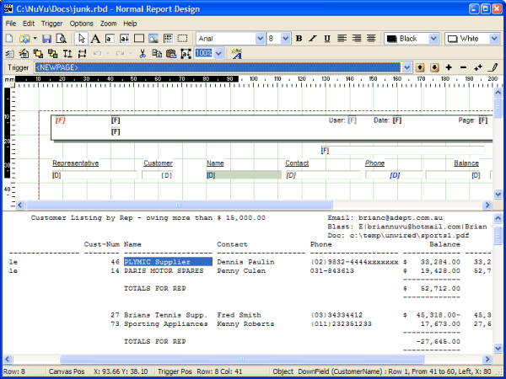
Figure 1

The designer tool is a single integrated solution, which incorporates the following functional areas normally available as seperate tools in competing products :

- a graphical canvas for drawing lines, rectangles, text and bitmaps directly on to it
- a legacy report viewer, which displays the contents of the associated text-based legacy report
- a mapping tool, which easily maps labels, fields and down-fields from the legacy report to the designer canvas
- a preview tool, which allows the user to view the legacy report as it would appear on the enhanced designer canvas at run-time
- a report wizard, which can be used to automatically convert elements of most legacy reports onto the GUI canvas in one easy operation

The report designer caters for both form-based (Invoices, Statements etc.) or columar-report-based (customer listings etc.) legacy reports, as well as XML document processing.

The NuVu Report Designer can also be used to design Fax cover pages which can be used with the integrated Fax Service that ships with the full version of the NuVu reporting suite. Refer to the Fax Cover Page Tutorial for more information regarding the design of Fax cover pages using the NuVu Designer.

Trigger-Based Processing
The report suite relies on the identification of Trigger Text within the legacy report being processed in order to activate the designer section associated with the trigger. Each report may have up to 15 independant triggers associated with it. Only one trigger may define the primary down section of the report.

A trigger is simply a text string that is searched for (at an optional column position) each time a new line of the legacy report is read into the processing buffer. Up to 15 different triggers may be advised for each report definition. An example of a commonly used trigger is text that can be uniquely identified at the start of each page of the report (a program identification number for example).

Each trigger has an associated GUI canvas onto which text (labels), bitmaps, rectangles, fields and down-fields may be placed. It is common practice to define one trigger (normally the first one) for the start of each new page (a special keyword <NEWPAGE> may be advised into the search string in this case). This trigger normally defines the page headings, column headings and associated detail rows of the report.

It is important to note that fields defined for a trigger CAN be defined on a row preceding the row on which the trigger is found. For example, if the trigger search text contains "pa001r00.rep" and this string is located on row 3 of each page of the legacy report, then a field can be defined which is mapped to a row preceding row 3 on the legacy report. The logical rows can therefore become negative.

Designer Objects
There are various objects which may be drawn or dropped onto the designer canvas during the design process. These objects are summarised below, and are explained in detail in the following sub-sections:

- Text Objects – Static objects NOT mapped to the legacy report, which are drawn on to the designer canvas when the associated trigger fires at run-time.
- Field Objects – These objects are mapped to a particular static row (relative to the defined trigger start text) and column position on the associated legacy report, and are normally found in the header section of the legacy report.
- DownField Objects – These objects are mapped to a particular starting row (relative to the defined trigger start text) and column position on the associated legacy report, and repeat for each detail row on the legacy report.
- Picture Objects – These graphical objects (bitmaps) are NOT mapped to the legacy report, and are drawn onto the designer canvas when the associated trigger fires at runtime.
- Rectangle Objects – These objects (squares, rectanges, horizontal and vertical lines) are NOT mapped to the legacy report, and are drawn onto the designer canvas when the associated trigger fires at run-time.
- TextBox Objects – These objects allow for multi-line static text and defined fields to be combined into a defined rectangle area. The text within a TextBox will automatically word-wrap. These objects are ideal for mail-merge applications.

Objects that have been drawn/dropped onto the canvas (ie: Text, TextBox, Field, Downfield, Rectangle or Picture objects) can be selected on their own (or in conjunction with others on the canvas) by either:

- Ensuring the current mode is set to 'Pointer' (See 'Change the current mode to Pointer' for details on how to do this), then left-click anywhere within the bounds of a created object. This will de-select any other objects and select this object. A selected object is identified by the 'grab handles' which are placed around the object. These grab handles allow the user to re-size and re-position the selected object using the mouse and normal drag techniques.
- Ensuring the current mode is set to 'Pointer' (See 'Change the current mode to Pointer' for details on how to do this), and then holding down the shift key, and simultaneously clicking within the bounds of any drawn objects. This will allow multiple objects to be selected. Multiple selected objects are identified by the grey 'grab handles' which are placed around the objects individually. These grab handles allow the user to re-position (but not re-size) the selected objects using normal mouse drag techniques.

Please note, if you are attempting to select single or multiple items within a rectangle (box) which is already selected, the system will NOT select the items. To achieve this, ensure that the rectange is de-selected first, then select the individual items (as explained above) within the rectange, and finally click on the outer edge of the rectange to select it as the last object.

Text Objects

These objects are drawn as static text (unmapped text) at run-time. A good example of when text objects would be used, is when defining the fixed column headings of a report onto the designer canvas.
Various properties may be set for the defined Text objects, including the font, size, foreground/background colors, bold, underline, italics and the justification of the object (left/right).
Text objects are placed onto the canvas by initially clicking on the designer canvas at the appropriate position, when the ‘Text Object’ button is depressed. Refer to the Change the current mode to 'Text Fields' for information regarding the drawing of text objects onto the current trigger designer canvas.
There are additional properties which may be set for any defined Text object, by right-clicking on a defined text object on the designer canvas window. The following dialog window is displayed when the mouse is 'right-clicked' on a text object on the current trigger designer canvas. The dialog window displays as follows:
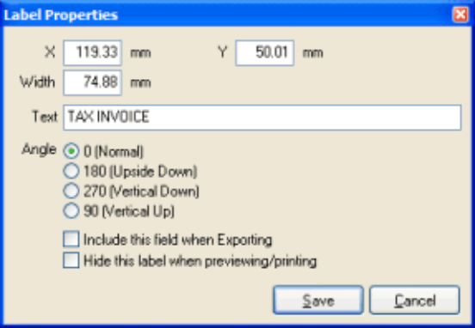
This dialog window allows the user to advise a new text caption to be displayed for the currently selected text object, and also whether this text caption is to be exported when the 'Export' button is pressed from the report viewer window.
Clicking either the in the top right-hand corner of the dialog window, or the CANCEL button will cancel any changes made to the properties of the object, and return the user to the designer canvas, with the object still selected. Pressing 'ENTER' at any time (or clicking the SAVE button) while the dialog window is visible will accept all changes made to the properties and return the user to the designer canvas, with the object still selected, and visually reflecting the changes made to its properties.
The caption advised in the 'Text' property can either be static ('Contact' for example), or one of these pre-defined functions:
- PrintDateTime()

This is replaced at run-time with the current date and/or time. If there is NO optional parameter advised between the braces, then the current date is shown using the format of the 'Short Date Style' property advised on the Windows Control Panel (Regional Settings), followed by the time shown using the format of the 'Short Time Style' property advised on the Windows Control Panel (Regional Settings). An optional formatting string can be advised (within quotes) to define the format of the generated date/time, as per the following rules:

c generates a date using the windows 'Short Date' regional setting, followed by the time using the windows 'Short Time' regional setting.
d Displays the day as a number without a leading zero (1-31).
dd Displays the day as a number with a leading zero (01-31).
ddd Displays the day as an abbreviated name (Sun-Sat).
dddd Displays the day as a full name (Sunday-Saturday).
ddddd Displays the date using the windows 'Short Date' regional setting.
dddddd Displays the date using the windows 'Long Date' regional setting.
mm Displays the month as a number with a leading zero (01-12).
mmm Displays the month as an abbreviated name (Jan-Dec).
mmmm Displays the month as a full name (January-December).
yy Displays the year as a two-digit number (00-99).
yyyy Displays the year as a four-digit number (0000-9999).
h Displays the hour without a leading zero (0-23).
hh Displays the hour with a leading zero (00-23).
n Displays the minute without a leading zero (0-59).
nn Displays the minute with a leading zero (00-59).
s Displays the second without a leading zero (0-59).
ss Displays the second with a leading zero (00-59).
z Displays the millisecond without a leading zero (0-999).
zzz Displays the millisecond with a leading zero (000-999).
t Displays the time using the format given by the windows 'Short Time' regional setting.
tt Displays the time using the format given by the windows 'Long Time' regional setting.
am/pm Uses the 12-hour clock for the preceding h or hh specifier, and displays 'am' for any hour before noon, and 'pm' for any hour after noon. The am/pm specifier can use lower, upper, or mixed case, and the result is displayed accordingly.
a/p Uses the 12-hour clock for the preceding h or hh specifier, and displays 'a' for any hour before noon, and 'p' for any hour after noon. The a/p specifier can use lower, upper, or mixed case, and the result is displayed accordingly.
ampm Uses the 12-hour clock for the preceding h or hh specifier, and displays the contents of the windows 'TimeAM' regional setting for any hour before noon, and the contents of the windows 'TimePM' regional setting for any hour after noon.
space Separates format variables.
‘other’ Any other characters that are enclosed within single quotes are output directly (without being formatted by the function).

Example1: PrintDateTime("mmm d, yyyy - hh:nn") would output Sep 5, 2005 - 12:45, assuming September 5th, 2005 was the current date, and 12h45 was the current time.
Example2: PrintDateTime("'Prepared on 'mmmm d, yyyy' at 'hh:nn am/pm") would output “Prepared on September 5, 2005 at 12:45 pm” (without the double quotes), assuming September 5th, 2005 was the current date, and 12h45 was the current time.

- PrintPage()

This is replaced at run-time with the current page number.

- PrintSubPage()

This is replaced at run-time with the current page number relative to the last time a trigger fired that has the ‘Reset sub-page counter’ tick-box ticked. For example, this is useful when wanting to print the pages of an invoice for a particular customer, starting at page 1 for each new customer.

X

This option can be used to manually position the selected text object at an exact millimeter position, relative to the left edge of the canvas. This option can be used as an alternative to moving the text object by clicking on the text object on the canvas, and then dragging it to a new position.

Y

This option can be used to manually position the selected text object at an exact millimeter position, relative to the top edge of the canvas. This option can be used as an alternative to moving the text object by clicking on the text object on the canvas, and then dragging it to a new position.

Width

This option can be used to manually adjust the width (in millimeters) of the selected text object. This option can be used as an alternative to resizing the text object by clicking on the text object on the canvas, and then dragging the width drag-handles to adjust the width of the object.

Angle

This set of radio buttons determines the orientation of the text that will be positioned on the designer canvas. Options include:

- 0 (Normal) - Text is positioned normally (ie: horizontally and right way up)
- 180 (Upside Down) - Text is positioned horizontally but upside down
- 270 (Vertically Down) - Text is drawn from top to bottom, vertically
- 90 (Vertically Up) - Text is drawn from bottom to top, vertically

Include this Field when Exporting:

By default, this option is left un-ticked for label objects. If this option is ticked, then the field will be exported to the comma-delimited (csv) file output when the 'Export' button is pressed on the report viewer window.

Hide this label when previewing/printing:

This check-box can be ticked to hide a label (text field) when the report is previewed using the report viewer. This feature is useful when you need to hide a complete column, including the headers (which are normally labels).

Please note: Hidden labels are still exported to the comma-delimited (csv) file when the 'Export' button is pressed on the report viewer window, as long as the 'Include this field when Exporting' option on the text attributes window is ticked.

NOTE: A sub-set of these properties are also able to be manipulated by means of the 'Property Editor', invoked by clicking the right-mouse button when more than one object (of the same type) is currently selected. See Changing multiple object properties or more details of this option.

Field Objects

These objects are drawn as linked fields from the legacy report at run-time. Each Field object is associated with a row (either absolute, or relative to the trigger text) and column from/to mapped from the legacy report during the design of the report. An example of when you would use a field object, is the mapping of the report header at the start of each new page.
Various properties may be set for the defined Field objects, including the font, size, foreground/background colors, bold, underline, italics and the justification of the object (left/right).
Field objects are placed onto the canvas by initially pressing the associated button. Refer to the Change the current mode to 'Field' for information regarding the drawing of field objects onto the current trigger designer canvas.
NOTE: A sub-set of these properties are also able to be manipulated by means of the 'Property Editor', invoked by clicking the right-mouse button when more than one object (of the same type) is currently selected. See Changing multiple object properties or more details of this option.

The following dialog window is displayed if XML input is advised :
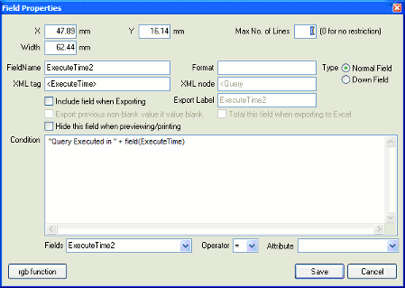

The following dialog window is display for normal text report input :
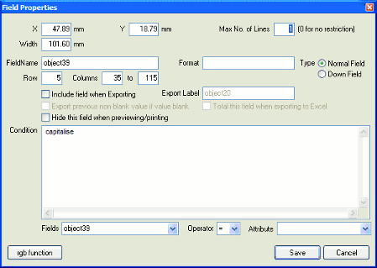

Clicking either the in the top right-hand corner of the dialog window, or the CANCEL button will cancel any changes made to the properties of the object, and return the user to the designer canvas, with the object still selected. Pressing 'ENTER' at any time (or clicking the SAVE button) while the dialog window is visible will accept all changes made to the properties and return the user to the designer canvas, with the object still selected, and visually reflecting the changes made to its properties.
Clicking the ‘rgb function’ button has the same effect as selecting the ‘rgb’ function from within the ‘Attribute’ combo-box. Please refer to the ‘Condition’ help for more information in this regard.

X

This option can be used to manually position the selected field object at an exact millimeter position, relative to the left edge of the canvas. This option can be used as an alternative to moving the field object by clicking on the field object on the canvas, and then dragging it to a new position.

Y

This option can be used to manually position the selected field object at an exact millimeter position, relative to the top edge of the canvas. This option can be used as an alternative to moving the field object by clicking on the field object on the canvas, and then dragging it to a new position.

Width

This option can be used to manually adjust the width (in millimeters) of the selected field object. This option can be used as an alternative to resizing the field object by clicking on the field object on the canvas, and then dragging the width drag-handles to adjust the width of the object.

Max No. of Lines

This option can be used to introduce text-wrapping into fields and downfields. The default is for this value to be 1 - meaning there is only every a single line output to this field (and the field therefore does not wrap). Advising a value of zero will set the field to unrestricted wrapping - ie: the field will be output on the advised row and subsequent rows until there is no more information to be output for the field. Advising a value of between 2 and 99 will restrict the wrapping to this advised number of rows.

FieldName :
This automatically defaults to the word 'object' followed by a number corresponding to the order in which the field objects were drawn onto the canvas. A more meaningful name can be advised here, so that conditional formatting of other fields based on this field becomes more intuitive. For example, if the current Fieldname is changed from 'object32' to 'Balance', then the conditional formatting statement would read something like: if val(Balance) < 100 then.....
There are a few 'special' fieldnames that perform certain functionality at runtime :
- ReportDescription
The contents of this fieldname will replace the default report description advised within the designer (via the Report Properties dialog window). The default or overriding report description is output to the email subject and message areas when a report is emailed from the NuVu viewer. The user is still able to advise an overriding value into this field if so desired.
- EmailTo
The contents of this fieldname will be used to populate the 'Email Address' field when a report is emailed from the NuVu viewer. The user is still able to advise an overriding value into this field if so desired.
- EmailSubject
The contents of this fieldname will be used to populate the 'Email Subject' field when a report is emailed from the NuVu viewer. The user is still able to advise an overriding value into this field if so desired.
- FaxNumber
The contents of this fieldname will be used to populate the 'Fax Number' field when a report is faxed from the NuVu viewer. The user is still able to advise an overriding value into this field if so desired.
- FaxRecipient
The contents of this fieldname will be used to populate the 'Fax Recipient' field when a report is faxed from the NuVu viewer. The user is still able to advise an overriding value into this field if so desired.
- EmailAddr
This field is used to determine the various email address that the relevant pages of the report will be emailed to at runtime - ie: perform an email blast. When the 'email' button is clicked from the NuVu report viewer, the viewer will interrogate the report to see if there is a defined field called 'EmailAddr'. If so, then an email blast is initiated, resulting in the single report being split up into pages for each unique email recipient. Each recipient email address is then emailed with either a raw NuVu report attachment (extension .rbi) or a PDF attachment. For more information, refer to the 'Email' button reference within the NuVu Viewer manual.
- BlastInfo
This field is used to determine the email, fax and other destinations for the relevant pages of the report. A report can be 'blasted' either by clicking the 'blast' button from the NuVu viewer toolbar, or alternatively by using the 'B:...' command-line option to the 'rbd_prepare' utility tool (described in the NuVu Technical Reference manual). For more information on blasting, refer to the 'Blast' button reference within the NuVu Viewer manual.
- DocLibInfo
This field is used to determine the filename to which relevent pages of the report will be saved into. The field contains a physical filename (eg: c:\MyDocs\mydoc.rbi). The extension of this filename MUST be either '.rbi' or '.pdf'. An extension of '.rbi' will ensure that the relevant pages get saved in raw NuVu viewer format, whereas an extension of '.pdf' will result in the relevant pages being saved in acrobat format.
When this fieldname is detected within a report, the NuVu reporting engine will automatically process the report a second time, collating and outputting the pages that match the unique 'DocLibInfo' field to the advised filename. In order to use this function effectively, normally the 'DocLibInfo' field is derived from other fields on the report (for example: the customer number plus the invoice number, prefixed with the desired folder in which the file will be saved into).
- EmailFilename
This field is used to name the file (pdf or rbi) that is automatically attached to an email. This field should NOT include the extention but this will be stripped off if found. If the derived filename already exists (in the temporary folder of the user), then a suffix will be automatically added onto the end of the filename. This temporary file will be removed after the email has been sent.

Format :
This field allows the user to specify special formatting of the current field.
Format strings passed to the string formatting routines contain two types of objects -- literal characters and format specifiers. Literal characters are copied verbatim to the resulting string.
Format specifiers fetch arguments from the argument list and apply formatting to them.
Format specifiers have the following form:
["("|"-"]"%" [width] ["." prec] type
Normally the format specifier begins with a % character, but there are two exceptions to this rule:
- An optional opening bracket ("("). Advising this opening bracket will ensure that negative numbers are enclosed with brackets, irrespective of the Windows numeric and currency settings.
- An optional negative sign ("-"). Advising this negative sign will ensure that negative numbers will always start with a negative sign, irrespective of the Windows numeric and currency settings.
A "%" character must follow the optional "(" or "-" character. If no optional "(" or "-" character is advised, then the format specifier must begin with "%". After the % come the following, in this order:
- An optional left-justification indicator ["-"]
- An optional width specifier, [width]
- An optional precision specifier, ["." prec]
- The conversion type character, type
The following table summarizes the possible values for type:
d Decimal. The argument must be an integer value. The value is converted to a string of decimal digits. If the format string contains a precision specifier, it indicates that the resulting string must contain at least the specified number of digits; if the value has less digits, the resulting string is left-padded with zeros.
u Unsigned decimal. Similar to 'd' but no sign is output.
e Scientific. The argument must be a floating-point value. The value is converted to a string of the form "-d.ddd...E+ddd". The resulting string starts with a minus sign if the number is negative. One digit always precedes the decimal point.The total number of digits in the resulting string (including the one before the decimal point) is given by the precision specifier in the format string-a default precision of 15 is assumed if no precision specifier is present. The "E" exponent character in the resulting string is always followed by a plus or minus sign and at least three digits.
f Fixed. The argument must be a floating-point value. The value is converted to a string of the form "-ddd.ddd...". The resulting string starts with a minus sign if the number is negative.The number of digits after the decimal point is given by the precision specifier in the format string-a default of 2 decimal digits is assumed if no precision specifier is present.
g General. The argument must be a floating-point value. The value is converted to the shortest possible decimal string using fixed or scientific format. The number of significant digits in the resulting string is given by the precision specifier in the format string-a default precision of 15 is assumed if no precision specifier is present.Trailing zeros are removed from the resulting string, and a decimal point appears only if necessary. The resulting string uses fixed point format if the number of digits to the left of the decimal point in the value is less than or equal to the specified precision, and if the value is greater than or equal to 0.00001. Otherwise the resulting string uses scientific format.
n Number. The argument must be a floating-point value. The value is converted to a string of the form "-d,ddd,ddd.ddd...". The "n" format corresponds to the "f" format, except that the resulting string contains thousand separators.
m Money. The argument must be a floating-point value. The value is converted to a string that represents a currency amount. Negative values are shown with surrounding brackets. The CurrencyString ($ for example), Thousand separator and format of the Currency String is determined by the values defined in the Windows 'Regional Settings' on the PC on which the report is graphically rendered. If the format string contains a precision specifier, it overrides the value given by the CurrencyDecimals Windows global variable.
s String. The argument must be a string. The string or character is inserted in place of the format specifier. The precision specifier, if present in the format string, specifies the maximum length of the resulting string. If the argument is a string that is longer than this maximum, the string is truncated.
Examples:
1234.56 using -%.2m = $1,234.56 (assuming Windows currency settings include "," as thousands separators).
-1234.56 using -%.2m = -$1,234.56 (assuming Windows currency settings include "," as thousands separators).
-1234.56 using (%.2m = ($1,234.56) (assuming Windows currency settings include "," as thousands separators).
1234.56 using %.2n = 1,234.56 (assuming Windows currency settings include "," as thousands separators).

Row : (Only available if XML input is NOT advised)
This defines on which row to map this field object to on the legacy report. This Row is relative to the Trigger 'Start Text' for Field objects, or relative to the Trigger 'Starting Row' property for Down Fields. For Down Fields, this value is normally set to 1, but may be adjusted if the legacy report is defined with more than one physical line per logical line, and the user wishes to format the field objects on the other rows. For example, advise a value of 2 here if you are defining a downfield object for the phone number, if the Legacy report looks something like this:
ABC001 Joe Bloggs EnterPrises 400.00
Phone: 123-222-444
BBD002 Fred Smith Plumbers 489.44
Phone: 77780-2323

Column From : (Only available if XML input is NOT advised)
This field specifies the starting column position to map the defined Field or DownField object to in the legacy report. This field is normally automatically calculated when the mapped field is highlighted within the legacy report and then a new field/downfield object is dropped onto the designer canvas, but may be changed at the users discretion.

Column To : (Only available if XML input is NOT advised)
This field specifies the ending column position to map the defined Field or DownField object to in the legacy report. This field is normally automatically calculated when the mapped field is highlighted within the legacy report and then a new field/downfield object is dropped onto the designer canvas, but may be changed at the users discretion.

XML tag: (Only displayed if input is from XML)
This field defines which XML tag (element or attribute) is mapped from the sample XML document to this field object. An XML element must contain the starting and ending brackets (for example: <SalesPerson_Name> is a valid XML element). An XML attribute must contain the trailing '=' sign (for example: MTD_Sales= is a valid XML attribute).

The system will verify that the advised XML tag is valid, and that it can be found within the sample XML document linked to the current NuVu design.

XML node: (Only displayed if input is from XML)
This field displays the associated XML node for the current field object. This corresponds to the parent XML node (Element) to which the current XML tag belongs. This field is read-only and automatically determined by the system, and therefore cannot be modified by the user.

Include Field when Exporting :
By default, this option is automatically ticked for all new DownField objects, and left unticked for Field objects. If this option is ticked, then the field will be exported to the comma-delimited (csv) file output when the 'Export' button is pressed on the report viewer window.

Export Label :
This field is only visible when the current object is a DownField. The advised label is exported on the first row of the comma-delimited (csv) file output when the 'Export' button is pressed on the report viewer window.

Export previous non-blank value if value blank :
This field is only applicable when fields are being exported to a comma-delimited file (.csv) or as a native Excel spreadsheet format. If the legacy report has report values which are only printed at the start of a control break (eg: at the start of a new Sales Representative), then this option can be ticked on the Sales Representative's name which will ensure that the value at the start of the control break is exported for all occurances of lines where the subsequent field values are blank. For example, examine the following snippet of legacy report:

SalesPerson Customer Balance
--------------------- -------------------- ---------
Donna Mills Fred Funk 1245.44
Gary Smith 222.44
Jenny Postumous 2433.00
Greg Hippo Karen Jones 100.00
Larry Myers 332.12
If this report is exported WITHOUT the option ticked, the following data will be exported:
"SalesPerson","Customer","Balance"
"Donna Mills","Fred Funk","1245.44"
"","Gary Smith","222.44"
"","Jenny Postumous","2433.00"
"Greg Hippo","Karen Jones","100.00"
"","Larry Myers","332.12"
If this report is exported WITH the option ticked, the following data will be exported:
"SalesPerson","Customer","Balance"
"Donna Mills","Fred Funk","1245.44"
"Donna Mills","Gary Smith","222.44"
"Donna Mills","Jenny Postumous","2433.00"
"Greg Hippo","Karen Jones","100.00"
"Greg Hippo","Larry Myers","332.12"
If the user wishes to perform filtering or graphing on the exported information, then it is desirable to leave this option ticked, for the relevant fields only.
NOTE: This option should not be ticked for amount fields, otherwise blank amounts can be replaced with the value of the previous non-blank value.

Total this field when exporting to Excel:

If this tick-box is ticked, the NuVu viewer will ensure that the contents of this field are totalled and shown at the bottom of the set of data for this trigger. Of course, you should probably ensure that you are mapping to numeric data, otherwise this total will contain invalid data when shown within the Excel spreadsheet.

Hide Field when previewing/printing :
This check-box can be ticked to hide a field when the report is previewed using the report viewer. This feature is useful when you need to define fields from the legacy report for conditional printing of other columns, but these fields need not be viewed. For Example, the legacy report might have a field on it called 'AmtColor', which is set to Green or Red. If the field contains Green, then the Overdue amount field must display in a Green color, otherwise Red. To achieve this, a conditional statement may be advised on the 'OverDue' downfield object thus:
if AmtColor = "Green" then
forecolor = Green
else
forecolor = Red
Please note: Hidden fields are still exported to the comma-delimited (csv) file when the 'Export' button is pressed on the report viewer window.

Condition :
This advanced feature allows the user to advise conditional formatting of the current Field or DownField. The format of the condition must conform to a syntax which is validated, according to the following rules:
[ optional Statements... ]
[ if [Condition] [Operator] [Value] then
[Attribute] [= AttributeValue]
....
else
if [Condition] [Operator] [Value] then
[Attribute] [= AttributeValue]
....
else ... ]

The [Condition] must be either a FieldName (See Fields below) or val(FieldName).
The [Operator] must be one of the operators in the Operation combo-box explained below.
The [Value] is either a numeric or alphanumeric constant, or a valid FieldName (See Fields below).
The [Attribute] must be one of the defined attributes in the Attributes combo-box explained below.
The [AttributeValue] must contain 'Yes', 'No', a corresponding font name or color value (Green for example), or a valid FieldName (See Fields below).
The following example unconditionally Capitalises the current field first, then sets the color of the current field to green and bold if the 'balance' field < 30000:
Capitalise
if val(Balance) < 30000 then
forecolor = green
bold
else
if val(Balance) < 50000 then
forecolor = blue
italic
Please note that because the ‘Balance’ field is assumed to be numeric, the ‘val’ statement was used to convert the contents of the field into a decimal value. If this was a string field, then you could have issued a statement similar to:
Capitalise
if CustomerName = “” then
Caption = “<Empty>”

Fields :
This combo-box will contain a list of all defined fields within ALL triggers. This is just an aid in determining what fields can be used when building a conditional statement. If a fieldname is selected from this combo-box, then that name is automatically typed at the current cursor position within the 'Condition' text area.
At run-time, the current trigger will first be examined to locate the field name. If the required field-name is not located, then all other triggers are then examined.
Operation :
This combo-box contains a list of all defined operations allowed on the conditional statement. If an operation is selected from this combo-box, then that operation code is automatically typed at the current cursor position within the 'Condition' text area.

Attribute :
This combo-box contains a list of all defined attributes allowed on the conditional statement. If an attribute is selected from this combo-box, then that attribute is automatically typed at the current cursor position within the 'Condition' text area.
The available attributes that may be advised are:
+ The field concatenation attribute which allows the values of fields and text to be combined together for display in the current field.
For example: The current field must display the value of field 'CustNum' plus a string of ":" plus the value of the field 'Balance' - this could be achieved by advising the following conditional statement: field(CustNum) + text(":") + field(Balance).
This attribute can also be used to sum calculated fields (#amt1 through #amt50).
For Example: #amt1 = #amt2 + field(Balance)

- This attribute is used to subtract calculated fields (#amt1 through #amt50).
For Example: #amt1 = field(Balance) - #amt2

* This attribute is used to multiply calculated fields (#amt1 through #amt50).
For Example: #amt1 = field(Balance) * 2

/ This attribute is used to divide calculated fields (#amt1 through #amt50). Divide by zero is automatically trapped.
For Example: #amt1 = field(Balance) / #amt2

angle Must be followed with ' = 0 | 90 | 180 | 270'. This attribute is only applicable to fields that are LEFT JUSTIFIED, and is used to rotate the text as follows:
      - 0: no rotation - text appears horizontally, left to right.
      - 90: rotate vertical up - text appears vertically, from bottom to top.
      - 180: rotate text so it appears horizontally, but upside down.
      - 270: rotate vertical down - text appears vertically, from top to bottom.
Example: Angle = 90

backcolor Must be followed with ' = colorname', where colorname is the name of the desired color (green, red, maroon, white, black, lime etc.). Results in the background color of the current field to changed to this advised value (ONLY applied the next time the field is displayed).
Example: backcolor = red

barcode30f9 Must occur on its own on a line. Specifying this string will result in the contents of the field being converted into a "3 of 9" barcode. The leading and trailing asterisks will be automatically added to the contents of the field. An optional check-digit can be added to the field, via advise of the 'barcodecheckdigit' attribute, described below.

barcode2of5 Must occur on its own on a line. Specifying this string will result in the contents of the field being converted into a "2 of 5" barcode. ‘2 of 5’ barcodes are for numeric values only – therefore if the current field does not contain digits between 0 and 9, then the barcode will NOT be drawn at all. An optional check-digit can be added to the field, via advise of the 'barcodecheckdigit' attribute, described below.
The ‘barcodeinterspace’ option is ignored for this barcode type.

barcodei2of5 Must occur on its own on a line. Specifying this string will result in the contents of the field being converted into an "interleaved 2 of 5" barcode. ‘2 of 5’ barcodes are for numeric values only – therefore if the current field does not contain digits between 0 and 9, then the barcode will NOT be drawn at all. Furthermore, the interleaved ‘2 of 5’ barcode can only operate on an even number of digits (which includes the optional checkdigit). If the calculated number of digits is not divisible by 2, then a leading zero will be added to the value of the current field to ensure that it is. An optional check-digit can be added to the field, via advise of the 'barcodecheckdigit' attribute, described below.
The ‘barcodeinterspace’ option is ignored for this barcode type.

barcodebleed Must be followed with ‘ = mm value’. If advised, this attribute will be used to reduce the width of the ‘dark’ barcode lines. This attribute is of particular importance on older inkjet printers, where the ink will bleed on solid black lines, resulting in lines that are slightly wider than expected, and could result in barcode read errors. If this attribute is advised, it is normally set to a fairly small value (0.05mm for example). The system will ensure that the value of this attribute does not exceed half the line width of the lines of thebarcode.

barcodecheckdigit Must occur on its own on a line. Specifying this string will result in any converted barcode having an optional check digit automatically calculated and inserted at the end of the barcode.
barcodeean13 Must occur on its own on a line. Specifying this string will result in the contents of the field being converted into a "EAN13" barcode. If the contents of the field contains any alpha-numeric characters (ie: non-numeric) then the barcode will NOT be drawn. Similarly if the length of the digits on the barcode is not exactly 12 (without check-digit) or 13 (with check-digit) then the barcode will NOT be drawn. EAN13 barcodes are commonly used internationally as product barcodes. If the length of the digits in the barcode is 12 (or the optional 'barcodecheckdigit') attribute is advised, then a modulus 10 check digit will be computed for the barcode and attached as the 13th character. The 'barcodeinterspace' option is ignored for this barcode type.
barcodeean13_long This produces an EAN13 barcode exactly the same as the 'barcodeean13' barcode explained above, except that this version produces the barcode with leading, center and trailing guard bars that are 1/5th longer than the rest of the barcode lines.

barcodeinterspace Must be followed with ' = mm value'. If advised, this attribute will be used to specify the millimeter gap that is inserted between each character of the generated barcode. If not advised, the 'interspace' is automatically set to the calculated line width of each bar of the barcode. Please note that only certain barcodes (eg : Barcode3of9) use the Interspace parameter, so this may have no effect on the generated barcode.
Example: barcodeinterspace = 0.2

barcodethinmm Must be followed with ' = mm value'. If advised, this attribute will be used to specify the millimeter value of each thin bar (blank and black bars) of the generated barcode. If not advised, then this value is automatically calculated using the current height of the field. This calculation takes the point size of the font of the current field, and multiplies this by 0.0333333333.
Example: barcodethinmm = 0.2

barcodefatmm Must be followed with ' = mm value'. If advised, this attribute will be used to specify the millimeter value of each fat bar (blank and black bars) of the generated barcode. If not advised, then this value is automatically calculated based on the value of the BarcodeThinMM value, described previously. This calculation takes the value of the BarcodeThinMM and multiplies it by a factor depending on the current barcode type. For example, Barcode2of5 uses a ratio of 3:1 so that the fat bars are 3 times the width of the thin bars.
Example: barcodefatmm = 0.5

Barcodeucc128b Must occur on its own on a line. Specifying this string will result in the contents of the field being converted into a "EAN-128/UCC-128" barcode, of "Code B" variant. EAN/UCC 128 barcodes accommodate upper and lowercase alphanumeric codes, and is commonly used in retail operations. The barcode will have a checkdigit automatically calculated and attached to it, therefore the optional ‘barcodecheckdigit' attribute is ignored for this barcode type. Also, the ‘barcodeinterspace’ option is ignored for this barcode type.

Barcodeucc128c Must occur on its own on a line. Specifying this string will result in the contents of the field being converted into a "EAN-128/UCC-128" barcode, of "Code C" variant. The “Code C” variant ONLY processes numeric barcodes. If the contents of the field to be converted are NOT found to be pure numeric, then the barcode will revert to a Barcodeucc128b derivative (see above for more details). In addition, the number of digits in the code MUST be divisible by 2. So if the contents of the field being converted is not divisible by 2 (ie: even number of digits), then a leading zero will be added to the code. The barcode will have a checkdigit automatically calculated and attached to it, therefore the optional ‘barcodecheckdigit' attribute is ignored for this barcode type. Also, the ‘barcodeinterspace’ option is ignored for this barcode type.

bold Optionally followed with ' = yes' or ' = no', default is ' = yes'. Results in the font of the current field being displayed in BOLD, but only applied for the next display of this field.
Example: bold = false

capitalise Must NOT be followed with an assignment statement ( = ...). The current field will be converted to Proper Case (where the first letter of each word is changed to upper-case, with the remaining characters in the word converted to lowercase). ). For example, If the current value of the field contained 'DONNA MILLS-SMITH', the value would be converted to 'Donna Mills-Smith'.

caption Can be followed with the assignment statement ( = ) followed by either static text (Eg: "balance") or alternatively another field (chosen from the fields combo-box). Can also be used inside the sum and if statements. If so used, it will take the computed value of the current field, as opposed to 'currfield' or fieldname, which derives the value back from the legacy report IF AND ONLY IF the current line being processed contains the current field or advised fieldname, otherwise it will also take the computed value of that field.
Example: caption = "<not applicable>"

concat(...) Must NOT be followed with the assignment statement ( = ...). Static text (Eg: ", ") must be placed within the brackets, or alternatively another field (chosen from the fields combo-box). The result of this operation is that the current field will have this text concatenated to it. Very useful when concatenating surname and first names from two different fields at run-time.

convert_date Followed by three parameters, separated with comma's, and optionally enclosed in quotes. This function allows for the conversion of original dates into a new format.

The Syntax of this function is: convert_date(fieldname,old_format,new_format), where:
- fieldname contains the name of the field (or 'currfield' to indicate the current field) to be converted.
- old_format contains the old date format (of the original field). See the available format strings below.
- new_format contains the new date format that is to be applied and displayed in this field. See the available format strings below for details.

Format Strings:

c generates a date using the windows 'Short Date' regional setting, followed by the time using the windows 'Short Time' regional setting.
d Displays the day as a number without a leading zero (1-31).
dd Displays the day as a number with a leading zero (01-31).
ddd Displays the day as an abbreviated name (Sun-Sat).
dddd Displays the day as a full name (Sunday-Saturday).
ddddd Displays the date using the windows 'Short Date' regional setting.
dddddd Displays the date using the windows 'Long Date' regional setting.
mm Displays the month as a number with a leading zero (01-12).
mmm Displays the month as an abbreviated name (Jan-Dec).
mmmm Displays the month as a full name (January-December).
yy Displays the year as a two-digit number (00-99).
yyyy Displays the year as a four-digit number (0000-9999).
/ Displays the date separator character.
space Separates format variables.
- Alternate date separator
other Any other characters are output as typed

Example: convert_date(DatePaid,"dd/mm/yy","mmmm d, yyyy") would output 'September 3, 2002' if the original field contains a date of 01/09/02.

endif This statement can be used to end a previous 'if' condition. The format of 'if' statements is as follows:

if condition = value then
statement1
statement2...
else
statement3
statement4...
endif

exit Exits the conditional statement at this point. Useful in large conditional statements and can dramatically improve performance during report rendering.

entry entry(element,field,delimiter) returns a string corresponding to the nth element within the advised field, using the advised delimiter character. For example, given a field 'Name' containing the string 'Brian Culverwell', entry(2,Name," ") will return 'Culverwell'.

export Optionally followed with ' = yes' or ' = no', default is ' = yes'. Results in current field being exported or not exported when the 'Export' button is pressed from the preview window.

field followed by the desired fieldname (enclosed in brackets). Results in the contents of the advised fieldname (or 'currfield' for the current field contents) to be transferred to this field. This option is normally used in combination with the '+' concatenation attribute to combine several field values together for display. See the '+' attribute for an example of the usage of this attribute.

fontname Must be followed with the assignment statement ( = ) followed by the name of a valid font (eg: Arial). Results in this field being displayed in the chosen font at run-time (if the optional conditions are met).

fontsize Must be followed with the assignment statement ( = ) followed by the required size of the font (as in integer). Results in this field being displayed in the chosen font at run-time (if the optional conditions are met).

forecolor Must be followed with the assignment statement ( = ) followed by the name of a valid system color (eg: black, white, maroon, green etc). Results in this field being displayed in the chosen foreground color at run-time (if the optional conditions are met).

format Must be followed by two comma-separated values, and enclosed in brackets. The first value must be enclosed in double-quotes, and contains the format string to be applied to the second value string. The second value string can contain a literal value (enclosed in quotes), or alternatively ‘currfield’, ‘caption’, field(..fieldname..), #amt1..#amt50. If the format string (first value string) contains an integer format string, then the value of the 2nd parameter is automatically converted into an integer (if possible, otherwise a zero is assigned to this value). If the format string contains a decimal format string, then the value of the 2nd parameter is automatically converted into a decimal value (if possible, otherwise a zero is assigned to the value).

Format strings passed to the string formatting routines contain two types of objects -- literal characters and format specifiers. Literal characters are copied verbatim to the resulting string (Example : ‘The value of the field is ‘).

Format specifiers are replaced with the actual contents of the 2nd parameter passed to the format function, and have the following form:

%[-][width][.prec]type

The format specifier MUST begin with a "%" (without the enclosing quotes). After the « % come the following, in this order:

An optional "-" symbol indicates that the resulting string must be left-padded with spaces, if appropriate. This is common when a ‘string’ is being output. If omitted, then the string will be right-justified.

An optional width specifier, [width]

An optional precision specifier ["."prec]. This specifier is only normally used with decimal values, and is typically used to specify the number of decimals to show after the decimal point.
Finally, the conversion type character, as follows:
d The argument must be an integer value. The value is converted to a string of decimal digits. If the format string contains a precision specifier, it indicates that the resulting string must contain at least the specified number of digits; if the value has less digits, the resulting string is left-padded with zeros.

u The argument must be an nsigned integer. Similar to 'd' but no sign is output.

e Scientific. The argument must be a floating-point value. The value is converted to a string of the form "-d.ddd...E+ddd". The resulting string starts with a minus sign if the number is negative. One digit always precedes the decimal point.The total number of digits in the resulting string (including the one before the decimal point) is given by the precision specifier in the format string-a default precision of 15 is assumed if no precision specifier is present. The "E" exponent character in the resulting string is always followed by a plus or minus sign and at least three digits.

f Fixed. The argument must be a floating-point value. The value is converted to a string of the form "-ddd.ddd...". The resulting string starts with a minus sign if the number is negative.The number of digits after the decimal point is given by the precision specifier in the format string-a default of 2 decimal digits is assumed if no precision specifier is present.

g General. The argument must be a floating-point value. The value is converted to the shortest possible decimal string using fixed or scientific format. The number of significant digits in the resulting string is given by the precision specifier in the format string-a default precision of 15 is assumed if no precision specifier is present.Trailing zeros are removed from the resulting string, and a decimal point appears only if necessary. The resulting string uses fixed point format if the number of digits to the left of the decimal point in the value is less than or equal to the specified precision, and if the value is greater than or equal to 0.00001. Otherwise the resulting string uses scientific format.

n Number. The argument must be a floating-point value. The value is converted to a string of the form "-d,ddd,ddd.ddd...". The "n" format corresponds to the "f" format, except that the resulting string contains thousand separators.

m Money. The argument must be a floating-point value. The value is converted to a string that represents a currency amount. Negative values are shown with surrounding brackets. The CurrencyString ($ for example), Thousand separator and format of the Currency String is determined by the values defined in the Windows 'Regional Settings' on the PC on which the report is graphically rendered. If the format string contains a precision specifier, it overrides the value given by the CurrencyDecimals Windows global variable.

s String. The argument must be a string. The string or character is inserted in place of the format specifier. The precision specifier, if present in the format string, specifies the maximum length of the resulting string. If the argument is a string that is longer than this maximum, the string is truncated.

x Hexadecimal. The argument must be an integer. The integer is converted to a hexadecimal string of digits.

Examples:

1234.56 using “%.2m” = $1,234.56 (assuming Windows currency settings include "," as thousands separators).

-1234.56 using “%.2m” = $-1,234.56 (assuming Windows currency settings include "," as thousands separators).

-1234.56 using “%.2f” = 1234.56.

1234.56 using “%.2n” = 1,234.56 (assuming Windows currency settings include "," as thousands separators).

1234.56 using “%10.2f” = “ 1234.56” (three spaces before the ‘1234.56’, because the width is set to 10).

1234.56 using “The available balance is: %.2m” = “The available balance is: $1,234.56”.

hidden Optionally followed with ' = yes' or ' = no', default is ' = yes'. Results in current field being hidden or not hidden when the report is displayed in the preview window.

hiderepeating Must NOT be followed with an assignment statement (= ...). If the value of the current field is IDENTICAL to the value of the previous non-blank value of that field, then the field will be automatically hidden. This does NOT affect when the report is exported to a comma-delimited file.

italic Optionally followed with ' = yes' or ' = no', default is ' = yes'. Results in the font of the current field being displayed in ITALIC, but only applied for the next display of this field.

loadgraphic Expects 2 parameters, the first one being the object name of the actual image that will be replaced on the form, and the second being a filename (must end in .bmp or .jpg). This filename can also be derived from another field on the form. A special placeholder $NuVu can be placed at the start of the second parameter - this will be automatically replaced with the full path of the folder that the NuVu Report Previewer is running from.
For example :
loadgraphic(LogoObject,$NuVu\Docs\MyLogo.bmp)
loadgraphic(LogoObject,FilenameObject) – where FilenameObject is another field on the form that contains the actual filename.

logicalrow Returns the current logical row number in a multiple-logical-row set. This attribute is therefore only applicable to conditions on a downfield. This attribute is useful in an if statement to determine certain processing depending on the current row of the logical downfield set.

lowercase Must NOT be followed with an assignment statement ( = ...). The current field will be converted to lowercase, but only applied for the next display of this field.

moneytowords Must NOT be followed with any other parameters (ie : must stand alone on a line). The current numeric value (if numeric and not negative) will be converted into uppercase wording. For example : A value of 1234.56 in the current field would be converted to “ONE THOUSAND TWO HUNDRED THIRTY FOUR DOLLARS FIFTY SIX CENTS”.
Please note that if the value is negative, the contents of this field will be filled with ‘NEGATIVE’. Also, if the value is more than 999999999.99 then the contents of this field will be filled with ‘OVERFLOW’.

moneytowords2 Must NOT be followed with any other parameters (ie : must stand alone on a line). The current numeric value (if numeric and not negative) will be converted into uppercase wording using an alternate format to the ‘moneytowords’ attribute described previously. Hundred Thousand and Ten Thousand values will be output separately. This format is very useful for converting to asian fonts, where the word representation of numeric values is normally different to the english equivalent. For example : A value of 123234.56 in the current field would be converted to “ONE HUNDRED THOUSAND 2 TEN THOUSAND THREE THOUSAND TWO HUNDRED THIRTY FOUR DOLLARS FIFTY SIX CENTS”.
Please note that if the value is negative, the contents of this field will be filled with ‘NEGATIVE’. Also, if the value is more than 999999999.99 then the contents of this field will be filled with ‘OVERFLOW’.

normal Optionally followed with ' = yes' or ' = no', default is ' = yes'. Results in the font of the current field being displayed with a normal attribute (not BOLD, not UNDERLINE and not ITALIC), but only applied for the next display of this field.

rgb Must be followed by three integer arguments, enclosed in brackets. The three integer values correspond to the red, green and blue values that will be used to calculate the actual color to be used. These integer values should have a value between zero and 255 only. Values outside this range will be converted to zero.
Clicking this option from the combo-box will automatically invoke the standard color-chooser dialoag window, as shown below:
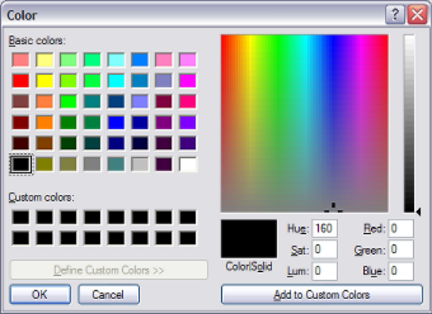
Use this color-selection tool to choose the desired color using the displayed palette. Clicking the OK button will insert the “rgb” function into the conditions edit box with the appropriate values for the red, green and blue setting filled in automatically.
This function should be preceded with a ‘ForeColor = ‘ or ‘BackColor = ‘ statement, otherwise the function will have no effect.

replace Must be followed by two quoted arguments, enclosed in brackets. The attribute will scan the current contents of the field, and replace all occurrances of the ‘old string’ with the value of the ‘new string’.
For example : The current field has a value of ‘ONE THOUSAND DOLLARS’ – when the replace(“DOLLARS”,”POUNDS”) is applied to the value, the resulting value of the field will contain ‘ONE THOUSAND POUND’.

sectionheight Very useful for incrementing (or decrementing) the current Section height of the downfield row when the number of actual lines in a logical section are not known at design time. For example, the statement:
if currfield <> "" then sectionheight = sectionheight + 4 will increment the section height of the downfields by 4 each time the current field is non-blank. The sectionheight attribute can also be included in an 'if' statement. This is useful to determine if conditional processing should occur based on the current value of the sectionheight.

substr substr(field,index,count) returns a substring containing count characters starting at field[index], where index starts at one.
If index is larger than the length of S, substr returns an empty string. If count specifies more characters than are available in the field, only the characters from field[index] to the end of the field are returned.

sum Followed by a bracketed list of fields separated with a plus or minus sign). The attribute will evaluate the contents of the brackets, adding and subtracting the numeric contents of each field identified within the brackets.
For example, the statement:
sum(Balance + Interest + GST) will compute the value of the Balance, Interest and GST fields and return the result to the caption for the current field.

text followed by the desired text (optionally enclosed in double-quotes). Results in the contents of the advised text to be transferred to this field. This option is normally used in combination with the '+' concatenation attribute to combine several field and text values together for display. See the '+' attribute for an example of the usage of this attribute.

trim followed by the desired fieldname will result in the contents of the advised fieldname to be trimmed (right and left) and returned.

underline Optionally followed with ' = yes' or ' = no', default is ' = yes'. Results in the font of the current field being displayed in UNDERLINE, but only applied for the next display of this field.

uppercase Must NOT be followed with an assignment statement ( = ...). The current field will be converted to uppercase, but only applied for the next display of this field.

urltext Powerful feature allowing a hyperlink (hotspot) to be inserted when the report is previewed. The mouse pointer will change to a 'hand' when over this hotspot, allowing the user to click on the hyperlink to invoke whatever program is associated with the corresponding 'urlcommand' (see 'urlcommand' below). Syntax is:
urltext = "whatever string is to show on the report"

urlcommand Powerful feature allowing the invocation of the program contained within the urlcommand whenever a user clicks on the associated hyperlink defined with the 'urltext' attribute described above. Syntax is:
urlcommand = [ "text" | field(fieldname) ][ + ][ "text" | field(fieldname) ][ + ]....etc.
Example: urlcommand = "http://www.nuvusoftware.com/?tenantcode=" + field(tenantcode)
The urlcommand can be used to either invoke an associated URL (website), mailto address (using "mailto://" + address), or any windows executable program (eg: notepad).

x This attribute contains the X-Axis of the current field, and can be changed to reposition the field along the X-Axis at run-time. The millimeter value assigned to this attribute can be advised in one of two formats:
x = value or x = [+ | -] value, example x = x + 4.

y This attribute contains the Y-Axis of the current field (relative to the start of the trigger if the trigger is a floating section, or relative to the starting downfield position if this field is a downfield), and can be changed to reposition the field on the Y-Axis at run-time. The millimeter value assigned to this attribute can be advised in one of two formats:
y = value or y = [+ | -] value, example y = y - 4.

DownField Objects

These objects are very similar to Field Objects, and are drawn as linked down (detail row) fields from the legacy report at run-time. Each DownField object is associated with a row (either absolute, or relative to the defined starting row of the trigger 'Details Start on' property), as well as the column from/to mapped from the legacy report during the design of the report.
Various properties may be set for the defined DownField objects, including the font, size, foreground/background colors, bold, underline, italics and the justification of the object (left/right).
DownField objects are placed onto the canvas by clicking at the appropriate designer canvas position while the ‘DownField’ button is depressed. Refer to the Change the current mode to 'Down Field' for information regarding the drawing of DownField objects onto the current trigger designer canvas.
There are additional properties which may be set for any defined DownField (or Field) object. To invoke these properties, the user must right-click on the DownField or Field object. Depending of whether the input to this report is XML or not, one of two dialog windows are displayed.
NOTE: A sub-set of these properties are also able to be manipulated by means of the 'Property Editor', invoked by clicking the right-mouse button when more than one object (of the same type) is currently selected. See Changing multiple object properties or more details of this option.

The following dialog window is displayed if XML input is advised :

The following dialog window is display for normal text report input :

Clicking either the in the top right-hand corner of the dialog window, or the CANCEL button will cancel any changes made to the properties of the object, and return the user to the designer canvas, with the object still selected. Pressing 'ENTER' at any time (or clicking the SAVE button) while the dialog window is visible will accept all changes made to the properties and return the user to the designer canvas, with the object still selected, and visually reflecting the changes made to its properties.
Clicking the ‘rgb function’ button has the same effect as selecting the ‘rgb’ function from within the ‘Attribute’ combo-box. Please refer to the ‘Condition’ help for more information in this regard.

X

This option can be used to manually position the selected field object at an exact millimeter position, relative to the left edge of the canvas. This option can be used as an alternative to moving the field object by clicking on the field object on the canvas, and then dragging it to a new position.

Y

This option can be used to manually position the selected field object at an exact millimeter position, relative to the top edge of the canvas. This option can be used as an alternative to moving the field object by clicking on the field object on the canvas, and then dragging it to a new position.

Width

This option can be used to manually adjust the width (in millimeters) of the selected field object. This option can be used as an alternative to resizing the field object by clicking on the field object on the canvas, and then dragging the width drag-handles to adjust the width of the object.

Max No. of Lines

This option can be used to introduce text-wrapping into fields and downfields. The default is for this value to be 1 - meaning there is only every a single line output to this field (and the field therefore does not wrap). Advising a value of zero will set the field to unrestricted wrapping - ie: the field will be output on the advised row and subsequent rows until there is no more information to be output for the field. Advising a value of between 2 and 99 will restrict the wrapping to this advised number of rows.

FieldName
This automatically defaults to the word 'object' followed by a number corresponding to the order in which the field objects were drawn onto the canvas. A more meaningful name can be advised here, so that conditional formatting of other fields based on this field becomes more intuitive. For example, if the current Fieldname is changed from 'object32' to 'Balance', then the conditional formatting statement would read something like: if val(Balance) < 100 then.....
Format :
This field allows the user to specify special formatting of the current field.
Format strings passed to the string formatting routines contain two types of objects -- literal characters and format specifiers. Literal characters are copied verbatim to the resulting string.
Format specifiers fetch arguments from the argument list and apply formatting to them.
Format specifiers have the following form:
["("|"-"]"%" [width] ["." prec] type
Normally the format specifier begins with a % character, but there are two exceptions to this rule:
- An optional opening bracket ("("). Advising this opening bracket will ensure that negative numbers are enclosed with brackets, irrespective of the Windows numeric and currency settings.
- An optional negative sign ("-"). Advising this negative sign will ensure that negative numbers will always start with a negative sign, irrespective of the Windows numeric and currency settings.
A "%" character must follow the optional "(" or "-" character. If no optional "(" or "-" character is advised, then the format specifier must begin with "%". After the % come the following, in this order:
- An optional left-justification indicator ["-"]
- An optional width specifier, [width]
- An optional precision specifier, ["." prec]
- The conversion type character, type
The following table summarizes the possible values for type:
d Decimal. The argument must be an integer value. The value is converted to a string of decimal digits. If the format string contains a precision specifier, it indicates that the resulting string must contain at least the specified number of digits; if the value has less digits, the resulting string is left-padded with zeros.
u Unsigned decimal. Similar to 'd' but no sign is output.
e Scientific. The argument must be a floating-point value. The value is converted to a string of the form "-d.ddd...E+ddd". The resulting string starts with a minus sign if the number is negative. One digit always precedes the decimal point.The total number of digits in the resulting string (including the one before the decimal point) is given by the precision specifier in the format string-a default precision of 15 is assumed if no precision specifier is present. The "E" exponent character in the resulting string is always followed by a plus or minus sign and at least three digits.
f Fixed. The argument must be a floating-point value. The value is converted to a string of the form "-ddd.ddd...". The resulting string starts with a minus sign if the number is negative.The number of digits after the decimal point is given by the precision specifier in the format string-a default of 2 decimal digits is assumed if no precision specifier is present.
g General. The argument must be a floating-point value. The value is converted to the shortest possible decimal string using fixed or scientific format. The number of significant digits in the resulting string is given by the precision specifier in the format string-a default precision of 15 is assumed if no precision specifier is present.Trailing zeros are removed from the resulting string, and a decimal point appears only if necessary. The resulting string uses fixed point format if the number of digits to the left of the decimal point in the value is less than or equal to the specified precision, and if the value is greater than or equal to 0.00001. Otherwise the resulting string uses scientific format.
n Number. The argument must be a floating-point value. The value is converted to a string of the form "-d,ddd,ddd.ddd...". The "n" format corresponds to the "f" format, except that the resulting string contains thousand separators.
m Money. The argument must be a floating-point value. The value is converted to a string that represents a currency amount. Negative values are shown with surrounding brackets. The CurrencyString ($ for example), Thousand separator and format of the Currency String is determined by the values defined in the Windows 'Regional Settings' on the PC on which the report is graphically rendered. If the format string contains a precision specifier, it overrides the value given by the CurrencyDecimals Windows global variable.
s String. The argument must be a string. The string or character is inserted in place of the format specifier. The precision specifier, if present in the format string, specifies the maximum length of the resulting string. If the argument is a string that is longer than this maximum, the string is truncated.
Examples:
1234.56 using -%.2m = $1,234.56 (assuming Windows currency settings include "," as thousands separators).
-1234.56 using -%.2m = -$1,234.56 (assuming Windows currency settings include "," as thousands separators).
-1234.56 using (%.2m = ($1,234.56) (assuming Windows currency settings include "," as thousands separators).
1234.56 using %.2n = 1,234.56 (assuming Windows currency settings include "," as thousands separators).

Row : (Only available if XML input is NOT advised)
This defines on which row to map this field object to on the legacy report. This Row is relative to the Trigger 'Start Text' for Field objects, or relative to the Trigger 'Starting Row' property for Down Fields. For Down Fields, this value is normally set to 1, but may be adjusted if the legacy report is defined with more than one physical line per logical line, and the user wishes to format the field objects on the other rows. For example, advise a value of 2 here if you are defining a downfield object for the phone number, if the Legacy report looks something like this:
ABC001 Joe Bloggs EnterPrises 400.00
Phone: 123-222-444
BBD002 Fred Smith Plumbers 489.44
Phone: 77780-2323

Column From : (Only available if XML input is NOT advised)
This field specifies the starting column position to map the defined Field or DownField object to in the legacy report. This field is normally automatically calculated when the mapped field is highlighted within the legacy report and then a new field/downfield object is dropped onto the designer canvas, but may be changed at the users discretion.

Column To : (Only available if XML input is NOT advised)
This field specifies the ending column position to map the defined Field or DownField object to in the legacy report. This field is normally automatically calculated when the mapped field is highlighted within the legacy report and then a new field/downfield object is dropped onto the designer canvas, but may be changed at the users discretion.

XML tag: (Only displayed if input is from XML)
This field defines which XML tag (element or attribute) is mapped from the sample XML document to this field object. An XML element must contain the starting and ending brackets (for example: <SalesPerson_Name> is a valid XML element). An XML attribute must contain the trailing '=' sign (for example: MTD_Sales= is a valid XML attribute).

The system will verify that the advised XML tag is valid, and that it can be found within the sample XML document linked to the current NuVu design.

XML node: (Only displayed if input is from XML)
This field displays the associated XML node for the current field object. This corresponds to the parent XML node (Element) to which the current XML tag belongs. This field is read-only and automatically determined by the system, and therefore cannot be modified by the user.

Include Field when Exporting :
By default, this option is automatically ticked for all new DownField objects, and left unticked for Field objects. If this option is ticked, then the field will be exported to the comma-delimited (csv) file output when the 'Export' button is pressed on the report viewer window.

Export Label :
This field is only visible when the current object is a DownField. The advised label is exported on the first row of the comma-delimited (csv) file output when the 'Export' button is pressed on the report viewer window.

Export previous non-blank value if value blank :
This field is only applicable when fields are being exported to a comma-delimited file (.csv) or as a native Excel spreadsheet format. If the legacy report has report values which are only printed at the start of a control break (eg: at the start of a new Sales Representative), then this option can be ticked on the Sales Representative's name which will ensure that the value at the start of the control break is exported for all occurances of lines where the subsequent field values are blank. For example, examine the following snippet of legacy report:

SalesPerson Customer Balance
--------------------- -------------------- ---------
Donna Mills Fred Funk 1245.44
Gary Smith 222.44
Jenny Postumous 2433.00
Greg Hippo Karen Jones 100.00
Larry Myers 332.12
If this report is exported WITHOUT the option ticked, the following data will be exported:
"SalesPerson","Customer","Balance"
"Donna Mills","Fred Funk","1245.44"
"","Gary Smith","222.44"
"","Jenny Postumous","2433.00"
"Greg Hippo","Karen Jones","100.00"
"","Larry Myers","332.12"
If this report is exported WITH the option ticked, the following data will be exported:
"SalesPerson","Customer","Balance"
"Donna Mills","Fred Funk","1245.44"
"Donna Mills","Gary Smith","222.44"
"Donna Mills","Jenny Postumous","2433.00"
"Greg Hippo","Karen Jones","100.00"
"Greg Hippo","Larry Myers","332.12"
If the user wishes to perform filtering or graphing on the exported information, then it is desirable to leave this option ticked, for the relevant fields only.
NOTE: This option should not be ticked for amount fields, otherwise blank amounts can be replaced with the value of the previous non-blank value.

Total this field when exporting to Excel:

If this tick-box is ticked, the NuVu viewer will ensure that the contents of this field are totalled and shown at the bottom of the set of data for this trigger. Of course, you should probably ensure that you are mapping to numeric data, otherwise this total will contain invalid data when shown within the Excel spreadsheet.

Hide Field when previewing/printing :
This check-box can be ticked to hide a field when the report is previewed using the report viewer. This feature is useful when you need to define fields from the legacy report for conditional printing of other columns, but these fields need not be viewed. For Example, the legacy report might have a field on it called 'AmtColor', which is set to Green or Red. If the field contains Green, then the Overdue amount field must display in a Green color, otherwise Red. To achieve this, a conditional statement may be advised on the 'OverDue' downfield object thus:
if AmtColor = "Green" then
forecolor = Green
else
forecolor = Red
Please note: Hidden fields are still exported to the comma-delimited (csv) file when the 'Export' button is pressed on the report viewer window.

Condition :
This advanced feature allows the user to advise conditional formatting of the current Field or DownField. The format of the condition must conform to a syntax which is validated, according to the following rules:
[ optional Statements... ]
[ if [Condition] [Operator] [Value] then
[Attribute] [= AttributeValue]
....
else
if [Condition] [Operator] [Value] then
[Attribute] [= AttributeValue]
....
else ... ]

The [Condition] must be either a FieldName (See Fields below) or val(FieldName).
The [Operator] must be one of the operators in the Operation combo-box explained below.
The [Value] is either a numeric or alphanumeric constant, or a valid FieldName (See Fields below).
The [Attribute] must be one of the defined attributes in the Attributes combo-box explained below.
The [AttributeValue] must contain 'Yes', 'No', a corresponding font name or color value (Green for example), or a valid FieldName (See Fields below).
The following example unconditionally Capitalises the current field first, then sets the color of the current field to green and bold if the 'balance' field < 30000:
Capitalise
if val(Balance) < 30000 then
forecolor = green
bold
else
if val(Balance) < 50000 then
forecolor = blue
italic
Please note that because the ‘Balance’ field is assumed to be numeric, the ‘val’ statement was used to convert the contents of the field into a decimal value. If this was a string field, then you could have issued a statement similar to:
Capitalise
if CustomerName = “” then
Caption = “<Empty>”

Fields :
This combo-box will contain a list of all defined fields within ALL triggers. This is just an aid in determining what fields can be used when building a conditional statement. If a fieldname is selected from this combo-box, then that name is automatically typed at the current cursor position within the 'Condition' text area.
At run-time, the current trigger will first be examined to locate the field name. If the required field-name is not located, then all other triggers are then examined.
Operation :
This combo-box contains a list of all defined operations allowed on the conditional statement. If an operation is selected from this combo-box, then that operation code is automatically typed at the current cursor position within the 'Condition' text area.

Attribute :
This combo-box contains a list of all defined attributes allowed on the conditional statement. If an attribute is selected from this combo-box, then that attribute is automatically typed at the current cursor position within the 'Condition' text area.
The available attributes that may be advised are:
+ The field concatenation attribute which allows the values of fields and text to be combined together for display in the current field.
For example: The current field must display the value of field 'CustNum' plus a string of ":" plus the value of the field 'Balance' - this could be achieved by advising the following conditional statement: field(CustNum) + text(":") + field(Balance).
This attribute can also be used to sum calculated fields (#amt1 through #amt50).
For Example: #amt1 = #amt2 + field(Balance)

- This attribute is used to subtract calculated fields (#amt1 through #amt50).
For Example: #amt1 = field(Balance) - #amt2

* This attribute is used to multiply calculated fields (#amt1 through #amt50).
For Example: #amt1 = field(Balance) * 2

/ This attribute is used to divide calculated fields (#amt1 through #amt50). Divide by zero is automatically trapped.
For Example: #amt1 = field(Balance) / #amt2

angle Must be followed with ' = 0 | 90 | 180 | 270'. This attribute is only applicable to fields that are LEFT JUSTIFIED, and is used to rotate the text as follows:
      - 0: no rotation - text appears horizontally, left to right.
      - 90: rotate vertical up - text appears vertically, from bottom to top.
      - 180: rotate text so it appears horizontally, but upside down.
      - 270: rotate vertical down - text appears vertically, from top to bottom.
Example: Angle = 90

backcolor Must be followed with ' = colorname', where colorname is the name of the desired color (green, red, maroon, white, black, lime etc.). Results in the background color of the current field to changed to this advised value (ONLY applied the next time the field is displayed).
Example: backcolor = red

barcode30f9 Must occur on its own on a line. Specifying this string will result in the contents of the field being converted into a "3 of 9" barcode. The leading and trailing asterisks will be automatically added to the contents of the field. An optional check-digit can be added to the field, via advise of the 'barcodecheckdigit' attribute, described below.

barcode2of5 Must occur on its own on a line. Specifying this string will result in the contents of the field being converted into a "2 of 5" barcode. ‘2 of 5’ barcodes are for numeric values only – therefore if the current field does not contain digits between 0 and 9, then the barcode will NOT be drawn at all. An optional check-digit can be added to the field, via advise of the 'barcodecheckdigit' attribute, described below.
The ‘barcodeinterspace’ option is ignored for this barcode type.

barcodei2of5 Must occur on its own on a line. Specifying this string will result in the contents of the field being converted into an "interleaved 2 of 5" barcode. ‘2 of 5’ barcodes are for numeric values only – therefore if the current field does not contain digits between 0 and 9, then the barcode will NOT be drawn at all. Furthermore, the interleaved ‘2 of 5’ barcode can only operate on an even number of digits (which includes the optional checkdigit). If the calculated number of digits is not divisible by 2, then a leading zero will be added to the value of the current field to ensure that it is. An optional check-digit can be added to the field, via advise of the 'barcodecheckdigit' attribute, described below.
The ‘barcodeinterspace’ option is ignored for this barcode type.

barcodebleed Must be followed with ‘ = mm value’. If advised, this attribute will be used to reduce the width of the ‘dark’ barcode lines. This attribute is of particular importance on older inkjet printers, where the ink will bleed on solid black lines, resulting in lines that are slightly wider than expected, and could result in barcode read errors. If this attribute is advised, it is normally set to a fairly small value (0.05mm for example). The system will ensure that the value of this attribute does not exceed half the line width of the lines of thebarcode.

barcodecheckdigit Must occur on its own on a line. Specifying this string will result in any converted barcode having an optional check digit automatically calculated and inserted at the end of the barcode.
barcodeean13 Must occur on its own on a line. Specifying this string will result in the contents of the field being converted into a "EAN13" barcode. If the contents of the field contains any alpha-numeric characters (ie: non-numeric) then the barcode will NOT be drawn. Similarly if the length of the digits on the barcode is not exactly 12 (without check-digit) or 13 (with check-digit) then the barcode will NOT be drawn. EAN13 barcodes are commonly used internationally as product barcodes. If the length of the digits in the barcode is 12 (or the optional 'barcodecheckdigit') attribute is advised, then a modulus 10 check digit will be computed for the barcode and attached as the 13th character. The 'barcodeinterspace' option is ignored for this barcode type.
barcodeean13_long This produces an EAN13 barcode exactly the same as the 'barcodeean13' barcode explained above, except that this version produces the barcode with leading, center and trailing guard bars that are 1/5th longer than the rest of the barcode lines.

barcodeinterspace Must be followed with ' = mm value'. If advised, this attribute will be used to specify the millimeter gap that is inserted between each character of the generated barcode. If not advised, the 'interspace' is automatically set to the calculated line width of each bar of the barcode. Please note that only certain barcodes (eg : Barcode3of9) use the Interspace parameter, so this may have no effect on the generated barcode.
Example: barcodeinterspace = 0.2

barcodethinmm Must be followed with ' = mm value'. If advised, this attribute will be used to specify the millimeter value of each thin bar (blank and black bars) of the generated barcode. If not advised, then this value is automatically calculated using the current height of the field. This calculation takes the point size of the font of the current field, and multiplies this by 0.0333333333.
Example: barcodethinmm = 0.2

barcodefatmm Must be followed with ' = mm value'. If advised, this attribute will be used to specify the millimeter value of each fat bar (blank and black bars) of the generated barcode. If not advised, then this value is automatically calculated based on the value of the BarcodeThinMM value, described previously. This calculation takes the value of the BarcodeThinMM and multiplies it by a factor depending on the current barcode type. For example, Barcode2of5 uses a ratio of 3:1 so that the fat bars are 3 times the width of the thin bars.
Example: barcodefatmm = 0.5

Barcodeucc128b Must occur on its own on a line. Specifying this string will result in the contents of the field being converted into a "EAN-128/UCC-128" barcode, of "Code B" variant. EAN/UCC 128 barcodes accommodate upper and lowercase alphanumeric codes, and is commonly used in retail operations. The barcode will have a checkdigit automatically calculated and attached to it, therefore the optional ‘barcodecheckdigit' attribute is ignored for this barcode type. Also, the ‘barcodeinterspace’ option is ignored for this barcode type.

Barcodeucc128c Must occur on its own on a line. Specifying this string will result in the contents of the field being converted into a "EAN-128/UCC-128" barcode, of "Code C" variant. The “Code C” variant ONLY processes numeric barcodes. If the contents of the field to be converted are NOT found to be pure numeric, then the barcode will revert to a Barcodeucc128b derivative (see above for more details). In addition, the number of digits in the code MUST be divisible by 2. So if the contents of the field being converted is not divisible by 2 (ie: even number of digits), then a leading zero will be added to the code. The barcode will have a checkdigit automatically calculated and attached to it, therefore the optional ‘barcodecheckdigit' attribute is ignored for this barcode type. Also, the ‘barcodeinterspace’ option is ignored for this barcode type.

bold Optionally followed with ' = yes' or ' = no', default is ' = yes'. Results in the font of the current field being displayed in BOLD, but only applied for the next display of this field.
Example: bold = false

capitalise Must NOT be followed with an assignment statement ( = ...). The current field will be converted to Proper Case (where the first letter of each word is changed to upper-case, with the remaining characters in the word converted to lowercase). ). For example, If the current value of the field contained 'DONNA MILLS-SMITH', the value would be converted to 'Donna Mills-Smith'.

caption Can be followed with the assignment statement ( = ) followed by either static text (Eg: "balance") or alternatively another field (chosen from the fields combo-box). Can also be used inside the sum and if statements. If so used, it will take the computed value of the current field, as opposed to 'currfield' or fieldname, which derives the value back from the legacy report IF AND ONLY IF the current line being processed contains the current field or advised fieldname, otherwise it will also take the computed value of that field.
Example: caption = "<not applicable>"

concat(...) Must NOT be followed with the assignment statement ( = ...). Static text (Eg: ", ") must be placed within the brackets, or alternatively another field (chosen from the fields combo-box). The result of this operation is that the current field will have this text concatenated to it. Very useful when concatenating surname and first names from two different fields at run-time.

convert_date Followed by three parameters, separated with comma's, and optionally enclosed in quotes. This function allows for the conversion of original dates into a new format.

The Syntax of this function is: convert_date(fieldname,old_format,new_format), where:
- fieldname contains the name of the field (or 'currfield' to indicate the current field) to be converted.
- old_format contains the old date format (of the original field). See the available format strings below.
- new_format contains the new date format that is to be applied and displayed in this field. See the available format strings below for details.

Format Strings:

c generates a date using the windows 'Short Date' regional setting, followed by the time using the windows 'Short Time' regional setting.
d Displays the day as a number without a leading zero (1-31).
dd Displays the day as a number with a leading zero (01-31).
ddd Displays the day as an abbreviated name (Sun-Sat).
dddd Displays the day as a full name (Sunday-Saturday).
ddddd Displays the date using the windows 'Short Date' regional setting.
dddddd Displays the date using the windows 'Long Date' regional setting.
mm Displays the month as a number with a leading zero (01-12).
mmm Displays the month as an abbreviated name (Jan-Dec).
mmmm Displays the month as a full name (January-December).
yy Displays the year as a two-digit number (00-99).
yyyy Displays the year as a four-digit number (0000-9999).
/ Displays the date separator character.
space Separates format variables.
- Alternate date separator
other Any other characters are output as typed

Example: convert_date(DatePaid,"dd/mm/yy","mmmm d, yyyy") would output 'September 3, 2002' if the original field contains a date of 01/09/02.

endif This statement can be used to end a previous 'if' condition. The format of 'if' statements is as follows:

if condition = value then
statement1
statement2...
else
statement3
statement4...
endif

exit Exits the conditional statement at this point. Useful in large conditional statements and can dramatically improve performance during report rendering.

entry entry(element,field,delimiter) returns a string corresponding to the nth element within the advised field, using the advised delimiter character. For example, given a field 'Name' containing the string 'Brian Culverwell', entry(2,Name," ") will return 'Culverwell'.

export Optionally followed with ' = yes' or ' = no', default is ' = yes'. Results in current field being exported or not exported when the 'Export' button is pressed from the preview window.

field followed by the desired fieldname (enclosed in brackets). Results in the contents of the advised fieldname (or 'currfield' for the current field contents) to be transferred to this field. This option is normally used in combination with the '+' concatenation attribute to combine several field values together for display. See the '+' attribute for an example of the usage of this attribute.

fontname Must be followed with the assignment statement ( = ) followed by the name of a valid font (eg: Arial). Results in this field being displayed in the chosen font at run-time (if the optional conditions are met).

fontsize Must be followed with the assignment statement ( = ) followed by the required size of the font (as in integer). Results in this field being displayed in the chosen font at run-time (if the optional conditions are met).

forecolor Must be followed with the assignment statement ( = ) followed by the name of a valid system color (eg: black, white, maroon, green etc). Results in this field being displayed in the chosen foreground color at run-time (if the optional conditions are met).

format Must be followed by two comma-separated values, and enclosed in brackets. The first value must be enclosed in double-quotes, and contains the format string to be applied to the second value string. The second value string can contain a literal value (enclosed in quotes), or alternatively ‘currfield’, ‘caption’, field(..fieldname..), #amt1..#amt50. If the format string (first value string) contains an integer format string, then the value of the 2nd parameter is automatically converted into an integer (if possible, otherwise a zero is assigned to this value). If the format string contains a decimal format string, then the value of the 2nd parameter is automatically converted into a decimal value (if possible, otherwise a zero is assigned to the value).

Format strings passed to the string formatting routines contain two types of objects -- literal characters and format specifiers. Literal characters are copied verbatim to the resulting string (Example : ‘The value of the field is ‘).

Format specifiers are replaced with the actual contents of the 2nd parameter passed to the format function, and have the following form:

%[-][width][.prec]type

The format specifier MUST begin with a "%" (without the enclosing quotes). After the « % come the following, in this order:

An optional "-" symbol indicates that the resulting string must be left-padded with spaces, if appropriate. This is common when a ‘string’ is being output. If omitted, then the string will be right-justified.

An optional width specifier, [width]

An optional precision specifier ["."prec]. This specifier is only normally used with decimal values, and is typically used to specify the number of decimals to show after the decimal point.
Finally, the conversion type character, as follows:
d The argument must be an integer value. The value is converted to a string of decimal digits. If the format string contains a precision specifier, it indicates that the resulting string must contain at least the specified number of digits; if the value has less digits, the resulting string is left-padded with zeros.

u The argument must be an nsigned integer. Similar to 'd' but no sign is output.

e Scientific. The argument must be a floating-point value. The value is converted to a string of the form "-d.ddd...E+ddd". The resulting string starts with a minus sign if the number is negative. One digit always precedes the decimal point.The total number of digits in the resulting string (including the one before the decimal point) is given by the precision specifier in the format string-a default precision of 15 is assumed if no precision specifier is present. The "E" exponent character in the resulting string is always followed by a plus or minus sign and at least three digits.

f Fixed. The argument must be a floating-point value. The value is converted to a string of the form "-ddd.ddd...". The resulting string starts with a minus sign if the number is negative.The number of digits after the decimal point is given by the precision specifier in the format string-a default of 2 decimal digits is assumed if no precision specifier is present.

g General. The argument must be a floating-point value. The value is converted to the shortest possible decimal string using fixed or scientific format. The number of significant digits in the resulting string is given by the precision specifier in the format string-a default precision of 15 is assumed if no precision specifier is present.Trailing zeros are removed from the resulting string, and a decimal point appears only if necessary. The resulting string uses fixed point format if the number of digits to the left of the decimal point in the value is less than or equal to the specified precision, and if the value is greater than or equal to 0.00001. Otherwise the resulting string uses scientific format.

n Number. The argument must be a floating-point value. The value is converted to a string of the form "-d,ddd,ddd.ddd...". The "n" format corresponds to the "f" format, except that the resulting string contains thousand separators.

m Money. The argument must be a floating-point value. The value is converted to a string that represents a currency amount. Negative values are shown with surrounding brackets. The CurrencyString ($ for example), Thousand separator and format of the Currency String is determined by the values defined in the Windows 'Regional Settings' on the PC on which the report is graphically rendered. If the format string contains a precision specifier, it overrides the value given by the CurrencyDecimals Windows global variable.

s String. The argument must be a string. The string or character is inserted in place of the format specifier. The precision specifier, if present in the format string, specifies the maximum length of the resulting string. If the argument is a string that is longer than this maximum, the string is truncated.

x Hexadecimal. The argument must be an integer. The integer is converted to a hexadecimal string of digits.

Examples:

1234.56 using “%.2m” = $1,234.56 (assuming Windows currency settings include "," as thousands separators).

-1234.56 using “%.2m” = $-1,234.56 (assuming Windows currency settings include "," as thousands separators).

-1234.56 using “%.2f” = 1234.56.

1234.56 using “%.2n” = 1,234.56 (assuming Windows currency settings include "," as thousands separators).

1234.56 using “%10.2f” = “ 1234.56” (three spaces before the ‘1234.56’, because the width is set to 10).

1234.56 using “The available balance is: %.2m” = “The available balance is: $1,234.56”.

hidden Optionally followed with ' = yes' or ' = no', default is ' = yes'. Results in current field being hidden or not hidden when the report is displayed in the preview window.

hiderepeating Must NOT be followed with an assignment statement (= ...). If the value of the current field is IDENTICAL to the value of the previous non-blank value of that field, then the field will be automatically hidden. This does NOT affect when the report is exported to a comma-delimited file.

italic Optionally followed with ' = yes' or ' = no', default is ' = yes'. Results in the font of the current field being displayed in ITALIC, but only applied for the next display of this field.

loadgraphic Expects 2 parameters, the first one being the object name of the actual image that will be replaced on the form, and the second being a filename (must end in .bmp or .jpg). This filename can also be derived from another field on the form. A special placeholder $NuVu can be placed at the start of the second parameter - this will be automatically replaced with the full path of the folder that the NuVu Report Previewer is running from.
For example :
loadgraphic(LogoObject,$NuVu\Docs\MyLogo.bmp)
loadgraphic(LogoObject,FilenameObject) – where FilenameObject is another field on the form that contains the actual filename.

logicalrow Returns the current logical row number in a multiple-logical-row set. This attribute is therefore only applicable to conditions on a downfield. This attribute is useful in an if statement to determine certain processing depending on the current row of the logical downfield set.

lowercase Must NOT be followed with an assignment statement ( = ...). The current field will be converted to lowercase, but only applied for the next display of this field.

moneytowords Must NOT be followed with any other parameters (ie : must stand alone on a line). The current numeric value (if numeric and not negative) will be converted into uppercase wording. For example : A value of 1234.56 in the current field would be converted to “ONE THOUSAND TWO HUNDRED THIRTY FOUR DOLLARS FIFTY SIX CENTS”.
Please note that if the value is negative, the contents of this field will be filled with ‘NEGATIVE’. Also, if the value is more than 999999999.99 then the contents of this field will be filled with ‘OVERFLOW’.

moneytowords2 Must NOT be followed with any other parameters (ie : must stand alone on a line). The current numeric value (if numeric and not negative) will be converted into uppercase wording using an alternate format to the ‘moneytowords’ attribute described previously. Hundred Thousand and Ten Thousand values will be output separately. This format is very useful for converting to asian fonts, where the word representation of numeric values is normally different to the english equivalent. For example : A value of 123234.56 in the current field would be converted to “ONE HUNDRED THOUSAND 2 TEN THOUSAND THREE THOUSAND TWO HUNDRED THIRTY FOUR DOLLARS FIFTY SIX CENTS”.
Please note that if the value is negative, the contents of this field will be filled with ‘NEGATIVE’. Also, if the value is more than 999999999.99 then the contents of this field will be filled with ‘OVERFLOW’.

normal Optionally followed with ' = yes' or ' = no', default is ' = yes'. Results in the font of the current field being displayed with a normal attribute (not BOLD, not UNDERLINE and not ITALIC), but only applied for the next display of this field.

rgb Must be followed by three integer arguments, enclosed in brackets. The three integer values correspond to the red, green and blue values that will be used to calculate the actual color to be used. These integer values should have a value between zero and 255 only. Values outside this range will be converted to zero.
Clicking this option from the combo-box will automatically invoke the standard color-chooser dialoag window, as shown below:
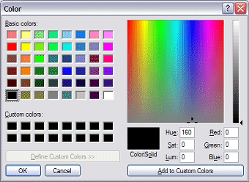
Use this color-selection tool to choose the desired color using the displayed palette. Clicking the OK button will insert the “rgb” function into the conditions edit box with the appropriate values for the red, green and blue setting filled in automatically.
This function should be preceded with a ‘ForeColor = ‘ or ‘BackColor = ‘ statement, otherwise the function will have no effect.

replace Must be followed by two quoted arguments, enclosed in brackets. The attribute will scan the current contents of the field, and replace all occurrances of the ‘old string’ with the value of the ‘new string’.
For example : The current field has a value of ‘ONE THOUSAND DOLLARS’ – when the replace(“DOLLARS”,”POUNDS”) is applied to the value, the resulting value of the field will contain ‘ONE THOUSAND POUND’.

sectionheight Very useful for incrementing (or decrementing) the current Section height of the downfield row when the number of actual lines in a logical section are not known at design time. For example, the statement:
if currfield <> "" then sectionheight = sectionheight + 4 will increment the section height of the downfields by 4 each time the current field is non-blank. The sectionheight attribute can also be included in an 'if' statement. This is useful to determine if conditional processing should occur based on the current value of the sectionheight.

substr substr(field,index,count) returns a substring containing count characters starting at field[index], where index starts at one.
If index is larger than the length of S, substr returns an empty string. If count specifies more characters than are available in the field, only the characters from field[index] to the end of the field are returned.

sum Followed by a bracketed list of fields separated with a plus or minus sign). The attribute will evaluate the contents of the brackets, adding and subtracting the numeric contents of each field identified within the brackets.
For example, the statement:
sum(Balance + Interest + GST) will compute the value of the Balance, Interest and GST fields and return the result to the caption for the current field.

text followed by the desired text (optionally enclosed in double-quotes). Results in the contents of the advised text to be transferred to this field. This option is normally used in combination with the '+' concatenation attribute to combine several field and text values together for display. See the '+' attribute for an example of the usage of this attribute.

trim followed by the desired fieldname will result in the contents of the advised fieldname to be trimmed (right and left) and returned.

underline Optionally followed with ' = yes' or ' = no', default is ' = yes'. Results in the font of the current field being displayed in UNDERLINE, but only applied for the next display of this field.

uppercase Must NOT be followed with an assignment statement ( = ...). The current field will be converted to uppercase, but only applied for the next display of this field.

urltext Powerful feature allowing a hyperlink (hotspot) to be inserted when the report is previewed. The mouse pointer will change to a 'hand' when over this hotspot, allowing the user to click on the hyperlink to invoke whatever program is associated with the corresponding 'urlcommand' (see 'urlcommand' below). Syntax is:
urltext = "whatever string is to show on the report"

urlcommand Powerful feature allowing the invocation of the program contained within the urlcommand whenever a user clicks on the associated hyperlink defined with the 'urltext' attribute described above. Syntax is:
urlcommand = [ "text" | field(fieldname) ][ + ][ "text" | field(fieldname) ][ + ]....etc.
Example: urlcommand = "http://www.nuvusoftware.com/?tenantcode=" + field(tenantcode)
The urlcommand can be used to either invoke an associated URL (website), mailto address (using "mailto://" + address), or any windows executable program (eg: notepad).

x This attribute contains the X-Axis of the current field, and can be changed to reposition the field along the X-Axis at run-time. The millimeter value assigned to this attribute can be advised in one of two formats:
x = value or x = [+ | -] value, example x = x + 4.

y This attribute contains the Y-Axis of the current field (relative to the start of the trigger if the trigger is a floating section, or relative to the starting downfield position if this field is a downfield), and can be changed to reposition the field on the Y-Axis at run-time. The millimeter value assigned to this attribute can be advised in one of two formats:
y = value or y = [+ | -] value, example y = y - 4.

TextBox Objects

These objects can contain a combination of static text and replacable fields, contained within a bound area which is word-wrapped.
Various properties may be set for the defined TextBox objects, including the font, size, foreground/background colors, bold, underline, italics and the justification of the object (left/right). These properties will be applied to the ENTIRE contents of the textbox.
Textbox objects are placed onto the canvas by clicking at the appropriate designer canvas position while the ‘TextBox’ button is depressed. Refer to the Change the current mode to 'TextBox' for information regarding the drawing of TextBox objects onto the current trigger designer canvas.
There are additional properties which may be set for any defined TextBox object. To invoke these properties, the user must right-click on the selected TextBox object. The following dialog window is displayed:
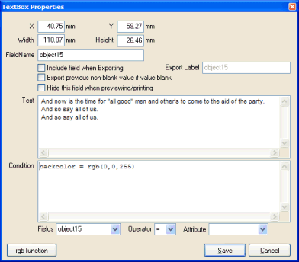

Clicking either the in the top right-hand corner of the dialog window, or the CANCEL button will cancel any changes made to the properties of the object, and return the user to the designer canvas, with the object still selected. Pressing 'ENTER' at any time (or clicking the SAVE button) while the dialog window is visible will accept all changes made to the properties and return the user to the designer canvas, with the object still selected, and visually reflecting the changes made to its properties.

X

This option can be used to manually position the selected textbox object at an exact millimeter position, relative to the left edge of the canvas. This option can be used as an alternative to moving the textbox object by clicking on the textbox object on the canvas, and then dragging it to a new position.

Y

This option can be used to manually position the selected textbox object at an exact millimeter position, relative to the top edge of the canvas. This option can be used as an alternative to moving the textbox object by clicking on the textbox object on the canvas, and then dragging it to a new position.

Width

This option can be used to manually adjust the width (in millimeters) of the selected textbox object. This option can be used as an alternative to resizing the textbox object by clicking on the textbox object on the canvas, and then dragging the width drag-handles to adjust the width of the object.

Height

This option can be used to manually adjust the height (in millimeters) of the selected textbox object. This option can be used as an alternative to resizing the textbox object by clicking on the textbox object on the canvas, and then dragging the width drag-handles to adjust the height of the object.

FieldName:

This automatically defaults to the word 'object' followed by a number corresponding to the order in which the field objects were drawn onto the canvas. A more meaningful name can be advised here, so that conditional formatting of other fields based on this field becomes more intuitive. For example, if the current Fieldname is changed from 'object32' to 'SalesInfo', then the conditional formatting statement would read something like: if (SalesInfo) = "" then.....

Include Field when Exporting:

By default, this option is NOT ticked for all new TextBox objects. If this option is ticked, then the contents of the Textbox will be exported to the comma-delimited (csv) file output when the 'Export' button is pressed on the report viewer window.
It is not a common practice to tick this option for Textbox objects.

Export Label:

This field is only enabled when the corresponding 'Include field when exporting' option is ticked. The advised label is exported on the first row of the comma-delimited (csv) file output when the 'Export' button is pressed on the report viewer window.

A literal value can be advised here (for example 'Balance' (without the single quotes)), or alternatively a FIELD(...) function can be advised, in the format FIELD(fieldname), where fieldname is the name of a Field object already drawn onto the canvas in the current trigger. A good example of when the FIELD(...) function can be used, is when there are variable column labels containing month values, and these values need to be exported as column labels.

Export previous non-blank value if value blank:

This field is only applicable when fields are being exported to a comma-delimited file (.csv). If the contents of the current TextBox is blank, then the contents of the previous textbox will be exported to the .csv file.

It is not a common practice to tick this option for Textbox objects.

Hide Field when previewing/printing:

This check-box can be ticked to hide a textbox when the report is previewed using the report viewer. This feature is not normally set by default, but may be set conditionally to hide a textbox.

Please note: Hidden fields are still exported to the comma-delimited (csv) file when the 'Export' button is pressed on the report viewer window (and the 'Include field when exporting' item is ticked).

Text:

This memo field allows the user to advise the actual fixed text that will be displayed within the text box at run-time.

This text can contain other fields that have been defined elsewhere on the report. In order to place a defined field within the text of the textbox, enclose the fieldname with a '@[fieldname]' (where the 'fieldname' must be replaced with the actual name of the field that you wish to insert into the text. For example: inserting the following text "We note that you have an unpaid balance on your account of @[AmountOwing]. Please pay immediately." will interrogate the contents of the 'AmountOwing' field at run-time and replace the token within this text-box.

Another feature of the TextBox (currently will only apply to left-justified text boxes) is the ability to format the individual words or sentences within the text. This is achieved by inserting start and end formatting tokens, as follows:

{b} - Start Bold
{/b} - End Bold
{i} - Start Italic
{/i} - End Italic
{u} - Start Underline
{/u} - End Underline

The color of words can also be changed by applying the following token within the text box:

{c}color{/c} - Change color to advised SIMPLE color (one of: black, blue, fushia, gray, green, lime, maroon, navy, olive, purple, aqua, red, silver, teal, yellow, white, moneygreen, skyblue, cream or medgray).

For example, the text "Please {b}NOTE{/b} that your account is {c}red{/c}{b}OVERDUE!{/b}{c}black{/c}" will result in the 'NOTE' showing in bold, and the 'OVERDUE' text showing in bold and red.

There is also a feature that enables a graphic to be inserted into the text box at run-time, as explained below:

{g}ImageFileName{/g} - will insert the bitmap or jpeg image at the current location on the text box - the image must be sized exactly (no stretch allowed) and must exist and be of bitmap or jpeg format. Be aware that the vertical position on the canvas will advance automatically by the height of the image at run-time. Also ensure that the 'ImageFileName' only contains 'forward slashes' to denote a break in folder - NOT backslashes. A special placeholder $NuVu can be placed at the start of the 'ImageFileName' - this will be automatically replaced with the full path of the folder that the NuVu Report Previewer is running from.

For example: {g}$NuVu/docs/signature.bmp{/g} will evaluate at run-time to 'c:\nuvu\docs\signature.bmp' assuming the NuVu Preview tool was being run from its default install folder of 'c:\nuvu'.

Condition:

This advanced feature allows the user to advise conditional formatting of the current TextBox. The format of the condition must conform to a syntax which is validated, according to the following rules:

[ optional Statements... ]
[ if [Condition] [Operator] [Value] then
[Attribute] [= AttributeValue]
....
else
if [Condition] [Operator] [Value] then
[Attribute] [= AttributeValue]
....
else ... ]

The [Condition] must be either a FieldName (See Fields below) or val(FieldName).

The [Operator] must be one of the operators in the Operation combo-box explained below.
The [Value] is either a numeric or alphanumeric constant, or a valid FieldName (See Fields below).
The [Attribute] must be one of the defined attributes in the Attributes combo-box explained below.

The [AttributeValue] must contain 'Yes', 'No', a corresponding font name or color value (Green for example), or a valid FieldName (See Fields below), or is optional depending on if the attribute is of a boolean nature (Bold for example). If an AttributeValue is advised, it MUST be preceded with the '=' operator.

The following example unconditionally Capitalises the contents of the current TextBox, then sets the color of the text inside the textbox to green and bold if the 'balance' field < 30000:

Capitalise
if val(Balance) < 30000 then
forecolor = green
bold
else
if val(Balance) < 50000 then
forecolor = blue
italic

Fields:

This combo-box will contain a list of all defined fields within the current trigger. This is just an aid in determining what fields can be used when building a conditional statement. If a fieldname is selected from this combo-box, then that name is automatically typed at the current cursor position within the 'Condition' text area.

Operation:

This combo-box contains a list of all defined operations allowed on the conditional statement. If an operation is selected from this combo-box, then that operation code is automatically typed at the current cursor position within the 'Condition' text area. The available Operations are:

= The Field must be equal to the value advised (case-insensitive for string searches)
> The Field must be greater than the value advised (case-insensitive for string searches)
< The Field must be less than the value advised (case-insensitive for string searches)
>= The Field must be greater than or equal to the value advised (case-insensitive for string searches)
<= The Field must be less than or equal to the value advised (case-insensitive for string searches)
<> The Field must NOT be equal to the value advised (case-insensitive for string searches)

Attribute:

This combo-box contains a list of all defined attributes allowed on the conditional statement. If an attribute is selected from this combo-box, then that attribute is automatically typed at the current cursor position within the 'Condition' text area. The available attributes that may be advised are:

backcolor Must be followed with ' = colorname', where colorname is the name of the desired color (green, red, maroon, white, black, lime etc.). Results in the background color of the current field to changed to this advised value (ONLY applied the next time the field is displayed).

bold Optionally followed with ' = yes' or ' = no', default is ' = yes'. Results in the font of the current field being displayed in BOLD, but only applied for the next display of this field.

capitalise Must NOT be followed with an assignment statement ( = ...). The current field will be converted to Proper Case (where the first letter of each word is changed to upper-case, with the remaining characters in the word converted to lowercase). ). For example, If the current value of the field contained 'DONNA MILLS-SMITH', the value would be converted to 'Donna Mills-Smith'.

caption Must be followed with the assignment statement ( = ) followed by either static text (Eg: "balance") or alternatively another field (chosen from the fields combo-box).

concat(...) Must NOT be followed with the assignment statement ( = ...). Static text (Eg: ", ") must be placed within the brackets, or alternatively another field (chosen from the fields combo-box). The result of this operation is that the current field will have this text concatenated to it. Very useful when concatenating surname and first names from two different fields at run-time.

export Optionally followed with ' = yes' or ' = no', default is ' = yes'. Results in current field being exported or not exported when the 'Export' button is pressed from the preview window.

fontname Must be followed with the assignment statement ( = ) followed by the name of a valid font (eg: Arial). Results in this field being displayed in the chosen font at run-time (if the optional conditions are met).

fontsize Must be followed with the assignment statement ( = ) followed by the required size of the font (as in integer). Results in this field being displayed in the chosen font at run-time (if the optional conditions are met).

forecolor Must be followed with the assignment statement ( = ) followed by the name of a valid system color (eg: black, white, maroon, green etc). Results in this field being displayed in the chosen foreground color at run-time (if the optional conditions are met).

format Must be followed by two comma-separated values, and enclosed in brackets. The first value must be enclosed in double-quotes, and contains the format string to be applied to the second value string. The second value string can contain a literal value (enclosed in quotes), or alternatively ‘currfield’, ‘caption’, field(..fieldname..), #amt1..#amt50. If the format string (first value string) contains an integer format string, then the value of the 2nd parameter is automatically converted into an integer (if possible, otherwise a zero is assigned to this value). If the format string contains a decimal format string, then the value of the 2nd parameter is automatically converted into a decimal value (if possible, otherwise a zero is assigned to the value).

Format strings passed to the string formatting routines contain two types of objects -- literal characters and format specifiers. Literal characters are copied verbatim to the resulting string (Example : ‘The value of the field is ‘).

Format specifiers are replaced with the actual contents of the 2nd parameter passed to the format function, and have the following form:

%[-][width][.prec]type

The format specifier MUST begin with a "%" (without the enclosing quotes). After the “%” come the following, in this order:

An optional "-" symbol indicates that the resulting string must be left-padded with spaces, if appropriate. This is common when a ‘string’ is being output. If omitted, then the string will be right-justified.

An optional width specifier, [width]

An optional precision specifier ["."prec]. This specifier is only normally used with decimal values, and is typically used to specify the number of decimals to show after the decimal point.

Finally, the conversion type character, as follows:

d The argument must be an integer value. The value is converted to a string of decimal digits. If the format string contains a precision specifier, it indicates that the resulting string must contain at least the specified number of digits; if the value has less digits, the resulting string is left-padded with zeros.

u The argument must be an nsigned integer. Similar to 'd' but no sign is output.

e Scientific. The argument must be a floating-point value. The value is converted to a string of the form "-d.ddd...E+ddd". The resulting string starts with a minus sign if the number is negative. One digit always precedes the decimal point.The total number of digits in the resulting string (including the one before the decimal point) is given by the precision specifier in the format string-a default precision of 15 is assumed if no precision specifier is present. The "E" exponent character in the resulting string is always followed by a plus or minus sign and at least three digits.

f Fixed. The argument must be a floating-point value. The value is converted to a string of the form "-ddd.ddd...". The resulting string starts with a minus sign if the number is negative.The number of digits after the decimal point is given by the precision specifier in the format string-a default of 2 decimal digits is assumed if no precision specifier is present.

g General. The argument must be a floating-point value. The value is converted to the shortest possible decimal string using fixed or scientific format. The number of significant digits in the resulting string is given by the precision specifier in the format string-a default precision of 15 is assumed if no precision specifier is present.Trailing zeros are removed from the resulting string, and a decimal point appears only if necessary. The resulting string uses fixed point format if the number of digits to the left of the decimal point in the value is less than or equal to the specified precision, and if the value is greater than or equal to 0.00001. Otherwise the resulting string uses scientific format.

n Number. The argument must be a floating-point value. The value is converted to a string of the form "-d,ddd,ddd.ddd...". The "n" format corresponds to the "f" format, except that the resulting string contains thousand separators.

m Money. The argument must be a floating-point value. The value is converted to a string that represents a currency amount. Negative values are shown with surrounding brackets. The CurrencyString ($ for example), Thousand separator and format of the Currency String is determined by the values defined in the Windows 'Regional Settings' on the PC on which the report is graphically rendered. If the format string contains a precision specifier, it overrides the value given by the CurrencyDecimals Windows global variable.

s String. The argument must be a string. The string or character is inserted in place of the format specifier. The precision specifier, if present in the format string, specifies the maximum length of the resulting string. If the argument is a string that is longer than this maximum, the string is truncated.

x Hexadecimal. The argument must be an integer. The integer is converted to a hexadecimal string of digits.

Examples:

1234.56 using “%.2m” = $1,234.56 (assuming Windows currency settings include "," as thousands separators).

-1234.56 using “%.2m” = $-1,234.56 (assuming Windows currency settings include "," as thousands separators).

-1234.56 using “%.2f” = 1234.56.

1234.56 using “%.2n” = 1,234.56 (assuming Windows currency settings include "," as thousands separators).

1234.56 using “%10.2f” = “ 1234.56” (three spaces before the ‘1234.56’, because the width is set to 10).

1234.56 using “The available balance is: %.2m” = “The available balance is: $1,234.56”.

hidden Optionally followed with ' = yes' or ' = no', default is ' = yes'. Results in current field being hidden or not hidden when the report is displayed in the preview window.

hiderepeating Must NOT be followed with an assignment statement (= ...). If the value of the current field is IDENTICAL to the value of the previous non-blank value of that field, then the field will be automatically hidden. This does NOT affect when the report is exported to a comma-delimited file.

italic Optionally followed with ' = yes' or ' = no', default is ' = yes'. Results in the font of the current field being displayed in ITALIC, but only applied for the next display of this field.

lowercase Must NOT be followed with an assignment statement ( = ...). The current field will be converted to lowercase, but only applied for the next display of this field.

normal Optionally followed with ' = yes' or ' = no', default is ' = yes'. Results in the font of the current field being displayed with a normal attribute (not BOLD, not UNDERLINE and not ITALIC), but only applied for the next display of this field.

rgb Must be followed by three integer arguments, enclosed in brackets. The three integer values correspond to the red, green and blue values that will be used to calculate the actual color to be used. These integer values should have a value between zero and 255 only. Values outside this range will be converted to zero.
Clicking this option from the combo-box will automatically invoke the standard color-chooser dialoag window, as shown below:
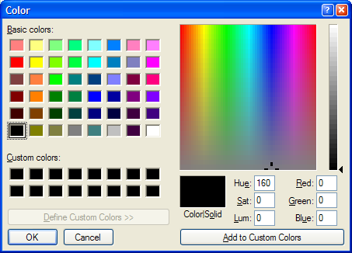
Use this color-selection tool to choose the desired color using the displayed palette. Clicking the OK button will insert the “rgb” function into the conditions edit box with the appropriate values for the red, green and blue setting filled in automatically.
This function should be preceded with a ‘ForeColor = ‘ or ‘BackColor = ‘ statement, otherwise the function will have no effect.

underline Optionally followed with ' = yes' or ' = no', default is ' = yes'. Results in the font of the current field being displayed in UNDERLINE, but only applied for the next display of this field.

uppercase Must NOT be followed with an assignment statement ( = ...). The current field will be converted to uppercase, but only applied for the next display of this field.

urltext Powerful feature allowing a hyperlink (hotspot) to be inserted when the report is previewed. The mouse pointer will change to a 'hand' when over this hotspot, allowing the user to click on the hyperlink to invoke whatever program is associated with the corresponding 'urlcommand' (see 'urlcommand' below).
Syntax is: urltext = "whatever string is to show on the report"

urlcommand Powerful feature allowing the invocation of the program contained within the urlcommand whenever a user clicks on the associated hyperlink defined with the 'urltext' attribute described above.
Syntax is: urlcommand = [ "text" | field(fieldname) ][ + ][ "text" | field(fieldname) ][ + ]....etc.
Example: urlcommand = "http://www.nuvusoftware.com/?tenantcode=" + field(tenantcode)
The urlcommand can be used to either invoke an associated URL (website), mailto address (using "mailto://" + address), or any windows executable program (eg: notepad).

Rectangle Objects

Rectangles, Squares and horizontal/vertical lines may be drawn onto the canvas as static objects at run-time. These objects are not linked to the legacy report, and are drawn whenever the associated trigger "fires".
Various properties may be set for the defined rectangle objects, including the border and fill colors.
Rectangle (Shape) objects are placed onto the canvas by clicking on the appropriate position on the designer canvas corresponding to the top-left corner of the rectangle when the ‘Rectangle’ button is depressed. Refer to the Change the current mode to 'Rectangle' for information regarding the drawing of Rectangle objects onto the current trigger designer canvas.
There are additional properties which may be set for any defined Rectangle object. The user may right-click the mouse when the mouse pointer is over a rectangle object in order to invoke the rectangle properties window, which is displayed as follows:
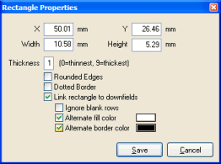
Although the height and width of the rectangle object can be set by dragging the associated 'drag handles' when the rectangle object is selected, the exact values for the height and width can be advised here.
Clicking either the in the top right-hand corner of the dialog window, or the CANCEL button will cancel any changes made to the properties of the object, and return the user to the designer canvas, with the object still selected. Pressing 'ENTER' at any time (or clicking the SAVE button) while the dialog window is visible will accept all changes made to the properties and return the user to the designer canvas, with the object still selected, and visually reflecting the changes made to its properties.

X

This option can be used to manually position the selected rectangle object at an exact millimeter position, relative to the left edge of the canvas. This option can be used as an alternative to moving the rectangle object by clicking on the rectangle object on the canvas, and then dragging it to a new position.

Y

This option can be used to manually position the selected rectangle object at an exact millimeter position, relative to the top edge of the canvas. This option can be used as an alternative to moving the rectangle object by clicking on the rectangle object on the canvas, and then dragging it to a new position.

Width

This option can be used to manually adjust the width (in millimeters) of the selected rectangle object. This option can be used as an alternative to resizing the rectangle object by clicking on the rectangle object on the canvas, and then dragging the width drag-handles to adjust the width of the object.

Height

This option can be used to manually adjust the height (in millimeters) of the selected rectangle object. This option can be used as an alternative to resizing the rectangle object by clicking on the rectangle object on the canvas, and then dragging the width drag-handles to adjust the height of the object.

Thickness

The 'Thickness' edit box is used to advise the desired thickness of the border shown around the rectangle. A value of 1 will result in a thin line, and a value of 9 will result in a very fat line being drawn. Values between these two extremes will deliver varying widths of line around the edges of the rectangle (or line).

Rounded Edges

The 'Rounded Edges' check-box indicates whether the rectangle object has rounded corners or not.

Dotted Borders

The ‘Dotted Border’ check-box indicates if the rectangle is to be drawn with a dotted border or not. Dotted borders are useful when defining lines (where height or width = 0.3).
Note, advising a width of .3mm will result in a vertical line being drawn, and advising a height of .3mm will result in a horizontal line being drawn.

Clicking either the 'x' in the top-right-hand corner of the dialog window, or the CANCEL button will cancel any changes made to the properties of the object, and return the user to the designer canvas, with the object still selected. Pressing 'ENTER' at any time (or clicking the SAVE button) while the dialog window is visible will accept all changes made to the properties and return the user to the designer canvas, with the object still selected, and visually reflecting the changes made to its properties.
Link to Downfields

This option can be used to link this rectangle object to the downfields of the current trigger. Ticking this option will result in this rectangle object being redrawn for each downfield row drawn. This is particularly useful when drawing a grid onto the canvas.

If linked, ignore blank rows

This option is only available when the 'Link to Downfields' option (described previously) has been ticked. Ticking this option will ensure that the rectangle object will NOT be drawn onto the canvas if the current downfield row is completely blank.

Link rectangle to Downfields
This very useful option can be used to output rectangles (and lines) that REPEAT each time a new downfield row is output to the canvas. This option can be used to shade a particular column (or columns), and a very pleasing effect can be achieved by means of the 'Alternamte Fill Color' and 'Alternate Border Color' options explained below to show downfields with alternate shaded bands.

Linked to Downfields: Ignore blank rows
This tick-box is only enabled if the user has ticked the 'Link rectangle to downfields' option explained above. If this option is ticked, then this rectangle will only be output to the canvas if there is at least one non-blank downfield output to the canvas for the current row.

Linked to Downfields: Alternate fill color
This tick-box is only enabled if the user has ticked the 'Link rectangle to downfields' option explained above. If this option is ticked, then a small colored button will appear to the right of the tick-box. Clicking on the button will invoke the standard color chooser dialog window, allowing the user to select the FILL color of the rectangle. This color will be used on every second row.

Linked to Downfields: Alternate border color
This tick-box is only enabled if the user has ticked the 'Link rectangle to downfields' option explained above. If this option is ticked, then a small colored button will appear to the right of the tick-box. Clicking on the button will invoke the standard color chooser dialog window, allowing the user to select the BORDER color of the rectangle. This color will be used on every second row.

NOTE: A sub-set of these properties are also able to be manipulated by means of the 'Property Editor', invoked by clicking the right-mouse button when more than one object (of the same type) is currently selected. See Changing multiple object properties or more details of this option.

Picture Objects

Pictures (Bitmaps) may be drawn onto the canvas as static objects at run-time. Picture objects are useful for printing company logo's, Barcode images etc. at pre-defined positions on the printer canvas at run-time.
Picture objects may be re-sized to any dimension, and the contents of the picture are automatically stretched to accomodate the defined height and width defined by the user.
There are additional properties which may be set for any defined Picture object. The user may right-click the mouse when the mouse pointer is over a picture object in order to invoke the picture properties window, which is displayed as follows:
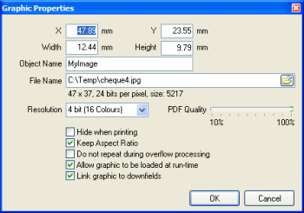
This dialog prompts the user to advise the location of the physical graphic file (only Bitmaps or Jpegs are allowed to be selected), as well as the resolution of the graphic when it will be drawn to the preview canvas. The dialog window is set initially to the location of a placemarker picture (noimage.bmp, located in your NuVu installation directory), but may be changed here.

Once an image is loaded from disk (by either choosing from the browser, or manually advising the filename), statistics of the current image will be displayed, including the width and width of the image (before scaling), the number of bits used to store each pixel, and the estimated size in memory of the image. It is important to at least examine the size in memory, as any figure over 100K is not recommended, and will introduce performance and memory bottlenecks at run-time (as well as outputting a considerable footprint if the report is sent to the print spooler). Most images can be easily reduced in size and color-depth using image editing software (Paint Shop Pro for example). This reduction seldom affects the quality of the output.

Clicking either the in the top right-hand corner of the dialog window, or the CANCEL button will cancel any changes made to the properties of the object, and return the user to the designer canvas, with the object still selected. Pressing 'ENTER' at any time (or clicking the SAVE button) while the dialog window is visible will accept all changes made to the properties and return the user to the designer canvas, with the object still selected, and visually reflecting the changes made to its properties.

X

This option can be used to manually position the selected picture object at an exact millimeter position, relative to the left edge of the canvas. This option can be used as an alternative to moving the picture object by clicking on the picture object on the canvas, and then dragging it to a new position.

Y

This option can be used to manually position the selected picture object at an exact millimeter position, relative to the top edge of the canvas. This option can be used as an alternative to moving the picture object by clicking on the picture object on the canvas, and then dragging it to a new position.

Width

This option can be used to manually adjust the width (in millimeters) of the selected picture object. This option can be used as an alternative to resizing the picture object by clicking on the picture object on the canvas, and then dragging the width drag-handles to adjust the width of the object.

Height

This option can be used to manually adjust the height (in millimeters) of the selected picture object. This option can be used as an alternative to resizing the picture object by clicking on the picture object on the canvas, and then dragging the width drag-handles to adjust the height of the object.

Object Name

This setting is only important if you need to reference the graphic object at run-time (for example, when calling the ‘LoadGraphic’ function from within the conditional formatting section of a defined field (or down-field)). If advised, please ensure that the name given here is unique across all triggers in the defined report. Duplicate names are allowed, but the first graphic object that matches the advised Object Name will be selected.

File Name

This setting is used to advise the actual graphic file (.bmp or .jpg only) that is to be loaded into the current design. The small icon at the extreme right of this field may be optionally clicked in order to browse the network for the desired file. The system will ensure that a valid filename is advised before the ‘OK’ button will be actioned.

Resolution

The 'Resolution' combo-box can be used to specify the resolution of the bitmap that will be drawn onto the preview canvas. This setting is very important, as it governs the size of the spool file that will be created on disk (or paged memory) when the report is rendered at run-time. This setting also affects the speed that the report will be rendered and printed. Always attempt to advise a bit size as LOW as possible, in order to conserve graphic memory (and disk space). Typically the default value of 4 bits (16 colours) should suffice for most logo's, and need only be changed if a detailed graphic in many colours is required. An example of the saving in disk space or paged memory follows:

- 200 pages, with 4 jpeg images per page, all set to 32 bits, produces a spool file which exceeds 500 MB
- 200 pages, with 4 jpeg images per page, all set to 4 bits (16 colours), produces a spool file which is under 80 MB.

The available options for the 'Resolution' combo-box are as follows:

- 4 bit (16 colours) - most economical, colours are scaled to the closest of the 16 available colours (or shades of gray). RECOMMENDED.
- 8 bit (256 colours) - still economical, but colours are sclaed to the closest of the 256 available colours (or shades of gray).
- 16 bit (High colour (65535 colours)) - less economical - gives excellent picture quality on 600x600 pixels printers.
- 24 bit (True colour) - even less economical - but even better picture quality on all printers.
- 32 bit (True colour) - lowest economy, but produces photograph-quality results on appropriate printers.

PLEASE NOTE: This setting is ignored when outputting directly to PDF - so it is better to ensure that you use a graphic manipulation tool (eg: Paint Shop Pro) to reduce the size and color depth of the image before using it within NuVu, to ensure that the size of the graphic is within reason (less than 200K is a good start), otherwise this could severely hamper rendering performance, significantly increase the size of the spool file (when printing) and utilise extensive graphics memory during the redering process.

PDF Quality

This slider allows you to specify the quality of the image when it is rendered to a PDF document. The default is 70% quality, but values from 10% to 100% can be advised. A value of 100% results is zero compression and produces the image in the original quality - although it increases the size of the generated PDF document.

Hide when printing

The 'Hide when printing' check-box may be optionally checked (ticked). If ticked, then this graphic will NOT be drawn to the canvas when the report is prepared for automatic printing. This option is ignored if the report is viewed using the PDF or NuVu viewer, and only applies when NuVu is producing a printfile automatically (via the P: command-line option of the rbd_prepare utility). This option is useful when the report is printed onto pre-printed stationary (which has the graphics pre-printed onto it). When the report is viewed (and then perhaps subsequenty emailed), then the desired action is to therefore include the graphic, because the recipient of the report will generally not have the appropriate pre-printed stationary when printing the document at the remote site.

Keep Aspect Ratio

The 'Keep Aspect Ratio' check-box may be ticked in order for the NuVu Designer to automatically retain the aspect ratio (the ratio between the original width and height of the graphic) as the graphic is re-sized on the canvas. This option is very useful for logo's which should retain their original aspect ratio to ensure that the look of the logo does not change no matter how the graphic is resized on the canvas.

The drawn picture object will be initially sized to the actual size of the bitmap/jpeg image stored on disk, but may be resized to any appropriate size (depending on the ‘Keep Aspect Ratio’ setting described above) after its initial placement on the designer canvas.

The optional filename icon at the end of the ‘File Name’ field may be clicked in order to invoke a standard Windows 'Open File' dialog window, allowing the user to browse the network neighbourhood for the desired graphic filename. Once the picture object has been drawn with the correct image, it may be dragged and resized to the correct dimentions by dragging on the 'handles' which are automatically placed around it when the picture is created (or later selected by clicking on the picture object).

Do not repeat during overflow processing

This check-box may be ticked in order to exclude this graphic image from being redrawn during overflow processing. This option is ignored if the trigger properties have not been set to ‘Repeat this trigger on Overflow’.

Allow graphic to be loaded at runtime

This check-box may be ticked in order to enable the loading of this graphic at runtime (as opposed to storing the image within the designer document). This feature is very useful when you wish to load independent corporate logo’s, depending on a field within the legacy report, that will indicate which image to load in at run-time.

In order to utilise this feature, a ‘LoadGraphic’ function call then needs to be inserted into one of the fields or down-fields that are contained within the current trigger.

Link graphic to downfields

This check-box may be ticked if you wish the graphic to be repeated as part of the downfield processing logic. That is, whenever the downfield section is processed for a logical line, the images that have been marked as linked to the downfields will be evaluated. This option is most often used in conjunction with the 'Allow graphic to be loaded at runtime' option described above, in order to load custom images at run time for the current row of downfields - for example displaying a product image for the current product displayed in the downfield row.

NOTES:

Once a picture has been dragged (drawn) onto the designer canvas, the current mode is automatically changed back to 'pointer' mode, but the drawn picture remains 'selected'. This is due to the normal behaviour where only single bitmaps or pictures are normally added to the designer canvas for the current trigger.

See 'Selecting an object' for information regarding the selection of an object or objects after they are created. Also note that if a picture object is re-sized, the image is automatically 'stretched' to accomodate the new size.

A sub-set of these properties are also able to be manipulated by means of the 'Property Editor', invoked by clicking the right-mouse button when more than one object (of the same type) is currently selected. See Changing multiple object properties or more details of this option.

Chart Objects

Chart objects are used to visually graph sections of the legacy (or XML) report at run-time. The Chart object itself has many properties that can be set to achieve the desired result.

The following dialog window is displayed (and centered on the screen) when the mouse is 'right-clicked' on a chart object on the current trigger designer canvas. The dialog window displays as follows:

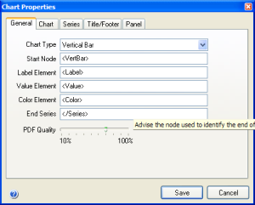

Clicking either the in the top right-hand corner of the dialog window, or the CANCEL button will cancel any changes made to the properties of the object, and the chart will revert to showing the values that were applicable before this dialog window was shown, and return the user to the designer canvas with the object still selected. Pressing 'ENTER' at any time (or clicking the SAVE button) while the dialog window is visible will accept all changes made to the properties and return the user to the designer canvas, with the object still selected, and visually reflecting the changes made to its properties.

The items contained within the Chart, Series, Title/Footer and Panel tabs all affect the visual appearance of the chart, and are self-explanatory - and any changes that are made are immediately reflected on the chart, so experiment with the different settings until the desired effect has been found.

PLEASE NOTE: At design-time, the chart is auto-populated with 3 sample point values (and thus do not reflect the actual chart values that will be extracted from the legacy (or XML) document at run-time.

General Tab

The General tab contains information that links the chart to the actual data in the legacy (or XML) report. Typically you will change your application to insert the following lines into the report (although the names can be whatever you like):

<VertChart>
<Series>
<Label>Brian</Label>
<Value>200</Value>
<Color>Aqua</Color>
</Series>
<Series>
<Label>Peter</Label>
<Value>400</Value>
<Color>Red</Color>
</Series>
<Series>
<Label>Denise</Label>
<Value>50</Value>
<Color>Green</Color>
</Series>
<Series>
<Label>Les</Label>
<Value>350</Value>
<Color>rgb(255,0,255)</Color>
</Series>
</VertChart>

In the above example:

<VertChart> is the name given to the chart - this must be unique to every chart within the current trigger.
<Series> is the name given for the header at the start of each series point.
<Label> is the name given to the 'label' element. The format of this line MUST be in XML format as shown in the example above. That is, must have <Name>Desired Label</Name>, where 'Name' is the name you have given to this element. In the example above, this 'Name' is called 'Label'.
<Value> is the name given to the 'value' element. The format of this line MUST be in XML format as shown in the example above. That is, must have <Name>Desired Value</Name>, where 'Name' is the name you have given to this element. In the example above, this 'Name' is called 'Value'.
<Color> is the name given to the 'color' element. The format of this line MUST be in XML format as shown in the example above. That is, must have <Name>Desired Color</Name>, where 'Name' is the name you have given to this element. In the example above, this 'Name' is called 'Color'.
The 'Desired Color' can be any of the primary colors (one of: black, blue, fushia, gray, green, lime, maroon, navy, olive, purple, aqua, red, silver, teal, yellow, white, moneygreen, skyblue, cream or medgray) or else the rgb(red,green,blue) function can be used here. Examine the last series node in the above example to see the syntax for the rgb function.

Chart Type:

There are three single-series chart types available: Vertical Bar, Horizontal Bar and Pie.

Start Node:

This option must define the node that will be identified as the start of the chart data within the legacy (or XML) report. If text was highlighted on the sample report before the chart was dropped onto the designer canvas, then this property will contain this highlighted text. In the above example, the Start Node would be '<VertChart>'.

Label Element:

This option must define the element that will be identified as the 'Label' for each point on the chart. In the above example, the Label Element would be '<Label>'.

Value Element:

This option must define the element that will be identified as the 'Value' for each point on the chart. In the above example the Value Element would be '<Value>'.

Color Element:

This property is OPTIONAL - and only needs to be advised if the user wishes to manually color each point on the chart.
If the property is advised, it must define the element that will be identified as the 'Color' for each point of the chart. In the above example the Color Element would be '<Color>'.

End Series:

This option must define the ending node of a single point in the series. When this identifier is found in the legacy (or XML) report at run-time, then a new point will be drawn to the chart. In the above example, the End Series node would be '</Series>'.

PDF Quality

This slider allows you to specify the quality of the chart when it is rendered to a PDF document. The default is 70% quality, but values from 10% to 100% can be advised. A value of 100% results is zero compression and produces the chart in the original quality - although it increases the size of the generated PDF document.

Changing multiple object properties

Although individual objects can be selected, and a property window opened by right-clicking on the single selected object, there is a more useful mechanism available, which allows for the individual properties of SELECTED objects at the same time.

To invoke the ‘multiple properties’ dialog window, simply select as many objects as are required (by holding down the <control> key while clicking on the individual objects. The system will first ensure that all selected objects are of the same type (text, Field, Rectangle, TextBox, Image or Downfield). Depending on the currently selected set of objects, the following dialog window will be displayed:

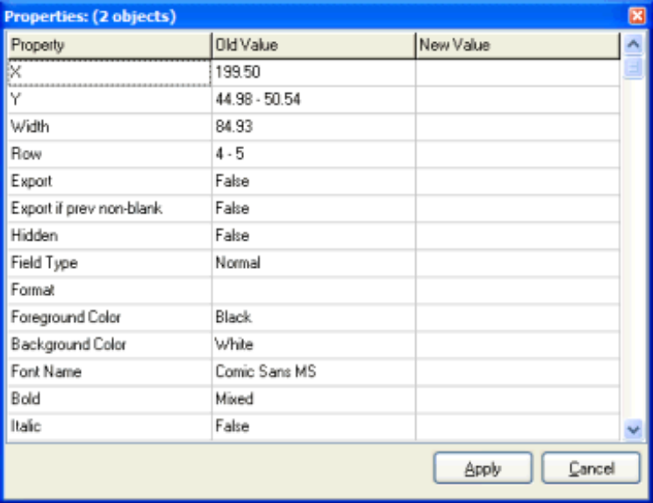

The dialog window displays a list of all attributes that may be simultaneously changed. There are three columns shown. The first column indicates the individual attribute that can be changed (for example: Font Name). The second column displays the current value of the attribute. This column will either show an individual value (if all objects selected share a common setting for the attribute), or else a range of values (or 'Multiple') will be shown, indicating that there are multiple values for the various selected items. The third column allows the user to advise a new value for ALL selected items for the current attribute. This third column either allows the user to advise an exact value ('X' for example), otherwise a combo-box will be displayed, allowing the user to select from a valid list of values for this attribute.

Clicking the 'Apply' button will apply the changes made to ALL selected objects, and the Properties dialog window will be closed. If the changes made are not desirable, the UNDO button can be immediately clicked to undo these changes.

Clicking the 'CANCEL' button on this dialog window will cancel any changes made, and close the dialog window.

For more help on the individual attributes available to be changed, refer to the following sections in the User Reference Manual:

- Text Objects
- Field (and Downfield) Objects
- Rectangle Objects
- Picture Objects
- TextBox Objects

Designer Properties

There are various global settings that can be applied to the Designer. These settings are written to the windows registry and are thus re-used between sessions until the user decides to change them. The Designer Properties are displayed when the user chooses the 'Tools' / ‘Designer Properties’ menu option. A dialog window is displayed, showing the current settings applied to the Report Designer, and allows the user to change thesel properties. The dialog window displays as follows:

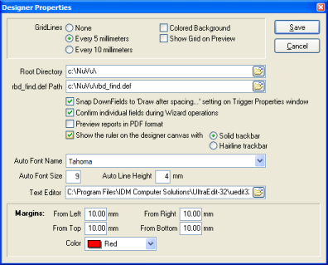

Clicking either the 'x' in the top-right-hand corner of the dialog window, or the CANCEL button will cancel any changes made to the designer properties and return the user to the designer canvas without effecting any of these changes. Pressing 'ENTER' at any time (or clicking the SAVE button) while the dialog window is visible will accept all changes made to the designer properties and return the user to the designer canvas, with all changed settings being applied.

GridLines:

This setting controls the drawing of a background grid onto the designer canvas. A visible grid enables the user to align objects more easily onto the canvas at design time. The only drawback of a drawn grid, is that it makes the designer canvas look more 'busy' than without a grid.

There are three settings for this option:

- None - No grid is drawn onto the canvas at all (not recommended).
- Every 5 millimeters - A gray grid will be drawn onto the canvas at 5 millimeter intervals
- Every 10 millimeters - A gray grid will be drawn onto the canvas at 10 millimeter intervals

If the Colored Background toggle box is ticked, then the grid (if selected) will show with a white grid-line on a colored background. This option is normally used when users have chosen to advise widths of fields manually (refer to the Edit Report Definition Properties section for more details on selecting the Manual Width option).

If the Show Grid in Preview toggle box is ticked, then the grid (if selected) will show on the NuVu Preview window as well as the Designer canvas. This option is useful in determining the overall layout and position of objects as they will appear in the printed report.

Root Directory:

This setting allows the user to advise the Root Directory to default to when saving and loading design files and sample reports. This is normally set to C:\NuVu\ for local development, and changed to a mapped drive for common network repository development (Eg: G:\Nuvu\).

rbd_find.def Path:

This setting allows the user to advise a full pathname of the location of the associated 'templates definitions' file. This file is typically named 'rbd_find.def', but can be changed to any name the user desires. The contents of this file is a list of all defined NuVu design files (.rbd's), and is used by the 'rbd_find.exe' utility at run-time to locate the appropriate design to use with a legacy report. Each time you save a new (or existing) design within the NuVu Report Designer (this tool), the ID information contained within the report properties window are written as a single line to this file. During the saving process, if any duplicate entries are found, the user will be shown these entries, and will then be given the chance to remove them.

Snap DownFields to ‘Draw after spacing...' setting on Trigger Properties window:

This toggle setting allows the user to choose whether to automatically snap any downfields dropped onto the designer canvas to the millimeter setting advised in the 'Starting YPos' field of the Trigger Properties dialog window.

Ticking this option will enable the snapping of dropped downfield objects to the setting advised in the 'Starting YPos' field of the Trigger Properties dialog window (recommended).

Leaving this option unticked will automatically set ALL downfield objects to the vertical position of the downfield object dropped onto the designer canvas.

Confirm individual fields during Wizard operations:

This toggle setting allows the user to choose whether the properties of individual fields (identified by the Wizard) will be prompted for during the creation of these downfield objects during the wizard creation process.

Ticking this option will enable the confirmation of the individual downfield objects during the wizard creation process (recommended).

Leaving this option unticked will result in the automatic creation of all identified downfields without prompting for the individual properties of each one during the wizard opertion. This option is NOT recommended because sometimes the wizard will make the incorrect assumtions about the properties of the downfields (for example, a blank field will be assumed to be right-aligned which might not be the case in reality).

Preview reports in PDF format:

This toggle setting allows the user to choose whether reports are previewed in the standard NuVu Previewer window, or using the installed PDF viewer (normally Adobe Acrobat).

Ticking this option will result in all previewing being output in PDF format.

Leaving this option unticked will result in the the reports being previewed using the NuVu Report Previewer.

Please note, currently the PDF output option does NOT incorporate the following NuVu design features:

- Angled Labels - these are excluded from the preview
- URL hyperlinks - these are excluded from the preview
- Fonts other than Arial, Courier or Times Roman (or derivatives). Fonts will be converted to their nearest equivalent.

Show the Ruler on the Designer canvas with…:

This toggle setting allows the user to choose whether to show the Rulers on the designer canvas or not. Rulers allow the user to easily align properties during the object creation process, but do occupy window real-estate.

Ticking this option will show the Vertical and Horizontal rulers on the designer canvas (recommended). A style of ruler can also be advised here, by choosing either the ‘Solid Trackbar’ or ‘Hairline Trackbar’ options. The ‘Solid Trackbar’ is more visible than the ‘Hairline Trackbar’ and it is purely a matter of user preference as to which one to choose.

Leaving this option unticked will hide the Rulers, and allow more of the designer canvas to be displayed.

Auto Font Name:

This field is used to advise the font name that will be used when the NuVu designer places an object automatically onto the canvas when the user presses the F2 button after selecting a section of the legacy report. A typical value here is 'Arial' - although any true-type font can be selected from the drop-down box.

This setting is also used as the default font name when a new definition is started.

Auto Font Size:

This field is used to advise the font size that will be used when the NuVu designer places an object automatically onto the canvas when the user presses the F2 button after selecting a section of the legacy report. A typical value here is 8 points.

This setting is also used as a default font size when a new definition is started.

Auto Font Height:

This field is used to advise the font height (in millimeters) that will be used when the NuVu designer places an object automatically onto the canvas when the user presses the F2 button after selecting a section of the legacy report. A typical value here is 4mm.

Text Editor:

This field is used to advise the name of the executable program that will be invoked when the 'Edit Legacy Report' button is clicked on the toolbar. The standard 'Notepad.exe' program supplied with windows is used as a starting point, but this can be changed to any installed editor of the users choosing.

Margins:

This section deals with the settings for drawing the optional margin onto the designer canvas. Margins are visible if the 'From Left' margin setting is set to any non-zero value. The margin is drawn with a dotted line, and assists the user during report design, so that it is plainly visible if any drawn object is outside the bounds of the advised margins.

Note: Top and Bottom margins are only drawn if the current trigger section is NOT a floating section. If the section is a floating one, then the left and right margins are drawn up to the top and bottom edges of the canvas area.

Margins: From Left

Advising a value of zero here effectively disables the drawing of ALL margins. Advising a non-zero millimeter value here will govern how far from the left edge of the canvas area to draw the optional margin. A value of 10mm is a good starting point, as most printers are able to print to within 10mm of the left margin.

Margins: From Right

Advising a non-zero millimeter value here will govern how far from the right edge of the canvas area to draw the optional margin. A value of 10mm is a good starting point, as most printers are able to print to within 10mm of the right margin.

Margins: From Top

Advising a non-zero millimeter value here will govern how far from the top edge of the canvas area to draw the optional margin. A value of 10mm is a good starting point, as most printers are able to print to within 10mm of the top margin.

Margins: Color

Select the required color in which to draw the dotted margin from the drop-down list provided here.

Start a New Report Definition
New reports may be either created from scratch (ie: from an initially empty designer canvas), or may be copied from other existing report definitions (by choosing the SAVE AS menu option when an existing report definition is currently displayed within the designer tool.

This function assumes you wish to create a new Report Definition from scratch..If there is an existing report definition currently advised in the designer tool (and there are unsaved changes made to this definition), the user will be asked if the changes to the current definition can be discarded. If the user clicks on the 'No' button, indicating that the current report definition is NOT to be discarded, then the starting of a new report definition is CANCELLED, and the user is returned to the existing report definition, so that it may be saved, or edited further. If the user clicks the 'Yes' button, then the changes made to the existing report definition WILL be discarded.

Assuming the user is proceeding with the definition of a new report, the contents of the designer and sample report panes will be automatically cleared, and the Report Options dialog window will be displayed. This window allows the user to advise the various options to be set for the current report as a whole.

Proceed with the steps involved in the 'Editing the properties of the Report Definition' option to advise the various report property values.

Open an existing Report Definition
This function assumes you wish to open an existing (previously created) Report Definition. If there are unsaved changes made to the current report definition loaded into the designer tool, the user will be asked if the changes to the current definition can be discarded. If the user clicks on the 'No' button, indicating that the current report definition is NOT to be discarded, then the starting of a new report definition is CANCELLED, and the user is returned to the existing report definition, so that it may be saved, or edited further. If the user clicks the 'Yes' button, then the changes made to the existing report definition WILL be discarded. If the 'Cancel' button is clicked, then the user will be returned to editing of the report definition that was active before this option was chosen.

The button on the toolbar has an associated 'drop-down' option next to the icon, which when pressed will present the user with a list of recently opened (or saved) report definitions. The user may simply click on any of the report definitions in this displayed list in order to open it. This 'Most Recently Used' list of files is also available from the main NuVu Designer menu, under the 'File', 'Reopen' section.

Assuming the user is proceeding with the opening of a previously created report definition, a standard Windows 'Open File' dialog window will be displayed, allowing the user to browse the network neighbourhood for the location of the report definition. If the user presses the 'Cancel' button in the Windows 'Open File' dialog window, then the opening of an existing definition file is CANCELLED, and the user is returned to the report definition that was previously displayed before the 'Open' button was pressed (if any), otherwise the selected report definition is loaded into the designer, and the user may then proceed with the normal editing of the definition.

Save changes to the Report Definition
This function assumes you wish to save the changes made to the current report definition. If you are currently working on a previously created report definition (ie: you selected the 'Open an existing Report Definition' option from within the designer tool), then the changes will be silently saved to disk, overwriting the previously saved report definition of the same name. If you have selected 'Start a new Report Definition', then a standard Windows 'Save As' dialog window will be displayed, allowing the user to browse the network neighbourhood for the desired folder and filename to save the report definition against. By default, the 'docs' folder, a sub-folder of the installation folder (normally 'rbd') is displayed. It is recommended that Report Definitions are kept in this folder only, to maintain design standards.

If the user presses the 'Cancel' button in the Windows 'Save As' dialog window, then the saving of the changes to the current Report Definition are NOT performed, and the user is returned to the report definition for further editing.

NOTE:

Whenever a design is saved to disk, an entry is automatically written (or updated) to the associated 'rbd_find.def' definitions file, the full pathname of which is advised on the 'Design Properties' dialog window. During this process, a check is also made to see if there are any duplicate entries within this definition file. If duplicates are found, they will be displayed in a confirmation message window, allowing the user to select the option to automatically REMOVE these duplicate entries. An example of this window is shown below:

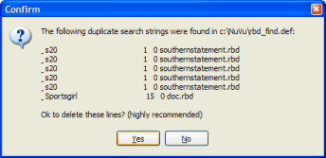

If this window is displayed, you are given the option to automatically remove the duplicates. This is highly recommended, as having duplicate entries in the definitions file will result in always invoking the FIRST design that satisfies the current legacy report at run-time.

Preview the current Report Definition
This function allows the current changes made to the current report design to be previewed as they would appear when the viewer is invoked by the end user. The report preview tool will be automatically invoked and the changes made (including any unsaved changes) will be displayed on the preview canvas. It is therefore NOT necessary to save any changes made to the report definition before pressing the print preview button.

Once the preview window is displayed, the report can be printed to any attached windows printer at this stage by pressing the print button contained on the Print Preview toolbar menu.

Once you have finished examining the preview canvas, simply close the preview window to return to the designer window.

Change the current mode to 'Pointer'
This function is used to place the designer into 'Pointer' mode. Clicking in a blank area of the designer when in 'Pointer' mode does NOT automatically create (add) a text, field, downfield, rectangle or picture object onto the designer canvas.

This mode is used when items already drawn onto the designer canvas need to be selected or manipulated individually.

Certain functions performed by clicking icons on the toolbar will automatically select 'Pointer' mode when the function completes (for example, dropping a rectangle or bitmap object onto the designer canvas).

Refer to the 'Selecting an object' for information regarding the selection of an object or objects after they are created.

Change current mode to 'Text Fields' (Ctrl-T)
Text items are static report items which are non-recurring by nature, and contain static text (ie: not derived at run-time from the associated legacy report). Examples of these are the 'Page No:'. 'Date:' and 'User:' literal strings.

Invoking this function automatically places the designer into 'add Text' mode. Clicking in a blank area of the designer will automatically create (add) a text object onto the designer canvas.

There are two different methods for drawing Text (labels) onto the canvas. If the user clicks once on the button (if the button was previously not depressed), the button will be depressed. This will allow the user to add a SINGLE text objext onto the canvas using the procedures described later in this section. Once the text object has been added to the canvas, the 'Add Text' button will be automatically de-selected. The second method of drawing text onto the canvas is to DOUBLE-CLICK the button. The buttons appearance will be changed to . Once this mode is in operation, the user is able to draw multiple text objects onto the canvas, until the button is pressed to cancel this mode.

HINT: This option can be automatically selected by pressing the <Control>T keyboard combination at any time. Pressing this combination twice will select PERSISTENT drawing mode, as described above.

The correct procedure to add a new Text Field to the designer canvas from existing text in the legacy report is to:
- Position the mouse pointer on the first character of an existing text field in the sample report, and then press and hold down the left mouse button, then drag the mouse pointer across to the right until the complete text is highlighted.
- Release the mouse button, and position the mouse pointer at the approximate position on the designer canvas and then press the left mouse button again. This will automatically create the text object for you.
- Note that the created object is automatically selected by this process (ie: drag handles are placed around it).

At any time after the text object is created, the user may select the text object, and then right-click the mouse in order to invoke the 'Text Properties' window which will allow the user to change the caption of the text object, and also allow the optional exporting of this text if the 'Export' button is pressed from the report viewer screen.

Refer to the 'Text Object' section for information regarding the advise of the available properties with regard to selected text objects after they are created.

Refer to the 'Selecting an object' for information regarding the selection of an object or objects after they are created.

Change the current mode to 'Field' (Ctrl-F)
Field items are report items which are non-recurring by nature, but are mapped to an area (row and column range) on the legacy report. Examples of these are the report header, date, time, username etc. and are normally found in the header section of the legacy report (ie: above the column headings of the report).

Invoking this function automatically places the designer into 'add Field' mode. Clicking in a blank area of the designer will automatically create (add) a field object onto the designer canvas.

There are two different methods for drawing Fields onto the canvas. If the user clicks once on the button (if the button was previously not depressed), the button will be depressed. This will allow the user to add a SINGLE text objext onto the canvas using the procedures described later in this section. Once the text object has been added to the canvas, the 'Add Text' button will be automatically de-selected. The second method of drawing text onto the canvas is to DOUBLE-CLICK the button. The buttons appearance will be changed to . Once this mode is in operation, the user is able to draw multiple text objects onto the canvas, until the button is pressed to cancel this mode.

HINT: This option can be automatically selected by pressing the <Control>F keyboard combination at any time. Pressing this combination twice will select PERSISTENT drawing mode, as described above.

The correct procedure to add a new Field to the designer canvas is:

- Position the mouse pointer on the first character of an existing field in the sample report, and then press and hold down the left mouse button, then drag the mouse pointer across to the right until the complete field is highlighted. Care should be taken with numeric fields, so that leading spaces are also included in the highlighted area.
- Release the mouse button, and position the mouse pointer at the approximate position on the designer canvas and then press the left mouse button again. This will automatically create the field definition for you.
- Note that the created field is automatically selected by this process (ie: drag handles are placed around it).

See 'Selecting an object' for information regarding the selection of an object or objects after they are created.

Change current mode to 'DownField' (Ctrl-D)
DownField items are report items which repeat themselves down the page. These are also commonly referred to as 'Detail fields' in a legacy report, and are normally the items that appear after the column headings and the bottom of the page.

Invoking this function automatically places the designer into 'add DownField' mode. Clicking in a blank area of the designer will automatically create (add) a downfield object onto the designer canvas.

There are two different methods for drawing Fields onto the canvas. If the user clicks once on the button (if the button was previously not depressed), the button will be depressed. This will allow the user to add a SINGLE text objext onto the canvas using the procedures described later in this section. Once the text object has been added to the canvas, the 'Add Text' button will be automatically de-selected. The second method of drawing text onto the canvas is to DOUBLE-CLICK the button. The buttons appearance will be changed to . Once this mode is in operation, the user is able to draw multiple text objects onto the canvas, until the button is pressed to cancel this mode.

HINT: This option can be automatically selected by pressing the <Control>D keyboard combination at any time. Pressing this combination twice will select PERSISTENT drawing mode, as described above.

The correct procedure to add a new Downfield to the designer canvas is:

- Position the mouse pointer on the first character of the existing downfield in the sample report, and then press and hold down the left mouse button, then drag the mouse pointer across to the right until the complete downfield is highlighted. Care should be taken with numeric fields, so that leading spaces are also included in the highlighted area.
- Release the mouse button, and position the mouse pointer at the approximate position on the designer canvas and then press the left mouse button again. This will automatically create the downfield definition for you.
- Note that the created downfield is automatically selected by this process (ie: drag handles are placed around it).

See 'Selecting an object' for information regarding the selection of an object or objects after they are created.

Change the current mode to 'Rectangle'
Rectangle objects are report items which are drawn onto the designer canvas to represent a rectangular shape, with the border of the rectangle drawn in the current foreground color, and the background (fill) color drawn in the current background color. Rectangles are typically used to encompass text and field objects in the header area of a report (ie: above the column headings of the report), but may be placed anywhere on a report in practice, and can also be used to draw lines on the canvas.

The NuVu Reporting Suite has no equivalent ‘Line’ component. In order to draw a line onto the canvas, the ‘Rectangle’ object must be chosen, and the width or height of the rectangle object is to be set to the appropriate line width value (0.3mm is an example of a thin line).

Invoking this function automatically places the designer into 'add Rectangle' mode. Clicking in a blank area of the designer will automatically create (add) a rectangle object onto the designer canvas. The drawn rectangle will be of default size, whereafter it may be dragged and resized to the correct dimensions by dragging on the 'handles' which are automatically placed around it when the rectangle is created (or later selected by clicking on the rectangle).

When a rectangle is first drawn onto the canvas, the default behaviour is to automatically move it behind all other objects that it may be obscuring. If this is not what is required, simply click the ‘Move to front’ button while the rectangle is still selected in order to bring it in front of all the objects that are bound by the dimensions of the rectangle.

Once a rectangle has been dragged (drawn) onto the designer canvas, the current mode is automatically changed back to 'pointer' mode, but the drawn rectangle remains 'selected'. This is due to the normal behaviour where only single rectangles are normally added to the designer canvas for the current trigger.

HINT: This option can be automatically selected by pressing the <Control>R keyboard combination at any time.

See 'Selecting an object' for information regarding the selection of an object or objects after they are created.

Please refer to the ‘Rectangle Objects’ section above this for a detailed overview of the attributes associated with a rectangle/line.

Change the current mode to 'Pictures'
Picture objects are report items which are drawn onto the designer canvas to render a bitmap image onto the form at the desired position on the canvas. This feature is typically used to draw a bitmap of a company logo in the header area of a report (or in the footer area for that matter), but may be placed anywhere on a report in practice.

Invoking this function automatically places the designer into 'add Picture' mode. Clicking in a blank area of the designer will automatically create (add) a picture object onto the designer canvas. The drawn picture object will be of default size, and contain a place marker picture (with a caption of 'No Image'), whereafter a dialog window will be displayed allowing the user to advise the full pathname of an existing bitmap image file. The optional filename icon at the end of the bitmap field may be clicked in order to invoke a standard Windows 'Open File' dialog window, allowing the user to browse the network neighborhood for the desired bitmap filename. Once the picture object has been drawn with the correct image, it may be dragged and resized to the correct dimensions by dragging on the 'handles' which are automatically placed around it when the picture is created (or later selected by clicking on the picture object).

Once a picture has been dragged (drawn) onto the designer canvas, the current mode is automatically changed back to 'pointer' mode, but the drawn picture remains 'selected'. This is due to the normal behavior where only single bitmaps or pictures are normally added to the designer canvas for the current trigger.Picture objects are report items which are drawn onto the designer canvas to render a bitmap or jpeg image onto the form at the desired position on the canvas. This feature is typically used to draw a bitmap/jpeg of a company logo in the header area of a report (or in the footer area for that matter), but may be placed anywhere on a report in practice.

Also note that if a picture object is re-sized, the image is automatically 'stretched' to accommodate the new size. The basis for the 'stretching' is determined by the 'Keep Aspect Ratio' indicator for the rectangle. If this option is ticked, then the original aspect ratio is maintained when the image is resized - the NuVu Designer will examine which aspect has changed (Height or Width) and adjust the dimensions of the image object appropriately.

See 'Selecting an object' for information regarding the selection of an object or objects after they are created.

Change current mode to 'TextBox' (Ctrl-B)
TextBox items are report items which can contain multiple lines of text, with optional embedded fields. Textboxes are very useful in keeping a section of text together. The text inside the textbox may optionally be aligned to the left margin, right margin or centered within the box.

Invoking this function automatically places the designer into 'add TextBox' mode. Clicking in a blank area of the designer will automatically create (add) a textbox object onto the designer canvas.

Unlike the label, field and downfield drawing methods, drawing a textbox onto the designer canvas automatically de-selects the 'add TextBox' mode after the textbox object is drawn onto the designer canvas. Once the textbox has been drawn onto the canvas, the newly created object will automatically be selected (with drag-handles drawn around it, allowing the user to resize this textbox object by dragging the mouse cursor in the desired direction.

HINT: This option can be automatically selected by pressing the <Control>B keyboard combination at any time.

The correct procedure to add a new TextBox to the designer canvas is:

Optionally position the mouse pointer on the first character of an existing field in the sample (legacy) report, and then press and hold down the left mouse button, then drag the mouse pointer across to the right until an area of the legacy report is highlighted. Release the mouse button to end the selection of text in the legacy report.

Position the mouse pointer at the approximate position on the designer canvas and then press the left mouse button. This will automatically create the textbox object and place it onto the designer canvas at the mouse cursor position, with a default width and height. The textbox will automatically be selected (with drag-handles drawn around it, allowing the user to resize this textbox object by dragging the mouse cursor in the desired direction). If an area of the legacy report was NOT selected, then sample text ('Insert text here....') will be drawn inside the textbox, otherwise the selected text from the legacy report will be copied into the textbox.

See ‘Selecting an Object’ for information regarding the selection of an object or objects after they are created.

Change current mode to 'Chart' (Ctrl-H)
Chart objects are used to visually graph sections of the legacy (or XML) report at run-time. The Chart object itself has many properties that can be set to achieve the desired result.

Invoking this function automatically places the designer into 'add Chart' mode. Clicking in a blank area of the designer will automatically create (add) a chart object onto the designer canvas.

Unlike the label, field and downfield drawing methods, dropping a chart onto the designer canvas automatically de-selects the 'add Chart' mode after the chart object is drawn onto the designer canvas. Once the chart object has been drawn onto the canvas, the newly created object will automatically be selected (with drag-handles drawn around it, allowing the user to resize this object by dragging the mouse cursor in the desired direction.

HINT: This option can be automatically selected by pressing the <Control>H keyboard combination at any time.

The correct procedure to add a new Chart object to the designer canvas is:

- Either left-click the chart icon in the toolbar, or press the <Control>H keyboard combination to select 'Chart Mode'.
- Optionally highlight the text inside the sample (legacy or XML) report that denotes the start of the chart details that will be used to generate the chart at run-time. This highlighted text will be used to automatically populate the 'Start Node' property of the chart.
- Position the mouse pointer at the approximate position on the designer canvas and then press the left mouse button. This will automatically create the object and place it onto the designer canvas at the mouse cursor position, with a default width and height. The object will automatically be selected (with drag-handles drawn around it, allowing the user to resize this object by dragging the mouse cursor in the desired direction). If an area of the legacy (or XML) report was selected, then the 'Start Node' property for this chart object will be populated with the contents of the highlighted area.

See ‘Selecting an Object’ for information regarding the selection of an object or objects after they are created.

The actual properties (there are many) of the chart object can be changed by right-clicking on the chart object, invoking the Chart Properties dialog window. All changes to items within the Chart Properties dialog are immediately shown on the chart.

Change the current mode to 'Lasoo' (F5)
'Lasoo' mode (or 'Rubber-Band' mode as it is also commonly known) allows the user to drag an area on the designer canvas, which will effectively select all objects contained withing the drawn 'Lasoo'. This is a very quick way of selecting multiple objects on the designer canvas, and is commonly used to select associated objects, and then moving them to a new position on the canvas.

This function may either be invoked by clicking on the associated Lasoo toolbutton, or else pressing the F5 function key.

Invoking this function automatically places the designer into 'Lasoo' mode. The user may then left-click at the estimated top-left of the lasoo area to be drawn, then, without releasing the left mouse button, drag the mouse down and to the right, until the lasoo area (shown with small dotted lines) encompases the relevant objects, then simply release the left-mouse button, which will automatically select all objects contained withing the lasoo area drawn, and then also automatically selects 'Pointer' mode (therefore de-selecting 'Lasoo' mode).

Once the objects are selected, they may be moved together to a new position on the canvas using normal mouse drag techniques (ie: click and hold down the left mouse button when the mouse pointer is positioned inside one of the selected objects, and then position the mouse to the new position on the canvas before releasing the mouse pointer, which cements the new objects into their new positions on the canvas.

Change the Font Name
Text, Field and DownField objects may be drawn on the designer canvas in any font supported by the Windows operating system. When a new object is drawn onto the canvas, the currently selected font name will be used when drawing the object onto the canvas, but this can be changed at any time.

Invoking this function (or dropping down the combo-box) will display all the true-type fonts currently installed on the client PC, and allows the user to select any of them (one only) as the currently selected font. The combo-box displays the font in the true type font style, making it easier for the user to determine which font to use.

Please note that if the font used on the designer canvas is NOT installed on the client machine which is used to view the report at a later time, then the font closest in characteristics will replace the designer font.

The current font name is used when creating new Text, Field and DownField objects on the designer canvas. In order to change the font name of an existing object (or objects), follow these simple steps:

- Select an object (or objects) first. See 'Selecting an object' for information regarding the selection of an object or objects after they are created.

- Click on this font name combo-box, and choose a different font. Once a new font name is chosen, all selected objects are changed to reflect the chosen font name.

Change the Font Size
Text, Field and DownField objects may be drawn on the designer canvas in any font size supported by the Windows operating system. When a new object is drawn onto the canvas, the currently selected font size will be used when drawing the object onto the canvas, but this can be changed at any time.

The 'font size' field displays the current font size (in integer units). The user may either simply overtype a new value into this field, or click on the up (increment) or down (decrement) buttons alongside this field to adjust the current font size. If the font size of existing object(s) need to be changed, firstly select the object(s) (see 'Selecting an object' for information regarding the selection of an object or objects after they are created), and then type a new value into the font size field, or press the up/down buttons alongside the field. All selected objects are then changed to reflect the chosen font size.

Change the Font ‘Bold’ Attribute
Text, Field and DownField objects may be drawn on the designer canvas in a 'Bold' or 'Normal' attribute. When a new object is drawn onto the canvas, the current value of the 'Bold' attribute will be used when drawing the object onto the canvas, but this can be changed at any time.

The 'bold' button is used as a toggle. If this button is depressed (pushed in), then objects drawn onto the canvas will be drawn in a 'Bold' font attribute. If the 'Bold' attribute of existing object(s) need to be changed (either turned on or off), firstly select the object(s) (see 'Selecting an object' for information regarding the selection of an object or objects after they are created), and then click on this button in order to toggle the 'Bold' attribute of all selected objects.

Change the Font ‘Italic’ Attribute
Text, Field and DownField objects may be drawn on the designer canvas in a 'Italic' or 'Normal' attribute. When a new object is drawn onto the canvas, the current value of the 'Italic' attribute will be used when drawing the object onto the canvas, but this can be changed at any time.

This button is used as a toggle. If this button is depressed (pushed in), then objects drawn onto the canvas will be drawn in a 'Italic' font attribute. If the 'Italic' attribute of existing object(s) need to be changed (either turned on or off), firstly select the object(s) (see 'Selecting an object' for information regarding the selection of an object or objects after they are created), and then click on this button in order to toggle the 'Italic' attribute of all selected objects.

Change the Font ‘Underline’ Attribute
Text, Field and DownField objects may be drawn on the designer canvas in a 'Underline' or 'Normal' attribute. When a new object is drawn onto the canvas, the current value of the 'Underline' attribute will be used when drawing the object onto the canvas, but this can be changed at any time.

This button is used as a toggle. If this button is depressed (pushed in), then objects drawn onto the canvas will be drawn in a 'Underline' font attribute. If the 'Underline' attribute of existing object(s) need to be changed (either turned on or off), firstly select the object(s) (see 'Selecting an object' for information regarding the selection of an object or objects after they are created), and then click on this button in order to toggle the 'Underline' attribute of all selected objects.

Left-Align the selected objects
Text, Field and DownField objects may be either left, right or center-aligned on the designer canvas. This option will automatically set the selected objects (or new objects if this option is depressed) to be left aligned.

The alignment buttons (Left, Right and Center) are all mutually exclusive. Depressing this button will result on the other alignment buttons being de-selected. If this button is depressed (pushed in), then objects drawn onto the canvas will be drawn left aligned. If the alignment of existing object(s) need to be changed to be left-aligned, firstly select the object(s) (see ‘Selecting an object’ for information regarding the selection of an object or objects after they are created), and then click on this button in order to effect the left aligning of these selected objects.

Right-Align the selected objects
Text, Field and DownField objects may be either left, right or center-aligned on the designer canvas. This option will automatically set the selected objects (or new objects if this option is depressed) to be right aligned.

The alignment buttons (Left, Right and Center) are all mutually exclusive. Depressing this button will result on the other alignment buttons being de-selected. If this button is depressed (pushed in), then objects drawn onto the canvas will be drawn right aligned. If the alignment of existing object(s) need to be changed to be right-aligned, firstly select the object(s) (see ‘Selecting an object’ for information regarding the selection of an object or objects after they are created), and then click on this button in order to effect the right aligning of these selected objects.

Center-Align the selected objects
Text, Field and DownField objects may be either left, right or center-aligned on the designer canvas. This option will automatically set the selected objects (or new objects if this option is depressed) to be center aligned.

The alignment buttons (Left, Right and Center) are all mutually exclusive. Depressing this button will result on the other alignment buttons being de-selected. If this button is depressed (pushed in), then objects drawn onto the canvas will be drawn center aligned. If the alignment of existing object(s) need to be changed to be center-aligned, firstly select the object(s) (see ‘Selecting an object’ for information regarding the selection of an object or objects after they are created), and then click on this button in order to effect the center aligning of these selected objects.

Change the Foreground Color
Text, Field, DownField and Rectangle objects may be drawn on the designer canvas with one of the standard foreground colors (or border colors in the case of Rectangle objects). When a new object of this type is drawn onto the canvas, the current value of the 'Foreground Color' combo-box will be used when drawing the object onto the canvas, but this can be changed at any time after that.

This combo-box displays the 16 primary Windows colors plus a few other standard colors, along with the associated color description available to be selected for these objects, and allows the user to select any of them (one only) as the currently selected foreground (or border) color. The combo-box displays the actual color (as opposed to the color name), making it easier for the user to determine which foreground color to use.

There is also the ability for the user to select ANY color from the available color palette. This is achieved by selecting the 'Custom...' item at the bottom of the list (or simply pressing the END key when the color combo-box has been dropped down. The following color palette window will be displayed:

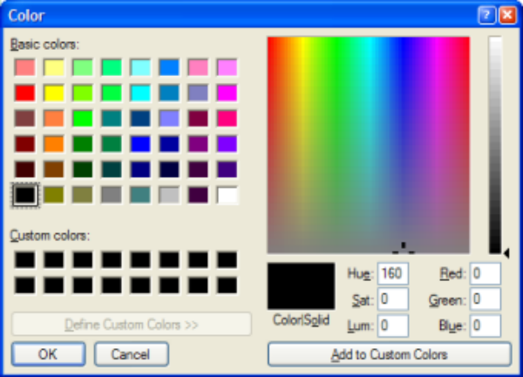

Select an appropriate color (or shade of color) and click the OK button to add a new CUSTOM color to the combo-box.

The current foreground color value is used when creating new Text, Field, DownField and Rectangle objects on the designer canvas. In order to change the foreground (or border) color of an existing object (or objects), follow these simple steps:

Select an object (or objects) first. See 'Selecting an object' for information regarding the selection of an object or objects after they are created.

Click on this foreground color combo-box, and choose a different color. Once a new foreground (or border) color is chosen, all selected objects are changed to reflect the chosen color.

Change the Background Color
Text, Field, DownField and Rectangle objects may be drawn on the designer canvas with one of the standard background colors (or fill colors in the case of Rectangle objects). When a new object of this type is drawn onto the canvas, the current value of the 'background Color' combo-box will be used when drawing the object onto the canvas, but this can be changed at any time after that.

This combo-box displays the 16 primary Windows colors plus a few other standard colors, along with the associated color description available to be selected for these objects, and allows the user to select any of them (one only) as the currently selected background (or fill) color. The combo-box displays the actual color (as opposed to the color name), making it easier for the user to determine which background color to use.

There is also the ability for the user to select ANY color from the available color palette. This is achieved by selecting the 'Custom...' item at the bottom of the list (or simply pressing the END key when the color combo-box has been dropped down. The following color palette window will be displayed:

Select an appropriate color (or shade of color) and click the OK button to add a new CUSTOM color to the combo-box.

The current background color value is used when creating new Text, Field, DownField and Rectangle objects on the designer canvas. In order to change the background (or fill) color of an existing object (or objects), follow these simple steps:

Select an object (or objects) first. See 'Selecting an object' for information regarding the selection of an object or objects after they are created.

Click on this background color combo-box, and choose a different color. Once a new background (or fill) color is chosen, all selected objects are changed to reflect the chosen color.

Move the selected object in front of others
This function is used to bring the selected object (only one, not multiple) in front of all others.

This means that the object will overlay all other objects that occupy the same co-ordinates. This button is only normally used for Rectangle objects on the designer canvas. Rectangles which act as shadows for other rectanges can be moved behind the primary rectangle by clicking this button on the primary rectangle (thus bringing it 'In Front' of the other rectangle).

Move the selected object behind all others
Move the selected object in Front of all others {bmc toback.bmp} Move the selected object Behind all others

This function is used to move the selected object (only one, not multiple) behind all others. This means that the object will be overlayed by all other objects that occupy the same co-ordinates.

This button is only normally used for Rectangle objects on the designer canvas. Rectangles which act as shadows for other rectanges can be moved behind the primary rectangle by clicking this button on the shadow rectangle (thus moving it behind the primary rectangle). Also the primary

Rectangle can be moved behind all Text and Field, and Picture objects if those objects need to be displayed and printed on top of the Rectangle.

Align all selected objects Horizontally
This function is used to align mutiple objects (normally Text, Field or DownField objects) on the same horizontal position (Y position). This is very useful when lining up column headings and the like.

In order to align multiple objects along the same horizontal plane, follow these simple steps:
Select the objects which are required to be horizontally aligned. See 'Selecting an object' for information regarding the selection of multiple objects.

Click on this button. All selected objects will then be re-positioned on the same horizontal position as the first selected object.

Align all selected objects Vertically
This function is used to align mutiple objects (normally Text, Field or DownField objects) on the same vertical position (X position). This is very useful when lining up address fields and the like.

In order to align multiple objects along the same vertical plane, follow these simple steps:
- Select the objects which are required to be vertically aligned. See 'Selecting an object' for information regarding the selection of multiple objects.
- Click on this button. All selected objects will then be re-positioned on the same vertical position as the first selected object.

Select a new current Trigger
This combo-box contains a list of the currently defined Triggers for the current report defintion.

The user may click on this combo-box to select a new current Trigger. Once selected, the objects defined for that Trigger will be displayed on the designer canvas, ready for editing.

Move Trigger above previous Trigger
This option allows the user to move the currently displayed Trigger so that it is positioned ABOVE the previous Trigger. The order of triggers is important during overflow and new page processing.

During overflow and new page processing, all Triggers that have been marked to repeat on the new page (or overflow) are processed in the order that they are defined within the designer (ie: the order that they appear in the drop-down Trigger list).

Choosing this option will present the user with a confirmation dialog window that asks if this process should be attempted or not. If the current trigger is already positioned at the top of the trigger list, then choosing this option has no effect.

Move Trigger below next Trigger
This option allows the user to move the currently displayed Trigger so that it is positioned BELOW the next Trigger. The order of triggers is important during overflow and new page processing.

During overflow and new page processing, all Triggers that have been marked to repeat on the new page (or overflow) are processed in the order that they are defined within the designer (ie: the order that they appear in the drop-down Trigger list).

Choosing this option will present the user with a confirmation dialog window that asks if this process should be attempted or not. If the current trigger is already positioned at the bottom of the trigger list, then choosing this option has no effect.

Add a new Trigger to the report definition
The user may advise up to a maximum of 15 different Triggers for each report definition. After pressing the button, the system will first validate that there are not already 15 triggers defined for the current report, and then proceed with creating a new trigger for the report. An error message will be displayed if there are already 15 triggers defined for the current report when this button is pressed.

Follow the same steps as the 'Edit the currently selected Trigger' option to advise the property values for the trigger.

Delete the currently selected Trigger
The user may delete any defined Trigger by pressing this button. A standard Windows dialog window will be displayed, allowing the user to confirm this step. Once a trigger has been deleted, there is NO undo facility to re-instate it (without abandoning the current changes to the definition, and reloading it from a saved version). Also note that the deletion of the trigger also removes the associated objects that existed for the trigger, so care should be taken when choosing this option.

Create a new trigger as a copy of another
This very useful function allows the user to create a new trigger (as per the option described elsewhere) which is a copy of the currently displayed trigger. As such, all objects contained on the currently displayed designer canvas will be copied to the new canvas, as well as all the trigger properties of the current trigger will be copied (apart from the 'Primary Down Section' property to the new trigger.

Before this function can be actioned, the system will ensure that there is at least one existing trigger in the current report definition. If none are found, an appropriate error message will be issued, and the function will be aborted.

The user will first be prompted for confirmation before the current trigger is copied. If the user declines the confirmation, then the new trigger is NOT copied, and control is returned to the existing current trigger, otherwise a new trigger will be created, and all objects copied from the old current trigger to the newly created one, whereafter the normal Trigger Properties dialog window will open, and allow the user to amend any of the trigger properties.

The same rules apply to this copy trigger function as to the 'Add Trigger' function. IE: The user may advise up to a maximum of 15 different Triggers for each report definition. Before the trigger is copied, the system will first validate that there are not already 15 triggers defined for the current report, and then proceed with creating a new trigger for the report. An error message will be displayed if there are already 15 triggers defined for the current report when this button is pressed. Also note, if you are running the DEMO version of the designer, you will not be able to use this function, as the DEMO version only allows a single trigger.

Follow the same steps as the ‘Edit the currently selected trigger’ option to advise the property values for the trigger.

Edit the current Trigger Properties
Pressing this button will automatically invoke the Trigger Dialog window, with default values automatically filled in for the user.

The Trigger Dialog window is presented slightly differently depending on the source of the input document.

If the input document is stipulated as being XML, then the following details are displayed:

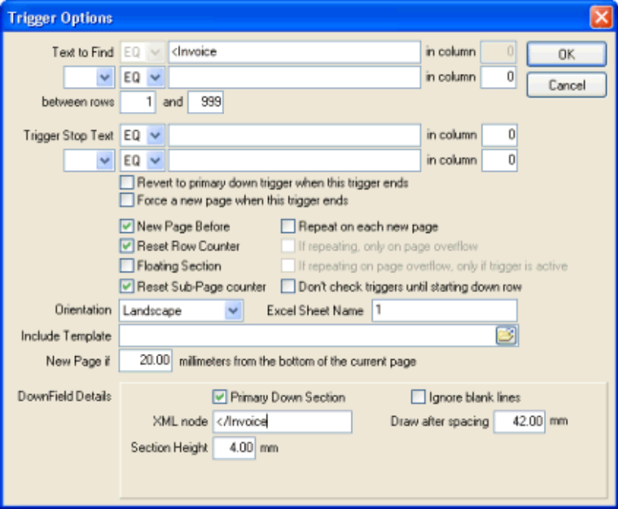

If the input document is stipulated as being a legacy report (ie: NOT XML), then the following details are displayed:

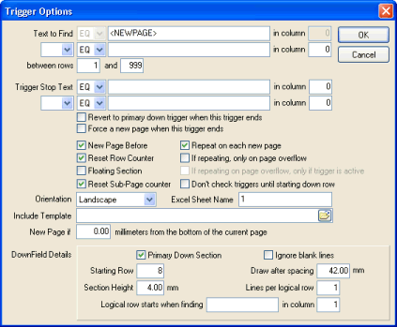

Advise the required parameters (described below) and click the OK button to save these Trigger options, or alternatively click on the CANCEL button to undo any changes made to the parameters on this screen.

Text to Find

Advise the text string (without quotes) to search for in order to 'fire' the trigger.

The 'Condition' drop-down combo-box that precedes this field can be used to either an equilty or inequality test on the search string. Advising a condition of 'EQ' will search for the existance of the advised text, advising a condition of 'NE' will perform an inequality check using the advised text, that is: the trigger will fire if the advised text is NOT found at the specified column.

Please note, if a condition other than 'EQ' is advised, then the designer will validate that the associated 'Column' field is non-zero.

Also note, if the 'Text to Find' begins with a '<', the designer will assume that a reserved word (or XML tag) is being advised, resulting in the 'Condition' field being automatically set to 'EQ' and disabled and the 'in Col' field to be set to zero and disabled also.

The reserved word "<NEWPAGE>" may be typed here, which will cause the trigger to 'fire' at the start of each new page. This is common practice when defining the main trigger for the report. The main trigger is normally used to advise the page and column headings for the report, as well as the associated static fields, and down-fields for the defined columns.

The reserved word "<NEWLINE>" may be typed here, which will cause the trigger to 'fire' on the reading of each record from the legacy report. This is sometimes used when processing a mail merge file (where each record in the file relates to a seperate set of details (for example, a record for each customer in your database).

The reserved word "<BEFOREOVERFLOW>" may be typed here, which will cause the trigger to 'fire' whenever the output to the current page reaches overflow, but BEFORE the output automatically advances to a new page. This trigger is useful to advise rectangle, text and bitmaps that will be printed just before advancing to a new page. For example, this trigger could be used to output a 'Details continue on next page' text.

The reserved word "<OVERFLOW>" may be typed here, which will cause the trigger to 'fire' whenever the output to the current page reaches overflow and automatically advances to a new page. This trigger will fire before all other 'repeat on new page, only if overflow' triggers, and is normally used to output column headings at the start of an overflow page.

The reserved word "<NONBLANKn>" may be typed here, which will cause the trigger to 'fire' when any non-blank text is found (at the optional 'Search in Column'). The length of the non-blank text to check is advised as the 'n' value (between 1 and 9). For example, if you wish to check for any non-blank text between columns 8 and 14, then you would advise <NONBLANK6> in this field, and 8 in the 'Search in Column' field.

The reserved word "<PASSTHROUGH>" may be typed here, which when used alone on a single report design, will result in the report not being processed AT ALL by the NuVu graphic rendering engine. This option is often useful for when a text report that contains embedded escape sequences to do things such as open the cash drawer, or cut the point-of-sale register slip can be passed directly through to the printer at run-time. If this trigger is used, there is NO need to advise any other triggers or fields/labels or downfields on the report, because they will simply be ignored.

Normally column-based reports have some unique identifier at the start of each page - a program id, common heading line etc - which can be advised here (assuming we are defining the main trigger of the report).

Search in Column

Advise the column in which to search for the string, or leave as zero if the search string can be located in any column of the report.

Find Condition

The application has the ability to search for two different sets of text in order to fire the trigger for the current section. The find condition combo-box allows the user to specify the relationship between the two search strings. This relationship can be one of the following three options:

- Blank The second search string is not checked at all
- AND Both the first and second search strings must be found before the trigger will fire
- OR Either the first or the 2nd search strings must be found before the trigger will fire

Second Text to Find

Advise the optional second text string (without quotes) to search for in order to 'fire' the trigger. This string will only be checked if the Find Condition (see previous field) is advised as either AND or OR.

The 'Condition' drop-down combo-box that precedes this field can be used to either an equilty or inequality test on the search string. Advising a condition of 'EQ' will search for the existance of the advised text, advising a condition of 'NE' will perform an inequality check using the advised text, that is: the trigger will fire if the advised text is NOT found at the specified column.

Please note, if a condition other than 'EQ' is advised, then the designer will validate that the associated 'Column' field is non-zero.

Also note, if the 'Text to Find' begins with a '<', the designer will assume that a reserved word (or XML tag) is being advised, resulting in the 'Condition' field being automatically set to 'EQ' and disabled and the 'in Col' field to be set to zero and disabled also.

The reserved word "<NEWPAGE>" may be typed here, which will cause the trigger to 'fire' at the start of each new page. This is common practice when defining the main trigger for the report. The main trigger is normally used to advise the page and column headings for the report, as well as the associated static fields, and down-fields for the defined columns.

The reserved word "<NEWLINE>" may be typed here, which will cause the trigger to 'fire' on the reading of each record from the legacy report. This is sometimes used when processing a mail merge file (where each record in the file relates to a seperate set of details (for example, a record for each customer in your database).

The reserved word "<NONBLANKn>" may be typed here, which will cause the trigger to 'fire' when any non-blank text is found (at the optional 'Search in Column'). The length of the non-blank text to check is advised as the 'n' value (between 1 and 9). For example, if you wish to check for any non-blank text between columns 8 and 14, then you would advise <NONBLANK6> in this field, and 8 in the 'Search in Column' field.

The reserved word "<PASSTHROUGH>" may be typed here, which when used alone on a single report design, will result in the report not being processed AT ALL by the NuVu graphic rendering engine. This option is often useful for when a text report that contains embedded escape sequences to do things such as open the cash drawer, or cut the point-of-sale register slip can be passed directly through to the printer at run-time. If this trigger is used, there is NO need to advise any other triggers or fields/labels or downfields on the report, because they will simply be ignored.

Second Search Column

Advise the column in which to search for the second text string, or leave as zero if the search string can be located in any column of the report.

Between rows [X] and [Y]

These options are only normally used on more advanced designs, and allow the user to specify the range of rows in which to search between for the identified Trigger text.

Trigger Stop Text

Advise an optional text string (without quotes) to search for in order to end the currently defined trigger.

The 'Condition' drop-down combo-box that precedes this field can be used to either an equilty or inequality test on the search string. Advising a condition of 'EQ' will search for the existance of the advised text, advising a condition of 'NE' will perform an inequality check using the advised text, that is: the trigger will fire if the advised text is NOT found at the specified column.

Please note, if a condition other than 'EQ' is advised, then the designer will validate that the associated 'Column' field is non-zero.

Also note, if the 'Text to Find' begins with a '<', the designer will assume that a reserved word (or XML tag) is being advised, resulting in the 'Condition' field being automatically set to 'EQ' and disabled and the 'in Col' field to be set to zero and disabled also.

The reserved word "<NEWPAGE>" may be typed here, which will cause the trigger to stop at the start of a new page.

The reserved word "<NEWLINE>" may be typed here, which will cause the trigger to stop when reading a new record from the legacy report.

The reserved word "<NONBLANKn>" may be typed here, which will cause the trigger to stop when any non-blank text is found (at the optional 'Search in Column'). The length of the non-blank text to check is advised as the 'n' value (between 1 and 9). For example, if you wish to check for any non-blank text between columns 8 and 14, then you would advise <NONBLANK6> in this field, and 8 in the 'Search in Column' field.

The reserved word "<PASSTHROUGH>" may be typed here, which when used alone on a single report design, will result in the report not being processed AT ALL by the NuVu graphic rendering engine. This option is often useful for when a text report that contains embedded escape sequences to do things such as open the cash drawer, or cut the point-of-sale register slip can be passed directly through to the printer at run-time. If this trigger is used, there is NO need to advise any other triggers or fields/labels or downfields on the report, because they will simply be ignored.

This option is rarely used (and is therefore normally left blank), but may be advised in unusual circumstances where the trigger is of unknown size (number of rows) but the end of the trigger section can be identified with a text string.

Stop Column

Advise the column in which to search for the "Trigger Stop Text" mentioned above, or leave as zero if the search string can be located in any column of the current line of the report.

Stop Condition

The application has the ability to search for two different sets of text in order to end the current trigger for the current section. The find condition combo-box allows the user to specify the relationship between the two search strings. This relationship can be one of the following three options:

- Blank The second search string is not checked at all
- AND Both the first and second search strings must be found before the trigger will fire
- OR Either the first or the 2nd search strings must be found before the trigger will fire

Second Trigger Stop Text

Advise the optional second text string (without quotes) to search for in order to stop the current trigger processing. This string will only be checked if the Stop Condition (see previous field) is advised as either AND or OR.

The 'Condition' drop-down combo-box that precedes this field can be used to either an equilty or inequality test on the search string. Advising a condition of 'EQ' will search for the existance of the advised text, advising a condition of 'NE' will perform an inequality check using the advised text, that is: the trigger will fire if the advised text is NOT found at the specified column.

Please note, if a condition other than 'EQ' is advised, then the designer will validate that the associated 'Column' field is non-zero.

Also note, if the 'Text to Find' begins with a '<', the designer will assume that a reserved word (or XML tag) is being advised, resulting in the 'Condition' field being automatically set to 'EQ' and disabled and the 'in Col' field to be set to zero and disabled also.

The reserved word "<NEWPAGE>" may be typed here, which will cause the trigger to stop at the start of a new page.

The reserved word "<NEWLINE>" may be typed here, which will cause the trigger to stop when reading a new record from the legacy report.

The reserved word "<NONBLANKn>" may be typed here, which will cause the trigger to stop when any non-blank text is found (at the optional 'Search in Column'). The length of the non-blank text to check is advised as the 'n' value (between 1 and 9). For example, if you wish to check for any non-blank text between columns 8 and 14, then you would advise <NONBLANK6> in this field, and 8 in the 'Search in Column' field.

The reserved word "<PASSTHROUGH>" may be typed here, which when used alone on a single report design, will result in the report not being processed AT ALL by the NuVu graphic rendering engine. This option is often useful for when a text report that contains embedded escape sequences to do things such as open the cash drawer, or cut the point-of-sale register slip can be passed directly through to the printer at run-time. If this trigger is used, there is NO need to advise any other triggers or fields/labels or downfields on the report, because they will simply be ignored.

Second Stop Column

Advise the column in which to search for the "Second Trigger Stop Text" mentioned above, or leave as zero if the search string can be located in any column of the current line of the report.

Revert to primary down trigger when this trigger ends

This tick-box is used to determine if the primary 'down' trigger (as advised by ticking the 'Primary Down Trigger' tick box in the down fields section of each trigger) will resume after this trigger ends or not. Ticking this item will result in the Primary Down Trigger resuming, otherwise no further processing will occur on the canvas until the next trigger fires. This option is automatically unticked when advising some value in the 'Stop Trigger Text' of the primary down trigger, as it does not make sense to advise a stop condition for the trigger but resume the primary down trigger (ie: the same trigger) on ending this trigger.

Force a new page when this trigger ends

This tick-box is used to determine if a new page will be output when this trigger ends or not. Ticking this option will result in a new page being output (but only when either another trigger fires, or else a non-blank downfield line is detected on the trigger that is automatically resumed when this trigger ends).

New Page Before

Tick this item if a new page must occur before actioning the trigger. Generally if this is the main trigger (ie: doing something at the start of each page), then this item is ticked.

Reset Row Counter

Tick this item if you require the internal row counter to be reset back to 1 (ie: set to the same row as the occurrence of the trigger search text). As a general rule, this item should be ticked for most triggers, and only be left un-ticked for 'Floating Section' triggers (explained below).

Floating Section

This is an more advanced feature of the report designer, and allows triggers is to be of a 'floating' nature. Floating triggers are normally used when the user wishes to output lines which are normally part of the detail rows of a report in a different style to the other detail rows.

For example, examine the following snippet of a legacy report:

SalesPerson Name Phone Balance
--------------- ------------------ ---------- ----------
Fred Bloggs Culverwell, B 843613 1000.00
Smith, S 2266233 452.22
Andrews, D 7882221 .00
----------
SalesPerson total 1452.22
----------
Joe Smith Killian, F 8733443 500.00
Peters, P 3322123 600.00
----------
SalesPerson total 1100.00
----------

A Trigger would have been defined for the defined columns in the report (Salesperson, Name, Phone and Balance). Assuming the design called for the totals being printed in a different colour, or font style. This is achieved by creating a new Trigger, and ticking the 'Floating Section' item on the Trigger Options dialog window. The Trigger Search text would be set to 'Salesperson total' in any column, and the design canvas would output the 'Salesperson total' as a Field, and the total balance for that salesperson as another field. Each of these fields can be customised with respect to their font style, name and colour. Normally the fields are dropped onto the designer canvas as close to the top of the canvas as possible. When the report is printed, each time the 'Salesperson total' string is identified in the legacy report, this trigger will fire, and output the 2 defined fields to the canvas at the current print position (because the trigger is defined as being 'Floating'. Once the trigger has fired for that line (and because in this case the floating trigger is not defined as having 'detail rows', the rest of the legacy report line is ignored, and the previous 'down fields' trigger is re-activated, so as to continue printing the details of the next salesperson.

If this check-box is ticked, and the 'Include floating triggers in overflow processing' check-box (on the Report Options screen) is not checked, then the 'Repeat on every page' and 'If repeating, only on overflow' tick-boxes will be automatically hidden, as they are not applicable in this scenario.

Reset Sub-Page Counter

Ticking this option will reset the current sub-page counter back to 1. This option is useful when collating the common pages for sets of customers, invoices etc. The option would be ticked on a trigger that was fired at the start of a new set of pages (eg: at the start of a new customer).

Repeat on each new Page

Ticking this option will cause the fields, rectangles, labels and bitmap objects contained within this trigger to be output to the preview canvas if a new page is output to the canvas. This will only occur during overflow processing, if the 'If Repeating, only on page overflow' check-box (described next) is also ticked. Overflow processing occurs when the current trigger attempts to output information to the canvas, and that trigger has the 'New page if...' set to anything other than zero millimeters. It is important to note that the triggers are processed in the same order as they appear in the 'Triggers' drop-down box.

This option is commonly ticked when the input to the NuVu report is an XML document. XML documents normally define the report headings and titles only once in the XML document, but these details need to be reflected on each page of the generated report. This option is also ticked on non-XML documents when the detailed output can overflow the page.

This option is hidden if the 'Include floating triggers in overflow processing' (on the Report Options window) is left un-ticked, and this trigger is set to be a 'floating' trigger.

If Repeating, only on page overflow

This option is only available to be ticked if the 'Repeat on each new page' option (described previously) has also been ticked, otherwise this option is unticked and disabled.

Ticking this option will result in fields, rectangles, labels and bitmap objects contained within this trigger to be output to the preview canvas if a new page is output to the canvas, but only if a new page is output as a result of page overflow.

Overflow occurs when output is attempted to the preview canvas within the advised 'New Page if...' property which is discussed later in this section. Please note that if the 'New Page if...' option is left at a value of zero, then NO overflow will occur at all for this trigger.

This option is commonly ticked when the input to the NuVu report is an XML document. XML documents normally define the report headings and titles only once in the XML document, but these details need to be reflected on each page of the generated report. This option is also ticked on non-XML documents when the detailed output can overflow the page.

This option is hidden if the 'Include floating triggers in overflow processing' (on the Report Options window) is left un-ticked, and this trigger is set to be a 'floating' trigger.

If repeating on page overflow, only if Trigger active

This option is only available to be ticked if the 'If Repeating, only on page overflow' option (described previously) has also been ticked, otherwise this option is unticked and disabled.

Ticking this option will result in fields, rectangles, labels and bitmap objects contained within this trigger to be output to the preview canvas if a new page is output to the canvas, but only if a new page is output as a result of page overflow, AND only if this trigger is active when the page overflow results.

Overflow occurs when output is attempted to the preview canvas within the advised 'New Page if...' property which is discussed later in this section. Please note that if the 'New Page if...' option is left at a value of zero, then NO overflow will occur at all for this trigger.

This option is commonly ticked when the input to the NuVu report is an XML document. XML documents normally define the report headings and titles only once in the XML document, but these details need to be reflected on each page of the generated report. This option is also ticked on non-XML documents when the detailed output can overflow the page.

This option can be useful when you have declared a few floating down sections, but only want to repeat the headings of the most recently fired down section when overflow occurs.

This option is hidden if the 'Include floating triggers in overflow processing' (on the Report Options window) is left un-ticked, and this trigger is set to be a 'floating' trigger.

Don't check triggers until starting down row

This option is commonly ticked when you have a second (or subsequent) page in the report that you wish to continue the downfields ONLY, but ignore the other triggers that might fire in the meantime. For example, assume you have a legacy invoice report that contains a first page of details, with a 'CONTINUED' text after the detail rows, followed by a page break and the next header details before the continued line items. You wish to combine the second (and subsequent) detail rows to the current page (thus saving paper). Ticking this option on a special trigger that is fired when the 'CONTINUED' text is found, will result in the contents of the legacy report from the start of the trigger to the advised 'Starting Down Row' to be simply ignored, without firing any triggers that may be found in this section of the report. Without this option, the header trigger would again fire and output a new page and header details, that is not the desired action required.

Orientation

This is similar to the report options 'Orientation' , but only applies to the pages printed when the current trigger is in operation. When a new trigger is added to the report definition, the value of the 'Orientation' property of the report will be copied to the new trigger as a default, but may be changed here. This gives the user the ability to change the orientation of individual pages of a single report, depending on the various defined triggers. For example, the legacy report may have sections which must be output in a portrait orientation, and others which should be output in a landscape orientation.

Excel Sheet Name

As a default, each trigger is output to its own Excel worksheet when the 'Export to Excel' button is clicked from the NuVu viewer. The value advised here will be used as the name of the worksheet. The system will check to ensure that you do not advise duplicate Excel Sheet names in other triggers of the current design.

Include Template

This is a very powerful feature of the report designer, and allows the user to include template information with any defined trigger. A template is simply another external report definition designed with the same designer tool as you are using to create the current report definition.

Typically this feature is used when an installation has legacy reports which have the same header information (User, Date/Time, Page etc.). All that is required is to create a report definition with the required layout for the header information within it, save it to the 'templates' directory and then associate that definition file here. The template definitions are visible in the designer (although the individual elements are NOT able to be moved or sized), but are removed from the main design, and called in at run-time. This allows changes to be made to the template which will then cause all reports linked to the template to be changed immediately.

New Page if ... millimetres from the bottom of the current page

This powerful feature of the report designer allows for the automatic throwing of a new page if an attempt is made to output to the current page within the advised number of millimeters from the bottom edge of the page. This feature is commonly used when there is an unknown number of sections on the current page, or the input is from an XML document. If input is from an XML document, then this field is automatically populated with a value of 20mm, and is validated to ensure that a value of zero is not advised.

If a value of zero is advised (and allowed only when the output is NOT from an XML document), then this results in the automatic overflow processing being totally ignored.

Primary Down Section

This field indicates if this Trigger section is to be viewed as the main section of the report. This advanced feature is used when there are more than a single down section in the report (For example, in a customer order report, the customer details (code, name, phone, balance) are printed on the first line, followed by the orders for that customer). The customer details would be defined as a trigger with the "Primary Down Section" ticked, and the order details would be defined as a separate section with this indicator left un-ticked. This indicator is used when processing the report so when the order details are printed (ie: the second trigger has fired) and then end (normally when a blank line is detected via use of the "Trigger Stop Text" mentioned previously), the system will automatically revert to the first (primary down) trigger to continue printing the next customer details.

This checkbox is automatically ticked if the user is adding the first trigger definition to the report.
Note that ticking this field in this trigger will automatically untick all other triggers where the "Primary Down Section" was ticked (ie: only one trigger can be defined as having a "Primary Down Section").

Ignore Blank Lines

This field indicates if the down fields in this Trigger section must include logic that will simply exclude lines that are completely blank or not. Ticking this box will result in any down field rows that are completely blank to be ignored, leaving this field unticked will process blank fields appropriately.

Starting Row (Only available when NOT processing XML input)

This field specifies on which row the down frame (detail rows) starts in the legacy report, based on the position of the found trigger text. The system attempts to determine this value automatically by examining the sample legacy report for the Trigger text, and then counting the rows from there down to the first row after a row of column underlines (dashes or underscores), but this cannot always be guaranteed of being correct.

XML node (Only available when processing XML input)

This string field is used to advise an identification string (XML element) that will denote the start of the current down-field collection. When this string is identified while processing XML input, it will result in the current position on the canvas being advanced by the specified 'Section Height' property explained previously in this section, at the end of processing all elements and atrributes for this XML element.

This field can be left blank, but only if there are NO down fields in the current trigger. Additional validation is performed when the current report definition is attempted to be saved, to ensure that this rule is followed.

If a non-blank value is advised into this field, the system will validate that the string can be located within the sample XML document. If the string cannot be located, an appropriate error message will be issued, and the changes to the Trigger Properties will not be saved until this rule is satisfied.

Draw after spacing … mm

This field is used to specify where the details will start on the designer canvas. This is advised in millimetres. A typical value for this field is 50 (50mm from the top edge of the page). All down fields which are created on the designer canvas are automatically placed at this position when either the wizard is used or fields are manually created by the "down field" tool button.

Normally this value can be assumed to be the same as the Section Height (see below) multiplied by the value of the starting row, plus the area needed for any headings.

This setting also takes the 'floating section' setting into account when determining if this setting is to be calculated from the top of the page or not.

Section Height

Advise the height (in millimetres) of each detail row in the beautified report. Be careful when advising this value, as partial overwriting of detail lines may occur if this value is made too small for the advised font size of the detail columns.

Note that advising a value too large may cause a single page of the legacy report to overflow on to the next page of the beautified report.

A typical value for this field is 3mm for a landscape report, and 5mm for a portrait report.

As a general rule, this value should be calculated as the number of lines per logical row multiplied by the default 3mm or 5mm for the orientation of the report. For example, if the current report is a landscape report, and the current No. of lines per logical row = 3, then the value should be calculated at 3mm X 3 logical rows = 9mm.

No. lines per logical row (only available when not processing XML input)

This more advanced feature allows a pre-defined number of detail rows of the legacy report to be acted upon as a single logical row. This is typically used when the detail rows of the report are split over more than a single line. For example, the customer code, name and address might be printed on the first line, and the phone number and balance might be printed on the second line.

In this case, advise a value of 2 here to treat both lines as a single logical row.

Logical row starts when finding [ ] in column [ ] (Only when NOT processing XML)

This optional field specifies the text that will be searched for on each legacy row within a logical row set. This text is searched for at the exact column as advised in the 'in column' field.

This option is very useful if the legacy report contains VARIABLE number of rows per logical row set. For example, examine the following legacy report segment:

1 2 3 4 5
1234567890123456789012345678901234567890123456789012

Address Phone Balance
------------------------- ---------- ----------
1/16 Darlington Drive 843613 1000.00
Cherrybrook
NSW 2126

27 East View Road 98947372 1100.00
Cheltenham
North Sydney
NSW 2001

112 South Bridge Rd 55442312 800.00
Malvern
Sydney 2052

You will see that the 2nd address contains an extra line... so we cannot advise a 'No. lines per logical row' of 4 (including the blank line after each address), because the 2nd address contains 5 lines and will throw out our logical row sets from that point onwards. So in this scenario, you could advise the MAXIMUM number of lines per logical row, being 5. Then advise a decimal point (.) as the text in this field, in column 50. So each time a decimal point is found in column 50 (only while processing the downfield rows of this trigger), the system will automatically begin a new logical row set, and advance the position on the canvas if required.

Edit the properties of the Report
The Report Options dialog displays the following window:

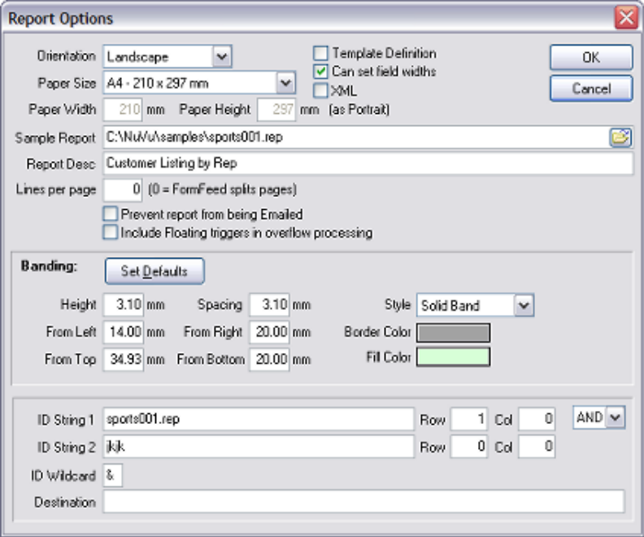

Advise the required parameters (described below) and click the OK button to save these report options, or alternatively click on the CANCEL button to undo any changes made to the parameters on this screen.

Orientation

The report may either be produced in a Landscape (wide) or Portrait (tall) orientation. The reporting system uses standard Windows printing mechanisms, which provide these two orientations on most printers that support graphical output.

This option defaults to Landscape, as in the real world, over 80% of all column-based reports are produced in this format, which allows for more information to be shown across the page as opposed to the Portrait format.

Template Definition

Tick this option if this report definition is to be used as a template in other reports. The report designer will first ensure that there is only a single trigger defined for this report (multiple triggers in a template definition are not allowed, because the whole template will be associated with a single trigger in the reports which utilise the template).

When a definition is marked as being a template, when the SAVE button is pressed, you will be prompted with the following dialog window:

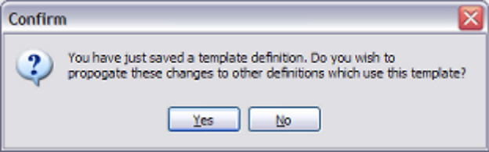

This dialog confirms whether or not the changes made to this template definition will be propogated (copied) to all (or selected) report definitions which utilise the template definition. Under normal circumstances, the user would respond with YES here, except if an interim save has been pressed and there are still further changes to be made to the template before it is finalised.

If the user chooses to propogate the template definition to the report definitions which utilise it, then the following dialog window will be presented:

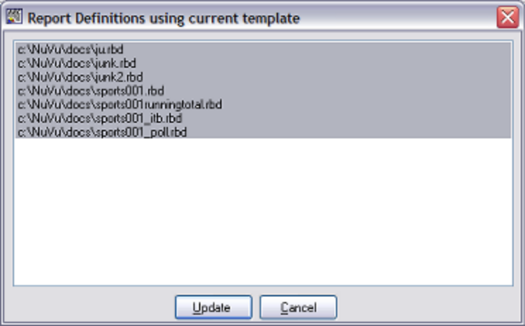

This dialog window will contain a list of report definitions which have been found, which use the current report template definition. By default, all definitions in the list will be highlighted, although the user may hold down the CONTROL key and click on any of the definitions to EXCLUDE them from being updated (not recommended). At this point, the user is given the choice of proceeding with the update (by pressing the UPDATE button), or cancelling the update of the associated report definitions (by pressing the CANCEL button). If the UPDATE button is pressed, then each of the highlighted definition files will be processed and the new template definition will replace the old one in each file. As the files are processed, they will be de-selected, giving the user visual feedback as to the progress of the operation. Note, if there is a sharing violation or other error when attempting to replace the template within any of the report definitions, an error message will be presented. Write down the name of the file(s), as these can then be manually loaded into the designer and saved (once the sharing violation or error has been resolved). This manual load/save is the same procedure which is performed automatically via the UPDATE button on the 'Replace Template' dialog window.

Paper Size

This drop-down combo-box contains all the possible page sizes that can be associated with the report. The default 'Portrait' sizes (width x height) are shown alongside each paper size.

Remember, advising a page orientation of 'Landscape' will reverse these paper sizes (ie: the height and width sizes are swapped around).

When either the orientation or paper size is changed by the user, the designer canvas area is automatically resized to accommodate the maximum sizes as shown in the combo-box.

The default shown when a new report is created is 'A4' but the following papersizes may be specified:

- A3 (297 x 420 mm)
- A4 (210 x 297 mm)
- A5 (148 x 210 mm)
- A6 (105 x 148 mm)
- B5 (176 x 250 mm)
- C5 (162 x 229 mm)
- Letter (8.5 x 14 inches)
- Legal (8.5 x 11 inches)
- Custom Size

Paper Width

This field displays the millimeter size of the currently selected Paper Size (as discussed in the previous section). This field is read-only (cannot be changed manually) unless the selected Paper Size is set to 'Custom Size'. If a custom size has been chosen, then you are able to advise the millimeter value of the width of the paper. This value will govern the defined size of the width of the paper when the report is viewed and printed.

Paper Height

This field displays the millimeter size of the currently selected Paper Size (as discussed in the previous section). This field is read-only (cannot be changed manually) unless the selected Paper Size is set to 'Custom Size'. If a custom size has been chosen, then you are able to advise the millimeter value of the height of the paper. This value will govern the defined size of the width of the paper when the report is viewed and printed.

Can set Field Widths

Tick this option to enable to manual sizing (horizontal only) of any fields or downfields. By default, this option is NOT ticked when a new report definition is created. When this option is not ticked, then fields (and downfields) cannot be sized. The width of these fields are determined automatically when the report is previewed. Note in this case, that if the contents of a field or downfield are larger than expected, the contents of these fields may overwrite other fields on the report. In other words, the width of fields that are not manually sized (ie: this option is NOT ticked) are not clipped, and the complete field contents will be output to the report.

If this option is ticked, then the fields will only display in the defined area (bounding rectangle) defined for each field or downfield. Although there is more work in determining the width of each field (although the designer attempts to create fields with the desired field width), the results are guaranteed to display correctly in the preview window.

NOTE1: If this option is ticked when there already fields or downfields defined for the report, these fields are automatically resized to defined widths, depending on the width of the field on the legacy report, and the defined fontsize of each field. There is NO automatic undo facility so ensure that the desired option is chosen before clicking the SAVE button.

NOTE2: If this option is unticked when there are already fields or downfields defined for the report, these fields are automatically resized to a value of 'Automatic Width'. There is NO automatic undo facility so ensure that the desired option is chosen before clicking the SAVE button.

XML

Tick this option if the input to the NuVu report is going to be XML (Extended Mark-up Language). XML input comprises of elements and attributes. XML differs to standard legacy reports, in that the format of the XML is variable.

If this option is ticked, then the field properties dialog window will contain XML tags and nodes, instead of the Row, Column-From and Column-To fields. Also, the Trigger Properties dialog window will contain the 'Ending XML tag' field instead of the 'No. of Logical Lines' field.

Sample Report

This is a mandatory field, where the user must advise the sample legacy report (ie: text-based report) which is to be loaded into the designer. This sample report is then used to map Text, Fields and Down Fields into the report definition. The full pathname of the sample report is required here, and the advised value will be validated to ensure that a physical report exists with the advised pathname.

The advised Sample report is automatically used by the Print Preview function when viewing the merged results of the report definition and data.

The 'Filename' icon at the end of this field may be clicked in order to invoke the standard Windows 'Open File' dialog window, allowing the user to browse the network neighbourhood to locate the desired sample report.

Normal practice is to extract a copy of the legacy report which needs to be beautified and delete all but the first page or two of data before saving it in a 'samples' sub-directory (directly below the RBD installation directory). Obviously if the report is stored on a UNIX server, that report will have to be electronically copied (or FTP'ed) across to the Windows environment.

Report Description

This description is used to identify the report amongst all the other defined reports. This description is also used as the default subject and body text when the report is emailed to email recipient(s), as well as the heading that appears at the top of the exported Excel spreadsheet.

Please note, this default report description can be overridden at run-time. This is achieved by mapping a normal field to the desired report description, and naming this field "ReportDescription". The NuVu previewer will examine the design file at run-time, and replace the default report description with the contents of the "ReportDescription" field if it is found.

Lines per page

A non-zero setting is required if the legacy report does not contain form-feeds (chr 12) to designate new pages, AND you require a <NEWPAGE> trigger to process at the start of each new page. For example, some legacy applications output fixed length logical pages (of lets say 48 lines) for form-based reports that output to a legacy printer that was also set to 48 lines per page. By setting this value to 48 here, the report will be processed as if there is a form-feed after every 48 lines in the legacy report.

Prevent report from being Emailed

This check-box may be ticked if the user wants the report to be prevented from being emailed via the NuVu report viewer. This option is applicable to sensitive reports (Cheques for example) which must only be printed.

Include Floating triggers in overflow processing

This check-box may be ticked if the user wants to include all triggers that are marked as 'floating' to be included in overflow processing. Overflow processing occurs when the current trigger attempts to output information to the canvas, and that trigger has the 'New page if...' set to anything other than zero millimeters. All fixed triggers that have the 'repeat on every page' and 'if repeating, only on overflow' tick-boxes set to true. If this check-box is ticked, then all floating triggers that have the 'repeat on every page' and 'if repeating, only on overflow' tick-boxes set to true are also included in overflow processing.

It is important to note that the triggers are processed in the same order as they appear in the 'Triggers' drop-down box.

Banding: Overview

Banding is a very useful feature which results in bands of color being printed down the printed page at run-time. The result of advising banding on the report is similar to the old pre-printed standard stock stationery that was used by the legacy line-printers. These used to use paper that was alternatively banded in sections of a coloured band (green or yellow) followed by a white band. This mechanism was useful to the end-user when attempting to read figures across a heavily populated report. To enable this option, the Banding Height (in millimeters) must be advised as non-zero.

Banding: Set Defaults

This button will automatically set the banding properties to the default, based on the current trigger downfield starting position and height. The Banding Height and Banding Spacing will be set to the height of the downfields (as specified on the Trigger dialog window). The Banding From Top will be set to start at the first downfield on the trigger. The Border and Fill colors of the banding will be set to Silver. The Left, Bottom and Right Margin properties will not be affected.

Be careful when clicking this button, as there is NO undo facility, except that the CANCEL button can be pressed which will not save any changes made (to the banding properties or any other properties on this dialog window).

Banding: Height

This Banding parameter determines how wide (ie: the height) to print each colored section of the band. Advising a value of zero here will effectively turn OFF the banding function. As a general rule, if banding is to be enabled, the height of the banding should correspond to the advised 'Section Height' of the primary down trigger (typically between 3 and 4 mm).

Banding: Spacing

This option is only effective if a non-zero Banding Height is advised (see the Banding: Height property above). This field is used to advise how high (in millimeters) the blank section is between each colored band. Typically this value should correspond to the advised Banding Height. This will result in a uniformly layered banding on the generated report.

Banding: From Left

This option is only effective if a non-zero Banding Height is advised (see the Banding: Height property above). This property is used to specify the distance, in millimeters, from the left margin of the page where the banding will start drawing.

Banding: From Right

This option is only effective if a non-zero Banding Height is advised (see the Banding: Height property above). This property is used to specify the distance, in millimeters, from the right margin of the page where the banding will stop drawing.

Banding: From Top

This option is only effective if a non-zero Banding Height is advised (see the Banding: Height property above). This property is used to specify the distance, in millimeters, from the top margin of the page where the banding will start drawing.

Banding: From Bottom

This option is only effective if a non-zero Banding Height is advised (see the Banding: Height property above). This property is used to specify the distance, in millimeters, from the bottom margin of the page where the banding will stop drawing.

Banding: Style

This option is only effective if a non-zero Banding Height is advised (see the Banding: Height property above). This drop-down combo-box is used to advise what type of banding is to be produced. Valid options are:

- Dotted Line - the border of the colored band will be printed with a dotted line (in the advised Border Color)
- Solid Band - the border of the colored band will be printed with a solid line (in the advised Border Color)

Banding: Border Color

This option is only effective if a non-zero Banding Height is advised (see the Banding: Height property above). This property is used to specify the color in which the edges of the colored portion of the band will be printed. Clicking on the displayed color panel (to the right of the 'Border Color' text), will present the user with a standard color dialog window, as shown below:

This dialog window allows for exact color determination, either by clicking on the selected area in the color spectrum window, or else advising an exact Red/Green/Blue (RGB) value in the available input fields.

Banding: Fill Color

This option is only effective if a non-zero Banding Height is advised (see the Banding: Height property above). This property is used to specify the color in which the inside (fill area) of the colored portion of the band will be printed. Clicking on the displayed color panel (to the right of the 'Fill Color' text), will present the user with a standard color dialog window, as shown below:

This dialog window allows for exact color determination, either by clicking on the selected area in the color spectrum window, or else advising an exact Red/Green/Blue (RGB) value in the available input fields.

ID Overview

Whenever a report is saved, the details advised in the ID section (described below) is automatically updated to the 'rbd_find.def' report definition file, as specified on the 'Designer Properties' dialog window. This file is normally named 'rbd_find.def' and normally stored in the same folder as the NuVu installion (Mapped Drive:\NuVu by default), but this can be changed to any file on any folder on your network.

The information contained within the written line of details is used by the 'rbd_find' utility program (see the Nuvu Technical Reference Manual for more details on this utility). This utility program is used to automatically identify which report definition to associate with the passed legacy report at run-time. This is done by reading in the first 100 lines of the processed legacy report, and then processing through the design definitions contained with the 'rbd_find.def' definition file to attempt to find the first entry that matches the advised search string(s) that are found within this definition file. These search strings (and other information) is automatically written to the definition file whenever a design is saved (or created) within the NuVu report designer tool.

ID String

The advised text string will be searched for at run-time by the 'rbd_find' utility program in order to determine which report definition to associate with the advised legacy report. This string is normally the same as the 'Trigger Search Text' advised in the primary trigger of the report, but does not necessarily have to be so.

If this string is left blank, then NO entry will be written into the 'rbd_find.def' file at all.

ID Row

If a non-zero value is advised here, then the ID string will only be searched for in the specified row of the legacy report. Leaving this option at zero, will search the legacy report for the ID string in any row (up to row 100 of the report).

ID Column

If a non-zero value is advised here, then the ID string will only be searched for in the specified column of the legacy report. Leaving this option at zero, will search the legacy report for the ID string in any column of each searched line.

AND/OR

This combo-box allows the advise of a second search string (and row/column specification). As a default, this combo-box is initially set to a value of blank, denoting that there is only a single search string. If this value is set to blank, then the second ID String, ID Row and ID Column will be automatically disabled as they are no longer applicable. Also if a non-blank value is advised here, then the designer will ensure that you advise both a primary ID String as well as the second ID String.

ID String 2

The advised text string will be searched for at run-time by the 'rbd_find' utility program in order to determine which report definition to associate with the advised legacy report. Depending on the AND/OR combo-box, this string will be searched in conjuction with the primary search string (AND), or as an alternate to the primary search string (OR).

ID Row 2

If a non-zero value is advised here, then the ID string will only be searched for in the specified row of the legacy report. Leaving this option at zero, will search the legacy report for the ID string in any row (up to row 100 of the report).

ID Column 2

If a non-zero value is advised here, then the ID string will only be searched for in the specified column of the legacy report. Leaving this option at zero, will search the legacy report for the ID string in any column of each searched line.

ID Wildcard

The advised character (& by default) will be used as a wildcard character, replacing the word in the ID string. For example, if an ID string of 'Customer Listing for Rep: &, sorted by date', then any string in the legacy report which contains 'Customer Listing for Rep: <any string>', but ending with a ', sorted by date' will be identified as the ID string.

Destination

If a non-blank value is advised here, then this destination string (if valid) will substitute any advised destination string during the preparation of NuVu reporting instances at run-time. This setting is very useful if the Nuvu POLL server/service is being utilised, and allows certain definitions to be directed to different printers/printer bins and other destinations. If the Poll server/service is being utilised and this string is left blank, then the default printer destination as advised on the NuVu Configuration 'Poll' page will be used instead.

Invoke the Wizard to build the report
The Report Wizard is a very useful tool which can be used to automatically create the primary down field and header objects given the sample legacy report advised. The report wizard is only able to be activated if a trigger has been defined, and a sample report has been advised in the reporting definition dialog window. Also, it is HIGHLY recommended that the down field row be manually edited to reflect the various fields located on the FIRST down field row. Each numeric field should contain a series of contiguous '>' characters (optionally ending with CR to denote a CR/DB field) or a series of contiguous 'x' characters, indicating an alpha-numeric field. The editing of the down field row of the legacy report is easily achieved by clicking on the {bmc edit.bmp} button, which will result in the legacy report being opened in the 'NotePad' editor. Scroll down to the first down field row, and then ensure that the 'Insert' option is not selected, then change all fields on that row to either a set of '>' (for right-aligned fields) or a series of any other characters (for left-aligned fields). Finally select the 'Save' option to save the changes and then close down the 'NotePad' application. The legacy report will be refreshed inside the NuVu designer, to reflect the changes made.

To invoke the wizard, click on the button. If there are already objects drawn onto the designer canvas, then the following dialog message will be presented:

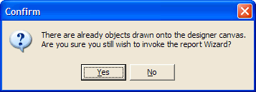

If this dialog message is displayed, click on the YES or NO buttons. If the NO button is clicked, then the current wizard operation is aborted at this stage, otherwise the following Wizard options screen is displayed:

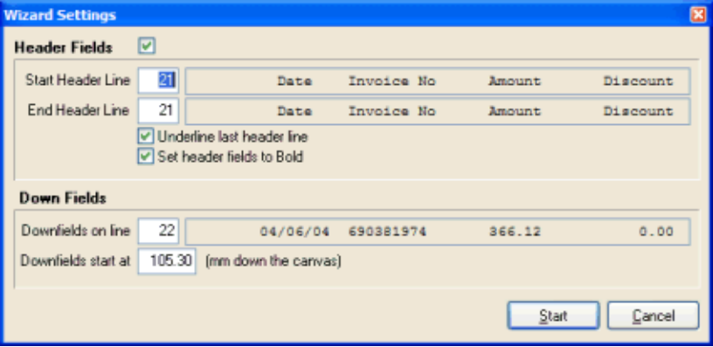

The previous Wizard Options screen is used to advise the following details:

Start Header Line

Advise the line number (row) which represents the FIRST heading row here. The field alongside this row will display the actual contents of the advised row in the legacy report, so that no mistake can be made when selecting this row.

End Header Line

Advise the line number (row) which represents the LAST heading row here. The field alongside this row will display the actual contents of the advised row in the legacy report, so that no mistake can be made when selecting this row.

Underline Last Header Line

Tick this option (the recommended approach) to ensure that the column headings on the last header line will be automatically underlined.

Set Header fields to Bold

Tick this option (the recommended approach) to ensure that the column headings are set to a bold font.

DownFields on line

Advise the row on which the down fields start on. Generally, the wizard will try to determine this value automatically, but the user can override this calculated value here. Again, the field alongside this row will display the actual contents of the row in the legacy report, so that no mistake can be made when selecting this row.

DownFields start at

Advise the millimeter position down the canvas where the first down field row will be positioned. Generally, the wizard will try to determine this value automatically, but the user can override this calculated value here.

Clicking the CANCEL button on this dialog window will cancel the current wizard operation, otherwise the wizard processing will begin, as follows:

The Wizard will examine the advised Down Field row for each non-blank contiguous set of characters (identified as a down field). The wizard will examine the first character of the non-blank set of characters, and if this character contains '>', then the field is assumed to be numeric (and will therefore default to be right-justified), otherwise the field will be assumed to be alpha-numeric, and left-justified. If the 'Confirm individual fields during Wizard operations' setting has been left UNTICKED on the Designer Properties window, then the wizard will automatically create a down field object for each identified field, otherwise the following dialog window will be displayed for each identified field:

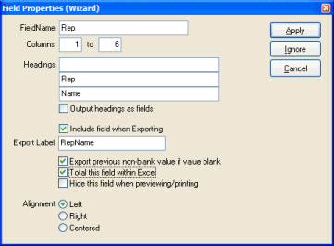

This dialog window contains a sub-set of the properties found on the normal field dialog window. Please refer to the Field Object Properties section for more details on each of these properties. The only sections unique to this dialog window are:

- The 'Alignment' section, which allows the user to choose if the current field should be left, right or center aligned. As previously mentioned, if the first character of the current field contains a '>', then the field will be assumed to be right-justified. If the user chooses the 'right' alignment property, the user will also be prompted whether this numeric field contains a trailing CR (credit). If the user ticks this option, then two separate fields will be created for the current legacy field, one containing the amount (right-justified) and a second containing the 'CR' field (left-justified).
- The 'Headings' section, which displays up to three lines of Heading area for the current legacy field. These headings will be retrieved automatically from the legacy report based on the start and Ending header rows advised on the previous dialog window, but may be changed if appropriate. There is a further option to output the headings as fields. Ticking this option will create Fields (as opposed to Labels) for the headings. This option is useful when there are variable headings (Periods or Months for example) being output to the legacy report, which change each time the report is run.

The Wizard can be used to quickly convert a legacy report with just a few keystrokes. To illustrate this, examine the following snippet of a legacy report, which has been manually edited to automatically define the numeric and alpha-numeric fields, as follows:

SalesPerson Name Phone Balance
--------------- ------------------ ---------- ----------
Fred_Bloggsxxxx Culverwell,_Bxxxxx 843613xxxx >>>1000.00
Smith, S 2266233 452.22
Andrews, D 7882221 .00
----------
SalesPerson Total 1452.22
----------
Joe Smith Killian, F 8733443 500.00
Peters, P 3322123 600.00
----------
SalesPerson total 1100.00
----------
1 2 3 4 5 6
1234567890123456789012345678901234567890123456789012345678901

Looking at the example legacy report above, you will notice that the 'Legacy Report Edit' option has been invoked to edit and prepare the legacy report prior to the execution of the designer wizard. The SalesPerson code (a left-justified alphanumeric code has been filled to the desired size (with a series of 'x's, same has been applied to the 'Name' and 'Phone' fields. The 'Balance' field has been padded with leading ''>' characters, signifying that the field is a numeric (right-justified) field.

To convert this report so that the SalesPerson, Name, Phone and Balance fields are displayed in Arial font, together with the defined heading line above them, perform the following:

1. Ensure that you initially select a fontname of 'Arial'.

2. Define a Trigger which has 'Search Text' set to 'SalesPerson' in Column 6. Also ensure that the 'Detail Rows' option is ticked, and the 'Floating Section' is left unticked. Click on the wizard button. Select the start and ending heading rows which both should be set the same, and reflect the selected heading details ('Salesperson Name Phone' etc.), and ensure that the 'Underline last header row' and 'Set Header fields to Bold' options are both ticked. Click the OK button to begin the Wizard process.

3. For each identified field, a dialog box will be displayed, allowing you to override the default settings for each field. In this example, simply click the OK button to accept the defaults, until all four fields have been drawn, and the wizard has finished processing the legacy report. The resulting designer canvas for this trigger would look something like this:

SalesPerson Name Phone Balance
[D] [D] [D] [D]

4. Once the Wizard has finished processing, all created objects (the down fields and heading fields) will be automatically selected, allowing you to fine-tune the position of the created objects by clicking the up, down, left and right keys to move them as a unit in the direction of the keys. Note, holding down the <control> key while pressing the arrow keys will move the objects 10 pixels at a time instead of the normal 1 pixel.

ALTERNATIVE DRAWING METHOD

As an alternative to the wizard, there is a shortcut method for drawing fixed labels, fields and down fields onto the canvas with just a few keystrokes. This next short tutorial will explain how to define a series of field objects and down field objects from the legacy report onto the designer canvas:

Again, we will display a sample legacy report snippet to illustrate this feature, as follows:

sports001.rep Demonstraton Company Date: 28/03/2003
SalesPerson Report

SalesPerson Name Phone Balance
--------------- ------------------ ---------- ----------
Fred Bloggs Culverwell, B 843613 1000.00
Smith, S 2266233 452.22
Andrews, D 7882221 .00
----------
SalesPerson Total 1452.22
----------
Joe Smith Killian, F 8733443 500.00
Peters, P 3322123 600.00
----------
SalesPerson total 1100.00
----------
1 2 3 4 5 6 7
1234567890123456789012345678901234567890123456789012345678901234567890

Comparing the legacy report above with the same legacy report that was manually prepared with the 'Legacy Report Edit' tool, you will notice that it represents a standard report. Therefore, using the alternative drawing method, there is no need to manually prepare the legacy report, and this method is sometimes quicker using the wizard itself.

1. We are going to initially draw the fields ('sports001.rep', 'Demonstration Company', Date and 'Salespersion Report' onto the designer canvas. First select (highlight) the 'sports001rep' field on the legacy report. Click <control>F twice to select 'persistent' field drawing mode. You will notice that the 'Draw field' icon in the toolbar will turn a red colour signifying that 'persistent' field drawing mode is enabled.

2. Now all you have to do is click the F2 button (the auto-draw button). You will notice that a field is automatically created on the designer canvas, representing the 'sports001.rep' field on the legacy report. The placement of this field onto the designer canvas is calculated using the 'Auto Font Size' and 'Auto Line Height' fields which can be manually set on the 'Designer Properties' dialog window.

3. Repeat this same step after selecting the 'Demonstration Company', Date and 'SalesPerson Report' fields on the legacy report. As per the Designer Wizard, objects are automatically selected as they are drawn onto the canvas.

4. Once all the fields have been drawn onto the canvas, click the 'pointer' toolbar button to ensure that items are all de-selected.

5. To draw the down fields (SalesPerson, Name, Phone and Balance fields), repeat steps 1 through 4 but this time selecting the 'down field' drawing mode by holding down the <control> key and clicking the 'D' key twice, thereby selecting persisent down field drawing mode, then highlight the first down field in the legacy report ('Fred Bloggs' plus any additional spaces required to make up the desired length of the down field), and then simply click the F2 key (auto-draw button). You will notice that a [D] down field is automatically created onto the designer canvas at the calculated position, as per step 2 above.

6. Repeat step 5 for the remaining down fields in the legacy report ('Name', 'Phone' and 'Balance' fields).

7. Finally, click the 'pointer' button to de-select all drawn down field objects. The designer canvas should represent something like the following:

sports001.rep Demonstration System 28/03/2003
SalesPerson Report

SalesPerson Name Phone Balance
[D] [D] [D] [D]

8. The same processing could also be applied to static text fields ('Date:' for example), following steps 1 through 4 above.

9. Once all desired objects have been drawn onto the canvas, these objects can be manually selected and their fontsize, font style, font name etc. changed as per normal designer drawing techniques.

Undo changes to objects on the canvas
This very useful function will allow any of the last 20 changes that have been applied to the object(s) on the designer canvas to be "undone". The undo button has an associated drop-down menu which can be dropped down to display a list of actions that have been applied to the objects on the canvas. Selecting (clicking) any action will result in all actions from the selected action to the most recent action being "undone". Clicking the button itself will result in only the most recent action being "undone".

There are certain functions performed on the canvas that cannot be undone. For example, opening the 'Designer Properties' dialog window and applying changes to this dialog window will NOT be able to be automatically undone, these changes will have to be manually undone.

The "undo" button will be disabled (grayed-out) if there is no current action that can be undone. If an "undo" function is supported, it will be applied to all selected objects that were involved in the action which is able to be undone.

WARNING: Changing the current trigger, saving the current report definition, adding a new trigger or deleting an existing trigger will clear the undo history, and therefore these functions are not able to be undone.

Redo changes to objects on the canvas
This very useful function will allow the user to "re-apply" any of the previous changes that were "undone". Each time the "undo" function is chosen, all steps which are to be undone are first copied to the "redo" structure. Each time a new change is written to the "undo" structure, the "redo" structure is cleared, therefore only changes that have immediately been undone may be redone.

The redo button has an associated drop-down menu which can be dropped down to display a list of actions that have been "undone" to the objects on the canvas. Selecting (clicking) any action will result in all actions from the first "redo" action to the selected "redo" action. Clicking the button itself will result in only the most recent action being "redone".

The "redo" button will be disabled (grayed-out) if there is no current action that can be redone. If a "redo" function is supported, it will be applied to all selected objects that were involved in the action which is able to be redone.

WARNING: Changing the current trigger, saving the current report definition, adding a new trigger or deleting an existing trigger will clear the undo and redo history, and therefore these functions are not able to be redone.

Cut the selected objects to the clipboard
This option is used when there are selected objects on the currently displayed trigger on the designer canvas that need to be "moved" to another trigger of the same definition, or to another report definition altogether. After this button is pressed, all selected objects are first copied to the internal clipboard, and then are deleted off the canvas. The contents of the clipboard may then be pasted onto any subsequently displayed designer canvas.

If the user presses this button by mistake, the action can be simply reversed (ie: the deleted objects may be redrawn to the current designer canvas) by immediately pressing the 'Paste' button.

This operation is not "undoable" in that the previous contents of the clipboard are automatically cleared before the selected objects are copied to the clipboard.

Copy the selected objects to the clipboard
This option is used when there are selected objects on the currently displayed trigger on the designer canvas that need to be "copied" to another trigger of the same definition, or to another report definition altogether. After this button is pressed, all selected objects are copied to the internal clipboard. The designer canvas of the current trigger will be unaffected by the copy operation.

The information stored within the internal clipboard will remain until a subsequent "Cut" or "Copy" operation is performed. The contents of the clipboard may then be pasted onto any subsequently displayed designer canvas, as many times as deemed necessary.

This operation is not "undoable" in that the previous contents of the clipboard are automatically cleared before the selected objects are copied to the clipboard.

Paste objects on the clipboard to the canvas
This option is used when there are objects placed within the internal clipboard that need to be drawn (pasted) onto the designer canvas of the currently displayed trigger. If there are no objects within the internal clipboard, then this function performs no action.

The "pasting" of the objects stored within the internal clipboard does NOT clear these objects from the clipboard, so that multiple "pastes" are allowed. Care must be taken in this respect, because a second and subsequent paste of the stored clipboard objects might not be apparant to the user, as the objects will be placed onto the canvas at the exact same position every time.

This will not affect the look of the report at run-time, but will slow down the processing of the report, as unnessesary objects will be drawn one on top of each other.

If the user presses this button by mistake, the action can be simply reversed (ie: the pasted objects will be removed from the current trigger designer canvas) by pressing the DELETE key.

Automatically select all downfields
This option is used when the user wishes to automatically select all downfields on the current canvas. This option is normally used when the user wishes to move all downfields to a new position on the canvas.

Once this button has been clicked, the designer will search the current canvas and automatically select all found downfield that are not part of any template object. Once the downfield objects are selected, they may be moved as a single unit via the mouse or arrow keys.

Clicking in a blank area of the canvas will automatically de-select the selected downfield objects.

Select the Zoom Factor for the Canvas
Displaying the designer canvas in a larger zoom (200% or 400%) is very useful when doing complex designs which need accurate positioning of the components on the designer canvas.

This option allows the user to display and work with the Designer Canvas in one of three different zoom settings, selected by opening the combo-box and clicking on:

- 100%: Displays the designer canvas as 100% of it's original size. This is the default which is set as part of the NuVu installation. Generally this setting is adequate for most designer tasks, but users with very high resolution settings might find this setting too small to work comfortably with.

- 200%: Displays the designer canvas at 200% of it's original size. This setting is useful when the users screen resolution is set high, or the user is working on a complex design that requires accurate placement and movement of the objects on the designer canvas.

- 400%: Displays the designer canvas at 400% of it's original size. This setting is only useful when the users screen resolution is set high.

The current zoom setting is automatically saved into the registry, so that it is remembered between designer sessions for each user.

Editing the sample legacy report

This option can be used to edit the associated sample legacy report, in order to prepare it for the NuVu Designer Wizard tool.

The Report Wizard is a very useful tool which can be used to automatically create the primary down field and header objects given the sample legacy report advised. The report wizard is only able to be activated if a trigger has been defined, and a sample report has been advised in the reporting definition dialog window. Also, it is HIGHLY recommended that the down field row be manually edited to reflect the various fields located on the FIRST down field row. Each numeric field should contain a series of contiguous '>' characters (optionally ending with CR to denote a CR/DB field) or a series of contiguous 'x' characters, indicating an alpha-numeric field. Examine the sample report below, which has been already prepared for the Designer Wizard:

Name Code Balance Last Paid
---- ---- ------- ---------
Brianxxxxxxxxxxxxxxxxxxxxxx Brianxxxxxx >>>>>>>>>.99 01/04/2003

The editing of the down field row of the legacy report is easily achieved by clicking on the button, which will result in the legacy report being opened using the text editor advised on the 'Designer Properties' window. During installation, this will automatically default to the standard Windows 'NotePad' editor. Scroll down to the first down field row, and then ensure that the 'Insert' option is not selected, then change all fields on that row to either a set of '>' (for right-aligned fields) or a series of any other characters (for left-aligned fields). Note that each non-blank field must start with a '>' character to indicate a numeric right-justified field, otherwise the field will be assumed to be alpha-numeric.

Finally select the 'Save' option of your text editor to save the changes and then close down the text editor application. The legacy report will be refreshed inside the NuVu designer, to reflect the changes made.

- The Report Previewer

Introduction
The report previewer allows the user to view the current report. The report is displayed in a WYSIWYG (What You See Is What You Get) window which represents the format of the report as it would appear on a printed page.

Once a report is being viewed, the report can then be printed, emailed, Faxed, Blasted, Exported to CSV, Exported directly to Excel, saved as a jpeg image or searched for text by clicking the appropriate toolbar buttons that are located at the top of the NuVu report viewer. These toolbar options are covered in detail in the subsequent sections of this help reference.

The preview window is automatically integrated within the Report Designer tool (and displayed when the ‘Print Preview’ button is pressed from within the designer, but is also available as a seperate tool which is able to be integrated within your applications print solution to present legacy reports in an enhanced way, by applying the formatting of text to the legacy report, as defined in the associated report designer template for this report.

There are a number of 'Hotkey' combinations that can be used while viewing the report (as long as the mouse pointer is in the report viewing area):

- PageDown key - will result in the next section OF THE CURRENT PAGE to be displayed
- PageUp key - will result in the previous section OF THE CURRENT PAGE to be displayed
- Shift-PageDown key - will result in the next page of the current report to be displayed
- Shift-PageUp key - will result in the previous page of the current report to be displayed
- Home key - will position the display at the top-left corner of the current page
- End key - will position the display at the bottom-right corner of the current page
- Shift-Home key - will display the FIRST page of the report (same as clikcing the 'first page' toolbar button)
- Shift-End key - will display the LAST page of the report (same as clikcing the 'first page' toolbar button)
- Alt-LeftArrow key - will move the display of the page across to the left (if not already displaying the left margin of the page)
- Alt-RightArrow key - will move the display of the page across to the right (if not already displaying the right margin of the page)
- Alt-UpArrow key - will move the display up a line (if not already at the top of the page)
- Alt-DownArrow key - will move the display down a line (if not already at the bottom of the page)
- Control-Click - will result in the current page being zoomed in (same as clicking the 'zoom in' toolbar button) until the maximum zoom level is reached
- Shift-Click - will result in the current page being zoomed out (same as clicking the 'zoom out' toolbar button) until the minimum zoom level is reached
- Control-RightClick - and dragging the mouse pointer and then releasing it will result in the area contained within the drag area (denoted with a dotted rectangle) to be zoomed in and displayed

The preview window is automatically maximised to fill the available area of the screen when the tool is opened, and is represented as shown in figure 1 below.

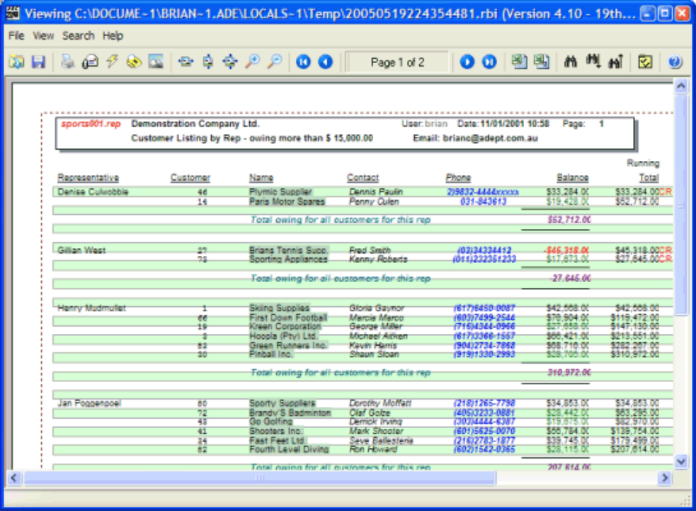
Figure 1

By default the first page of the report is initially displayed, but the user is able to navigate through the various pages from the first to the last pages of the report as required. The viewing area may be zoomed in (enlarged) by clicking the left mouse button on the preview area at any time. Each subsequent left click of the mouse button will result in the display being further magnified, until a maximum magnification is reached. The viewing area may be zoomed out (made smaller) by holding down the SHIFT key while clicking on the left mouse button at any time. Each subsequent SHIFT-LEFT click of the mouse button will result in the display being further reduced, until a minimum zoom level is reached. If the viewing area cannot completely display a page of the report, then the right mouse button can be depressed (and held down) which the mouse is moved, resulting in the panning of the page within the viewer window.

On-Line help is available at any time (within the preview window, or any associated dialog window) by pressing F1.

Key features of the previewer tool include :
- Page navigation – first, next, previous and last pages may be easily navigated to
- Email report – any displayed report may be emailed (attached) to any email recipient
- Text Search – A powerful text search capability exists to search forward or backward through the report for text
- Export – The displayed report can be exported in a comma-seperated format and automatically loaded into your favourite spreadsheet program
- Zooming and Panning – the displayed report can be zoomed in or out, or panned to display the relevant section of the report to the user

Open a previously saved report instance
Pressing this button assumes you wish to open an existing (previously created) Report Instance. Report Instances are able to be saved by pressing the 'Save current report instance for later retrieval' button.

After pressing this button, a standard Windows 'Open File' dialog window will be displayed, allowing the user to browse the network neighbourhood for the location of the report instance (which must exist). If the user presses the 'Cancel' button in the Windows 'Open File' dialog window, then the opening of an existing report instance is CANCELLED, and the user is returned to the report instance that was previously displayed before the 'Open' button was pressed.

Save report instance for later retrieval
Pressing this button assumes you wish to save the currently displayed report instance to disk, for later retrieval. A standard Windows 'Save As' dialog window will be displayed, allowing the user to browse the network neighbourhood for the desired folder and filename to save the report instance in to.

The user can choose to either save the report in native NuVu format (files with an extention of .rbi) or alternatively as Adobe Acrobat format (files with an extention of .pdf).

If the user presses the 'Cancel' button in the Windows 'Save As' dialog window, then the saving of the current report instance are NOT performed, and the user is returned to the display of the current report instance.

This option is often used, when a few reports need to be emailed to a single address, but the user wishes to only send one email, with all the report instances sent as attachments within it.

The procedure is then to view the desired report instances, and then press the save button, saving them with the appropriate filename. Once all the reports have been saved, invoke your email client (Outlook for example) and manually choose to attach the reports that were previously saved.

Print the current report instance
This function allows the user to print selected pages of the currently displayed report instance to any defined windows printer on the network. A print dialog window will be displayed thus:

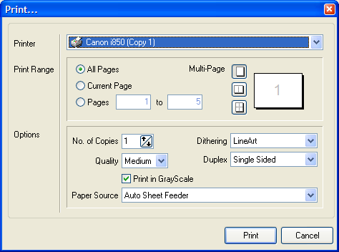

Printer

This combo-box contains a list of all available windows network printers. The currently selected 'Default' printer will be automatically selected, but any of the displayed printers may be selected here. Once a new printer is selected, that printer will be used for all subsequent printing, until the session is closed, or a new printer is selected.

Print Range

This set of radio buttons may be used to either print all pages of the currently displayed report instance, just the current page of the displayed report instance, or an advised range of pages of the currently displayed report instance. The print range defaults to 'All Pages'. Changes made to the print range will remain in effect until the session is closed.

No. of Copies

This option allows the user to change the default number of copies to print on the selected windows printer. The default is 1 copy. Changes made to the number of copies will remain in effect until the session is closed.

Quality

This combo-box allows the user to select in which quality to print the report in. Options exist from 'Draft', 'Low', 'Medium' and 'High'. Draft mode allows for the most economical use of the toner or ink cartridge, and High will produce the most appealing results on the printer, at the expense of using more toner or ink. Changes made to this option are saved to the registry, and become the default setting for all subsequent printing, even after closing the current session.

Print in GrayScale?

This check-box allows the user to print a color report in shades of gray. Ticking this option will result in the report being produced in shades of gray. This option allows for the bypassing of the color toner or ink cartridge for greater economy when printing.

Changes made to this option are saved to the registry, and become the default setting for all subsequent printing, even after closing the current session.

Multi-Page

This advanced setting allows for the printing of more than one report page onto a physical piece of paper. Options exist for one, two or four pages per piece of paper. Note that printing more than one report page per piece of paper will obviously result in a much smaller font being utilized, which makes report analysis more difficult.

Dithering

This combo-box allows the user to advise what type of image dithering is to be applied to the printed report. Options are:
- None - No dithering is applied to images at all
- Course - Course (Rough) dithering is applied to images in the report
- Fine - Fine (high quality) dithering is applied to all images in the report
- LineArt - The images are assumed to be of type LineArt, and appropriate dithering is applied
- GrayScale - The images are dithered in black and white

Duplex

This combo-box allows the user to advise if duplex printing is to be applied to the printed report. Optios are:
- Single Sided - Printing will only occur on one side of the paper
- Horizontal Duplex - Double-sided printing on the Horizontal axis
- Vertical Duplex - Double-sided printing on the Vertical axis

Email displayed report instance
This advanced function allows for the automatic emailing of the currently displayed report instance (or pages of this report) to any email recipient. Depending on the selected options, the email will be sent using the MAPI (Microsoft Applicaiton Programming Interface) or the SMTP (Simple Mail Transport Protocol) email protocols.

There are two different methods of emailing reports:

1. Email the WHOLE report to email recipient(s)

All pages of the currently displayed report instance will be attached to an email and sent to the email recipients advised in the TO field on the email dialog window (described later in this section). This is the only option that will be available unless the report definition has a defined field with a name of 'emailaddr' in any of the triggers.

2. Perform an email blast

This method will be available if the report definition contains a defined field with a name of 'emailaddr' in any of the triggers of the report. This method will allow the selective emailing of pages of the report to identified email recipients contained within the pages of the report. Note that even if a field has been defined with a name of 'emailaddr', the whole report can still be emailed to a single recipient, by simply overriding the TO field in the email dialog window (explained in a later section).

This option will automatically output a comma-separated (csv) logfile showing all email recipients sent an email during an email blast. The logfile will be located in the 'log' directory residing off the same root directory as the 'rbd_preview.exe' (or 'rbd_freepreview.exe') NuVu preview program, and will have a name beginning with 'Blast' and followed by the system data (yyyymmdd) and time (hhmmss), with an extension of .csv. This logfile may be double-clicked from the Windows explorer in order to invoke the standard csv viewer (Microsoft Excel for example), in order to check the recipients who were included in the email blast.

The user will be aware that this method is available by the display of the following dialog window:

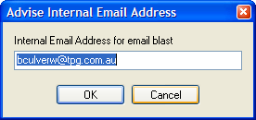

This dialog window will prompt the user for an internal (local) email address. This email address will be stored in the registry, and therefore only needs to be advised once (unless a change to this email address is required). All pages where the actual email address is blank will be collated and emailed to this address at the end of the email blast. The user will then have to open this email, double-click on the report attachment and print the report, for manual distribution to the recipients.

With either email method, an initial email dialog window will then be displayed as follows:

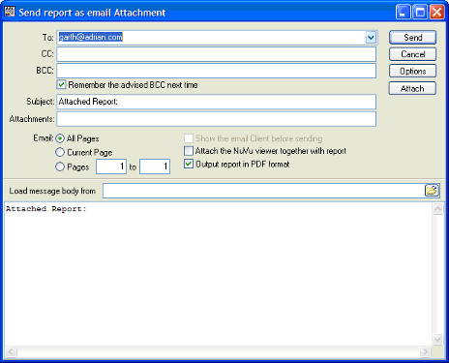

Advise the parameters as described below, and finally click on the SEND button to initiate the emailing of the report (or pages if an email blast). Clicking the CANCEL button will abort the sending of any emails.

To

Advise the email recipient(s) to send this email to. If more than one email address is advised, then a semi-colon must be placed between each address. For example, advising 'bculverw@mymail.com.au; dcul@webmail.com.au' will result in this email being sent to both bculverw@mymail.com.au as well as dcul@webmail.com.au.
Every email address that is advised is automatically stored into the registry for the current user - and is thus available to be selected from the drop-down list the next time the email function is chosen.
To select a previously advised email address, simply type the first few characters of the email address until the desired address is displayed, or alternatively click on the drop-down button alongside this field to show a list of previously sent email addresses and click on the desired one.
To delete an item in the drop-down list, highlight the item in the list and then press the DELETE key.

Validation may be performed on the email addresses typed (if MAPI is the selected email protocol), depending on your installed MAPI email client, but in all cases your email server should respond with 'undeliverable' messages for any incorrect email addresses.

If the report definition contains a defined field with a name of 'emailaddr', then this field will default to 'Individual emails', which signifies that the report will be split up into the various email recipients and emailed to them (by default).

CC

Advise the email recipient(s) to copy this email to. If more than one email address is advised, then a semi-colon must be placed between each address. For example, advising 'bculverw@mymail.com.au; dcul@webmail.com.au' will result in this email being sent to both bculverw@mymail.com.au as well as dcul@webmail.com.au.

Validation may be performed on the email addresses typed (if MAPI is the selected email protocol), depending on your installed MAPI email client, but in all cases your email server should respond with 'undeliverable' messages for any incorrect email addresses.

BCC

Advise the email recipient(s) to blind copy this email to. If more than one email address is advised, then a semi-colon must be placed between each address. For example, advising 'bculverw@mymail.com.au; dcul@webmail.com.au' will result in this email being blind copied to both bculverw@mymail.com.au as well as dcul@webmail.com.au.

Validation may be performed on the email addresses typed (if MAPI is the selected email protocol), depending on your installed MAPI email client, but in all cases your email server should respond with 'undeliverable' messages for any incorrect email addresses.

Remember the BCC next time

If this tick-box is ticked, then the value typed into the BCC field above is saved into the registry, and will be used automatically next time this email window is invoked from the Viewer (or the viewer is requested to email a report from the command-line). To clear out the BCC from the registry, simply blank out the BCC field above, and tick this box. After the email has been sent, the registry will be cleared.

Subject

This field is automatically filled in with the Report description associated with the current report instance (if a report description has been advised within the report definition), but this can be overridden with any appropriate description. Details advised here will be displayed in the subject line of the email when received by the recipient.

Email: All Pages, Current Page, Range of Pages

This set of radio buttons allow the user to select which part of the report is to be emailed to the email recipients. If the whole report is required to be emailed, then ensure that the 'All Pages' radio option is chosen. Choose the 'Current Page' radio option to only email the currently displayed page to the email recipients. Choose the 'Pages From/To' radio option to email the advised range of pages to the email recipients.

Show the email Client before sending

This option is only enabled if the current email settings are set to email using the MAPI (Microsoft Application Programming Interface) standard. If the SMTP (Standard Messaging Transport Protocol) has been selected, then this option will be disabled (greyed out).

The MAPI standard would be the desired method of operation. However, if multiple emails (email blast) is utilised, and the latest security patches have been applied to your MAPI software, then it may be desirable to select the SMTP protocol for sending email messages to overcome the restrictions placed on the sending of email messages via the MAPI client. The SMTP protocol is a simple mail protocol which does not suffer the same restrictions as the MAPI standard. However, in order to utilise the SMTP standard, there are manual settings (Hostname, Port number etc) which have to be advised, and certain email features offered with the MAPI protocol (address book, rich text output, automatic connection to the internet etc.) will also not be available when using this protocol.

If the user ticks this option, then the default 'send mail' MAPI email Client (Outlook, Outlook Express, Netscape Messenger etc.) will be displayed prior to the sending of each email. This is not normally chosen, but may be useful if individual Subject and Messages need to be advised for multiple emails, or if a rich-text output is required (different fonts, images etc embedded into the email).

For example, assuming Outlook Express is the default MAPI client, the following dialog window will be displayed :

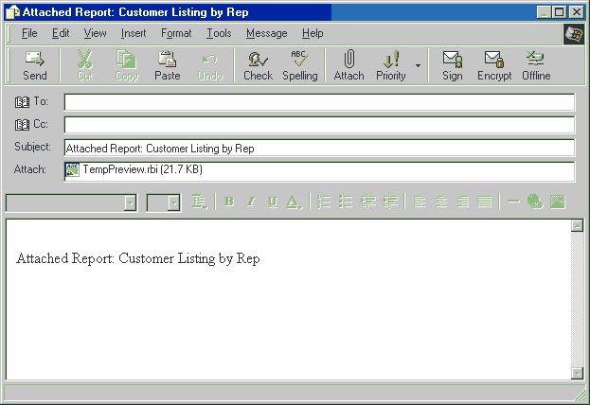

The advised address, copies, subject and message will be automatically copied to the MAPI mail client, but may be altered before the 'Send' (or equivalent) button is clicked to send the actual email to the recipient(s).

Attach the NuVu viewer together with the report

If the user ticks this option, then the auto-installing NuVu viewer will be attached to each sent email as well. This is normally chosen when the email recipient does not already have the NuVu viewer installed on their PC. When the recipient opens the sent email, there will be two attachments - the NuVu viewer installation file, and the report itself. The recipient needs to merely double-click on the NuVu Viewer installation file and the Viewer will be automatically installed into the default c:\nuvu directory.

Output report in PDF format

This toggle setting allows the user to choose whether the report is emailed in the standard NuVu Previewer format, or using the industry standard PDF format.

Ticking this option will result in the report being emailed in PDF format.

Leaving this option unticked will result in the the reports being emailed in standard NuVu Previewer format.

Please note, currently the PDF output option does NOT incorporate the following NuVu design features:

- Angled Labels - these are excluded from the preview
- URL hyperlinks - these are excluded from the preview
- Fonts other than Courier, Arial and Times New Roman are converted to their nearest equivalents

Users who are emailed reports which are attached as PDF documents will have to install a PDF viewer (eg: Adobe Acrobat) before being able to view the attached document. Similarly, reports which are emailed in standard NuVu Previewer format are only able to be viewed after the (free) NuVu Preview software has been installed on the email recipients PC.

Message Area

This field is automatically filled in with the Report description associated with the current report instance, but this can be overridden with any appropriate message. Details advised here will be displayed in the message area of the email when received by the recipient.

The user may optionally choose pre-defined message texts which have been previously created by any plain text editor, by either advising the full pathname in the 'Load message body from' field, or alternatively clicking on the small icon at the end of this field to invoke a standard windows open dialog window, which will allow exploring the network neighbourhood for the desired file. Once a filename has been selected, the contents of that file will automatically be loaded into the Message Area, so that manual adjustments can be made (if required).

Attachments

The NuVu viewer provides the ability to not only attach the generated NuVu report to an email, but also to attach any other files to the email as separate attachments. You are able to manually advise the full pathname of the file required to be attached, or alternatively can click the 'Attach' button in order to browse the network for the required file.

If more that one attachment is required, be sure to separate them with a semi-colon. Before sending the email, NuVu will check to make sure that the advised attachments are valid files on your network, and issue an error message if this is not the case.

Options

The 'Options' button is used to select which email protocol will be used when sending emails (MAPI or SMTP), as well as other connection parameters required if the SMTP protocol is selected. When this button is clicked, the following dialog window will be displayed:

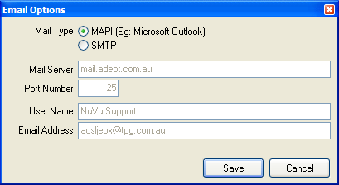

Advise the details as explained below, and ensure that the SAVE button is pressed. This will ensure that the advised values are used in the future. If the CANCEL button is pressed (or the user closes down the dialog window by clicking the X in the top-right corner of the window), then any advised values are ignored, and previous settings are used.

Mail Type

Here the user must select which email protocol will be used when sending emails out to clients. Each protocol has its own advantages and disadvantages. Generally speaking, if the user is doing ad-hoc emailing of displayed reports, and is using a MAPI email system (Microsoft Outlook for example) as a default for other emails, then the MAPI email protocol would be the obvious choice. However, if the user is doing numerous email blasts to many recipients, and the latest MAPI security patches have been applied to the MAPI software, then the SMTP protocol might be more appropriate, because this protocol does not do any security checking before sending emails out to the email server. Disadvantages of the SMTP protocol, is that the email configuration has to be manually advised (the Hostname, Port Number etc. needs to be manually advised on this dialog window) before the emailing via the SMTP protocol will be successful. Also note that a current internet or permanent email server connection is required before issuing an SMTP email send, as opposed to the MAPI protocol, which will prompt to auto-connect if appropriate.

Mail Server

This field is disabled (greyed out) if the selected email protocol is MAPI (because this setting is automatically determined by the MAPI software). If the SMTP protocol has been chosen, then the appropriate host name of the email server must be advised here. This information will probably need to be obtained from your network administrator.

Port Number

This field is disabled (greyed out) if the selected email protocol is MAPI (because this setting is automatically determined by the MAPI software). If the SMTP protocol has been chosen, then the appropriate port number on which to communicate between this PC and the host email server must be advised here. In 99% of cases, the normal smtp port of 25 can be used here. This will probably need to be confirmed with your network administrator.

User Name

This field is disabled (greyed out) if the selected email protocol is MAPI (because this setting is automatically determined by the MAPI software). If the SMTP protocol has been chosen, then the appropriate user name (sign-in name) might need to be advised here. In 99% of cases, this field can be left blank. This will probably need to be confirmed with your network administrator.

Email Address

This field is disabled (greyed out) if the selected email protocol is MAPI (because this setting is automatically determined by the MAPI software). If the SMTP protocol has been chosen, then an appropriate email address (normally your own) must be advised here. This email address will be included with the email message, so that recipients can reply back to the sender (or in the case of undelivered email messages, the email server will send the email back to this recipient address, marked as UNDELIVERED).

Send the report to multiple Recipients (Blast)
This advanced function allows for the automatic emailing, faxing and displaying of individual pages of the current report. This option is only allowed if there is a defined field within the current report with a fieldname of 'blastinfo'. This field must be blank, or filled with three sub-fields, delimited with a pipe (|) symbol. If the field is completely blank, then this page will be added to a list of displayed pages. Otherwise, the first sub-field must contain an 'E' to denote an email recipient, or a 'F' to denote a fax recipient. The second sub-field will contain either the email address of the recipient, or alternatively the fax number of the recipient. The third sub-field is only applicable if the destination is going to be to Fax, and will contain the fax recipient name. For example, a string containing 'F|98947373|Tony Holdgate', will denote that this page will be faxed to the fax number 98947373, for the attention of Tony Holdgate.

Fax the report to a recipient
This function allows the user to fax (using either Winfax or the NuVu Fax Server, depending on which is installed and configured) the contents of the current report to a fax recipient.

At the start of this function, the following dialog window is displayed, allowing the user to advise the various fax parameters:

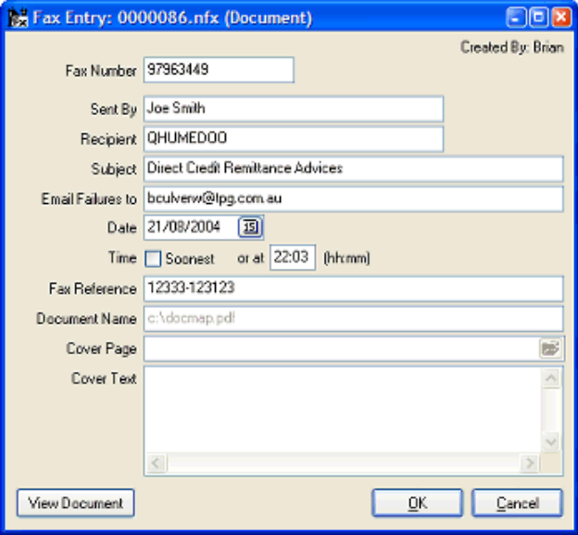

The user must advise at least the fax number and recipient name in order to be able to fax the current report. Clicking the OK button will validate the advised parameters, and then add the fax to the Pending queue, for immediate (or later) transmission, depending on the date/time parameters advised. Clicking the Cancel button will abort the sending of this report via fax.

The top-right hand corner of this window will reflect the user who submitted the fax in the first place.

The Fax Dialog window contains the following input fields:

Fax Number

Advise the fax number to whom the fax will be transmitted here. A comma (or comma's) can be inserted into appropriate positions within the fax number, which will cause the fax dialer to pause at each comma. This is a compulsory field.

Sent By

Advise the person's name who is sending the Fax. This information is stored in the windows registry for re-use the next time this dialog is invoked.

Recipient

Advise the name of the recipient who will be receiving the fax here. This is a compulsory field.

Subject

Advise the subject of the fax here. This subject content will appear on the cover page, if advised. This information is stored in the windows registry for re-use the next time this dialog is invoked.

Email Failures to

Advise the email address that will be used to send the Fax Failure notice if the fax is not able to be sent. If this address if left blank, then the email address that has been advised using the NuVuConfigWizard ON THE FAX SERVER will be used instead. In either case, an email notification will only be sent if the 'Email Failures' option within the NuVuConfigWizard ON THE FAX SERVER has been ticked.

The advised details are stored inside the windows registry and is automatically displayed the next time this utility is invoked.

Date

This field defaults to the current date, but may be changed by the user. This date will determine on which day the fax will be actually transmitted from the Pending queue. This is a compulsory field.

Time

This field defaults to the current time (indicating that the fax will be sent as soon as possible). A future time (and date) can be advised, which will determine the approximate time to send the fax from the Pending queue. This is a compulsory field.

Fax Reference

This contains the optional fax reference number that was extracted from the report as it was processed by the NuVu Reporting engine.

Document Name

If the contents of the fax is an external document (Word, Excel, PDF etc), then the name of the document is displayed here, otherwise this field is hidden.

Cover Page

Advise (or browse for) an appropriate cover page.

If Winfax is your currently installed Fax Server, then any of the Winfax cover pages may be advised. The Winfax cover pages are normally located in the \Program Files\Winfax\Cover folder, and have an extention of .CVP.

If the NuVu Fax Server is currently installed, then any of the NuVu Cover Pages may be advised. The NuVu cover pages are located in the 'Fax Cover Pages' folder within the NuVu installation directory, and have an extention of .nfc.

If this field is left blank, then the fax will NOT have a cover page.

This information is stored in the windows registry for re-use the next time this dialog is invoked.

Cover Text

This optional free-form text-box can be used to fill in the contents of the cover page.

This information is stored in the windows registry for re-use the next time this dialog is invoked.

Adjust display to show page width
This function allows the user to display the complete width of the report in the viewer, irrespective of the current size of the viewer window, or the orientation of the report (landscape or portrait). It is recommended however, that the viewer window is kept maximised at all times, in order that the displayed text within the viewer is visible without significant zooming and panning. It is further recommended that a screen resolution of at least 800 x 600 pixels is used.

Adjust display to show page height
This function allows the user to display the complete height of the report in the viewer, irrespective of the current size of the viewer window, or the orientation of the report (landscape or portrait). It is recommended however, that the viewer window is maximised at all times, in order that the displayed text within the viewer is visible without significant zooming and panning.

It is further recommended that a screen resolution of at least 800 x 600 pixels is used.

Adjust display to show whole page
This function allows the user to display the complete page of the report in the viewer, irrespective of the current size of the viewer window, or the orientation of the report (landscape or portrait). It is recommended that the viewer window is maximised at all times, in order that the displayed text within the viewer is visible without significant zooming and panning. This function is not recommended for portrait reports, as the text of the displayed report page will be illegible unless you are using a really large monitor and screen resolution (1024 x 768 for example).

Zoom in (Magnify)
This function allows for the repeditive zooming in (or magnification) of the current page of the report instance. This option is also automatically available by left-clicking the mouse button when the mouse pointer is within the bounds of the viewer window. The mouse pointer will change to a 'zoom in' icon when the mouse pointer is positioned within the viewer window.

Note that when the mouse button is used to zoom in, the display is automatically centered (where possible) on the text that the mouse pointer was positioned over before the mouse button was pressed.

If the viewer window cannot completely accomodate the current page of the report instance, then 'panning' of the current page of the report instance will be possible by right-clicking and holding down the mouse and then dragging it to a new position.

Zoom Out (Reduce magnification)
This function allows for the repeditive zooming out (or reduction of magnification) of the current page of the report instance. This option is also automatically available by left-clicking the mouse button and holding down the SHIFT key when the mouse pointer is within the bounds of the viewer window. The mouse pointer will change to a 'zoom out' icon when the mouse pointer is positioned within the viewer window and the SHIFT key is depressed.

Note that when the mouse button is used to zoom out, the display is automatically centered (where possible) on the text that the mouse pointer was positioned over before the mouse button was pressed.

If the viewer window cannot completely accomodate the current page of the report instance, then 'panning' of the current page of the report instance will be possible by right-clicking and holding down the mouse and then dragging it to a new position.

Display the first page of the report
This function displays the first page of the current report instance. The on-screen display will be changed to reflect ‘Page 1 of n’, where n is the total number of pages in the report instance.

Display the previous page of the report
This function displays the previous physical page of the current report instance. If the first page is already displayed, then this function simply re-displays the first page. For example, assuming you are displaying the third page, this function will result in the second page of the report being displayed. The on-screen display will be changed to reflect ‘Page m of n’, where m is the new current page (one less than the previously displayed page) and n is the total number of pages in the report instance.

Display the next page of the report
This function displays the next physical page of the current report instance. If the last page is already displayed, then this function simply re-displays the last page. For example, assuming you are displaying the third page, this function will result in the fourth page of the report being displayed (assuming there are more than three pages in the report). The on-screen display will be changed to reflect ‘Page m of n’, where m is the new current page (one greater than the previously displayed page) and n is the total number of pages in the report instance.

Display the last page of the report
This function will automatically display the last page of the current report instance. The on-screen display will be changed to reflect ‘Page n of n’, where n is the total number of pages in the report instance.

Export current report directly into Excel
This advanced feature allows the defined fields, downfields and labels (as specified during the design of the report) to be written directly to a new Microsoft Excel Worksheet. Once the details of the report have been written completely to the Excel worksheet, then the Microsoft Excel application will open to show the contents of the created worksheet.

As a default, only the downfields of each trigger of the defined report are automatically selected for export, but you can override this setting by manually selecting the properties dialog window for each field (and label) and selecting these to also be candidates for the Excel export. All fields (and labels) thus selected will ALWAYS be output first, before the selected downfields on a row.

It is important to note that the headings for the report are only output once (at the top of the Excel sheet), and that these column headings are automatically set to 'AutoFilter', so that you will be able to further filter the contents of the report when the Excel sheet is made visible after this step has been completed.

The layout and look of the Excel worksheet is governed by the settings advised on the 'Preview Options' dialog window that is available from the main menu of the NuVu previewer.

Export current report to .csv file
This advanced feature allows the defined fields and labels (as specified during the design of the report) to be exported to a comma-delimited file. A standard windows 'Save' dialog window will be displayed, allowing the user to navigate to the desired folder and advise an appropriate filename. A default filename of 'rbd_temp', and folder of 'temp' is displayed.

If the 'Save' dialog window is cancelled, then the Export operation is aborted, otherwise the associated viewer for comma-delimited files (normally Excel) will be invoked and the results displayed within it.

Export current report as raw text
This feature allows for the raw text that was used to produced the graphical NuVu report to be saved (exported) to an advised text file. A standard windows 'Save' dialog window will be displayed, allowing the user to navigate to the desired folder and advise an appropriate filename. A default filename of 'rbd_temp', and folder of 'temp' is displayed.
If the 'Save' dialog window is cancelled, then the Export operation is aborted, otherwise the associated viewer for pain-text files (normally Notepad) will be invoked and the results displayed within it.

Once the raw text has been saved to the nominated filename, you will be asked if the associated program should be invoked to view the results. Answering Yes will result in the associated program opening to display the results. If you wish to import the data into Microsoft Excel - best option is to choose No here, and then invoke Microsoft Excel manually and load the file, which will then invoke the Excel Text Import Wizard to format the data.

Begin searching for text
This advanced function allows the user to search for and identify text within the currently displayed report instance. A dialog window will be displayed thus:
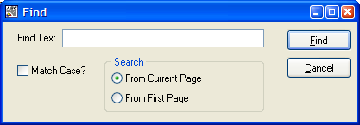
Once the OK button is pressed, the Find Text will be searched for and the first occurance (if any) of the found text will be highlighted with a red background.

Find Text

Allows the user to advise the text to search for. This text must NOT be quoted, unless the user is searching for text with quotes in it.

Match Case?

This check-box allows the user to perform a case-sensitive search or not. Leaving this check-box unticked (the default) will search for any matching text, irrespective of the case of that text.

Search From

This radio-set allows the user to specify that the search is to begin at the currently displayed page of the report instance, or the first page of the report instance. In both cases, the first occurance from the top of the relevant page will be displayed.

Search for the next occurance of text
This function will attempt to locate the next occurance of the search text, either on the current page, or subsequent pages (greater than the current page). If no match can be found, an appropriate message will be displayed informing the user of this event, otherwise the found occurance will be displayed with a red background.

Search for previous occurances of text
This function will attempt to locate the previous occurance of the search text, either on the current page, or prior pages. If no match can be found, an appropriate message will be displayed informing the user of this event, otherwise the found occurance will be displayed with a red background.

Advise Preview Options
This function allows the user to specify the options that can be changed within the report previewer. Once this option has been chosen, the following dialog window will be displayed:

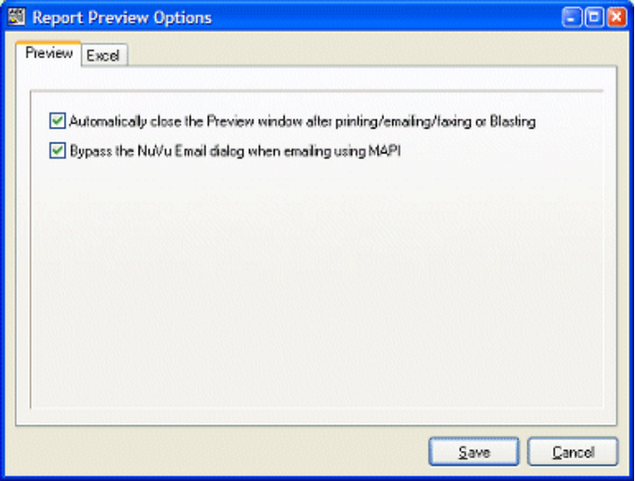

Advise new values for the displayed options within each Tab, and then ensure that you click the SAVE button in order to write these changes back to the registry (for all tabs). Alternatively, if these changes are not required to be saved, click the CANCEL button.

Preview Tab

The Preview Tab contains information that settings that govern the operation of the NuVu Viewing tool. The tab contains the following fields:

Automatically close the Preview window after printing/emailing/faxing/blasting:

If ticked, this setting will cause the NuVu viewer to be automatically closed after a successful print/email/fax or blast has been performed. This option is useful to ensure that a collection of NuVu viewers do not build up on the taskbar if the user does not remember to manually close the NuVu viewer window.

Bypass the NuVu Email dialog when emailing using MAPI:

If ticked, this setting will cause the NuVu dialog to be bypassed completely when the user clicks the 'email' button from the toolbar. Instead of the NuVu Email dialog, the appropriate installed MAPI email viewer is shown (Outlook Express for example).

This option is ignored if the current configuration is set to mail via SMTP, or the currently displayed report is a multiple email recipient candidate.

Excel Tab

The Excel Tab contains information that governs the way that information is output to Microsoft Excel, when this option is chosen as the destination for the viewed report at run-time. The tab contains the following fields:

Report Headings Row:

Advise the Excel Row on which the Report Headings will be placed when the current report is exported directly to a Microsoft Excel worksheet. The default is 1.

Report Headings Column:

Advise the Excel Column on which the Report Headings will be placed when the current report is exported directly to a Microsoft Excel worksheet. The default is 1 (which is the same as 'A' if you are used to Microsoft Excel Column termonology).

Report Headings Font Name:

Advise the font name that will be used to draw the Report Headings text within the Excel worksheet. The default is 'Impact' but may be changed to any available true-type font installed on the machine that is running the NuVu preview utility.

Report Headings Font Size:

Advise the font size (point size) that will be used to draw the Report Headings text within the Excel worksheet. The default is '18', but this can be changed to any available point size between 8 and 72.

Report Headings - Bold Attribute:

Ticking this option will result in the text of the Report Headings being rendered in a BOLD font style. The default is for this option to be ticked.

Report Headings - Italic Attribute:

Ticking this option will result in the text of the Report Headings being rendered in an ITALIC font style. The default is for this option not to be ticked.

Report Headings - Underline Attribute:

Ticking this option will result in the text of the Report Headings being rendered in an UNDERLINE font style. The default is for this option to be left unticked.

Date/Time Headings Row:

Advise the Excel Row on which the Date/Time Headings will be placed when the current report is exported directly to a Microsoft Excel worksheet. The default is 2.

Date/Time Headings Column:

Advise the Excel Column on which the Date/Time Headings will be placed when the current report is exported directly to a Microsoft Excel worksheet. The default is 1 (which is the same as 'A' if you are used to Microsoft Excel Column termonology).

Date/Time Headings Font Name:

Advise the font name that will be used to draw the Date/Time Headings text within the Excel worksheet. The default is 'Arial' but may be changed to any available true-type font installed on the machine that is running the NuVu preview utility.

Date/Time Headings Font Size:

Advise the font size (point size) that will be used to draw the Date/Time Headings text within the Excel worksheet. The default is '8', but this can be changed to any available point size between 8 and 72.

Date/Time Headings - Bold Attribute:

Ticking this option will result in the text of the Date/Time Headings being rendered in a BOLD font style. The default is for this option not to be ticked.

Date/Time Headings - Italic Attribute:

Ticking this option will result in the text of the Date/Time Headings being rendered in an ITALIC font style. The default is for this option not to be ticked.

Date/Time Headings - Underline Attribute:

Ticking this option will result in the text of the Date/Time Headings being rendered in an UNDERLINE font style. The default is for this option to be left unticked.

Column Headings Row:

Advise the Excel Row on which the Column Headings will be placed when the current report is exported directly to a Microsoft Excel worksheet. The default is 2.

Column Headings Column:

Advise the Excel Column on which the Column Headings will be placed when the current report is exported directly to a Microsoft Excel worksheet. The default is 1 (which is the same as 'A' if you are used to Microsoft Excel Column termonology).

Column Headings Font Name:

Advise the font name that will be used to draw the Column Headings text within the Excel worksheet. The default is 'Arial' but may be changed to any available true-type font installed on the machine that is running the NuVu preview utility.

Column Headings Font Size:

Advise the font size (point size) that will be used to draw the Column Headings text within the Excel worksheet. The default is '8', but this can be changed to any available point size between 8 and 72.

Column Headings - Bold Attribute:

Ticking this option will result in the text of the Column Headings being rendered in a BOLD font style. The default is for this option not to be ticked.

Column Headings - Italic Attribute:

Ticking this option will result in the text of the Column Headings being rendered in an ITALIC font style. The default is for this option not to be ticked.

Column Headings - Underline Attribute:

Ticking this option will result in the text of the Column Headings being rendered in an UNDERLINE font style. The default is for this option to be left unticked.

- Designer Tutorial (simple)

Introduction

This section takes you step by step through the process of building your first simple report using the Designer tool. It is assumed that you have little or no knowledge of the Designer tool prior to reading this chapter. Each step will be concluded with an illustration by means of screen images (or other methods) to cement the lessons learned.

The tutorial will use the 'tutorial.rpt' sample report in order to demonstrate the various features of the report Designer. The same steps shown in the tutorial should be able to be used in a live environment to achieve substantial enhancement of existing legacy reports. The sample report is presented below for ease of reference. Please note that the line numbers shown on the right of each line do NOT form part of the report, and are there to assist the user in determining values used in the tutorial:

pa003r00.p DEMONSTRATION SYSTEM (PTY) LTD. User: Brian Date: 24/05/2001 21:05 Page: 0001 1
CUSTOMERS AS AT 01/07/2002 - BY NAME 2
3
Customer 4
Code Customer Name Total Due Credit Limit Last Paid Contact Phone 5
-------- --------------------------------------- --------- ------------ ---------- ------------- 6
ABC001 Brian Culverwell Enterprises 100.00 2000.00 22/03/2001 011-34442333 7
ABC003 Denise's Toilet Supplies 1100.00 22000.00 21/03/2000 021-89797333 8
ABC005 Harrys Curry Den 500.00 42000.00 05/09/2000 031-34442333 9
ABC007 The One Dollar Shop 11100.00 2000.00 12/11/2000 011-35665763 10
ABC009 All in the family way trading company 300.00 100.00 11/02/2000 021-33232133 11
ABC011 Adrian Newey furniture removals 780.00 3000.00 30/05/1999 031-34442333 12
ABC013 Fred Smith Plumbers 333.22 22000.00 NEVER 021-333222113 13
--------- 14
TOTAL DUE: Category A 14213.22 15
========= 16
ABC011 Adrian Newey furniture removals 780.00 3000.00 30/05/1999 031-34442333 17
ABC013 Fred Smith Plumbers 333.22 22000.00 NEVER 021-333222113 18

The Designer tool has a ‘Wizard’ which automates a lot of what is to be demonstrated in the following steps, but the wizard will not be used during the tutorial, although it’s expected use will be shown at the relevant points in the tutorial. This method is adopted in order to show the user how to design a report without the wizard, so that underlying concepts are understood.

This tutorial breaks down the design process into the following logical steps :

- Step 1: Starting a new Report Definition
- Step 2: Specifying Options for the report
- Step 3: Adding a Trigger to the Definition
- Step 4: Adding static text and shapes
- Step 5: Linking Fields to the Definition
- Step 6: Linking Down Fields to the Definition
- Step 7: Previewing Changes
- Step 8: Finishing Up

Step 1 : Starting a new Report Definition
Although there are two different mechanisms for starting a new Report Definition, the tutorial will only cover the first, which is available when the Designer tool is started up (from the desktop icon, or program folder).

If the Designer is already open, close it now.

Choose the Report Designer menu option from the Designer folder, normally available from the Windows Start Menu (or alternatively available as an icon on the desktop). The Designer will load and the main window will be displayed. A welcome dialog window is displayed on top of the normal Designer window, as shown below :

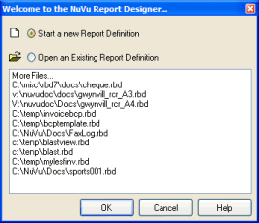

This welcome dialog window allows the user to either start a new report definition, or open an existing report definition, either by choosing one of the recently opened definitions, or by browsing the network to locate an existing report definition to modify.

This tutorial only covers the creation of a new Report Definition file, so simply ensure that the 'start a new report definition' option is selected, and then click the OK button. Note that pressing the ENTER key performs the same function as clicking on the OK button.

The Welcome Dialog will close and you will be presented with the following dialog window:
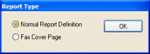

We are going to design a normal report definition, so ensure that the 'Normal Report Definition' radio button is ticked, and then click the OK button.

This dialog window will close and you will be presented with the Report Options Dialog, described in the next section of the tutorial.

Step 2: Specifying Options for the report
After selecting a new Report Definition, the system automatically displays the Report Options dialog window, which allows the user to advise the various options to be set for the current report as a whole. The Report Options dialog displays the following window:

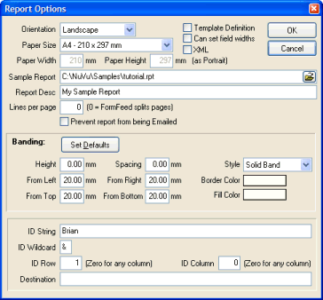

Advise the required parameters (described below) and click the OK button to save these report options, or alternatively click on the CANCEL button to undo any changes made to the parameters on this screen.

For purposes of the tutorial, please ensure that you advise all the settings as described below, and then click the OK button to apply these settings to the current report. Doing so will close the Report Options dialog window, and present you with the main Designer screen, containing a blank designer canvas, but showing the contents of the selected sample report in the bottom section of the window. Once the window has been displayed, the next step in creating a new report definition will automatically begin, that being the advise of the first Trigger for the report (described in the 'Next Step' of the tutorial).

Orientation

The report may either be produced in a Landscape (wide) or Portrait (tall) orientation. The reporting system uses standard Windows printing mechanisms, which provide these two orientations on most printers that support graphical output.

This option defaults to Landscape. In the real world, 80% plus of all operational reports are produced in this format, which allows for more information to be shown across the page as opposed to the Portrait format.

For purposes of the tutorial, select the 'Landscape' orientation option.

Template Definition

Tick this option if this report definition is to be used as a template in other reports. The report designer will first ensure that there is only a single trigger defined for this report (multiple triggers in a template definition are not allowed, because the whole template will be associated with a single trigger in the reports which utilise the template).

For purposes of the tutorial, leave this option unticked. Report templates are an advanced feature covered in the User Manual.

Paper Size

This drop-down combo-box contains all the possible page sizes that can be associated with the report. The default 'Portrait' sizes (width x height) are shown alongside each paper size.

Remember, advising a page orientation of 'Landscape' will reverse these paper sizes (ie: the height and width sizes are swapped around).

When the user changes either the orientation or paper size, the designer canvas area is automatically resized to accommodate the maximum sizes as shown in the combo-box.

The default shown when a new report is created is 'A4' but the following papersizes may be specified:

- A3 (297 x 420 mm)
- A4 (210 x 297 mm)
- A5 (148 x 210 mm)
- A6 (105 x 148 mm)
- B5 (176 x 250 mm)
- C5 (162 x 229 mm)
- Letter (8.5 x 14 inches)
- Legal (8.5 x 11 inches)
- Custom Size

For purposes of the tutorial, leave the default of A4 here.

Paper Width

This field displays the millimeter size of the currently selected Paper Size (as discussed in the previous section). This field is read-only (cannot be changed manually) unless the selected Paper Size is set to 'Custom Size'. If a custom size has been chosen, then you are able to advise the millimeter value of the width of the paper. This value will govern the defined size of the width of the paper when the report is viewed and printed.

Because a default paper size of A4 was advised, this field is read-only, so simply tab past it, leaving the value as displayed.

Paper Height

This field displays the millimeter size of the currently selected Paper Size (as discussed in the previous section). This field is read-only (cannot be changed manually) unless the selected Paper Size is set to 'Custom Size'. If a custom size has been chosen, then you are able to advise the millimeter value of the height of the paper. This value will govern the defined size of the width of the paper when the report is viewed and printed.

Because a default paper size of A4 was advised, this field is read-only, so simply tab past it, leaving the value as displayed.

Can set Field Widths

Tick this option to enable to manual sizing (horizontal only) of any fields or downfields. By default, this option is NOT ticked when a new report definition is created. When this option is not ticked, then fields (and downfields) cannot be sized. The width of these fields are determined automatically when the report is previewed. Note in this case, that if the contents of a field or downfield are larger than expected, the contents of these fields may overwrite other fields on the report. In other words, the width of fields that are not manually sized (ie: this option is NOT ticked) are not clipped, and the complete field contents will be output to the report.

If this option is ticked, then the fields will only display in the defined area (bounding rectangle) defined for each field or downfield. Although there is more work in determining the width of each field (although the designer attempts to create fields with the desired field width), the results are guaranteed to display correctly in the preview window.

NOTE1: If this option is ticked when there already fields or downfields defined for the report, these fields are automatically resized to defined widths, depending on the width of the field on the legacy report, and the defined font size of each field. There is NO automatic undo facility so ensure that the desired option is chosen before clicking the SAVE button.

NOTE2: If this option is unticked when there are already fields or downfields defined for the report, these fields are automatically resized to a value of 'automatic width'. There is NO automatic undo facility so ensure that the desired option is chosen before clicking the SAVE button.

For purposes of the tutorial, leave this option UNTICKED (ie: automatic field widths).

XML

Tick this option if the input to the NuVu report is going to be XML (Extended Mark-up Language). XML input comprises of elements and attributes. XML differs to standard legacy reports, in that the format of the XML is variable.

If this option is ticked, then the field properties dialog window will contain XML tags and nodes, instead of the Row, Column-From and Column-To fields. Also, the Trigger Properties dialog window will contain the 'Ending XML tag' field instead of the 'No. of Logical Lines' field.

For purposes of the tutorial, leave this option (UNTICKED) (ie: input is NOT from XML).

Sample Report

This is a mandatory field, where the user must advise the sample legacy report (ie: text-based report) which is to be loaded into the designer. This sample report is then used to map Text, Fields and Down Fields into the report definition. The full pathname of the sample report is required here, and the advised value will be validated to ensure that a physical report exists with the advised pathname.

The advised Sample report is automatically used by the Print Preview function when viewing the merged results of the report definition and data.

The 'Filename' icon at the end of this field may be clicked in order to invoke the standard Windows 'Open File' dialog window, allowing the user to browse the network neighbourhood to locate the desired sample report.

Normal practice is to extract a copy of the legacy report which needs to be beautified and delete all but the first page or two of data before saving it in a 'samples' sub-directory (directly below the NuVu installation directory). Obviously, if the report is stored on a UNIX server, that report will have to be electronically copied (or FTP'ed) across to the Windows environment.

For purposes of the tutorial, advise 'Mapped Drive:\Nuvu\samples\tutorial.rpt' here. (assuming you have installed the application into the default directory, otherwise change the string to the appropriate installation directory).

Report Description

This optional field is used for descriptive purposes (to indicate the contents of the report), and is also automatically copied to the 'Subject' line and 'Body' message of any emails that are sent (from the email button on the Print Preview window). Advise any descriptive text to identify the report here.

For purposes of the tutorial, advise 'My Sample Report' here.

Lines per page

A non-zero setting is required if the legacy report does not contain form-feeds (chr 12) to designate new pages, AND you require a <NEWPAGE> trigger to process at the start of each new page. For example, some legacy applications output fixed length logical pages (of lets say 48 lines) for form-based reports that output to a legacy printer that was also set to 48 lines per page. By setting this value to 48 here, the report will be processed as if there is a form-feed after every 48 lines in the legacy report.

For purposes of the tutorial, leave this setting at zero, because our sample report does have form-feeds separating pages.

Prevent report from being Emailed

This check-box may be ticked if the user wants the report to be prevented from being emailed via the NuVu report viewer. This option is applicable to sensitive reports (Cheques for example) which must only be printed.

For purposes of the tutorial, leave this option UNTICKED, thus allowing the report to be emailed if required.

Banding: Overview

Banding is a very useful feature which results in bands of color being printed down the printed page at run-time. The result of advising banding on the report is similar to the old pre-printed standard stock stationery that was used by the legacy line-printers. These used to use paper that was alternatively banded in sections of a coloured band (green or yellow) followed by a white band. This mechanism was useful to the end-user when attempting to read figures across a heavily populated report. To enable this option, the Banding Height (in millimeters) must be advised as non-zero.

For purposes of the tutorial, leave the default banding height at zero, which will turn OFF the banding option.

Banding: Set Defaults

This button will automatically set the banding properties to the default, based on the current trigger downfield starting position and height. The Banding Height and Banding Spacing will be set to the height of the downfields (as specified on the Trigger dialog window). The Banding From Top will be set to start at the first downfield on the trigger. The Border and Fill colors of the banding will be set to Silver. The Left, Bottom and Right Margin properties will not be affected.

Be careful when clicking this button, as there is NO undo facility, except that the CANCEL button can be pressed which will not save any changes made (to the banding properties or any other properties on this dialog window).

For purposes of the tutorial, do NOT click this button.

Banding: Height

This Banding parameter determines how wide (ie: the height) to print each colored section of the band. Advising a value of zero here will effectively turn OFF the banding function. As a general rule, if banding is to be enabled, the height of the banding should correspond to the advised 'Section Height' of the primary down trigger (typically between 3 and 4 mm).

For purposes of the tutorial, leave this setting at the default of zero.

Banding: Spacing

This option is only effective if a non-zero Banding Height is advised (see the Banding: Height property above). This field is used to advise how high (in millimeters) the blank section is between each colored band. Typically this value should correspond to the advised Banding Height. This will result in a uniformly layered banding on the generated report.

For purposes of the tutorial, leave this setting at the default of zero.

Banding: From Left

This option is only effective if a non-zero Banding Height is advised (see the Banding: Height property above). This property is used to specify the distance, in millimeters, from the left margin of the page where the banding will start drawing.

For purposes of the tutorial, leave this setting at the default of 20mm.

Banding: From Right

This option is only effective if a non-zero Banding Height is advised (see the Banding: Height property above). This property is used to specify the distance, in millimeters, from the right margin of the page where the banding will stop drawing.

For purposes of the tutorial, leave this setting at the default of 20mm.

Banding: From Top

This option is only effective if a non-zero Banding Height is advised (see the Banding: Height property above). This property is used to specify the distance, in millimeters, from the top margin of the page where the banding will start drawing.

For purposes of the tutorial, leave this setting at the default of 20mm.

Banding: From Bottom

This option is only effective if a non-zero Banding Height is advised (see the Banding: Height property above). This property is used to specify the distance, in millimeters, from the bottom margin of the page where the banding will stop drawing.

For purposes of the tutorial, leave this setting at the default of 20mm.

Banding: Style

This option is only effective if a non-zero Banding Height is advised (see the Banding: Height property above). This drop-down combo-box is used to advise what type of banding is to be produced. Valid options are:

- Dotted Line - the border of the colored band will be printed with a dotted line (in the advised Border Color)
- Solid Band - the border of the colored band will be printed with a solid line (in the advised Border Color)

For purposes of the tutorial, leave this setting at the default of ‘Solid Band’.

Banding: Border Color

This option is only effective if a non-zero Banding Height is advised (see the Banding: Height property above). This property is used to specify the color in which the edges of the colored portion of the band will be printed. Clicking on the displayed color panel (to the right of the 'Border Color' text), will present the user with a standard color dialog window, as shown below:

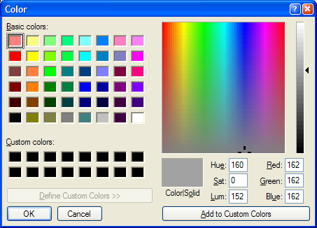

This dialog window allows for exact color determination, either by clicking on the selected area in the color spectrum window, or else advising an exact Red/Green/Blue (RGB) value in the available input fields.

For purposes of the tutorial, leave this setting at the default of Silver.

Banding: Fill Color

This option is only effective if a non-zero Banding Height is advised (see the Banding: Height property above). This property is used to specify the color in which the inside (fill area) of the colored portion of the band will be printed. Clicking on the displayed color panel (to the right of the 'Fill Color' text), will present the user with a standard color dialog window, as shown below:

This dialog window allows for exact color determination, either by clicking on the selected area in the color spectrum window, or else advising an exact Red/Green/Blue (RGB) value in the available input fields.

For purposes of the tutorial, leave this setting at the default of Silver.

ID Overview

Whenever a report is saved, the details advised in the ID section (described below) is automatically updated to the 'rbd_find.def' report definition file contained within the standard NUVU installation directory (Mapped Drive:\NuVu by default). The information contained within the written line of details is used by the 'rbd_find' utility program (see the Nuvu Reference Manual for more details). This utility program is used to automatically identify which report definition to associate with the passed legacy report at run-time.

ID String

The advised text string will be searched for at run-time by the 'rbd_find' utility program in order to determine which report definition to associate with the advised legacy report. This string is normally the same as the 'Trigger Search Text' advised in the primary trigger of the report.

For purposes of the tutorial, leave this setting at the default of blank.

ID Wildcard

The advised character (& by default) will be used as a wildcard character, replacing the word in the ID string. For example, if an ID string of ‘Customer Listing for Rep: &’, then any string in the legacy report which contains ‘Customer Listing for Rep: <any string>’ will be identified as the ID string.

For purposes of the tutorial, leave this setting at the default of &.

ID Row

If a non-zero value is advised here, then the ID string will only be searched for in the specified row of the legacy report. Leaving this option at zero, will search the legacy report for the ID string in any row (up to row 100 of the report).

For purposes of the tutorial, leave this setting at the default of zero.

ID Column

If a non-zero value is advised here, then the ID string will only be searched for in the specified column of the legacy report. Leaving this option at zero, will search the legacy report for the ID string in any column of each searched line.

For purposes of the tutorial, leave this setting at the default of zero.

Step 3: Adding a Trigger to the Definition
After clicking the OK button on the Report Options dialog window, the system automatically clicks on the 'Add new Trigger' button if the user is creating a new report definition. If the user pressed CANCEL on the Report Options dialog window, then the 'new report definition' procedure is cancelled at that point, and this step is NOT performed.

Every report definition MUST have at least one trigger defined. Triggers are nothing more than text strings that are searched for inside the report (at an optional column number). When these search strings are found, they trigger advised events which then occur on the report definition.

If you have followed the instructions from the previous step of the tutorial, then you should be presented with the Trigger Dialog window as shown below:

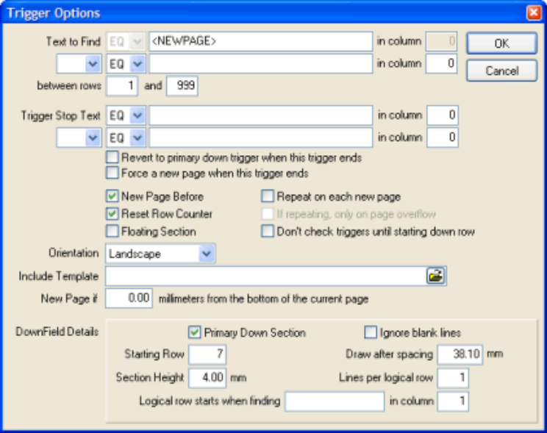

Advise the required parameters (described below) and click the OK button to save these Trigger options, or alternatively click on the CANCEL button to undo any changes made to the parameters on this screen.

Text to Find

Advise the text string (without quotes) to search for in order to 'fire' the trigger.

The 'Condition' drop-down combo-box that precedes this field can be used to either an equilty or inequality test on the search string. Advising a condition of 'EQ' will search for the existance of the advised text, advising a condition of 'NE' will perform an inequality check using the advised text, that is: the trigger will fire if the advised text is NOT found at the specified column.

Please note, if a condition other than 'EQ' is advised, then the designer will validate that the associated 'Column' field is non-zero.

Also note, if the 'Text to Find' begins with a '<', the designer will assume that a reserved word (or XML tag) is being advised, resulting in the 'Condition' field being automatically set to 'EQ' and disabled and the 'in Col' field to be set to zero and disabled also.

The reserved word "<NEWPAGE>" may be typed here, which will cause the trigger to 'fire' at the start of each new page. This is common practice when defining the main trigger for the report. The main trigger is normally used to advise the page and column headings for the report, as well as the associated static fields, and down-fields for the defined columns.

The reserved word "<NEWLINE>" may also be typed here, which will cause the trigger to 'fire' on the reading of each record from the legacy report. This is sometimes used when processing a mail merge file (where each record in the file relates to a separate set of details (for example, a record for each customer in your database).

The reserved word "<BEFOREOVERFLOW>" may be typed here, which will cause the trigger to 'fire' whenever the output to the current page reaches overflow, but BEFORE the output automatically advances to a new page. This trigger is useful to advise rectangle, text and bitmaps that will be printed just before advancing to a new page. For example, this trigger could be used to output a 'Details continue on next page' text.

The reserved word "<OVERFLOW>" may be typed here, which will cause the trigger to 'fire' whenever the output to the current page reaches overflow and automatically advances to a new page. This trigger will fire before all other 'repeat on new page, only if overflow' triggers, and is normally used to output column headings at the start of an overflow page.

The reserved word "<NONBLANKn>" may be typed here, which will cause the trigger to 'fire' when any non-blank text is found (at the optional 'Search in Column'). The length of the non-blank text to check is advised as the 'n' value (between 1 and 9). For example, if you wish to check for any non-blank text between columns 8 and 14, then you would advise <NONBLANK6> in this field, and 8 in the 'Search in Column' field.

The reserved word "<PASSTHROUGH>" may be typed here, which when used alone on a single report design, will result in the report not being processed AT ALL by the NuVu graphic rendering engine. This option is often useful for when a text report that contains embedded escape sequences to do things such as open the cash drawer, or cut the point-of-sale register slip can be passed directly through to the printer at run-time. If this trigger is used, there is NO need to advise any other triggers or fields/labels or downfields on the report, because they will simply be ignored.

Normally column-based reports have some unique identifier at the start of each page - a program id, common heading line etc, which can be advised here (assuming we are defining the main trigger of the report).

For purposes of the tutorial, advise a value of "pa003r00" here (without the quotes). Referring back to the sample report, the pa003r00 string appears at the top of each new page, so this is the trigger text that will be used to define each page of the report.

Search in Column

Advise the column in which to search for the string, or leave as zero if the search string can be located in any column of the report.

For purposes of the tutorial, advise "1" here (without the quotes). Refer back to the sample report shown at the start of this tutorial and you will see that the report identifier "pa003r00" appears in column 1 of each page.

Find Condition

The application has the ability to search for two different sets of text in order to fire the trigger for the current section. The find condition combo-box allows the user to specify the relationship between the two search strings. This relationship can be one of the following three options:

- Blank The second search string is not checked at all
- AND Both the 1st and 2nd search strings must be found before the trigger will fire
- OR Either the 1st or 2nd search strings must be found before the trigger will fire

For purposes of the tutorial, leave this option blank (ie: the trigger will fire just on the finding of the first search text).

Second Text to Find

Advise the optional second text string (without quotes) to search for in order to 'fire' the trigger. This string will only be checked if the Find Condition (see previous field) is advised as either AND or OR.

The 'Condition' drop-down combo-box that precedes this field can be used to either an equilty or inequality test on the search string. Advising a condition of 'EQ' will search for the existance of the advised text, advising a condition of 'NE' will perform an inequality check using the advised text, that is: the trigger will fire if the advised text is NOT found at the specified column.

Please note, if a condition other than 'EQ' is advised, then the designer will validate that the associated 'Column' field is non-zero.

Also note, if the 'Text to Find' begins with a '<', the designer will assume that a reserved word (or XML tag) is being advised, resulting in the 'Condition' field being automatically set to 'EQ' and disabled and the 'in Col' field to be set to zero and disabled also.

The reserved word "<NEWPAGE>" may be typed here, which will cause the trigger to 'fire' at the start of each new page. This is common practice when defining the main trigger for the report. The main trigger is normally used to advise the page and column headings for the report, as well as the associated static fields, and down-fields for the defined columns.

The reserved word "<NEWLINE>" may be typed here, which will cause the trigger to 'fire' on the reading of each record from the legacy report. This is sometimes used when processing a mail merge file (where each record in the file relates to a seperate set of details (for example, a record for each customer in your database).

The reserved word "<BEFOREOVERFLOW>" may be typed here, which will cause the trigger to 'fire' whenever the output to the current page reaches overflow, but BEFORE the output automatically advances to a new page. This trigger is useful to advise rectangle, text and bitmaps that will be printed just before advancing to a new page. For example, this trigger could be used to output a 'Details continue on next page' text.

The reserved word "<OVERFLOW>" may be typed here, which will cause the trigger to 'fire' whenever the output to the current page reaches overflow and automatically advances to a new page. This trigger will fire before all other 'repeat on new page, only if overflow' triggers, and is normally used to output column headings at the start of an overflow page.

The reserved word "<NONBLANKn>" may be typed here, which will cause the trigger to 'fire' when any non-blank text is found (at the optional 'Search in Column'). The length of the non-blank text to check is advised as the 'n' value (between 1 and 9). For example, if you wish to check for any non-blank text between columns 8 and 14, then you would advise <NONBLANK6> in this field, and 8 in the 'Search in Column' field.

The reserved word "<PASSTHROUGH>" may be typed here, which when used alone on a single report design, will result in the report not being processed AT ALL by the NuVu graphic rendering engine. This option is often useful for when a text report that contains embedded escape sequences to do things such as open the cash drawer, or cut the point-of-sale register slip can be passed directly through to the printer at run-time. If this trigger is used, there is NO need to advise any other triggers or fields/labels or downfields on the report, because they will simply be ignored.

For purposes of the tutorial, leave this field blank.

Second Search Column

Advise the column in which to search for the second text string, or leave as zero if the search string can be located in any column of the report.

For purposes of the tutorial, leave this field at the default of zero.

Between rows [X] and [Y]

These options are only normally used on more advanced designs, and allow the user to specify the range of rows of the legacy report which to search between for the identified Trigger text.

For purposes of the tutorial, leave these fields at their default of 1 to 999.

Trigger Stop Text

Advise an optional text string (without quotes) to search for in order to end the currently defined trigger.

The 'Condition' drop-down combo-box that precedes this field can be used to either an equilty or inequality test on the search string. Advising a condition of 'EQ' will search for the existance of the advised text, advising a condition of 'NE' will perform an inequality check using the advised text, that is: the trigger will fire if the advised text is NOT found at the specified column.

Please note, if a condition other than 'EQ' is advised, then the designer will validate that the associated 'Column' field is non-zero.

Also note, if the 'Text to Find' begins with a '<', the designer will assume that a reserved word (or XML tag) is being advised, resulting in the 'Condition' field being automatically set to 'EQ' and disabled and the 'in Col' field to be set to zero and disabled also.

The reserved word "<NEWPAGE>" may be typed here, which will cause the trigger to stop at the start of a new page.

The reserved word "<NEWLINE>" may be typed here, which will cause the trigger to stop when reading a new record from the legacy report.

The reserved word "<NONBLANKn>" may be typed here, which will cause the trigger to stop when any non-blank text is found (at the optional 'Search in Column'). The length of the non-blank text to check is advised as the 'n' value (between 1 and 9). For example, if you wish to check for any non-blank text between columns 8 and 14, then you would advise <NONBLANK6> in this field, and 8 in the 'Search in Column' field.

This option is rarely used (and is therefore normally left blank), but may be advised in unusual circumstances where the trigger is of unknown size (number of rows) but the end of the trigger section can be identified with a text string.

For purposes of the tutotial, we are not going to specify a stop trigger text, so leave this field blank.

Stop Column

Advise the column in which to search for the "Trigger Stop Text" mentioned above, or leave as zero if the search string can be located in any column of the current line of the report.

For purposes of the tutorial, leave this field at the default of zero.

Stop Condition

The application has the ability to search for two different sets of text in order to end the current trigger for the current section. The find condition combo-box allows the user to specify the relationship between the two search strings. This relationship can be one of the following three options:

- Blank The second search string is not checked at all
- AND Both the 1st and 2nd search strings must be found before the trigger will fire
- OR Either the 1st or 2nd search strings must be found before the trigger will fire

For purposes of the tutorial, we are not advising any stop trigger text, so leave this field at the default of blank.

Second Trigger Stop Text

Advise the optional second text string (without quotes) to search for in order to stop the current trigger processing. This string will only be checked if the Stop Condition (see previous field) is advised as either AND or OR.

The 'Condition' drop-down combo-box that precedes this field can be used to either an equilty or inequality test on the search string. Advising a condition of 'EQ' will search for the existance of the advised text, advising a condition of 'NE' will perform an inequality check using the advised text, that is: the trigger will fire if the advised text is NOT found at the specified column.

Please note, if a condition other than 'EQ' is advised, then the designer will validate that the associated 'Column' field is non-zero.

Also note, if the 'Text to Find' begins with a '<', the designer will assume that a reserved word (or XML tag) is being advised, resulting in the 'Condition' field being automatically set to 'EQ' and disabled and the 'in Col' field to be set to zero and disabled also.

The reserved word "<NEWPAGE>" may be typed here, which will cause the trigger to stop at the start of a new page.

The reserved word "<NEWLINE>" may be typed here, which will cause the trigger to stop when reading a new record from the legacy report.

The reserved word "<NONBLANKn>" may be typed here, which will cause the trigger to stop when any non-blank text is found (at the optional 'Search in Column'). The length of the non-blank text to check is advised as the 'n' value (between 1 and 9). For example, if you wish to check for any non-blank text between columns 8 and 14, then you would advise <NONBLANK6> in this field, and 8 in the 'Search in Column' field.

For purposes of the tutotial, we are not going to specify a stop trigger text, so leave this field blank.

Second Stop Column

Advise the column in which to search for the "Second Trigger Stop Text" mentioned above, or leave as zero if the search string can be located in any column of the current line of the report.

For purposes of the tutotial, we are not going to specify a stop trigger text, so leave this field at the default of zero.

Revert to primary down trigger when this trigger ends

This tick-box is used to determine if the primary 'down' trigger (as advised by ticking the 'Primary Down Trigger' tick box in the down fields section of each trigger) will resume after this trigger ends or not. Ticking this item will result in the Primary Down Trigger resuming, otherwise no further processing will occur on the canvas until the next trigger fires. This option is automatically unticked when advising some value in the 'Stop Trigger Text' of the primary down trigger, as it does not make sense to advise a stop condition for the trigger but resume the primary down trigger (ie: the same trigger) on ending this trigger.

This is an advanced feature, so leave this option UNTICKED for purposes of the tutorial.

Force a new page when this trigger ends

This tick-box is used to determine if a new page will be output when this trigger ends or not. Ticking this option will result in a new page being output (but only when either another trigger fires, or else a non-blank downfield line is detected on the trigger that is automatically resumed when this trigger ends).

This is an advanced feature, so leave this option UNTICKED for purposes of the tutorial.

New Page Before

Tick this item if a new page must occur before actioning the trigger. Generally if this is the main trigger (ie: doing something at the start of each page), then this item is ticked.

For purposes of the tutorial, please tick this box, to ensure that the report will skip to a new page each time the trigger fires.

Reset Row Counter

Tick this item if you require the internal row counter to be reset back to 1 (ie: set to the same row as the occurrence of the trigger search text). As a general rule, this item should be ticked for most triggers, and only be left un-ticked for 'Floating Section' triggers (explained below).

For purposes of the tutorial, tick this option, because this is the main section of the report, and we are relying on the contents of the row counter to select other fields to print onto the report.

Floating Section

This is an more advanced feature of the report designer, and allows triggers is to be of a 'floating' nature. Floating triggers are normally used when the user wishes to output lines which are normally part of the detail rows of a report in a different style to the other detail rows.

For example, examine the following snippet of a legacy report:

SalesPerson Name Phone Balance
--------------- ------------------ ---------- ----------
Fred Bloggs Culverwell, B 843613 1000.00
Smith, S 2266233 452.22
Andrews, D 7882221 .00
----------
SalesPerson total 1452.22
----------
Joe Smith Killian, F 8733443 500.00
Peters, P 3322123 600.00
----------
SalesPerson total 1100.00
----------

A Trigger would have been defined for the defined columns in the report (Salesperson, Name, Phone and Balance). Assuming the design called for the totals being printed in a different colour, or font style. This is achieved by creating a new Trigger, and ticking the 'Floating Section' item on the Trigger Options dialog window. The Trigger Search text would be set to 'Salesperson total' in any column, and the design canvas would output the 'Salesperson total' as a Field, and the total balance for that salesperson as another field. Each of these fields can be customised with respect to their font style, name and colour. Normally the fields are dropped onto the designer canvas as close to the top of the canvas as possible.

When the report is printed, each time the 'Salesperson total' string is identified in the legacy report, this trigger will fire, and output the 2 defined fields to the canvas at the current print position (because the trigger is defined as being 'Floating'. Once the trigger has fired for that line (and because in this case the floating trigger is not defined as having 'detail rows', the rest of the legacy report line is ignored, and the previous 'down fields' trigger is re-activated, so as to continue printing the details of the next salesperson.

For purposes of the tutorial, we will not complicate the design with floating triggers, so ensure this option is left UNTICKED.

Repeat on each new Page

Ticking this option will cause the fields, rectangles, labels and bitmap objects contained within this trigger to be output to the preview canvas if a new page is output as a result of overflow.

Overflow occurs when output is attempted to the preview canvas within the advised 'New Page if...' property which is discussed later in this section. This option is commonly ticked when the input to the NuVu report is an XML document. XML documents normally define the report headings and titles only once in the XML document, but these details need to be reflected on each page of the generated report.

For purposes of the tutorial, leave this at the default of UNTICKED.

If Repeating, only on page overflow

This option is only available to be ticked if the 'Repeat on each new page' option (described previously) has also been ticked, otherwise this option is unticked and disabled.

Ticking this option will result in fields, rectangles, labels and bitmap objects contained within this trigger to be output to the preview canvas if a new page but only if a new page is output as a result of page overflow.

Overflow occurs when output is attempted to the preview canvas within the advised 'New Page if...' property which is discussed later in this section. Please note that if the 'New Page if...' option is left at a value of zero, then NO overflow will occur at all for this trigger.

This option is commonly ticked when the input to the NuVu report is an XML document. XML documents normally define the report headings and titles only once in the XML document, but these details need to be reflected on each page of the generated report. This option is also ticked on non-XML documents when the detailed output can overflow the page.

For purposes of the tutorial, TICK this option to ensure that our heading information is repeated when a new page is forced as a result of page overflow.

Don't check triggers until starting down row

This option is commonly ticked when you have a second (or subsequent) page in the report that you wish to continue the downfields ONLY, but ignore the other triggers that might fire in the meantime. For example, assume you have a legacy invoice report that contains a first page of details, with a 'CONTINUED' text after the detail rows, followed by a page break and the next header details before the continued line items. You wish to combine the second (and subsequent) detail rows to the current page (thus saving paper). Ticking this option on a special trigger that is fired when the 'CONTINUED' text is found, will result in the contents of the legacy report from the start of the trigger to the advised 'Starting Down Row' to be simply ignored, without firing any triggers that may be found in this section of the report.

Without this option, the header trigger would again fire and output a new page and header details, that is not the desired action required.

For purposes of the tutorial, leave this option UNTICKED as this is an advanced feature not covered by the tutorial.

Orientation

This is similar to the report options 'Orientation' , but only applies to the pages printed when the current trigger is in operation. When a new trigger is added to the report definition, the value of the 'Orientation' property of the report will be copied to the new trigger as a default, but may be changed here. This gives the user the ability to change the orientation of individual pages of a single report, depending on the various defined triggers. For example, the legacy report may have sections which must be output in a portrait orientation, and others which should be output in a landscape orientation.

For purposes of the tutorial, we will assume that each page of the report will be printed in the same orientation, so ensure that this field is set to ‘Landscape’.

Include Template

This is a very powerful feature of the report designer, and allows the user to include template information with any defined trigger. A template is simply another external report definition designed with the same designer tool as you are using to create the current report definition.

Typically this feature is used when an installation has legacy reports which have the same header information (User, Date/Time, Page etc.). All that is required is to create a report definition with the required layout for the header information within it, save it to the 'templates' directory and then associate that definition file here. The template definitions are visible in the designer (although the individual elements are NOT able to be moved or sized), but are removed from the main design, and called in at run-time. This allows changes to be made to the template which will then cause all reports linked to the template to be changed immediately.

For purposes of the tutorial, we will again not complicate the issue with the templates feature, so ensure that this field is LEFT BLANK.

New Page if ... millimetres from the bottom of the current page

This powerful feature of the report designer allows for the automatic throwing of a new page if an attempt is made to output to the current page within the advised number of millimeters from the bottom edge of the page. This feature is commonly used when there is an unknown number of sections on the current page.

For purposes of the tutorial, we will again not complicate the issue with the page overflow handling. so ensure that a value of zero is advised here.

Primary Down Section

This field indicates if this Trigger section is to be viewed as the main section of the report.

This advanced feature is used when there are more than a single down section in the report (For example, in a customer order report, the customer details (code, name, phone, balance) are printed on the first line, followed by the orders for that customer). The customer details would be defined as a trigger with the "Primary Down Section" ticked, and the order details would be defined as a separate section with this indicator left un-ticked. This indicator is used when processing the report so when the order details are printed (ie: the second trigger has fired) and then end (normally when a blank line is detected via use of the "Trigger Stop Text" mentioned previously), the system will automatically revert to the first (primary down) trigger to continue printing the next customer details.

This checkbox is automatically ticked if the user is adding the first trigger definition to the report.

Note that ticking this field in this trigger will automatically untick all other triggers where the "Primary Down Section" was ticked (ie: only one trigger can be defined as having a "Primary Down Section").

For purpose of the tutorial, we are only defining a single trigger, so ensure that this item is TICKED.

Ignore Blank Lines

This field indicates if the down fields in this Trigger section must include logic that will simply exclude lines that are completely blank or not. Ticking this box will result in any down field rows that are completely blank to be ignored, leaving this field unticked will process blank fields appropriately.

For purpose of the tutorial, leave this option unticked, as this is an advanced feature.

Starting Row

This field specifies on which row the down frame (detail rows) starts in the legacy report, based on the position of the found trigger text. The system attempts to determine this value automatically by examining the sample legacy report for the Trigger text, and then counting the rows from there down to the first row after a row of column underlines (dashes or underscores), but this cannot always be guaranteed of being correct.

For purposes of the tutorial, advise a value of 7 here (which should be the automatically detected as the default in any case). Refer back to the sample report displayed at the start of this tutorial, and count the lines from the top of the report until the start of the detail rows, and you will see that the detail rows start on row 7 (in relation to the trigger text). Because the trigger text (“<NEWLINE>”) appears on line 1 of each page, the physical row (7) matches the logical row (7) but these two values could be different if the found trigger text was NOT on line 1 of the page.

Draw after spacing … mm

This field is used to specify where the details will start on the designer canvas. This is advised in millimetres. A typical value for this field is 40 (40mm from the top edge of the page). All down fields, which are created on the designer canvas are automatically placed at this position when either the wizard is used or fields are manually created by the "down field" tool button.

Normally this value can be assumed to be the same as the Section Height (see below) multiplied by the value of the starting row, plus the area needed for any headings.

This setting also takes the 'floating section' setting into account when determining if this setting is to be calculated from the top of the page or not.

For purposes of the tutorial, advise the typical value of 40 here.

Section Height

Advise the height (in millimetres) of each detail row in the beautified report. Be careful when advising this value, as partial overwriting of detail lines may occur if this value is made too small for the advised font size of the detail columns.

Note that advising a value too large may cause a single page of the legacy report to overflow on to the next page of the beautified report.

A typical value for this field is 3mm for a landscape report, and 5mm for a portrait report.

As a general rule, this value should be calculated as the number of lines per logical row multiplied by the default 3mm or 5mm for the orientation of the report. For example, if the current report is a landscape report, and the current No. of lines per logical row = 3, then the value should be calculated at 3mm X 3 logical rows = 9mm.

For purposes of the tutorial, advise the typical value of 3mm here.

Lines per logical row

This more advanced feature allows a pre-defined number of detail rows of the legacy report to be acted upon as a single logical row. This is typically used when the detail rows of the report are split over more than a single line. For example, the customer code, name and address might be printed on the first line, and the phone number and balance might be printed on the second line.

In this case, advise a value of 2 here to treat both lines as a single logical row.

For purposes of the tutorial, advise the default value of 1 here.

Logical row starts when finding [ ] in column [ ]

This optional field specifies the text that will be searched for on each legacy row within a logical row set. This text is searched for at the exact column as advised in the 'in column' field.

This option is very useful if the legacy report contains VARIABLE number of rows per logical row set.

This is an advanced feature that is not covered in the Tutorial, so leave these settings at their default values (blank and zero).

Step 4: Adding static text and shapes
Once the previous Trigger Dialog box has been closed (by pressing the OK button), the main designer window will now be active, allowing normal designer action to the canvas. The designer canvas is the section between the toolbars and the displayed sample report. The canvas is scrollable and the screen acts as a 'window' onto the underlying canvas area, as illustrated below:

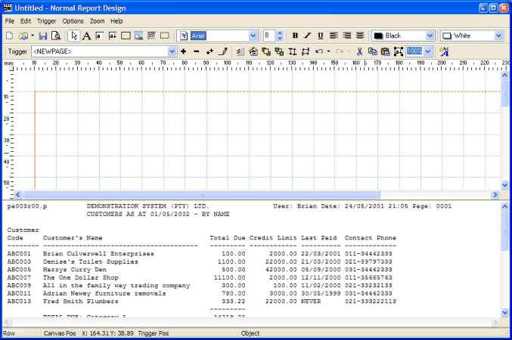

As a default, there are gray grid-lines drawn onto the designer canvas at intervals of 10mm. This can be changed to other settings, but this feature will not be covered during this tutorial.

The following section of the toolbar menu deals with the drawing of static text, rectangles and fields onto the designer canvas.

This toolbar section is operated as a set – meaning that only one of the options may be selected (depressed) at any one time.

The following screen-shot shows the desired results of this step, for reference purposes:
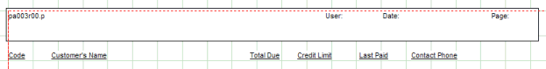

Drawing Static Text

Firstly, we are going to use an advanced feature of the designer to 'drag' text elements from the sample report onto the designer canvas in a semi-automatic fashion. We are going to rely on the built-in ability of the designer to determine the location that static text should be drawn at, given the existing location of the text in the legacy report.

Ensure the button is depressed and is showing with a red color. This is achieved by clicking this button twice, which indicates to the designer that you wish to add multiple static text items onto the canvas. Clicking on this button only once, indicates to the designer that you wish to only add one static text item onto the canvas.

HINT: The above steps can be replicated by pressing the <CTRL>T key combination twice.

Now take a moment to examine the sample report already loaded into the designer, as shown below:
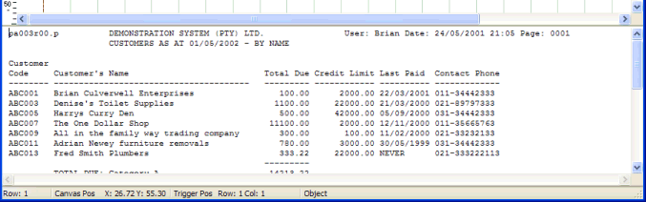

On the first line of the report there is a report identifier ('pa003r00', 'User:', 'Date:' and 'Page:') field headings which we are going to 'drag' from the report onto the canvas.

Move the mouse pointer into the sample report area until is just before the 'p' of the report identifier, and then, holding down the left mouse button, move it to the right until the whole identifier is selected ('pa003r00' should be highlighted).

Now simply press down the F2 key. The 'pa003r00' text field should now magically appear in the appropriate position on the designer canvas. Don't worry if the position is not quite as expected, as these text fields can be manually positioned at any time.

Repeat this step with the 'User:', 'Date:' and 'Page:' text. You will notice that as the objects are drawn onto the canvas, they are all automatically selected.

Now we will perform steps to drag the column labels from the legacy report to the designer canvas. Click the button to set the designer back into pointer mode, and then repeat the steps previously performed to add the field headings. That is, click twice on the button so that it turns red, and then select the various column headings ('Code', 'Customer's Name', 'Total Due', 'Credit Limit', 'Last Paid' and 'Contact Phone') in the legacy report and press the F2 button to automatically draw each one onto the designer canvas at the automatically calculated position.

Once all the column headings have been dropped onto the canvas (and are all selected), click the button to automatically underline all these labels

Finally, click the button to set the designer back into pointer mode to de-select all the objects. The final result should look something similar to the following:

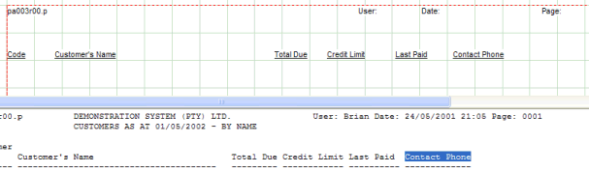

Drawing Rectanges

To make the report more appealing, we will now add a rectangle which will be positioned beneath all the text fields drawn in the header section of the canvas (ie : ‘pa003r00’, ‘User :’, ‘Date :’ and ‘Page :’).

Ensure the (rectangle) button is depressed. This indicates to the designer that you wish to add static rectangle items onto the canvas.

Move the mouse pointer up into the designer area and left-click it in a position approximately 10mm from the top edge of the canvas, and 10mm in from the left edge (just above and to the right of the ‘pa003r00’ text object). A small rectangle should be automatically drawn onto the canvas, with the top-left corner of the rectangle at the mouse pointer.

Drag-handles will automatically be drawn around the rectangle. These drag handles allow you to resize the rectangle to the desired size. Drag the rectange (using the drag handles) to the desired size, so that all text objects are completely covered. Ensure that you leave enough space below the ‘pa003r00’ text object to cater for the drawing of an additional row (the report description field). Note that the rectangle (while it is still selected) can be moved around the screen one pixel at a time by pressing the arrow keys at any stage.

The results of your efforts so far should resemble something like the following :

Step 5: Linking Fields to the Definition
Fields differ from static text, in that the contents of the field are extracted at run-time from the legacy report and inserted into the rendered graphical canvas, as opposed to static text that is 'fixed' in nature, and will never change at run-time.

We are going to use an advanced feature of the designer to 'drag' field elements from the sample report onto the designer canvas in a semi-automatic fashion. We are going to rely on the built-in ability of the designer to determine the location that field objects should be drawn at, given the existing location of the field in the legacy report.

Ensure the button is depressed and is showing with a red icon. This is achieved by clicking on this button twice, which indicates to the designer that you wish to add field items onto the canvas. Clicking on this button only once, indicating to the designer that you wish to only add one field element onto the canvas.

HINT: The above steps can be replicated by pressing the <CTRL>F key combination twice.

Now take a moment to examine the sample report already loaded into the designer, as shown below:

On the first line of the report there is a company name ('DEMONSTRATION SYSTEM (PTY) LTD').

Move the mouse pointer into the sample report area until is just before the 'D' of the report identifier, and then, holding down the left mouse button, move it to the right until the whole name is selected (including required trailing spaces to cater for longer company names if required).

Now simply click the F2 button. A [F] token will magically appear in the appropriate position on the designer canvas. Don't worry if the position is not quite as expected, as these fields can be manually positioned at any time.

Repeat this step with the User, Date/Time and Page fields. Remember to highlight the contents of the fields, and NOT the actual static text that reads 'User:' 'Date:' etc. You will notice that as the objects are drawn onto the canvas, they are all automatically selected (and drag-handles drawn around them).

Finally perform the same steps on the Report Description field (the field that has a contents of 'CUSTOMERS AS AT dd/mm/yyyy - BY NAME'). Press the {bmc pointer.bmp} button to de-select all field objects that have been drawn on the designer canvas.

The results so far achieved should resemble something like the following:

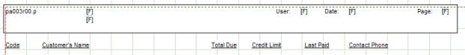

Step 6: Linking Down Fields
DownField objects are similar to field objects in that the contents of the downfields are extracted at run-time from the legacy report and inserted into the rendered graphical canvas. However, downfields repeat themselves down the page.

We are going to use an advanced feature of the designer to 'drag' downfield elements from the sample report onto the designer canvas in a semi-automatic fashion. We are going to rely on the built-in ability of the designer to determine the location that downfield objects should be drawn at, given the existing location of the field in the legacy report.

Ensure the button is depressed and is showing with a red icon. This is achieved by clicking on this button twice, which indicates to the designer that you wish to add multiple downfield items onto the canvas. Clicking on this button only once, indicating to the designer that you wish to only add one downfield element onto the canvas.

HINT: The above steps can be replicated by pressing the <CTRL>D key combination twice.

Now take a moment to examine the sample report already loaded into the designer, as shown below:

On the 7th line of the report (just below the underlined column headings), are the first line of downfields.

Move the mouse pointer into the sample report area until is just before the 'A' of the 'ABC001' downfield, and then, holding down the left mouse button, move it to the right until the whole field is selected (including required trailing spaces to cater for longer fields if required).

Now simply click the F2 button. A [D] token will magically appear in the appropriate position on the designer canvas. Don't worry if the position is not quite as expected, as these fields can be manually positioned at any time.

Repeat this step with the Customer Name, Credit Limit, Total Due and other fields required. Be careful to include leading spaces on the numeric field and trailing spaces on the alphanumeric fields to cater for the maximum length of the fields). You will notice that as the objects are drawn onto the canvas, they are all automatically selected. Finally, press the button to de-select all items.

Also notice that the numeric field (Credit Limit and Total Due) are not aligned with their corresponding column labels. This is because the designer has made assumptions that these two fields are to contain numeric right-justified fields (because of the leading spaces), and has converted the alignment of these fields to 'right-justified' - which is appropriate in this case.

The only thing left to do, it to change the column headings of the corresponding numeric fields to be right-aligned, and to position these fields to align with the drawn downfields. This is achieved by clicking on the 'Total Due' field (which will select this field and draw drag-handles around it), and then clicking the button. Then to align this static text field with the right-edge of the corresponding downfield, click the right arrow key a number of times until the static text field is correctly aligned. Repeat these steps for the 'Credit Limit' static text field.

Finally, click the button to de-select all items.

The results so far achieved should resemble something like the following:

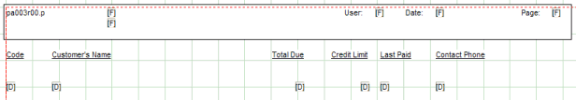

Step 7: Previewing Changes
In order to preview the design made so far (and at any time), simply press the (preview) button. The report preview tool will be automatically invoked and the changes made (including any unsaved changes) will be displayed on the preview canvas. The preview canvas reflects what the report will look like when printed to any Windows printer, as shown in the example below :

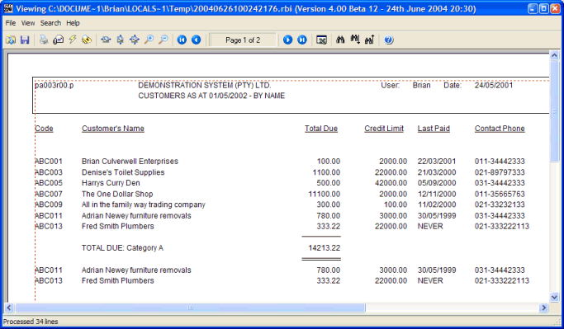

Note how the single and double underlines from the legacy report have been automatically converted to graphical lines.

The report can be printed to any attached windows printer at this stage by pressing the (print) button on the preview window.

Once you have finished examining the preview canvas, simply close the preview window to return to the designer window.

Step 8: Finishing Up
Congratulations! You have now completed your first report design.

If you want to save the changes made, press the (save) button and advise an appropriate filename, which may then be reloaded into the designer for modification at a later point.

Here are some of the more advanced options available to you in the report designer :

- Saving a report as a template and then re-using templates within other reports to provide consistent report sets. See Section 4 below for an explanation of the ‘template’ feature.
- Using the report ‘Wizard’ to create definitions with just a few keystrokes. This feature can be found in the ‘Report Designer’ reference section.
- Adding floating sections (triggers) to your reports. Floating sections are described in section 4 below.
- Suppress repeating values (see the ‘Conditional Formatting’ section of the downfields help for an explanation of this feature).
- Capitalise fields, or convert them to Upper or Lower case (see the ‘Conditional Formatting’ section of the downfields help for an explanation of this feature).
- Changing colors, fonts, font sizes and styles of text, fields and down fields. These attributes can all be changed by simply selecting the required objects, and then clicking the foreground/background combo-boxes, font style buttons, font name combo-box or font size fields in the toolbar of the report designer.
- Adding shadows and rounded corners to drawn rectangles. This is achieved by first selecting the rectangle object and then right-clicking the rectangle and choosing options from the ‘Rectangle Properties’ dialog window.
- Defining conditional attributes for fields (colors, fonts and styles) (see the ‘Conditional Formatting’ section of the downfields help for an explanation of this feature).

- Advise Banding on the canvas background. This feature can be set on the ‘Report Properties’ dialog window.
- Vertical/Upside-down Text. This can be set by first selecting a Text object, and then right-clicking the object to view the ‘Text Properties’ dialog window, from which the desired text orientation can be set.

- Designer Tutorial (XML)

Introduction

This section takes you step by step through the process of building your first simple report that utilizes XML as the source of report information, using the Designer tool. It is assumed that you have little or no knowledge of the Report Designer tool. Each step will be concluded with an illustration by means of screen images (or other methods) to cement the lessons learned.

The tutorial will use the 'testxml.xml' sample XML document installed into the default 'Samples' directory as part of the initial installation. This sample XML document will demonstrate the various features of the report Designer with regards to using an XML document as input at run-time. The same steps shown in the tutorial should be able to be used in a live environment to achieve substantial formatting of existing XML documents.

This tutorial breaks down the design process into the following logical steps :

- Step 1: Starting a new Report Definition
- Step 2: Specifying Options for the report
- Step 3: Adding a Trigger to the Definition
- Step 4: Adding static text and shapes
- Step 5: Linking Fields to the Definition
- Step 6: Linking Down Fields to the Definition
- Step 7: Previewing Changes
- Step 8: Finishing Up

Step 1 : Starting a new Report Definition
Although there are two different mechanisms for starting a new Report Definition, the tutorial will only cover the first, which is available when the Designer tool is started up (from the desktop icon, or program folder).

If the Designer is already open, close it now.

Choose the Report Designer menu option from the Designer folder, normally available from the Windows Start Menu (or alternatively available as an icon on the desktop). The Designer will load and the main window will be displayed. A welcome dialog window is displayed on top of the normal Designer window, as shown below :

This welcome dialog window allows the user to either start a new report definition, or open an existing report definition, either by choosing one of the recently opened definitions, or by browsing the network to locate an existing report definition to modify.

This tutorial only covers the creation of a new Report Definition file, so simply ensure that the 'start a new report definition' option is selected, and then click the OK button. Note that pressing the ENTER key performs the same function as clicking on the OK button.

The following dialog window will then be displayed:

We are going to design a normal report definition, so ensure that the 'Normal Report Definition' radio button is ticked, and then click the OK button.

This dialog window will close and you will be presented with the Report Options Dialog, described in the next section of the tutorial.

Step 2: Specifying Options for the report
After selecting a new Report Definition, the system automatically displays the Report Options dialog window, which allows the user to advise the various options to be set for the current report as a whole. The Report Options dialog displays the following window:

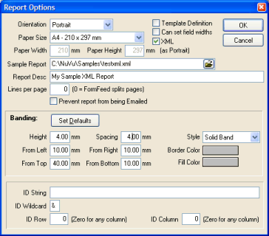

Advise the required parameters (as shown in the sample screen above, and described below) and click the OK button to save these report options, or alternatively click on the CANCEL button to undo any changes made to the parameters on this screen.

For purposes of the tutorial, please ensure that you advise all the settings as described below, and then click the OK button to apply these settings to the current report. Doing so will close the Report Options dialog window, and present you with the main Designer screen, containing a blank designer canvas, but showing the contents of the selected sample report in the bottom section of the window. Once the window has been displayed, the next step in creating a new report definition will automatically begin, that being the advise of the first Trigger for the report (described in the Next Step of the tutorial).

Orientation

The report may either be produced in a Landscape (wide) or Portrait (tall) orientation. The reporting system uses standard Windows printing mechanisms, which provide these two orientations on most printers that support graphical output.
In the real world, 80% plus of all reports are produced in a Landscape format, which allows for more information to be shown across the page as the Portrait format.

For purposes of the tutorial, select the 'Portrait' orientation option.

Template Definition

Tick this option if this report definition is to be used as a template in other reports. The report designer will first ensure that there is only a single trigger defined for this report (multiple triggers in a template definition are not allowed, because the whole template will be associated with a single trigger in the reports which utilize the template).

For purposes of the tutorial, leave this option unticked. Report templates are an advanced feature covered in the User Manual.

Paper Size

This drop-down combo-box contains all the possible page sizes that can be associated with the report. The default 'Portrait' sizes (width x height) are shown alongside each paper size.

Remember, advising a page orientation of 'Landscape' will reverse these paper sizes (ie: the size of the height and width are swapped around).

When the user either changes the orientation or paper size, the designer canvas area is automatically resized to accommodate the maximum sizes as shown in the combo-box. This resizing will occur only when this report options window is closed (via clicking the OK or CANCEL buttons).

The default shown when a new report is created is 'A4' but the following paper sizes may be specified:

- A3 (297 x 420 mm)
- A4 (210 x 297 mm)
- A5 (148 x 210 mm)
- A6 (105 x 148 mm)
- B5 (176 x 250 mm)
- C5 (162 x 229 mm)
- Letter (8.5 x 14 inches)
- Legal (8.5 x 11 inches)
- Custom Size

For purposes of the tutorial, leave the default of A4 here.

Paper Width

This field displays the millimeter size of the currently selected Paper Size (as discussed in the previous section). This field is read-only (cannot be changed manually) unless the selected Paper Size is set to 'Custom Size'. If a custom size has been chosen, then you are able to advise the millimeter value of the width of the paper. This value will govern the defined size of the width of the paper when the report is viewed and printed.

Because a default paper size of A4 was advised, this field is read-only, so simply tab past it, leaving the value as displayed.

Paper Height

This field displays the millimeter size of the currently selected Paper Size (as discussed in the previous section). This field is read-only (cannot be changed manually) unless the selected Paper Size is set to 'Custom Size'. If a custom size has been chosen, then you are able to advise the millimeter value of the height of the paper. This value will govern the defined size of the width of the paper when the report is viewed and printed.

Because a default paper size of A4 was advised, this field is read-only, so simply tab past it, leaving the value as displayed.

Can set Field Widths

Tick this option to enable to manual sizing (horizontal only) of any fields or downfields. By default, this option is NOT ticked when a new report definition is created. When this option is not ticked, then fields (and downfields) cannot be sized. The widths of these fields are determined automatically when the report is previewed. Note, in this case, that if the contents of a field or downfield are larger in width than expected, the contents of these fields may overwrite other fields on the report. In other words, the width of fields that are not manually sized (ie: this option is NOT ticked) are not clipped, and the complete field contents will be output to the report.

If this option is ticked, then the fields will only display in the defined area (bounding rectangle) defined for each field or downfield. Although there is more work in determining the width of each field (although the designer attempts to create fields with the desired field width), the results are guaranteed to display correctly in the preview window.

NOTE1: If this option is ticked when there are already fields or downfields defined for the report, these fields are automatically resized to defined widths, depending on the width of the field on the legacy report, and the defined font size of each field. There is NO automatic undo facility so ensure that the desired option is chosen before clicking the SAVE button.

NOTE2: If this option is unticked when there are already fields or downfields defined for the report, these fields are automatically resized to a value of 'automatic width'. There is NO automatic undo facility so ensure that the desired option is chosen before clicking the SAVE button.

For purposes of the tutorial, leave this option UNTICKED (ie: automatic field widths)

XML

Tick this option if the input to the NuVu report will be derived from an XML document (Extended Mark-up Language). XML input comprises of elements and attributes. XML differs to standard legacy reports, in that the format of the XML is variable.

If this option is ticked, then the field properties dialog window will contain XML tags and nodes, instead of the Row, Column-From and Column-To fields. Also, the Trigger Properties dialog window will contain the 'Ending XML tag' field instead of the 'No. of Logical Lines' field.

For purposes of the tutorial, TICK this option to denote that the report will be deriving its input from an XML document

Sample Report

This very important parameter specifies the full or relative pathname of the location of the sample XML document that will be used to cross-map the data to the report definition. This sample XML document is also used by the Print Preview function.

This field has an automatic Windows Open File dialog attached to it. By clicking on the Open icon at the end of the field, the open dialog will be presented, and allow the user to browse for the desired sample XML document. Note that the 'samples' directory will automatically be displayed as a default starting directory.

Normal practice is to extract a copy of the XML document which needs to be processed by the NuVu definition and delete all but the first page or two of data before saving it in a 'samples' sub-directory (directly below the Nuvu installation directory). Obviously if the XML document is stored on a UNIX server, that document will have to be electronically copied (or FTP'ed) across to the Windows environment.

If the sample XML document is not available at this time, it is possible to leave this field blank, but you will not be able to define any fields or down fields until you have associated a sample XML document.

For purposes of the tutorial, advise 'c:\nuvu\samples\testxml.xml' here. (this is assuming you have installed the application into the default c:\nuvu directory, otherwise change the string to the installation directory).

Report Desc

This description is used to identify the report amongst all the other defined reports. This description is also used as the default subject and body text when the report is emailed to email recipient(s).

For purposes of the tutorial, advise 'My Sample XML Report' here.

Lines per page

A non-zero setting is required if the legacy report does not contain form-feeds (chr 12) to designate new pages, AND you require a <NEWPAGE> trigger to process at the start of each new page. For example, some legacy applications output fixed length logical pages (of lets say 48 lines) for form-based reports that output to a legacy printer that was also set to 48 lines per page. By setting this value to 48 here, the report will be processed as if there is a form-feed after every 48 lines in the legacy report.

For purposes of the tutorial, leave this setting at zero, because our sample report does have form-feeds separating pages.

Prevent report from being Emailed

This check-box may be ticked if the user wants the report to be prevented from being emailed via the NuVu report viewer. This option is applicable to sensitive reports (Cheques for example) which must only be printed.

For purposes of the tutorial, leave this option UNTICKED, thus allowing the report to be emailed if required.

Banding: Overview

Banding is a very useful feature, which results in bands of color being printed down the printed page at run-time. The result of advising banding on the report is similar to the old pre-printed standard stock stationery that was used by the legacy line-printers. These used to use paper that was alternatively banded in sections of a colored band (typically green, gray or yellow) followed by a white band. This mechanism was useful to the end-user when attempting to read figures across a heavily populated report. To enable this option, the Banding Height (in millimeters) must be advised as non-zero.

Banding: Set Defaults

This button will automatically set the banding properties to the default, based on the current trigger downfield starting position and height. The Banding Height and Banding Spacing will be set to the height of the downfields (as specified on the Trigger dialog window). The Banding From Top will be set to start at the first downfield on the trigger. The Border and Fill colors of the banding will be set to Silver. The Left, Bottom and Right Margin properties will not be affected.

Be careful when clicking this button, as there is NO undo facility, except that the CANCEL button can be pressed which will not save any changes made (to the banding properties or any other properties on this dialog window).

For purposes of the tutorial, do NOT click this button.

Banding: Height

This Banding parameter determines how wide (ie: the height) to print each colored section of the band. Advising a value of zero here will effectively turn OFF the banding function. As a general rule, if banding is to be enabled, the height of the banding should correspond to the advised 'Section Height' of the primary down trigger (typically between 3 and 4 mm).

For purposes of the tutorial, advise a value of 4mm here, which will correspond to the height of each line in the output report (to be defined a little later).

Banding: Spacing

This option is only effective if a non-zero Banding Height is advised (see the Banding: Height property above). This field is used to advise how high (in millimeters) the blank section is between each colored band. Typically this value should correspond to the advised Banding Height. This will result in a uniformly layered banding on the generated report.

For purposes of the tutorial, advise a value of 4mm here.

Banding: From Left

This option is only effective if a non-zero Banding Height is advised (see the Banding: Height property above). This property is used to specify the distance, in millimeters, from the left margin of the page where the banding will start drawing.

For purposes of the tutorial, advise a value of 10mm here.

Banding: From Right

This option is only effective if a non-zero Banding Height is advised (see the Banding: Height property above). This property is used to specify the distance, in millimeters, from the right margin of the page where the banding will stop drawing.

For purposes of the tutorial, advise a value of 10mm here.

Banding: From Top

This option is only effective if a non-zero Banding Height is advised (see the Banding: Height property above). This property is used to specify the distance, in millimeters, from the top margin of the page where the banding will start drawing.

For purposes of the tutorial, advise a value of 40mm here, which will correspond with the starting position of the downfields when they are defined at a later point.

Banding: From Bottom

This option is only effective if a non-zero Banding Height is advised (see the Banding: Height property above). This property is used to specify the distance, in millimeters, from the bottom margin of the page where the banding will stop drawing.

For purposes of the tutorial, leave this setting at the default of 20mm.

Banding: Style

This option is only effective if a non-zero Banding Height is advised (see the Banding: Height property above). This drop-down combo-box is used to advise what type of banding is to be produced. Valid options are:

Dotted Line - the border of the colored band will be printed with a dotted line (in the advised Border Color)
Solid Band - the border of the colored band will be printed with a solid line (in the advised Border Color)

For purposes of the tutorial, leave this setting at the default of 'Solid Band'.

Banding: Border Color

This option is only effective if a non-zero Banding Height is advised (see the Banding: Height property above). This property is used to specify the color in which the edges of the colored portion of the band will be printed. Clicking on the displayed color panel (to the right of the 'Border Color' text), will present the user with a standard color dialog window, as shown below:

This dialog window allows for exact color determination, either by clicking on the selected area in the color spectrum window, or else advising an exact Red/Green/Blue (RGB) value in the available input fields.

For purposes of the tutorial, leave this setting at the default of Silver.

Banding: Fill Color

This option is only effective if a non-zero Banding Height is advised (see the Banding: Height property above). This property is used to specify the color in which the inside (fill area) of the colored portion of the band will be printed. Clicking on the displayed color panel (to the right of the 'Fill Color' text), will present the user with a standard color dialog window, as shown below:

This dialog window allows for exact color determination, either by clicking on the selected area in the color spectrum window, or else advising an exact Red/Green/Blue (RGB) value in the available input fields.

For purposes of the tutorial, leave this setting at the default of Silver.

ID Overview

Whenever a report is saved, the details advised in the ID section (described below) are automatically updated to the 'rbd_find.def' report definition file contained within the standard NUVU installation directory (Mapped Drive:\NuVu by default). The information contained within the written line of details is used by the 'rbd_find' utility program (see the Nuvu Reference Manual for more details). This utility program is used to automatically identify which report definition to associate with the passed legacy report at run-time.

ID String

The advised text string will be searched for at run-time by the 'rbd_find' utility program in order to determine which report definition to associate with the advised legacy report. This string is normally the same as the 'Trigger Search Text' advised in the primary trigger of the report.

For purposes of the tutorial, leave this setting at the default of blank.

ID Wildcard

The advised character (& by default) will be used as a wildcard character, replacing the word in the ID string. For example, if an ID string of 'Customer Listing for Rep: &', then any string in the legacy report which contains 'Customer Listing for Rep: <any string>' will be identified as the ID string.

For purposes of the tutorial, leave this setting at the default of &.

ID Row

If a non-zero value is advised here, then the ID string will only be searched for in the specified row of the legacy report. Leaving this option at zero will search the legacy report for the ID string in any row (up to row 100 of the report).

For purposes of the tutorial, leave this setting at the default of zero.

ID Column

If a non-zero value is advised here, then the ID string will only be searched for in the specified column of the legacy report. Leaving this option at zero will search the legacy report for the ID string in any column of each searched line.

For purposes of the tutorial, leave this setting at the default of zero.

Step 3: Adding a Trigger to the Definition
After clicking the OK button on the Report Options dialog window, the system automatically clicks on the 'Add new Trigger' button if the user is creating a new report definition. If the user pressed CANCEL on the Report Options dialog window, then the 'new report definition' procedure is cancelled at that point, and this step is NOT performed.

Every report definition MUST have at least one trigger defined. Triggers are nothing more than text strings that are searched for inside the XML document (at an optional column number). When these search strings are found, they trigger advised events which then occur on the report definition.

The Trigger Dialog window is now displayed with the following details:

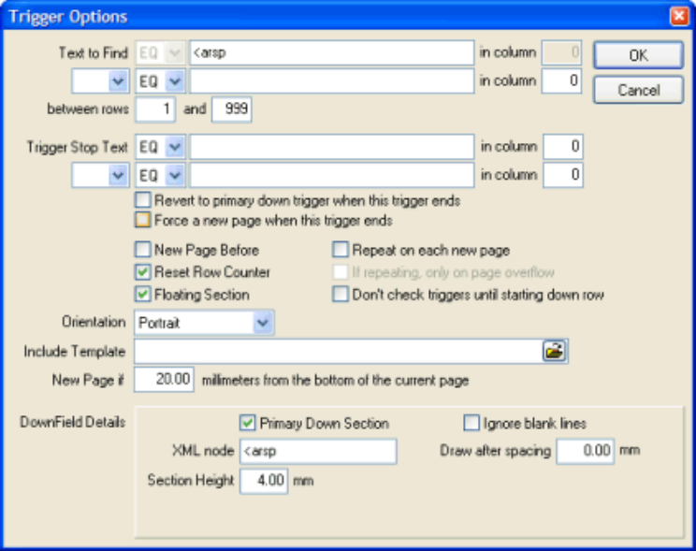

Advise the required parameters (as shown in the above screen image, and described below) and click the OK button to save these Trigger options, or alternatively click on the CANCEL button to undo any changes made to the parameters on this screen.

Text to Find

Advise the text string (without quotes) to search for in order to 'fire' (activate) the trigger when the report is converted at run-time.

The 'Condition' drop-down combo-box that precedes this field can be used to either an equilty or inequality test on the search string. Advising a condition of 'EQ' will search for the existance of the advised text, advising a condition of 'NE' will perform an inequality check using the advised text, that is: the trigger will fire if the advised text is NOT found at the specified column.

Please note, if a condition other than 'EQ' is advised, then the designer will validate that the associated 'Column' field is non-zero.

Also note, if the 'Text to Find' begins with a '<', the designer will assume that a reserved word (or XML tag) is being advised, resulting in the 'Condition' field being automatically set to 'EQ' and disabled and the 'in Col' field to be set to zero and disabled also.

The reserved word "<NEWPAGE>" may be typed here, which will cause the trigger to 'fire' at the start of each new page.

Normally XML documents have a node at the front of the XML document which contains parameters which are common to the whole document (Company Name, Run-Time parameters, Program Description etc). It is common practice to either advise the generic <NEWPAGE> text here, or alternatively advise the XML node of the common section.

For purposes of the tutorial, advise "<NEWPAGE>" here (without the quotes).

Search in Column

Advise the column in which to search for the string, or leave as zero if the search string can be located in any column of the current line of the report. For XML input documents, this field is normally left at zero, due to the variable layout of XML documents.

For purposes of the tutorial, advise zero here. This coExamine the contents of the sample report and you will see that the report identifier "pa003r00" appears in column 1 of each page.

Find Condition

The application has the ability to search for two different sets of text in order to fire the trigger for the current section. The find condition combo-box allows the user to specify the relationship between the two search strings. This relationship can be one of the following three options:

- Blank The second search string is not checked at all
- AND Both the 1st and 2nd search strings must be found before the trigger will fire
- OR Either the 1st or 2nd search strings must be found before the trigger will fire

For purposes of the tutorial, leave this option blank (ie: the trigger will fire just on the finding of the first search text).

Second Text to Find

Advise the optional second text string (without quotes) to search for in order to 'fire' the trigger. This string will only be checked if the Find Condition (see previous field) is advised as either AND or OR.

The 'Condition' drop-down combo-box that precedes this field can be used to either an equilty or inequality test on the search string. Advising a condition of 'EQ' will search for the existance of the advised text, advising a condition of 'NE' will perform an inequality check using the advised text, that is: the trigger will fire if the advised text is NOT found at the specified column.

Please note, if a condition other than 'EQ' is advised, then the designer will validate that the associated 'Column' field is non-zero.

Also note, if the 'Text to Find' begins with a '<', the designer will assume that a reserved word (or XML tag) is being advised, resulting in the 'Condition' field being automatically set to 'EQ' and disabled and the 'in Col' field to be set to zero and disabled also.

The reserved word "<NEWPAGE>" may be typed here, which will cause the trigger to 'fire' at the start of each new page. This is common practice when defining the main trigger for the report. The main trigger is normally used to advise the page and column headings for the report, as well as the associated static fields, and down-fields for the defined columns.

The reserved word "<NEWLINE>" may be typed here, which will cause the trigger to 'fire' on the reading of each record from the legacy report. This is sometimes used when processing a mail merge file (where each record in the file relates to a seperate set of details (for example, a record for each customer in your database).

The reserved word "<NONBLANKn>" may be typed here, which will cause the trigger to 'fire' when any non-blank text is found (at the optional 'Search in Column'). The length of the non-blank text to check is advised as the 'n' value (between 1 and 9). For example, if you wish to check for any non-blank text between columns 8 and 14, then you would advise <NONBLANK6> in this field, and 8 in the 'Search in Column' field.

The reserved word "<PASSTHROUGH>" may be typed here, which when used alone on a single report design, will result in the report not being processed AT ALL by the NuVu graphic rendering engine. This option is often useful for when a text report that contains embedded escape sequences to do things such as open the cash drawer, or cut the point-of-sale register slip can be passed directly through to the printer at run-time. If this trigger is used, there is NO need to advise any other triggers or fields/labels or downfields on the report, because they will simply be ignored.

For purposes of the tutorial, leave this field blank.

Second Search Column

Advise the column in which to search for the second text string, or leave as zero if the search string can be located in any column of the report.

For purposes of the tutorial, leave this field at the default of zero.

Between rows [X] and [Y]

These options are only normally used on more advanced designs, and allow the user to specify the range of rows of the legacy report which to search between for the identified Trigger text.

For purposes of the tutorial, leave these fields at their default of 1 to 999.

Trigger Stop Text

Advise an optional text string (without quotes) to search for in order to end the currently defined trigger.

The 'Condition' drop-down combo-box that precedes this field can be used to either an equilty or inequality test on the search string. Advising a condition of 'EQ' will search for the existance of the advised text, advising a condition of 'NE' will perform an inequality check using the advised text, that is: the trigger will fire if the advised text is NOT found at the specified column.

Please note, if a condition other than 'EQ' is advised, then the designer will validate that the associated 'Column' field is non-zero.

Also note, if the 'Text to Find' begins with a '<', the designer will assume that a reserved word (or XML tag) is being advised, resulting in the 'Condition' field being automatically set to 'EQ' and disabled and the 'in Col' field to be set to zero and disabled also.

This option is rarely used (and is therefore normally left blank), but may be advised in unusual circumstances where the trigger is of unknown size (number of rows) but the end of the trigger section can be identified with a text string.

For purposes of the tutorial, leave this field blank (an empty string).

Find Condition {bmc AndOr.bmp}

The application has the ability to search for two different sets of text in order to fire the trigger for the current section. The find condition combo-box allows the user to specify the relationship between the two search strings. This relationship can be one of the following three options:

- Blank The second search string is not checked at all
- AND Both the 1st and 2nd search strings must be found before the trigger will fire
- OR Either the 1st or 2nd search strings must be found before the trigger will fire

For purposes of the tutorial, leave this field Blank, because we do not need to check any additional search criteria.

Second Text to Find

Advise the optional second text string (without quotes) to search for in order to 'fire' the trigger. This string will only be checked if the Find Condition (see previous field) is advised as either AND or OR.

The 'Condition' drop-down combo-box that precedes this field can be used to either an equilty or inequality test on the search string. Advising a condition of 'EQ' will search for the existance of the advised text, advising a condition of 'NE' will perform an inequality check using the advised text, that is: the trigger will fire if the advised text is NOT found at the specified column.

Please note, if a condition other than 'EQ' is advised, then the designer will validate that the associated 'Column' field is non-zero.

Also note, if the 'Text to Find' begins with a '<', the designer will assume that a reserved word (or XML tag) is being advised, resulting in the 'Condition' field being automatically set to 'EQ' and disabled and the 'in Col' field to be set to zero and disabled also.

The reserved word "<NEWPAGE>" may be typed here, which will cause the trigger to 'fire' at the start of each new page. This is common practice when defining the main trigger for the report. The main trigger is normally used to advise the page and column headings for the report, as well as the associated static fields, and down-fields for the defined columns.

The reserved word "<NEWLINE>" may be typed here, which will cause the trigger to 'fire' on the reading of each record from the legacy report. This is sometimes used when processing a mail merge file (where each record in the file relates to a separate set of details (for example, a record for each customer in your database).

The reserved word "<NONBLANKn>" may be typed here, which will cause the trigger to 'fire' when any non-blank text is found (at the optional 'Search in Column'). The length of the non-blank text to check is advised as the 'n' value (between 1 and 9). For example, if you wish to check for any non-blank text between columns 8 and 14, then you would advise <NONBLANK6> in this field, and 8 in the 'Search in Column' field.

The reserved word "<PASSTHROUGH>" may be typed here, which when used alone on a single report design, will result in the report not being processed AT ALL by the NuVu graphic rendering engine. This option is often useful for when a text report that contains embedded escape sequences to do things such as open the cash drawer, or cut the point-of-sale register slip can be passed directly through to the printer at run-time. If this trigger is used, there is NO need to advise any other triggers or fields/labels or downfields on the report, because they will simply be ignored.

For purposes of the tutorial, leave this field blank, because we do not need to check any additional search criteria.

Second Search Column

Advise the column in which to search for the second text string, or leave as zero if the search string can be located in any column of the report.

For purposes of the tutorial, leave this field at zero, because we do not need to check any additional search criteria.

Stop Column

Advise the column in which to search for the "Trigger Stop Text" mentioned above, or leave as zero if the search string can be located in any column of the current line of the report. For XML input documents, this field is normally left at zero, due to the variable layout of XML documents.

For purposes of the tutorial, leave this as the default of zero here (because we are not going to stop the trigger based of searching for the occurrence of the "Trigger Stop Text".

New Page Before

Tick this item if a new page must occur before actioning the trigger. Generally if this is the main trigger (ie: doing something at the start of each page), then this item is ticked.

For purposes of the tutorial, tick this box, as we do require a new page on each occurrence of the found trigger text.

Reset Row Counter

Tick this item if you require the internal row counter to be reset back to 1 (ie: set to the same row as the occurrence of the trigger search text). As a general rule, this item should be ticked for most triggers, and only be left unticked for 'Floating Section' triggers (explained below).

For purposes of the tutorial, tick this option, because this is the main section of the report, and we are relying on the contents of the row counter to select other fields to print onto the report.

Floating Section

This is a more advanced feature of the report designer, and allows triggers to be of a 'floating' nature. Floating triggers are normally used when the user wishes to output lines (sub-sections of text) that are normally part of the detail rows of a report in a different style to the other detail rows.

For purposes of the tutorial, we will not complicate the design with floating triggers, so ensure this option is left UNTICKED.

Repeat on each new Page

Ticking this option will cause the fields, rectangles, labels and bitmap objects contained within this trigger to be output to the preview canvas if a new page is output as a result of overflow.

Overflow occurs when output is attempted to the preview canvas within the advised 'New Page if...' property which is discussed later in this section. This option is commonly ticked when the input to the NuVu report is an XML document. XML documents normally define the report headings and titles only once in the XML document, but these details need to be reflected on each page of the generated report.

For purposes of the tutorial, tick this option, because this trigger should be repeated on each new page output, when overflow occurs on the current page.

Orientation

This is another advanced feature of the report designer, and allows individual pages (triggers) to be of a different page orientation to the default as advised on the Report Options dialog window (described in the previous step). For example, the first page may be in Landscape orientation, while the second and third pages may be produced in a Portrait orientation.

For purposes of the tutorial, we will not complicate the design with multiple page orientations, so leave this option set to its default value of Landscape.

Include Template

This is a very powerful feature of the report designer, and allows the user to include template information with any defined trigger. A template is simply another external report definition designed with the same designer tool as you are using to create the current report definition.

Typically this feature is used when an installation has legacy reports which have the same header information (User, Date/Time, Page etc.). All that is required is to create a report definition with the required layout for the header information within it, save it to the 'templates' directory and then associate that definition file here. The template definitions are visible in the designer (although the individual elements are NOT able to be moved or sized), but are removed from the main design, and called in at run-time. This allows changes to be made to the template, which will then cause all reports linked to the template to be changed immediately.

For purposes of the tutorial, we will again not complicate the issue with the templates feature, so ensure that this field is LEFT BLANK.

New Page if nn mm from the bottom of the current Page

This option provides the user with automatic pagination if output to the canvas area of the current page is made within the advised number of millimeters of the bottom of the page (as determined by the currently selected Page Type). If a value of Zero is advised here, then this setting is effectively ignored, which can result in output overflowing the bottom of the page in certain cases. If input is from an XML document, then this field is automatically populated with a value of 20mm, and is validated to ensure that a value of zero is not advised.

For purposes of the tutorial, we will leave this option set to its default value of 20mm.

Primary Down Section

This field indicates if this Trigger section is to be viewed as the main section of the report.

This advanced feature is used when there are more than a single down section in the report (For example, in a customer order report, the customer details (code, name, phone, balance) are printed on the first line, followed by the orders for that customer). The customer details would be defined as a trigger with the "Primary Down Section" ticked, and the order details would be defined as a separate section with this indicator left unticked. This indicator is used when processing the report so when the order details are printed (ie: the second trigger has fired) and then end (normally when a blank line is detected via use of the "Trigger Stop Text" mentioned previously), the system will automatically revert to the first (primary down) trigger to continue printing the next customer details.
Note that ticking this field in this trigger will automatically untick all other triggers where the "Primary Down Section" was ticked (ie: only one trigger can be defined as having a "Primary Down Section").

For purpose of the tutorial, we are using a single trigger to process all aspects of this report, including down fields, so ensure that this item is TICKED.

Ignore Blank Lines

This field indicates if the down fields in this Trigger section must include logic that will simply exclude lines that are completely blank or not. Ticking this box will result in any down field rows that are completely blank to be ignored, leaving this field unticked will process blank fields appropriately.

For purpose of the tutorial, leave this option unticked, as this is an advanced feature.

XML node

This string field is used to advise an identification string (XML element) that will denote the start of the current down-field collection. When this string is identified while processing XML input, it will result in the current position on the canvas being advanced by the specified 'Section Height' property explained previously in this section, at the end of processing all elements and atrributes for this XML element.

This field can be left blank, but only if there are NO down fields in the current trigger. Additional validation is performed when the current report definition is attempted to be saved, to ensure that this rule is followed.

If a non-blank value is advised into this field, the system will validate that the string can be located within the sample XML document. If the string cannot be located, an appropriate error message will be issued, and the changes to the Trigger Properties will not be saved until this rule is satisfied.

Looking at the sample XML document, we wil choose the <arsp XML node as the node which fully encompases the elements and attributes of a single SalesPerson.

Draw after spacing nn mm

This field is used to specify where the details will start down the page of the resulting report.

This is advised in millimeters. A typical (and default) value for this field is 40 (40mm from the top edge of the page). All downfields that are created on the designer canvas are automatically placed at this position when either the wizard is used, or fields are manually created by the "down field" tool button. Normally this value can be assumed to be the same as the Row Height (see below) multiplied by the value of the starting row, plus the area needed for any headings.

For purposes of the tutorial, advise the default value of 40 here.

Section Height

Advise the height (in millimeters) of each detail row (section) in the beautified report. This value is used when advancing the position on the printer canvas after processing a detail row(s). Be careful when advising this value, as partial overwriting of detail lines may occur if this value is made too small for the advised font size of the detail columns.

Note that advising a value too large may cause a single page of the legacy report to overflow on to the next page of the beautified report.

A typical value for this field is 3mm for a landscape report, and 5mm for a portrait report.

For purposes of the tutorial, advise a value of 4mm here.

Step 4: Adding static text and shapes
Once the previous Trigger Dialog box has been closed (by pressing the OK button), the main designer window will now be active, allowing normal designer action to the canvas. The designer canvas is the white section between the toolbars and the displayed sample XML document. The canvas can be scrolled and the screen acts as a 'window' onto the underlying canvas area as illustrated below:

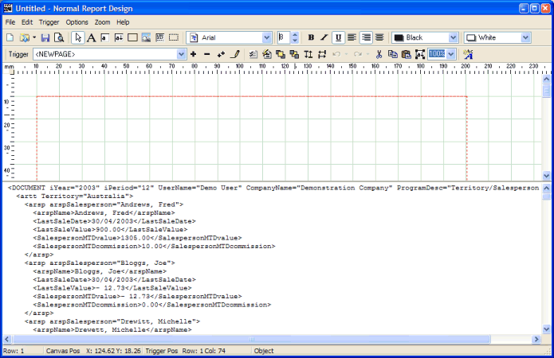

As a default, there are gray grid-lines drawn onto the designer canvas at intervals of 10mm. This can be changed to other settings, but this feature will not be covered during this tutorial.

The following section of the toolbar menu deals with the drawing of static text, rectangles and fields onto the designer canvas.

This toolbar section is operated as a set – meaning that only one of the options may be selected (depressed) at any one time.

Drawing Static Text

To assist with this tutorial, the final results of drawing the static text onto the canvas are shown in advance, to give you a template that you can refer to during this step, as follows:

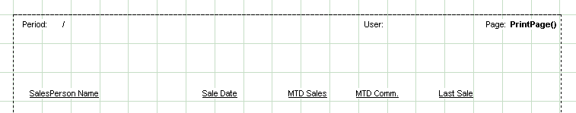

Firstly, we are going to use an advanced feature of the designer to 'drag' text elements from the sample report onto the designer canvas.

Ensure the button (draw text) is depressed button is depressed and is showing with a black color. This is achieved by clicking this button once only, which indicates to the designer that you wish to add a single static text item onto the canvas. Clicking on this button twice will change the button to a red color, indicates to the designer that you wish to add multiple static text items onto the canvas, one after the other.

As can be seen from the sample canvas shown above, we will be adding some static text ('Period:', '/' between the month and year, 'User:', 'Page:' plus an auto-static field for the page number, plus the labels for the detail rows).

Move the mouse pointer over the canvas to a position approximately 13mm from the top left corner of the canvas (using the ruler positions to help you here), and then click the left mouse button. A text field will automatically be drawn onto the canvas, with a default caption of 'Label'. This text field will be automatically selected (denoted by six little boxes around the edges of the field). Right-click on this newly created text field, and you will be presented with a text properties dialog window, where the appropriate caption can be advised. In this case, change the caption to 'Period:' (without the quotes), and then click the OK button to save the changes. The text field should reflect your changes.

Repeat the previous procedure (clicking the button once, then clicking in the appropriate position on the canvas, and then setting the caption of the text) for the '/', 'User:' and 'Page:' text items.

The 'PrintPage()' label needs some extra explanation. Add the text field as all the others have been added, but change the caption to read PrintPage(). This is a special reserved word which will be replaced at run-time with the actual page number. While the field is still selected, we also want to make it bold, so click the button.

To adjust the alignment and position of any of the text fields, simply click on the text field in question, and drag it to a new position.

Now repeat the previous steps to create the column labels of the report (SalesPerson Name, Sale Date, MTD Sales, MTD Comm. and Last Sale).

We will now select all the 'Column Label' text fields and align them on the same horizontal axis, as well as setting them to underlined. To select the column labels, firstly click on the 'SalesPerson Name' text field, so that it is selected (drag-handles drawn around it). Hold down the <Control> key, and then click on the other column label fields, so that they are all selected as a group. Now click on the button to automatically underline all these labels, and then click the button to automatically horizontally align these objects onto the same Y axis.

Click the button to set the designer back into pointer mode to de-select all the objects.
The final result should look something similar to the following:

Drawing Rectanges

To make the report more appealing, we will now add a rectangle underneath the header section of the canvas.

Ensure the (rectangle) button is depressed. This indicates to the designer that you wish to add static rectangle items onto the canvas.

Move the mouse pointer up into the designer area and left-click it in a position approximately 10mm from the top edge of the canvas, and 10mm in from the left edge. A small rectangle should be automatically drawn onto the canvas, with the top-left corner of the rectangle at the mouse pointer. The Rectangle will also be automatically selected (with drag-handles drawn around it).

Drag-handles will automatically be drawn around the rectangle. These drag handles allow you to resize the rectangle to the desired size. Drag the rectangle (using the drag handles) to the desired size, so that all text objects are completely covered. Ensure that you leave enough space below the text objects to cater for the drawing of an additional row (the report description field). Note that the rectangle (while it is still selected) can be moved around the screen one pixel at a time by pressing the arrow keys at any stage.

To make the report more appealing, we will now add a rectangle (with a shadow) beneath the header section of the canvas.

Ensure the {bmc rectangle.bmp} button is depressed. This indicates to the designer that you wish to add a static rectangle item onto the canvas.

Move the mouse pointer up into the designer area and left-click it in a position approximately 10mm from the top edge of the canvas, and 10mm in from the left edge. A small rectangle should be automatically drawn onto the canvas, with the top-left corner of the rectangle at the mouse pointer. The Rectangle will also be automatically selected (with drag-handles drawn around it).

Resize the rectangle by dragging its corners to the appropriate positions, as shown in the final result below.

We are going to simulate a 'shadow' underneath the drawn rectangle. to do this we need to replicate the drawn rectange again, and move it slightly to the right and down from the original rectangle, and change its background color. To do so, perform the following:

Ensure the original rectangle is still selected. If not, simply click anywhere on the rectangle to re-select it. Drag-handles will show around the edges of the rectangle if it is successfully selected.

- Press the <CTRL>C key combination to make a copy of the rectangle.
- Press the <CTRL>P key combination to paste a new copy of the rectangle onto the designer canvas.
- Press the right and down arrow keys to position this rectangle about 2mm to the right and down from the original rectangle.
- click the second color comb-box and select the 'Gray' color to set the shadow rectangle to a gray color, simulating a shadow.

The results of your efforts should look something like the following:

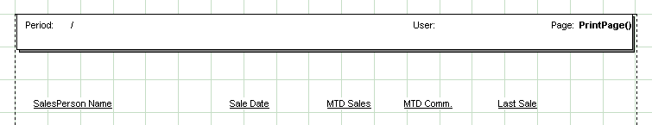

Step 5: Linking Fields to the Definition
We are going to use an advanced feature of the designer to 'drag' field elements from the sample report onto the designer canvas.

Ensure the (field) button is depressed and set to ‘persistent’ drawing mode. This indicates to the designer that you wish to add ‘Field’ objects onto the canvas. The ‘persistent’ drawing mode is achieved by clicking TWICE on the button (field). The ‘a’ inside this box will change from a black colour to a red colour to indicate this mode. This indicates to the designer that you wish to add multiple field objects onto the canvas.

Now take a moment to examine the sample XML document already loaded into the designer, an abbreviated version as shown below:

<DOCUMENT iYear="2003" iPeriod="12" UserName="Demo User" CompanyName="Demonstration Company" ProgramDesc="Territory/Salesperson Analysis">
<artt Territory="Australia">
<arsp arspSalesperson="Andrews, Fred">
<arspName>Andrews, Fred</arspName>
<LastSaleDate>30/04/2003</LastSaleDate>
<LastSaleValue>900.00</LastSaleValue>
<SalespersonMTDvalue>1305.00</SalespersonMTDvalue>
<SalespersonMTDcommission>10.00</SalespersonMTDcommission>
</arsp>
<arsp arspSalesperson="Bloggs, Joe">
<arspName>Bloggs, Joe</arspName>
<LastSaleDate>30/04/2003</LastSaleDate>
<LastSaleValue>- 12.73</LastSaleValue>
<SalespersonMTDvalue>- 12.73</SalespersonMTDvalue>
<SalespersonMTDcommission>0.00</SalespersonMTDcommission>
</arsp>
<arttDescription/>
<TerritoryMTDvalue>33538.26</TerritoryMTDvalue>
<TerritoryMTDcommission>880.00</TerritoryMTDcommission>
</artt>
</DOCUMENT>

The <DOCUMENT XML node contains the static information which is applicable to the report as a whole (the Program Description, Company Name etc).
The <artt XML node is output at the start of each new Territory (only one in the example above, being "Australia").
The <arsp XML node is output for each SalesPerson (ie: it is equivalent to a normal detail record in a report).

On the first line of the report there is an XML attribute called 'CompanyName=' (with a corresponding value of 'Demonstration Company').

Move the mouse pointer into the sample report area until is just before the 'C' of the CompanyName= XML attribute, and then, holding down the left mouse button, move it to the right until the whole name is selected (including the required trailing '=', which denotes an end-of-attribute). Please note here, that unlike a legacy text report, you are not highlighting the actual field contents (ie: Demonstration Company in this case), but rather the describing attribute (CompanyName=).

Now move the mouse pointer up into the designer area and left-click it in a position 50mm from the left margin, and in line with the 'Period:' text item. The field object should be automatically drawn onto the canvas (with a label of [F]), and the field object will also be selected (with drag-handles around it).

Repeat this step with the ProgramDesc=, UserName=, iYear= and iPeriod= attributes, spacing these items out along the canvas as appropriate. You will notice that as the objects are drawn onto the canvas, they are all automatically selected.

Click the button to set the designer back into pointer mode to de-select all the objects.

To move any individual field object to a new position, simply click inside the desired field object so that it becomes selected, and then either use the arrow keys to move it one pixel at a time in any direction, or alternatively drag the object to a new position.

The results so far achieved should resemble something like the following:

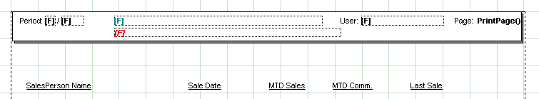

Step 6: Linking Down Fields
Down Field items are report items which repeat themselves down the page, and are often referred to as ‘Detail Rows’ of the report.

We are going to use an advanced feature of the designer to 'drag' downfield elements from the sample report onto the designer canvas.

Ensure the (down field) button is depressed and set to ‘persistent’ drawing mode. This indicates to the designer that you wish to add ‘DownField’ objects onto the canvas. The ‘persistent’ drawing mode is achieved by clicking TWICE on the button (downfield). The ‘a’ inside this box will change from a black colour to a red colour to indicate this mode. This indicates to the designer that you wish to add multiple downfield objects onto the canvas.

Now take a moment to examine the the relevant portion of the sample XML document already loaded into the designer, as shown below:

<arsp arspSalesperson="Andrews, Fred">
<arspName>Andrews, Fred</arspName>
<LastSaleDate>30/04/2003</LastSaleDate>
<LastSaleValue>900.00</LastSaleValue>
<SalespersonMTDvalue>1305.00</SalespersonMTDvalue>
<SalespersonMTDcommission>10.00</SalespersonMTDcommission>
</arsp>

The <arsp XML node fully describes the attributes and elements connected to a single SalesPerson. For example, the SalesPerson Name is stored in XML element '<arspName>', as well as the XML attribute 'arspSalesperson='.

Move the mouse pointer into the sample XML document until is just before the '<' of the '<arspName>' downfield, and then, holding down the left mouse button, move it to the right until the whole field is selected (including required '>' character to denote the end of an XML element (or '=' in respect of an XML attribute).

Now move the mouse pointer up into the designer area and left-click it in a position directly below the column heading already drawn ('SalesPerson Name'). The downfield object should be automatically drawn onto the canvas (with a label of [D]), and the object will also be selected (with drag-handles around it). Note that the Y axis of the drawn downfield will be determined by the value advised in the Trigger dialog window, defined previously at 40mm.

Repeat this step with the <LastSaleDate>, <SalespersonMTDvalue>, <SalespersonMTDcommission> and <LastSaleValue> XML elements. You will notice that as the objects are drawn onto the canvas, they are all automatically selected. Finally, press the {bmc pointer.bmp} button to de-select all items.

The only thing left to do, it to change the numeric fields to be right-aligned. This is achieved by clicking on the [D] field under the 'MTD Sales' column label, and then clicking the button. Repeat this step for the [D] fields under the 'MTD Comm.' and 'Last Sale' column labels.

The results so far achieved should resemble something like the following:

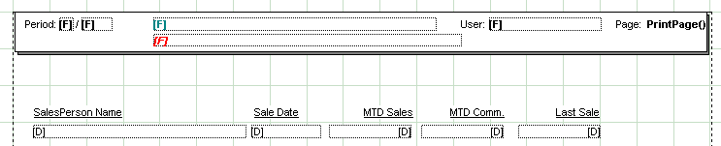

Step 7: Previewing Changes
In order to preview the design made so far (and at any time), simply press the (preview) button. The report preview tool will be automatically invoked and the changes made (including any unsaved changes) will be displayed on the preview canvas. The preview canvas reflects what the report will look like when printed to any Windows printer, as shown in the example below :

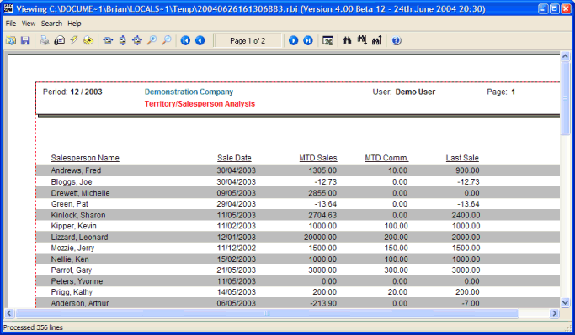

The report can be printed to any attached windows printer at this stage by pressing the (print) button on the preview window.

Once you have finished examining the preview canvas, simply close the preview window to return to the designer window.

Step 8: Finishing Up
Congratulations! You have now completed your first report design based on XML input..

If you want to save the changes made, press the (save) button and advise an appropriate filename, which may then be reloaded into the designer for modification at a later point.

Here are some of the more advanced options available to you in the report designer :

- Saving a report as a template and then re-using templates within other reports to provide consistent report sets. See Section 4 below for an explanation of the ‘template’ feature.

- Using the report ‘Wizard’ to create definitions with just a few keystrokes. This feature can be found in the ‘Report Designer’ reference section.
- Adding floating sections (triggers) to your reports. Floating sections are described in section 4 below.
- Suppress repeating values (see the ‘Conditional Formatting’ section of the downfields help for an explanation of this feature).
- Capitalise fields, or convert them to Upper or Lower case (see the ‘Conditional Formatting’ section of the downfields help for an explanation of this feature).
- Changing colors, fonts, font sizes and styles of text, fields and down fields. These attributes can all be changed by simply selecting the required objects, and then clicking the foreground/background combo-boxes, font style buttons, font name combo-box or font size fields in the toolbar of the report designer.
- Adding shadows and rounded corners to drawn rectangles. This is achieved by first selecting the rectangle object and then right-clicking the rectangle and choosing options from the ‘Rectangle Properties’ dialog window.
- Defining conditional attributes for fields (colors, fonts and styles) (see the ‘Conditional Formatting’ section of the downfields help for an explanation of this feature).
- Advise Banding on the canvas background. This feature can be set on the ‘Report Properties’ dialog window.
- Vertical/Upside-down Text. This can be set by first selecting a Text object, and then right-clicking the object to view the ‘Text Properties’ dialog window, from which the desired text orientation can be set.

- Advanced Features

Introduction
This section explains various more advanced features of the report designer, which together with the tutorials and general features discussed so far, will give the user a more complete understanding of the abilities of the report designer.

Templates
Templates are simply report definitions which are used by other report definitions. For example, assume your legacy application has a fairly consistent mechanism for outputting the report headers on all the reports. For example, the date, time, company name, report ID, report description fields are all found in the same positions (albeit with different information depending on the report being run). A single report definition can be created (using one of the consistent reports as the sample report) which will map the consistent sections of the report. The template wll normally include the companu logo as part of the definition.

Ensure that the ‘Template’ field on the report properties window is ticked to indicate that the current definition is a template. Once this template indicator is ticked, the report designer will ensure that there is only one trigger section within the template definition, as the whole template design will be included in other report triggers.

When a template is used in subsequent report definitions, a reference to the actual template filename is inserted into the report definition, as well as the actual object declarations of the template. This is to ensure that the template does not need to reside seperately on disk at run-time for the report to be rendered correctly.

When the template is saved within the report designer tool, a search is made through all report definitions which contain the current template, and the actual object declarations are replaced with the new ones.

Once a template definition is created and saved to disk (normally in the same ‘Docs’ directory as other report definitions), then this template definition can be used by new (or existing) report definitions by simply advising the filename of the template definition in the ‘Trigger Properties’ window of these designs.

NOTE: The report objects of any template included in any future report definitions will NOT be able to be altered in the definition in which the template is included. In order to change the definition, the user must open the orignal template definition and change it there.

For an example of the use of a report template, open the ‘sports001.rbd’ report definition and select the ‘<NEWPAGE>’ trigger. Open the ‘Trigger Properties’ window, and you will see that the report uses the ‘sportshdr.rbd’ template. This template defines the header area of the report. Remember the template objects cannot be modified inside this report design, but you may open the ‘sportshdr.rbd’ definition on its own and modify the object definitions there.

Floating Sections
Floating trigger sections are a really powerful mechanism used to format different sections of the legacy report. Floating sections are normally output starting at the current canvas position. Floating triggers are normally used when the user wishes to output lines which are normally part of the detail rows of a report in a different style to the other detail rows.

For example, examine the following snippet of a legacy report:

SalesPerson Name Phone Balance
--------------- ------------------ ---------- ----------
Fred Bloggs Culverwell, B 843613 1000.00
Smith, S 2266233 452.22
Andrews, D 7882221 .00
----------
SalesPerson total 1452.22
----------
Joe Smith Killian, F 8733443 500.00
Peters, P 3322123 600.00
----------
SalesPerson total 1100.00
----------

A Trigger would have been defined for the defined columns in the report (Salesperson, Name, Phone and Balance). Assuming the design called for the totals being printed in a different colour, or font style. This is achieved by creating a new Trigger, and ticking the 'Floating Section' item on the Trigger Options dialog window. The Trigger Search text would be set to 'Salesperson total' in any column, and the design canvas would output the 'Salesperson total' as a Field, and the total balance for that salesperson as another field. Each of these fields can be customised with respect to their font style, name and colour. Normally the fields are dropped onto the designer canvas as close to the top of the canvas as possible. When the report is printed, each time the 'Salesperson total' string is identified in the legacy report, this trigger will fire, and output the 2 defined fields to the canvas at the current print position (because the trigger is defined as being 'Floating'. Once the trigger has fired for that line (and because in this case the floating trigger is not defined as having 'detail rows', the rest of the legacy report line is ignored, and the previous 'down fields' trigger is re-activated, so as to continue printing the details of the next salesperson.

The ‘sports001.rbd’ definition has an example of this advanced feature.

Field Re-mapping
It is a simple task, by means of the NuVu Designer Wizard, to draw items from the legacy report to the designer canvas when the report is first designed. If the layout of the legacy report changes during the life-time of the NuVu design, it could be a labourious task to remap the existing fields to reflect their new positions.

Luckily, a shortcut exists within the designer to simplify this task. This shortcut applies both to normal fields as well as downfields.

To demonstrate this facility, it is best to refer to an example, as shown below.

Assuming an existing design had mapped the ‘Customer’ field to the legacy report at row 3, columns 6 to 10. Assuming the legacy report has now been changed so that the ‘Customer’ field now is positioned at row 4, columns 7 to 13. The following steps need to be performed to remap this field:

- Select the existing defined field by left-clicking the mouse button while the mouse cursor is anywhere over the defined field. The field should automatically be selected, denoted by drag-handles being drawn around the field.
- Move the mouse-cursor down to the legacy report section of the designer (the bottom panel) and left-click and hold down the left mouse button and drag the mouse until the required number of characters is selected, reflecting the new row, column and length of the remapped field.

- Lastly, simply click the F8 key to automatically remap the field on the legacy report to the selected field on the designer canvas.
- Repeat steps 1 to 3 for each field that needs to be remapped.

Shortcut for mapping objects

There is a shortcut method for drawing fixed labels, fields and down fields onto the canvas with just a few keystrokes. This next short tutorial will explain how to define a series of field objects and down field objects from the legacy report onto the designer canvas:

To illustrate this mechanism, we will display a sample legacy report snippet to illustrate this feature, as follows:

sports001.rep Demonstraton Company Date: 28/03/2003
SalesPerson Report

SalesPerson Name Phone Balance
--------------- ------------------ ---------- ----------
Fred Bloggs Culverwell, B 843613 1000.00
Smith, S 2266233 452.22
Andrews, D 7882221 .00
----------
SalesPerson Total 1452.22
----------
Joe Smith Killian, F 8733443 500.00
Peters, P 3322123 600.00
----------
SalesPerson total 1100.00
----------
1 2 3 4 5 6 7
1234567890123456789012345678901234567890123456789012345678901234567890

The example above represents a standard report, albeit a simple one. Follow these steps to map labels, fields and downfields from the legacy report to the designer canvas.

- We will start by drawing static text fields (‘Date:’) onto the designer canvas. First select (highlight) the ‘Date:’ text on the legacy report. Press the <control>T key combination once to select ‘static text’ drawing mode. You will notice that the ‘Draw Text’ icon in the toolbar will automatically be depressed, indicating that we are ready to create a static text field.
- Now simply click the F2 button (the auto-draw button). You will notice that a static text field is automatically created on the designer canvas, representing the 'Date:’ text object on the legacy report. The placement of this field onto the designer canvas is calculated using the 'Auto Font Size' and 'Auto Line Height' fields which can be manually set on the 'Designer Properties' dialog window.
- We are going to initially draw the static text fields ('sports001.rep', 'Demonstration Company', Date and 'Salesperson Report') onto the designer canvas. First select (highlight) the 'sports001rep' field on the legacy report. Press the <control>F twice in a row to select the 'persistent' field drawing mode. You will notice that the 'Draw field' icon in the toolbar will automatically be depressed and turn a red colour signifying that 'persistent' field drawing mode is enabled.
- Now all you have to do is click the F2 button (the auto-draw button). You will notice that a static text field is automatically created on the designer canvas, representing the 'sports001.rep' field on the legacy report. The placement of this field onto the designer canvas is calculated using the 'Auto Font Size' and 'Auto Line Height' fields which can be manually set on the 'Designer Properties' dialog window.
- Repeat this same step after selecting the 'Demonstration Company', Date and 'SalesPerson Report' fields on the legacy report. As per the Designer Wizard, objects are automatically selected as they are drawn onto the canvas.
- Once all the fields have been drawn onto the canvas, click the 'pointer' toolbar button to ensure that items are all de-selected.
- To draw the down fields (SalesPerson, Name, Phone and Balance fields), repeat steps 1 through 4 but this time selecting the 'down field' drawing mode by holding down the <control> key and clicking the 'D' key twice, thereby selecting persisent down field drawing mode, then highlight the first down field in the legacy report ('Fred Bloggs' plus any additional spaces required to make up the desired length of the down field), and then simply click the F2 key (auto-draw button). You will notice that a [D] down field is automatically created onto the designer canvas at the calculated position, as per step 2 above.
- Repeat step 5 for the remaining down fields in the legacy report ('Name', 'Phone' and 'Balance' fields).
- Finally, click the 'pointer' button to de-select all drawn down field objects. The designer canvas should represent something like the following:

sports001.rep Demonstration System Date: 28/03/2003
SalesPerson Report

SalesPerson Name Phone Balance
[D] [D] [D] [D]

- Once all desired objects have been drawn onto the canvas, these objects can be manually selected and their fontsize, font style, font name etc. changed as per normal designer drawing techniques. The position on the canvas could also be adjusted by clicking the arrow keys in the desired direction to move all selected objects one pixel at a time, or alternatively holding down the left mouse button and dragging all selected objects to their new position on the canvas.

Barcodes

Although the user can use 3rd party fonts to output barcodes, there is a negative with this approach, in that 3rd party fonts are not supported when the output from NuVu is PDF. These fonts are automatically converted to ‘Arial’ font, and the desired result is not as expected.

With the advent of version 4.5 of the NuVu Reporting Suite, a following barcodes are natively supported within the product:
- Barcode3of9
- Barcode2of5
- Interleaved 2 of 5
- EAN13
- EAN128/UCC128 – variant B
- EAN128/UCC128 – variant C

The barcodes are implemented by drawing black lines onto the canvas to represent the barcode. The barcode can be shown in a normal horizontal position anywhere on the canvas, or alternatively shown vertically (up or down) or even upside down.

To implement this feature, special attributes have to be applied to either a defined field or down field.

These attributes are:
- Barcode30f9
Must occur on its own on a line. Specifying this string will result in the contents of the field being converted into a "3 of 9" barcode. The leading and trailing asterisks will be automatically added to the contents of the field. An optional check-digit can be added to the field, via advise of the 'barcodecheckdigit' attribute, described below.

- barcode2of5
Must occur on its own on a line. Specifying this string will result in the contents of the field being converted into a "2 of 5" barcode. ‘2 of 5’ barcodes are for numeric values only – therefore if the current field does not contain digits between 0 and 9, then the barcode will NOT be drawn at all. An optional check-digit can be added to the field, via advise of the 'barcodecheckdigit' attribute, described below. The ‘barcodeinterspace’ option is ignored for this barcode type.

- barcodei2of5
Must occur on its own on a line. Specifying this string will result in the contents of the field being converted into an "interleaved 2 of 5" barcode. ‘2 of 5’ barcodes are for numeric values only – therefore if the current field does not contain digits between 0 and 9, then the barcode will NOT be drawn at all. Furthermore, the interleaved ‘2 of 5’ barcode can only operate on an even number of digits (which includes the optional checkdigit). If the calculated number of digits is not divisible by 2, then a leading zero will be added to the value of the current field to ensure that it is. An optional check-digit can be added to the field, via advise of the 'barcodecheckdigit' attribute, described below.
The ‘barcodeinterspace’ option is ignored for this barcode type.

- Barcodebleed
Must be followed with ‘ = mm value’. If advised, this attribute will be used to reduce the width of the ‘dark’ barcode lines. This attribute is of particular importance on older inkjet printers, where the ink will bleed on solid black lines, resulting in lines that are slightly wider than expected, and could result in barcode read errors. If this attribute is advised, it is normally set to a fairly small value (0.05mm for example). The system will ensure that the value of this attribute does not exceed half the line width of the lines of thebarcode.

- Barcodecheckdigit
Must occur on its own on a line. Specifying this string will result in any converted barcode having an optional check digit automatically calculated and inserted at the end of the barcode.
- Barcodeean13
Must occur on its own on a line. Specifying this string will result in the contents of the field being converted into a "EAN13" barcode. If the contents of the field contains any alpha-numeric characters (ie: non-numeric) then the barcode will NOT be drawn. Similarly if the length of the digits on the barcode is not exactly 12 (without check-digit) or 13 (with check-digit) then the barcode will NOT be drawn. EAN13 barcodes are commonly used internationally as product barcodes. If the length of the digits in the barcode is 12 (or the optional 'barcodecheckdigit') attribute is advised, then a modulus 10 check digit will be computed for the barcode and attached as the 13th character. The 'barcodeinterspace' option is ignored for this barcode type.
- Barcodeean13_long
This produces an EAN13 barcode exactly the same as the 'barcodeean13' barcode explained above, except that this version produces the barcode with leading, center and trailing guard bars that are 1/5th longer than the rest of the barcode lines.

- BarcodeInterspace
Must be followed with ' = mm value'. If advised, this attribute will be used to specify the millimeter gap that is inserted between each character of the generated barcode. If not advised, the 'interspace' is automatically set to the calculated line width of each bar of the barcode. Please note that only certain barcodes (eg : Barcode3of9) use the Interspace parameter, so this may have no effect on the generated barcode.
Example: barcodeinterspace = 0.2

- BarcodeThinMM
Must be followed with ' = mm value'. If advised, this attribute will be used to specify the millimeter value of each thin bar (blank and black bars) of the generated barcode. If not advised, then this value is automatically calculated using the current height of the field. This calculation takes the point size of the font of the current field, and multiplies this by 0.0333333333.
Example: barcodethinmm = 0.2

- BarcodeFatMM
Must be followed with ' = mm value'. If advised, this attribute will be used to specify the millimeter value of each fat bar (blank and black bars) of the generated barcode. If not advised, then this value is automatically calculated based on the value of the BarcodeThinMM value, described previously. This calculation takes the value of the BarcodeThinMM and multiplies it by a factor depending on the current barcode type. For example, Barcode2of5 uses a ratio of 3:1 so that the fat bars are 3 times the width of the thin bars.
Example: barcodefatmm = 0.5

- Barcodeucc128b
Must occur on its own on a line. Specifying this string will result in the contents of the field being converted into a "EAN-128/UCC-128" barcode, of "Code B" variant. EAN/UCC 128 barcodes accommodate upper and lowercase alphanumeric codes, and is commonly used in retail operations. The barcode will have a checkdigit automatically calculated and attached to it, therefore the optional ‘barcodecheckdigit' attribute is ignored for this barcode type. Also, the ‘barcodeinterspace’ option is ignored for this barcode type.

- Barcodeucc128c
Must occur on its own on a line. Specifying this string will result in the contents of the field being converted into a "EAN-128/UCC-128" barcode, of "Code C" variant. The “Code C” variant ONLY processes numeric barcodes. If the contents of the field to be converted are NOT found to be pure numeric, then the barcode will revert to a Barcodeucc128b derivative (see above for more details). In addition, the number of digits in the code MUST be divisible by 2. So if the contents of the field being converted is not divisible by 2 (ie: even number of digits), then a leading zero will be added to the code. The barcode will have a checkdigit automatically calculated and attached to it, therefore the optional ‘barcodecheckdigit' attribute is ignored for this barcode type. Also, the ‘barcodeinterspace’ option is ignored for this barcode type.

- BarcodeCheckDigit
Advising this attribute will result in a check digit being automatically calculated from the value of the current field, and appended onto the drawn bitmap.
- Angle = [0 | 90 | 180 | 270]
This attribute can be used to adjust the orientation of the drawn bitmap. A value of zero will result in the barcode being drawn horizontally from left to right. A value of 90 will result in the barcode being drawn vertically, from top to bottom. A value of 180 will result in the barcode being drawn upside down (ie: from right to left). A value of 270 will result in the barcode being drawn vertically, from bottom to top.

The height of the barcode is determined by the current font point-size of the field to which the barcode is to be applied. The width of the barcode is either determined from the advised ‘BarcodeLineWidth’ attribute (if advised), or automatically determined from the width of the current field if the user has enabled the ‘can set field widths’ option on the designer properties window. If neither of these two mechanisms has been employed, then the linewidth of the barcode is set to a default of 0.3mm.

To illustrate how to add a barcode to your current design, follow these steps:
- Draw a field (or down field) onto the designer canvas, mapped to the field that you wish to translate into a barcode.
- Set the point-size of the font until the field is of the desired size for the barcode that will be drawn, starting at the top left corner of the field.
- Drag the width of the field to the desired width of the barcode. This is only applicable if the ‘can set field widths’ option on the designer properties window has been enabled.
- Right-click on the field and advise the following into the ‘conditional statement’ edit window:
  - Barcode3of9
  - Optionally the type of barcode can be changed to any of the supported barcode types, as specified above
- Other attributes can be experimented with, as outlined above (BarcodeThinMM, BarcodeFatMM, BarcodeInterSpace, BarcodeCheckDigit, BarcodeBleed and Angle).
- Preview the report – you should see the generated 3of9 barcode.
NOTE:

Normally the human-readable form of the barcode number/characters is placed underneath the barcode. If the current output is to a PDF format, and orientation is not set to ‘horizontal’ or ‘upside-down’, then the only option is to print the corresponding number/characters in the horizontal plane.

Other versions of barcodes will be implemented in future releases of the product, based on the demands from the user base. If you require a barcode that is not currently supported, please email this request through to the NuVu help desk so that the barcode can be considered for inclusion in a future release of the NuVu Reporting Suite.

- Email Blast Tutorial

Introduction
This section takes you step by step through the process of setting up and performing an email blast to individual email recipients within a generated report instance.

An email blast inspects the generated report instance and splits it up into pages for each email recipient. An email recipient is identified by a defined field object with a fieldname of 'emailaddr' in any of the defined triggers in the report.

The tutorial will use the 'invoice.rbd' report definition to demonstrate this feature. The 'invoice.rbd' report definition uses the 'invoice.rep' sample report which contains three pages, containing invoice information for three different email recipients. The first and third pages have a blank email address, and the second page contains information to be emailed to the email recipient 'dencul@nuvu.com.au'.

The same steps shown in the tutorial should be able to be used in a live environment to achieve an email blast of existing legacy reports.

Please refer to the ‘Email’ option on the report preview section for explanations on how to set up the default email mechanism (MAPI or SMTP) before attempting the email blast.

Step 1: Identification of the email recipients
This is the most importent step which must be performed before an email blast can be achieved. This involves identifying the field in the legacy report which is going to be used to extract the email address of each email recipient.

Open the report designer if it is not already open, and click on the (Open Definition) button. The contents of the 'Docs' directory should be displayed by default, similar to the window below:

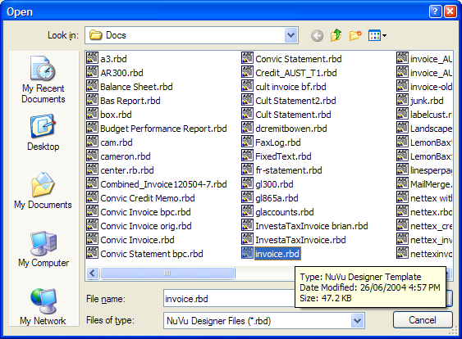

Locate the definition with the name of 'invoice', and double-click on it. This will automatically close the dialog window and open the definition for the 'invoice.rbd' inside the designer tool.

Examine the designer canvas between the address box and transaction box. You will see a label with a caption of 'Email:'. We will now create a field which is going to be mapped to the actual email address in the legacy report.

Ensure that the current font is set to 'Arial', with a point size of 8, and that the Bold, Underline and Italic settings are all OFF (not depressed). Click on the (New Field) button.

Now position the mouse pointer next to the email address in the legacy report (see sample below), and hold down the left-mouse button and select an area of the legacy report which will be large enough for any typical email address (drag the left-mouse button to the right until just before the 'Terms:' label. This area is signified with a row of 'X''s in the sample report below:

Account Number: A1238873 Tax Invoice: 100244

Invoice Date: 12/03/2002

Bill To: Freddy Funk Grocerers Ship To: Freddy's Grocery Store
P.O. Box 2337 13 Malvern Street
Randwick East Malvern
NSW, 2126 NSW, 2125
Australia Australia

Email: XXXXXXXXXXXXXXXXXXXXXXXXXXXXXXXXXXXXXXX Terms: C.O.D.

Now position the mouse pointer next to the 'Email:' label in the canvas area (just below the address box) and click the left mouse button. This should create a field ([F]) alongside the 'Email:' label. Use the arrow keys to line up the field if necessary.

If the field is not selected, do that now by clicking the left mouse button anywhere on the [F] field. Then click the RIGHT mouse button. This will invoke the standard field properties window for this field object, as illustrated below:

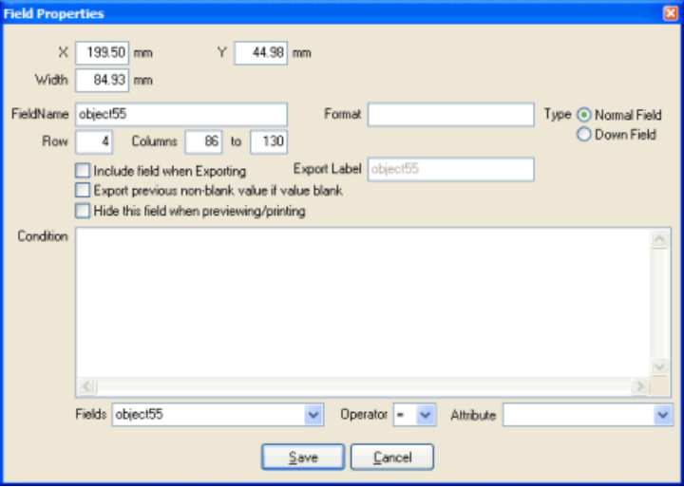

The only remaining thing to do now is to change the name of the 'FieldName' attribute to 'emailaddr' (one word). Click on the SAVE button once this has been completed.

Click on the (Save) button to save the changes made to this definition.

Step 2: Invoking the email on the previewer
Any report definition that has a defined field with a FieldName of 'emailaddr' is able to be email blasted by clicking the button while displaying a report instance in the report previewer.

When the button is pressed, the report previewer checks to see if there is a field with a FieldName of 'emailaddr' defined in any trigger of the report definition. If one is found, then the following dialog window will be displayed:

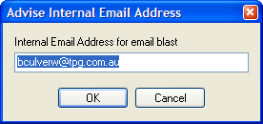

This dialog prompts the user for the internal email address to which all BLANK email pages will be forwarded to. The advised information is written to the Windows Registry so only change this information if necessary. Also note, if the CANCEL button is pressed (or clicking the 'x' in the top right-hand corner of the window), it will be assumed that you do NOT want to perform an email blast for this report instance.

Advising email options before sending
The following dialog window will now be displayed, allowing the user to advise various email options as explained below:

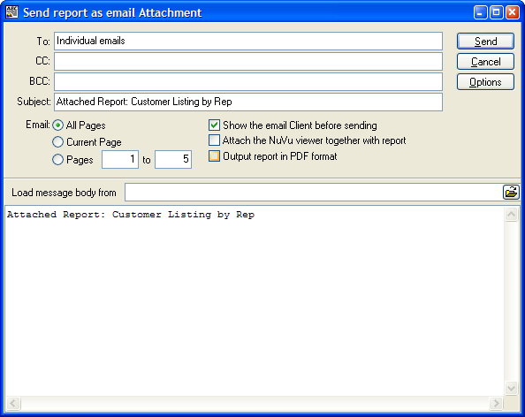

Advise the parameters as described below, and finally click on the SEND button to initiate the emailing of the various pages of the report for the email blast. Clicking the CANCEL button will abort the sending of any emails.

To

This field will default to 'Individual emails', which signifies that the report will be split up into the various email recipients and emailed to them (by default).

CC

Advise the email recipient(s) to copy this email to. If more than one email address is advised, then a semi-colon must be placed between each address. For example, advising 'bculverw@mymail.com.au; dcul@webmail.com.au' will result in this email being sent to both bculverw@mymail.com.au as well as dcul@webmail.com.au.
Validation may be performed on the email addresses typed, depending on your installed MAPI email client, but in all cases your email server should respond with 'undeliverable' messages for any incorrect email addresses.

Subject

This field is automatically filled in with the Report description associated with the current report instance (if a report description has been advised within the report definition), but this can be overridden with any appropriate description. Details advised here will be displayed in the subject line of the email when received by the recipient.

Email: All Pages, Current Page, Range of Pages

This set of radio buttons allow the user to select which part of the report is to be emailed to the email recipients. If the whole report is required to be emailed, then ensure that the 'All Pages' radio option is chosen. Choose the 'Current Page' radio option to only email the currently displayed page to the email recipients. Choose the 'Pages From/To' radio option to email the advised range of pages to the email recipients.

Show the email Client before sending

This option is only enabled if the current email settings are set to email using the MAPI (Microsoft Application Programming Interface) standard. If the SMTP (Standard Messaging Transport Protocol) has been selected, then this option will be disabled (greyed out).

The MAPI standard would be the desired method of operation. However, if multiple emails (email blast) is utilised, and the latest security patches have been applied to your MAPI software, then it may be desirable to select the SMTP protocol for sending email messages to overcome the restrictions placed on the sending of email messages via the MAPI client. The SMTP protocol is a simple mail protocol which does not suffer the same restrictions as the MAPI standard. However, in order to utilise the SMTP standard, there are manual settings (Hostname, Port number etc) which have to be advised, and certain email features offered with the MAPI protocol (address book, rich text output, automatic connection to the internet etc.) will also not be available when using this protocol.

If the user ticks this option, then the default 'send mail' email Client (Outlook, Outlook Express, Netscape Messenger etc.) will be displayed prior to the sending of each email. This is not normally chosen, but may be useful if individual Subject and Messages need to be advised for multiple emails.
For example, assuming Outlook Express is the default MAPI client, the following dialog window will be displayed :

The advised address, copies, subject and message will be automatically copied to the MAPI mail client, but may be altered before the 'Send' (or equivalent) button is clicked to send the actual email to the recipient(s).

Attach the NuVu viewer together with the report

If the user ticks this option, then the auto-installing NuVu viewer will be attached to each sent email as well. This is normally chosen when the email recipient does not already have the NuVu viewer installed on their PC. When the recipient opens the sent email, there will be two attachments - the NuVu viewer installation file, and the report itself. The recipient needs to merely double-click on the NuVu Viewer installation file and the Viewer will be automatically installed into the default c:\nuvu directory.

Output report in PDF format

This toggle setting allows the user to choose whether the report is emailed in the standard NuVu Previewer format, or using the industry standard PDF format.

Ticking this option will result in the report being emailed in PDF format.

Leaving this option unticked will result in the the reports being emailed in standard NuVu Previewer format.

Please note, currently the PDF output option does NOT incorporate the following NuVu design features:

- Angled Labels - these are excluded from the preview
- URL hyperlinks - these are excluded from the preview
- Fonts other than Courier, Arial or Times New Roman are converted to their nearest equivalents

Users who are emailed reports which are attached as PDF documents will have to install a PDF viewer (eg: Adobe Acrobat) before being able to view the attached document. Similarly, reports which are emailed in standard NuVu Previewer format are only able to be viewed after the (free) NuVu Preview software has been installed on the email recipients PC.

Message Area

This field is automatically filled in with the Report description associated with the current report instance, but this can be overridden with any appropriate message. Details advised here will be displayed in the message area of the email when received by the recipient.

The user may optionally choose pre-defined message texts which have been previously created by any plain text editor, by either advising the full pathname in the 'Load message body from' field, or alternatively clicking on the small icon at the end of this field to invoke a standard windows open dialog window, which will allow exploring the network neighbourhood for the desired file. Once a filename has been selected, the contents of that file will automatically be loaded into the Message Area, so that manual adjustments can be made (if required).

Options

The 'Options' button is used to select which email protocol will be used when sending emails (MAPI or SMTP), as well as other connection parameters required if the SMTP protocol is selected. When this button is clicked, the following dialog window will be displayed:

Advise the details as explained below, and ensure that the SAVE button is pressed. This will ensure that the advised values are used in the future. If the CANCEL button is pressed (or the user closes down the dialog window by clicking the X in the top-right corner of the window), then any advised values are ignored, and previous settings are used.

Mail Type

Here the user must select which email protocol will be used when sending emails out to clients. Each protocol has its own advantages and disadvantages. Generally speaking, if the user is doing ad-hoc emailing of displayed reports, and is using a MAPI email system (Microsoft Outlook for example) as a default for other emails, then the MAPI email protocol would be the obvious choice. However, if the user is doing numerous email blasts to many recipients, and the latest MAPI security patches have been applied to the MAPI software, then the SMTP protocol might be more appropriate, because this protocol does not do any security checking before sending emails out to the email server. Disadvantages of the SMTP protocol, is that the email configuration has to be manually advised (the Hostname, Port Number etc. needs to be manually advised on this dialog window) before the emailing via the SMTP protocol will be successful. Also note that a current internet or permanent email server connection is required before issuing an SMTP email send, as opposed to the MAPI protocol, which will prompt to auto-connect if appropriate.

Mail Server

This field is disabled (greyed out) if the selected email protocol is MAPI (because this setting is automatically determined by the MAPI software). If the SMTP protocol has been chosen, then the appropriate host name of the email server must be advised here. This information will probably need to be obtained from your network administrator.

Port Number

This field is disabled (greyed out) if the selected email protocol is MAPI (because this setting is automatically determined by the MAPI software). If the SMTP protocol has been chosen, then the appropriate port number on which to communicate between this PC and the host email server must be advised here. In 99% of cases, the normal smtp port of 25 can be used here. This will probably need to be confirmed with your network administrator.

User Name

This field is disabled (greyed out) if the selected email protocol is MAPI (because this setting is automatically determined by the MAPI software). If the SMTP protocol has been chosen, then the appropriate user name (sign-in name) might need to be advised here. In 99% of cases, this field can be left blank. This will probably need to be confirmed with your network administrator.

Email Address

This field is disabled (greyed out) if the selected email protocol is MAPI (because this setting is automatically determined by the MAPI software). If the SMTP protocol has been chosen, then an appropriate email address (normally your own) must be advised here. This email address will be included with the email message, so that recipients can reply back to the sender (or in the case of undelivered email messages, the email server will send the email back to this recipient address, marked as UNDELIVERED).

Sending the email blast
This final step will perform the actual emailing of the individual pages of the report instance to the identified email recipients. This step is performed after the user clicks on the 'SEND' button on the email options window, as described in the previous step.

If the user ticks has ticked the 'Show the email Client before sending' option on the email options window, then the default 'send mail' email Client (Outlook, Outlook Express, Netscape Messenger etc.) will be displayed prior to the sending of each email. This is not normally chosen, but may be useful if individual Subject and Messages need to be advised for multiple emails.
For example, assuming Outlook Express is the default MAPI client, the following dialog window will be displayed :

If this option has been ticked, the user will then have to manually click the SEND button (or similar) on each email before the email is actually sent. If this option has NOT been ticked, then the emails will automatically be sent to the outbox of your email client. Please note that depending on the email security settings of your email client, a virus warning may be issued before each email. Contact your system administrator to turn off this security setting if it is not required.

- Printing Labels

Introduction
The NuVu report designer is able to print sticky labels in a variety of formats, given any number of different input formats.

Modern cut sheet labels are normally found on an A4 or Letter format sheet of paper, with a defined number of rows and columns. Typical sizes are 2 columns x 4 rows and 2 columns x 5 rows, normally bounded with a border, as shown in the following example of a 2 x 5 label format page:

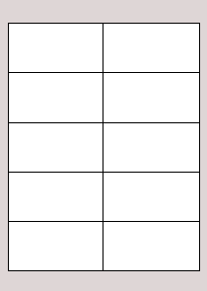

NuVu is able to reformat labels from almost any format of legacy report, but only the 3 most common legacy formats will be discussed here. An example of each legacy format will be given, followed by the steps involved in creating a NuVu report definition to process that format.

One row per line-contents of each label
This format is where each line of each label is shown on its own line in the legacy report, as per the following example :

Label01
Address01-Line1
Address01-Line2
Address01-Line3
Address01-Line4
Label02
Address02-Line1
Address02-Line2
Address02-Line3
Address02-Line4
Label03
Address03-Line1
Address03-Line2
Etc…

To create a NuVu report definition for this format, follow these steps:

- Create a new NuVu report definition, and set the Orientation of the report to Portrait and advise the appropriate sample report which contains the legacy label details similar to that shown above.
- Create a new trigger, as per the displayed Trigger Properties dialog window below :
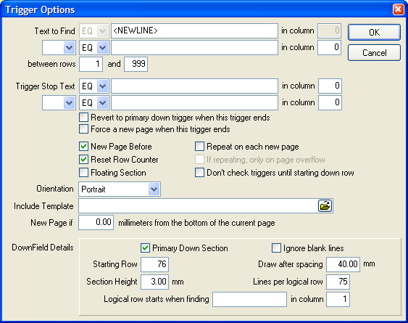
- To confirm the above Trigger Properties settings, advise the Trigger Text = <NEWLINE>, which informs the NuVu Processing Engine to treat each line (or group of lines in this case) as an individual set.
- Set the ‘No. Logical Lines’ to be equal to the total number of rows that will be used to print ALL the labels on any one page of the NuVu report definition. If there are 3 columns by 5 rows of labels, then you will advise a value of 3 columns X 5 rows X 5 lines per row = 75.
- Advise ‘Starting Row’ on the Trigger properties dialog window to be one greater than this calculated value, therefore advise 76 here.
- Close down and save the Trigger Properties window by clicking OK.
- Create a normal field (not down-field) onto the designer canvas for each of the 75 positions on the page. This can be simplified by creating the 5 fields for one label, and then copying them to the clipboard and pasting them back, before moving the new label to its correct position, and then right-clicking on each field to change its ‘Row’ property.

Refer to the ‘LabelCust.rbd’ report definition in the Docs directory of your NuVu install to see a working example using the above format.

One row per label
This format is where all the information required to print a SINGLE label is stored as a single record within the legacy report, as illustrated in the following example :

Label01 Address01-Line1 Address01-Line2 etc…
Label02 Address02-Line1 Address02-Line2 etc…
Label03 Address03-Line1 Address03-Line2 etc…
Label04 Address04-Line1 Address04-Line2 etc…

To create a NuVu report definition for this format, follow these simple steps:

- Create a new NuVu report definition, and set the Orientation of the report to Portrait and advise the appropriate sample report which contains the legacy label details similar to that shown above.
- Create a new Trigger.
- Advise the Trigger Text = <NEWLINE>, which informs the NuVu Processing Engine to treat each line (or group of lines in this case) as an individual set.
- Set the ‘No. Logical Lines’ to be equal to the total number of rows that will be used to print ALL the labels on any one page of the NuVu report definition. If there are 3 columns by 5 rows of labels required on the NuVu Label page, then you will advise a value of 3 columns X 5 rows = 15.
- Advise ‘Starting Row’ on the Trigger properties dialog window to be one greater than this calculated value, therefore advise 16 here.
- Close down and save the Trigger Properties window by clicking OK.
- Create a normal field (not down-field) onto the designer canvas for each of the 75 positions on the page. This can be simplified by creating the 5 fields for one label, and then copying them to the clipboard and pasting them back, before moving the new label to its correct position, and then right-clicking on each field to change its ‘Row’ property.

Laid out in exact print format
This format is where the labels are already output in label printing positions on the legacy report. This format is commonly found on printfiles which were designed to be printed directly onto tractor-fed label stationery, as illustrated in the following example :

Label01 Label02 Label03
Address01-Line1 Address02Line1 Address03-Line1
Address01-Line2 Address02-Line1 Address03-Line1
Address01-Line3 Address02-Line1 Address03-Line1
Address01-Line4 Address02-Line1 Address03-Line1

Label04 Label02 Label03
Address01-Line1 Address02Line1 Address03-Line1
Address01-Line2 Address02-Line1 Address03-Line1
Address01-Line3 Address02-Line1 Address03-Line1
Address01-Line4 Address02-Line1 Address03-Line1

Etc…

To create a NuVu report definition for this format, follow these steps:

- Create a new NuVu report definition, and set the Orientation of the report to Portrait and advise the appropriate sample report which contains the legacy label details similar to that shown above.
- Create a new Trigger.
- Advise the Trigger Text = <NEWLINE>, which informs the NuVu Processing Engine to treat each line (or group of lines in this case) as an individual set.
- Set the ‘No. Logical Lines’ to be equal to the total number of rows that will be used to print ALL the labels on any one page of the NuVu report definition. If there are 3 columns by 5 rows of labels required on the NuVu Label page, then you will advise a value of 3 columns X 7 label lines here = 35. We have chosen 7 label lines here because that is how many input lines are used to produce a row of 3 labels (including the space lines between labels on the legacy report).
- Advise ‘Starting Row’ on the Trigger properties dialog window to be one greater than this calculated value, therefore advise 36 here.
- Close down and save the Trigger Properties window by clicking OK.
- Create a normal field (not down-field) onto the designer canvas for each of the 75 positions on the page. Ignore (do not map) the blank lines on the legacy report. This process can be simplified by creating the 5 fields for one label, and then copying them to the clipboard and pasting them back, before moving the new label to its correct position, and then right-clicking on each field to change its ‘Row’ property.

- Fax Cover Page Tutorial

Introduction

The NuVu Designer is able to create definitions for legacy reports as well as designing of custom Fax Cover pages. Fax Cover pages can be associated with a defined NuVu report at run-time, in order to provide a leading page containing the fax recipient name, fax number, subject and optional message text. The Fax Cover page can contain text (in any of the available fonts, colours and sizes), as well as images (company logo for example), and a set of fields (recipient name, fax number etc.). The Fax Cover Page does NOT contain any down fields.

This tutorial explains to you what you need to know to create a Fax Cover Page with the NuVu Report Designer tool. It is assumed that you have little or no knowledge of the report designer tool. Each step will be concluded with an illustration by means of screen images (or other methods) to cement the lessons learned.

Step 1 : Introduction

Although there are two different mechanisms for starting a new Fax Cover Definition, the tutorial will only cover the first, which is available when the Designer tool is started up.

If the Designer is already open, close it now.

Choose the Report Designer menu option from the NuVu Installation folder, normally available from the Windows Start Menu. An alternative to this is to click the appropriate icon, which is placed onto the desktop as part of the normal install. The Designer will load and the main window will be displayed. A welcome dialog window is displayed on top of the normal Designer window, as shown below.

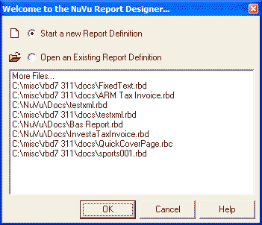

This welcome dialog window allows the user to either start a new report definition, or open an existing report definition, either by choosing one of the recently opened definitions, or by browsing the network to locate an existing report definition to modify.

This tutorial only covers the creation of a new Fax Cover Definition file, so simply ensure that the 'start a new report definition' option is selected, and then click the OK button. Note that pressing the ENTER key performs the same function as clicking on the OK button.

The following dialog window will then be displayed:

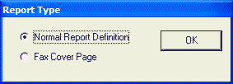

We are going to design a Fax Cover Page, so ensure that the 'Fax Cover Page' radio button is ticked, and then click the OK button.

This dialog window will close and the Designer Canvas will be displayed. The Designer Canvas will occupy the whole screen, and will contain a single trigger ('<COVERPAGE>'), that is automatically created for you. Note that many of the buttons and menu options associated with a normal report definition are removed when designing a Fax Cover page.

Step 2 : Adding Text, Rectangles and Images
The main designer window will now be active, allowing normal designer action to the canvas.

The designer canvas occupies the major part of the designer window, below the toolbars.

The canvas can be scrolled and the screen acts as a 'window' onto the underlying canvas area as illustrated below:

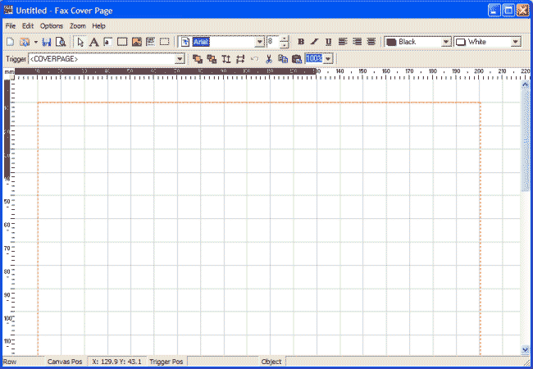

As a default, there are gray grid-lines drawn onto the designer canvas at intervals of 10mm. This can be changed to other settings, but this feature will not be covered during this tutorial.

The following section of the toolbar menu deals with the drawing of static text, rectangles and fields onto the designer canvas.

This toolbar section is operated as a set - ie: only one of the options may be selected (depressed) at any one time.

Drawing Static Text

The Fax Cover page that we are going to design is going to have a few static text fields on it. We will start with the creation of the main title for the fax cover page, simply called 'Fax'.

The 'Fax' title should be in a large fontsize, so at this point, select the 'Arial' font, and change the fontsize to 48 (or a more appropriate size). Also depress the 'Bold' button to ensure that the static text is created with a bold attribute.

Ensure the button is depressed and is showing with a red color. This is achieved by clicking this button twice, which indicates to the designer that you wish to add multiple static text items onto the canvas. Clicking on this button only once, indicates to the designer that you wish to only add one static text item onto the canvas.

Now move the mouse pointer into the designer area and left-click it in a position approximately 10mm from the top edge of the canvas, and 10mm in from the left edge. A text object will automatically be drawn onto the canvas, and the object will also be selected (with drag-handles around it).

By default, the text will show with a caption of 'Label'. To change this to the desired value of 'Fax', right-click the mouse while the mouse pointer is hovering over the selected text object. The label properties window will appear. Replace the 'Label' text with 'Fax' and click the OK button to accept the changes. The label properties window will close and the text object should now show on the canvas with the correct caption of 'Fax'.

Change the fontsize to 14, and repeat this step to create text objects for the 'To:', 'From:', 'Subject:' and 'Message:', as illustrated below:

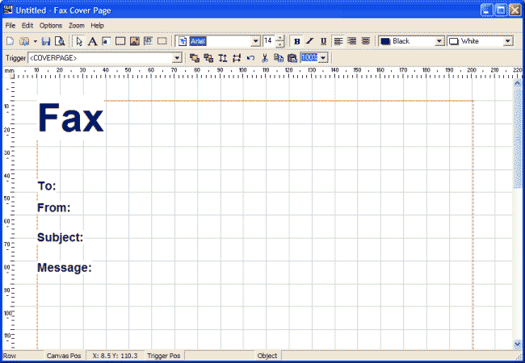

Note, as text objects are drawn onto the canvas, they will be automatically selected. Once all objects have been drawn, click the button to automatically align these objects vertically onto the same X axis.

Finally, click the button to set the designer back into pointer mode to de-select all the objects.

Drawing Rectangles

To make the Fax Cover page more appealing, we will now add a rectangle alongside the 'Message:' text object. This rectangle will be drawn around the message that will be printed when the report is faxed.

Ensure the button is depressed. This indicates to the designer that you wish to add static rectangle items onto the canvas.

Move the mouse pointer up into the designer area and left-click it in a position approximately 5mm on the right of the 'Message:' text object. A rectangle will be automatically drawn onto the designer canvas and will be selected by default. Use the drag-handles to resize the rectangle to the appropriate size, as illustrated below:

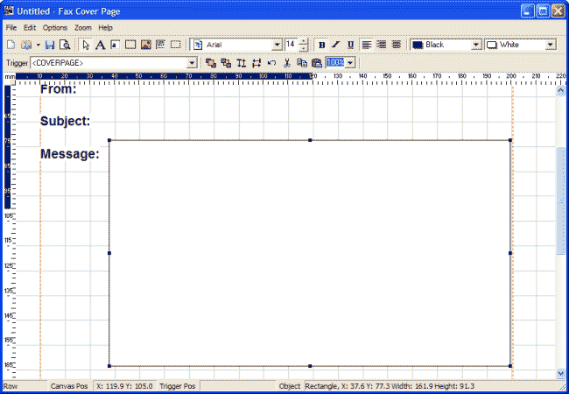

Finally, click the button to set the designer back into pointer mode to de-select the rectangle object.

Drawing an Image

The last step in this segment is to add a company logo (image) onto the Fax Cover Page. We will add the standard 'Sterland Computing' logo supplied with the NuVu Reporting Suite, and position the image at the top-right hand corner of the page.

Ensure the button is depressed. This indicates to the designer that you wish to add an image onto the canvas.

Move the mouse pointer up into the designer area and left-click it in a position approximately 30mm from the right margin of the canvas, and just below the top margin of the canvas. The image property window will be automatically displayed, allowing you to advise the filename of the required image, as shown below:

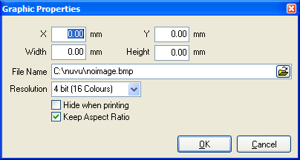

Ensure that you tick the 'Keep Aspect Ratio' option on this dialog window. This will ensure that the image retains its dimensions when it is resized. Click the OK button which will close the graphic properties window and automatically draw the image onto the canvas. This image will be selected by default. Use the drag-handles to resize the image to the appropriate size, as illustrated below:

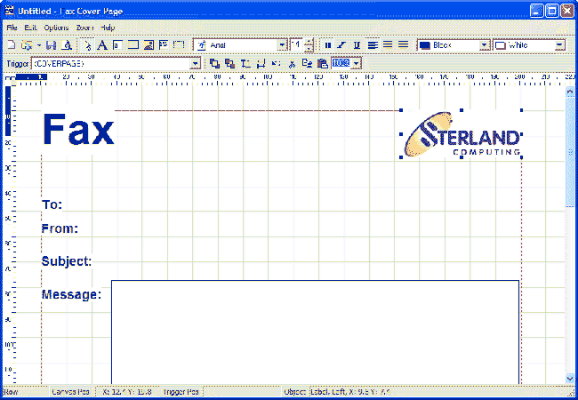

Finally, click the button to set the designer back into pointer mode to de-select the image object.

Step 3 : Linking fields to the Fax Cover
Unlike the mechanism involved with creating fields on a normal report definition, creating fields for a Fax Cover page is simply a matter of choosing from a list of available Fax Cover page fields.

Ensure the {bmc field.bmp} button is depressed and is showing with a red icon. This is achieved by clicking on this button twice, which indicates to the designer that you wish to add field items onto the canvas. Clicking on this button only once, indicating to the designer that you wish to only add one field element onto the canvas.

Move the mouse pointer into the designer canvas until is alongside the 'To:' label object drawn previously, and then click the left mouse button. A field selection dialog window will then be displayed, as illustrated below:

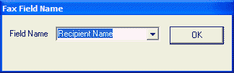

Choose the 'Recipient Name' field from the drop-down box, and then click the OK button.
The field object should be automatically drawn onto the canvas (with a label of [F]), and the object will also be selected (with drag-handles around it).

Repeat this step with the Subject field. You will notice that as the objects are drawn onto the canvas, they are all automatically selected.

Once the field objects have been pasted onto the top line (and are still selected), the button can be pressed to automatically align these objects vertically onto the same X axis.

Press the button to de-select all items and the process is complete. The results so far achieved should resemble something like the following:

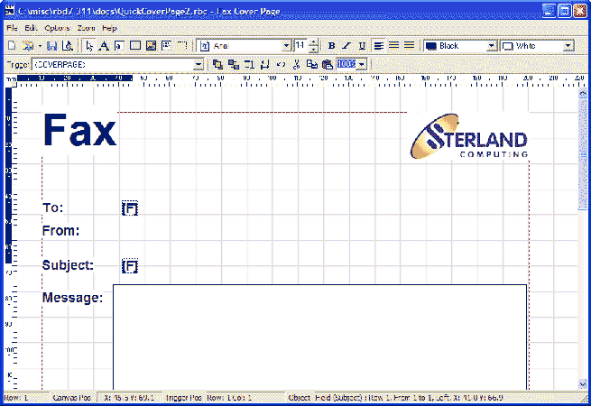

Lastly, we need to add the message body. The message body is defined as a textbox. Ensure the {bmc textbox.bmp} button is depressed, and then move the mouse pointer into the designer canvas until is just inside the rectangle previously drawn, and then click the left mouse button. A textbox should be automatically drawn onto the canvas and will be automatically selected. Use the drag handles to stretch the textbox so that it fits just inside the drawn rectangle.

The design is now complete, and should reflect something similar to the following:

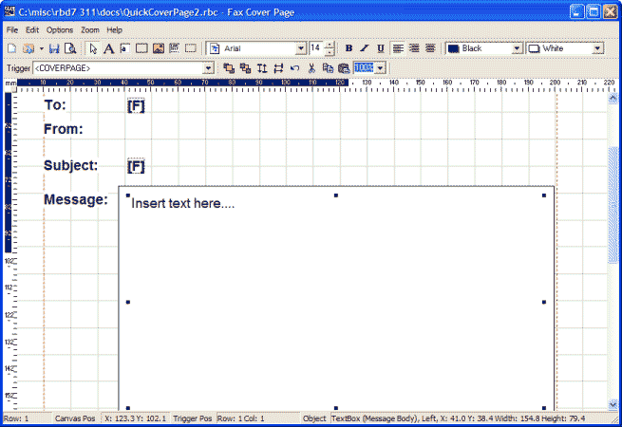

Step 4 : Previewing the Fax Cover
In order to preview the design made so far, simply press the button. The report preview tool will be automatically invoked and the changes made (including any unsaved changes) will be displayed on the preview canvas, in a format similar to the image shown below:

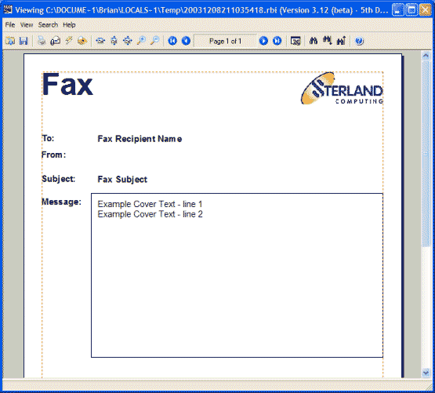

The report can be printed to any attached windows printer at this stage by pressing the button.

Once you have finished examining the preview canvas, simply close this window (by clicking in the X in the top-right hand corner of the window) to return to the designer window.

- Nuvu Letter Writing

Introduction

With the advent of the NuVu Reporting Suite Version 4.3 onwards, there is now a very powerful letter writing capability built into the product. The following components are used together to create professional mail-merge letters with the minimum of fuss:
- rbd_designer.exe (or the free rbd_freedesigner.exe as long as the letter design contains less than 3 triggers and 40 objects – which is very achievable for a standard letter) – used to design the actual report template (the layout of the letter, logo, address, hyperlinks and position of the body text of the letter).
- NuVuLetterDesigner.exe – used to define the body text (including replacable merge-field tokens) that will appear within the letter.
- NuVuMergeFields.exe – used to create and maintain named sets of merge-field tokens (and associated sample data) to be used by the defined letters.
- Engines\rld_prepare.exe – used to prepare a given csv or name/value pairs file into a format that is compatible with the required format for the letters data file.
- Engines\rbd_prepare.exe – the standard NuVu report preparation tool used to produce all NuVu reports – takes the letter data file prepared using the rld_prepare.exe utility to produce a NuVu .rbi file for use with the rbd_preview.exe tool which will deliver the letters to the desired destination (view, pdf, print, fax, email, blast etc).
- rbd_preview.exe – takes the .rbi file prepared with the rbd_prepare.exe utility to render the letters graphically and deliver them to the desired destination (view, pdf, print, fax, email, blast etc).
Although the above list looks daunting, the process of designing the letters and producing them is very simple, and will be described in detail in the following sections of this User Reference.
Merging letters using the NuVu Mail-Merge function (instead of other mail-merge tools) offers significant improvements in speed as well as added functionality during the production of the letters. For example, a common word-processing program can take 20 or more minutes to perform a 200 letter mail-merge, the NuVu mail-merge equivalent can take seconds. The NuVu mail-merge is also able to automatically email/fax the recipients within the mail-merge, and also save individual letters as PDF documents into a nominated folder/file-name.

Before we begin the tutorial, we will show a single page of the final output of the letter production in below:
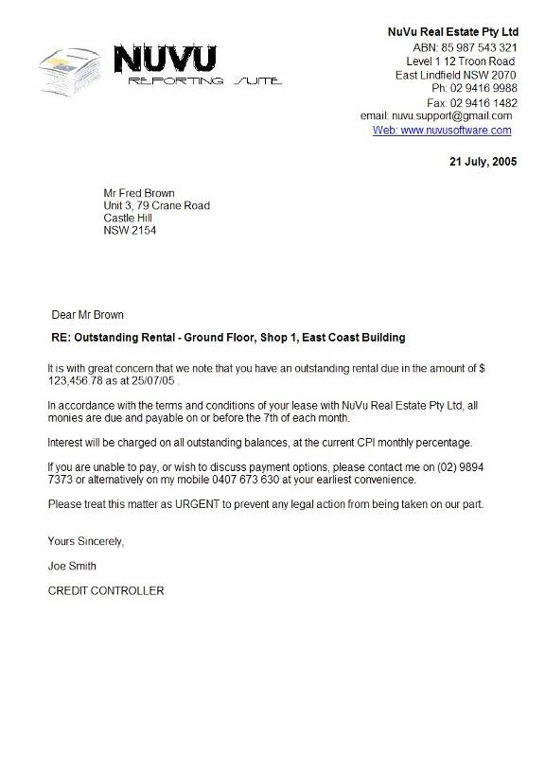

Step 1: Defining the MergeField definitions

The first step to producing letters using the NuVu Reporting Suite is to determine the various MergeField definitions that will be used by all letters. In a typical production environment, generally only a single letter MergeField definition needs to be created, that can be re-used by all letters utilising the NuVu letter-writing capability.

The NuVu Letter MergeFields designer (NuVuMergeFields.exe) is an interactive graphical tool that allows the user to quickly and easily define the merge fields (and sample data) that can be used by any given NuVu Letter definition. Merge Fields are fields that are placed into a letter definition during the design of the letter. These merge fields are replaced at run-time with the actual contents of the merge field. For example, you design a merge field called 'RecipientAddress1'. When the report is mail-merged at run-time, the actual recipient address line 1 will replace the merge field.

The NuVu Letter MergeFields definitions are saved in standard XML format, with an associated .rlm file extention.

The NuVu MergeFields designer tool is invoked from the NuVu Program Group. The main window of this tool is shown below:

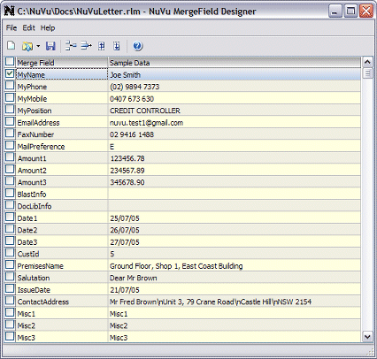

When the tool is first invoked, a familiar ‘Last Used’ dialog window is displayed, allowing the user to choose either to start a new definition from scratch, or (more commonly) open a recently worked on design. An example of the welcome dialog window is shown below:

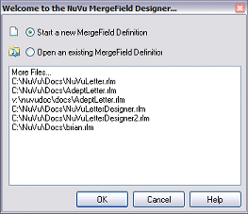

If the user wishes to start a brand new definition, then ensure that the 'Start a new definition' radio button is selected (this is the default in any case) and then either click the OK button, or press ENTER. This welcome dialog will be closed and you will be presented with an empty MergeFields browser.

If the user wishes to select a previously worked on design, then either double-click on any one of the ten most recently worked on designs shown in the list box on this dialog window (entries are shown in order of most recently used), or alternatively double-click the very first item in the list, whereafter a normal windows 'Open' dialog will be displayed, allowing the user to open a design by browsing the network. In this latter case, the folder of the most recently saved or opened design will be the initial folder displayed.

Clicking either the button in the top right-hand corner of the dialog window, or the CANCEL button will close the Welcome dialog window, and assume that you are going to create a new definition from scratch anyway.
The main NuVu MergeField designer screen comprises a toolbar and grid which displays the already defined MergeFields (together with their sample letter values). The first column of the grid can be used to select or de-select individual rows by clicking into the checkbox field for any row. There is also an option to select (or de-select) all rows by clicking in the first (header) checkbox. This is explained in more detail in subsequent sections of this document.

ToolBar Section

The toolbar section is shown in the above sample MergeFields Designer screen just below the menu options. Each icon available from the standard toolbar is shown, together with a description of the icon. The function of each of these icons is described in detail in sub-sections of this document.

Start a new MergeFields Definition
Open an existing MergeFields Definition
Save changes made to the current MergeFields Definition
Add a new row to the MergeFields Definition
Delete Row(s) from the MergeFields Definition
Move selected rows up one row
Move selected rows down one row

Start a new MergeFields Definition

This function assumes you wish to create a new MergeField Definition. If there is an existing MergeField definition currently advised in the designer tool (and there are unsaved changes made to this definition), the user will be asked if the changes to the current definition can be discarded. If the user clicks on the 'No' button, indicating that the current definition is NOT to be discarded, then the starting of a new definition is CANCELLED, and the user is returned to the existing definition, so that it may be saved, or edited further. If the user clicks the 'Yes' button, then the changes made to the existing definition WILL be discarded.

Assuming the user is proceeding with a new definition, the current row definitions will be cleared for the new definition.

Open an existing MergeFields Definition

This function assumes you wish to open an existing (previously created) MergeField Definition. If there are unsaved changes made to the current definition loaded into the designer tool, the user will be asked if the changes to the current definition can be discarded. If the user clicks on the 'No' button, indicating that the current definition is NOT to be discarded, then the starting of a new definition is CANCELLED, and the user is returned to the existing definition, so that it may be saved, or edited further. If the user clicks the 'Yes' button, then the changes made to the existing definition WILL be discarded. If the 'Cancel' button is clicked, then the user will be returned to editing of the definition that was active before this option was chosen.

The button on the toolbar has an associated 'drop-down' option next to the icon, which when pressed will present the user with a list of recently opened (or saved) definitions. The user may simply click on any of the definitions in this displayed list in order to open it. This 'Most Recently Used' list of files is also available from the main NuVu MergeField Designer menu, under the 'File', 'Reopen' section.

Assuming the user is proceeding with the opening of a previously created definition, a standard Windows 'Open File' dialog window will be displayed, allowing the user to browse the network neighborhood for the location of the definition. If the user presses the 'Cancel' button in the Windows 'Open File' dialog window, then the opening of an existing definition file is CANCELLED, and the user is returned to the definition that was previously displayed before the 'Open' button was pressed (if any), otherwise the selected definition is loaded into the designer, and the user may then proceed with the normal editing of the definition.
assumes you wish to create a new MergeField Definition. If there is an existing MergeField definition currently advised in the designer tool (and there are unsaved changes made to this definition), the user will be asked if the changes to the current definition can be discarded. If the user clicks on the 'No' button, indicating that the current definition is NOT to be discarded, then the starting of a new definition is CANCELLED, and the user is returned to the existing definition, so that it may be saved, or edited further. If the user clicks the 'Yes' button, then the changes made to the existing definition WILL be discarded.

Save Changes made to the MergeFields Definition

This function assumes you wish to save the changes made to the current MergeField definition. If you are currently working on a previously created definition (ie: you selected the 'Open an existing Definition' option from within the designer tool), then the changes will be silently saved to disk, overwriting the previously saved definition of the same name. If you have selected 'Start a new Definition', then a standard Windows 'Save As' dialog window will be displayed, allowing the user to browse the network neighborhood for the desired folder and filename to save the definition against. By default, the 'docs' folder, a sub-folder of the installation folder (normally 'c:\nuvu') is displayed. It is recommended that definitions are kept in this folder only, to maintain design standards.

If the user presses the 'Cancel' button in the Windows 'Save As' dialog window, then the saving of the changes to the current definition are NOT performed, and the user is returned to the definition for further editing.

Add a new row to the MergeFields Definition

This function allows the user to add a new row to the current MergeFields definition. The row is always added BEFORE the currently selected row, or as the first row of the definition in the case where the definition is empty before the 'Add' button is clicked.

To add a new row AFTER all defined rows in the definition, simply press the down-arrow until you move past the last defined row - a new row will then be automatically added to the definition. You will only be able to add one empty row (that is, pressing the down arrow on the last row is inactive unless you have advised at least a MergeField name on the last row).

After the new row is added to the definition, this row is cleared of all data, allowing the user to advise the appropriate details.

Delete row(s) from the MergeFields Definition

This function allows the user to delete all selected rows from the design. Selected rows are those rows which have a tick in the first column.

The Designer has a very flexible and powerful mechanism in place that allows the user to select multiple (disjoint) rows. To select (or de-select) any individual row, the user may simply click the tick-box of the appropriate row. If the row is already selected (denoted with a tick in this column) then clicking in this column will de-select this row, and the tick-box will be cleared. Conversly, if the row is not yet selected (denoted with a clear box) then click in this column will select this row, and the tick-box will be ticked. To select multiple consecutive rows the user can depress the left mouse button while over this column and then drag the mouse down (or up) over the required range of rows, then release the mouse button. All previously unselected rows will become selected.

Move row(s) up one row

This function allows the user to move all selected rows one row up the design. This function is ineffective if the very first row of the design is already selected.

The Designer has a very flexible and powerful mechanism in place that allows the user to select multiple (disjoint) rows. To select (or de-select) any individual row, the user may simply click the tick-box of the appropriate row. If the row is already selected (denoted with a tick in this column) then clicking in this column will de-select this row, and the tick-box will be cleared. Conversly, if the row is not yet selected (denoted with a clear box) then click in this column will select this row, and the tick-box will be ticked. To select multiple consecutive rows the user can depress the left mouse button while over this column and then drag the mouse down (or up) over the required range of rows, then release the mouse button. All previously unselected rows will become selected.

Move row(s) down one row

This function allows the user to move all selected rows down one row in the design. This function is ineffective if the very last row of the design is already selected.

The Designer has a very flexible and powerful mechanism in place that allows the user to select multiple (disjoint) rows. To select (or de-select) any individual row, the user may simply click the tick-box of the appropriate row. If the row is already selected (denoted with a tick in this column) then clicking in this column will de-select this row, and the tick-box will be cleared. Conversly, if the row is not yet selected (denoted with a clear box) then click in this column will select this row, and the tick-box will be ticked. To select multiple consecutive rows the user can depress the left mouse button while over this column and then drag the mouse down (or up) over the required range of rows, then release the mouse button. All previously unselected rows will become selected.

Browser Columns

☑

This column is the 'row select' column and indicates which rows are currently selected. Selected rows are shown with the tick-box ticked, whereas unselected rows are shown with an unticked box. There are various functions that act on all selected rows - these include the 'Move Up' , 'Delete Rows' and 'Move Down' functions.

The Designer has a very flexible and powerful mechanism in place that allows the user to select multiple (disjoint) rows. To select (or de-select) any individual row, the user may simply click the tick-box of the appropriate row. If the row is already selected (denoted with a tick in this column) then clicking in this column will de-select this row, and the tick-box will be cleared. Conversly, if the row is not yet selected (denoted with a clear box) then click in this column will select this row, and the tick-box will be ticked. To select multiple consecutive rows the user can depress the left mouse button while over this column and then drag the mouse down (or up) over the required range of rows, then release the mouse button. All previously unselected rows will become selected.

Merge Field

This column contains the defined merge field names for the current definition. Care should be taken not to advise duplicate values for merge field names in the current definition, although this is checked for when the definition is attempted to be saved to disk.

Sample Data

This column contains the sample data that is used to display the replacement value for the associated merge field when the 'preview' button is clicked from within the NuVu Letter Designer. Care should be taken when advising certain fields, as the underlying NuVu report definition may be expecting dates, or numeric values for certain fields. Please consult with your application developers in determining the appropriate field types and sample values.

When advising sample data for the body of the letter, you may advise \n anywhere in the text to force a new line.

Tutorial Notes

For purposes of the tutorial, please just examine the fields that have been defined in the ‘NuVuLetter.rlm’ file and ensure that no changes are saved. If you wish to create your own version of the design, rather choose the ‘Save As’ option from the menu and save your own copy that you can expirement with until the desired results are achieved.

Step 2: Designing the Letter Body Text(s)

Once the NuVu MergeField definition(s) have been setup (as per step 1 of this section), then the user can define the various body texts that will be used for each report. The body text is the word-wrapped section of text that follows the address and salutation section of a letter. The body text will contain static text as well as embedded MergeField tags (as available from the associated MergeField definition file). At run-time, these MergeField tags will be replaced with the actual field values as read in from the prepared NuVu letter datafile.

The NuVu Letter Designer (NuVuLetterDesigner.exe) is an interactive graphical tool that allows the user to quickly and easily define the body text for a given NuVu Letter definition. The NuVu Letter definitions are saved in standard XML format, with an associated .rld file extention.

The NuVu Letter designer tool is invoked from the NuVu Program Group. The main window of this tool is shown below:

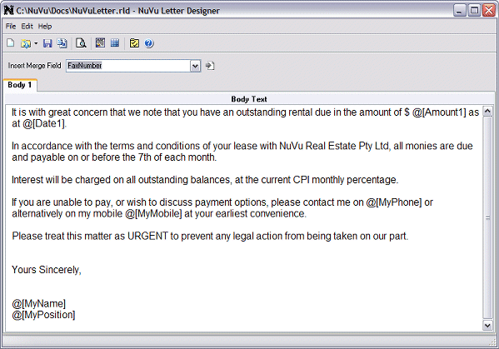

Please refer to the ‘TextBox’ attributes section of this manual for instructions on how complex formatting can be achieved with the body of the letter. This includes change font attributes (Bold, Italic, Underline, Color) and inserting images (for example an electronic signature) into the body of the letter.

When the tool is first invoked, a familiar ‘Last Used’ dialog window is displayed, allowing the user to choose either to start a new definition from scratch, or (more commonly) open a recently worked on design. An example of the welcome dialog window is shown below:

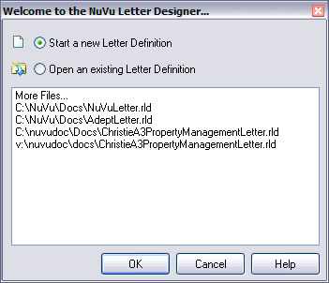

If the user wishes to start a brand new definition, then ensure that the 'Start a new definition' radio button is selected (this is the default in any case) and then either click the OK button, or press ENTER. This welcome dialog will be closed and you will be presented with an empty MergeFields browser.

If the user wishes to select a previously worked on design, then either double-click on any one of the ten most recently worked on designs shown in the list box on this dialog window (entries are shown in order of most recently used), or alternatively double-click the very first item in the list, whereafter a normal windows 'Open' dialog will be displayed, allowing the user to open a design by browsing the network. In this latter case, the folder of the most recently saved or opened design will be the initial folder displayed.

Clicking either the button in the top right-hand corner of the dialog window, or the CANCEL button will close the Welcome dialog window, and assume that you are going to create a new definition from scratch anyway.
The NuVu Letter Designer tool is a single integrated solution, which incorporates the following functional areas normally available as seperate tools in competing products :

- a graphical view of the body of the letter being defined
- a link to the NuVu report designer that allows the user to define and modify the underlying NuVu report definition that is normally used to produce the actual mail-merge letters
- a preview tool, which allows the user to view the sample letter as it would appear at run-time

Each section of the letter designer tool is explained in detail below.

ToolBar Section

The toolbar section is shown in the above sample Letter Designer screen just below the menu options. Each icon available from the standard toolbar is shown, together with a description of the icon, which is able to be 'drilled-down' to explain the function of the icon in more detail.

Start a new Letter Definition
Open an existing Letter Definition
Save changes made to the current Letter Definition
Save XML example of report for use by the NuVu Report Designer
Preview the current Letter Definition
Invoke the NuVu Report Designer
Invoke the NuVu MergeField Designer
Edit Properties for this Letter Definition

Inserting MergeFields

The 'Insert Merge Field' combo-box that is visible just below the Toolbar section can be used to insert the chosen merge field at the current insertion point within the body text area. Dropping down the merge field combo-box you will see a list of available merge fields that can be inserted.

To insert a merge field, select the appropriate merge field from the combo-box, and then click the button to insert the merge field into the body text.

Start a new Letter Definition

This function assumes you wish to create a new Letter Definition. If there is an existing Letter definition currently advised in the designer tool (and there are unsaved changes made to this definition), the user will be asked if the changes to the current definition can be discarded. If the user clicks on the 'No' button, indicating that the current definition is NOT to be discarded, then the starting of a new definition is CANCELLED, and the user is returned to the existing definition, so that it may be saved, or edited further. If the user clicks the 'Yes' button, then the changes made to the existing definition WILL be discarded.

Open an existing Letter Definition

This function assumes you wish to open an existing (previously created) Letter Definition. If there are unsaved changes made to the current definition loaded into the designer tool, the user will be asked if the changes to the current definition can be discarded. If the user clicks on the 'No' button, indicating that the current definition is NOT to be discarded, then the starting of a new definition is CANCELLED, and the user is returned to the existing definition, so that it may be saved, or edited further. If the user clicks the 'Yes' button, then the changes made to the existing definition WILL be discarded. If the 'Cancel' button is clicked, then the user will be returned to editing of the definition that was active before this option was chosen.

The button on the toolbar has an associated 'drop-down' option next to the icon, which when pressed will present the user with a list of recently opened (or saved) definitions. The user may simply click on any of the definitions in this displayed list in order to open it. This 'Most Recently Used' list of files is also available from the main NuVu MergeField Designer menu, under the 'File', 'Reopen' section.

Assuming the user is proceeding with the opening of a previously created definition, a standard Windows 'Open File' dialog window will be displayed, allowing the user to browse the network neighborhood for the location of the definition. If the user presses the 'Cancel' button in the Windows 'Open File' dialog window, then the opening of an existing definition file is CANCELLED, and the user is returned to the definition that was previously displayed before the 'Open' button was pressed (if any), otherwise the selected definition is loaded into the designer, and the user may then proceed with the normal editing of the definition.
assumes you wish to create a new Letter Definition. If there is an existing Letter definition currently advised in the designer tool (and there are unsaved changes made to this definition), the user will be asked if the changes to the current definition can be discarded. If the user clicks on the 'No' button, indicating that the current definition is NOT to be discarded, then the starting of a new definition is CANCELLED, and the user is returned to the existing definition, so that it may be saved, or edited further. If the user clicks the 'Yes' button, then the changes made to the existing definition WILL be discarded.

Save Changes made to the Letter Definition

This function assumes you wish to save the changes made to the current Letter definition. If you are currently working on a previously created definition (ie: you selected the 'Open an existing Definition' option from within the designer tool), then the changes will be silently saved to disk, overwriting the previously saved definition of the same name. If you have selected 'Start a new Definition', then a standard Windows 'Save As' dialog window will be displayed, allowing the user to browse the network neighborhood for the desired folder and filename to save the definition against. By default, the 'docs' folder, a sub-folder of the installation folder (normally 'c:\nuvu') is displayed. It is recommended that definitions are kept in this folder only, to maintain design standards.

If the user presses the 'Cancel' button in the Windows 'Save As' dialog window, then the saving of the changes to the current definition are NOT performed, and the user is returned to the definition for further editing.

Save XML for use by the NuVu Report Designer

This function can be used to save an XML file using the associated NuVu MergeFields definition and NuVu Letter Definition to be used as a sample that can be used by the NuVu Report Designer. It uses the sample data that has been defined within the associated NuVu Mergefield definition file to produce the XML. After clicking the 'Export XML' button, a standard Windows 'Save As' dialog window will be displayed, allowing the user to browse the network neighborhood for the desired folder and filename to save the sample XML against. By default, the 'samples' folder, a sub-folder of the installation folder (normally 'c:\nuvu') is displayed. It is recommended that all sample XML letter files are kept in this folder only, to maintain design standards.

If the user presses the 'Cancel' button in the Windows 'Save As' dialog window, then the saving of the sample XML file is NOT performed, and the user is returned to the letter definition for further editing.

Preview the current Letter Definition

This function allows the current changes made to the current letter definition to be previewed as they would appear when the letters are generated at run-time by the end user. The NuVu preview tool will be automatically invoked and the changes made (including any unsaved changes) will be displayed on the preview canvas. It is therefore NOT necessary to save any changes made to the letter definition before pressing the preview button.

When the NuVu Viewer is invoked, the current NuVu Letter Designer tool will be disabled (with an appropriate splash screen indicating this) and will be re-enabled once the user has closed the NuVu Viewer.

Once the preview window is displayed, the report can be printed to any attached windows printer at this stage by pressing the print button contained on the Print Preview toolbar menu.

Once you have finished examining the preview canvas, simply close the preview window to return to the letter designer window.

Invoke the NuVu Report Designer

This function is used to invoke either the free NuVu Designer tool (rbd_freedesigner.exe) or the registered NuVu designer tool (rbd_designer.exe) in order to edit the associated letter template (as advised on the Letter Properties window, and shown in the hint for this button). When this function is invoked, a check will be made to see if there is a free NuVu Designer tool available. If so, then the free NuVu Designer tool will be launched, otherwise the registered NuVu Designer tool will be launched.

When the NuVu Report Designer is invoked, the current NuVu Letter Designer tool will be disabled (with an appropriate splash screen indicating this) and will be re-enabled once the user has closed the NuVu Report Designer.

Refer to the NuVu User Reference manual and online help for more information regarding the use of the NuVu Report Designer.

Invoke the NuVu MergeField Designer

This function is used to invoke the NuVu MergeField Designer tool. This tool allows the user to define all of the merge fields that will be used in a letter.

This tool can also be invoked by clicking on the associated button alongside the 'Merge Field Definition' field on the Letter Properties window. An example of the main NuVu MergeField designer window is shown below:

When the NuVu MergeField designer tool is invoked, the current NuVu Letter Designer tool will be disabled (with an appropriate splash screen indicating this) and will be re-enabled once the NuVu MergeField designer tool is closed.

Refer to the online help available from within the NuVu MergeField designer tool for more information regarding the use of the NuVu MergeField Designer. This function is also explained in the previous section of this User Reference manual.

Edit properties for this Letter Design

There are various properties that can be applied to a Letter definition. The Designer Properties are displayed when the user chooses the 'File' ➔ 'Options' menu option. A dialog window is displayed, showing the current settings applied to this design, and allows the user to change these properties. The dialog window displays as follows:

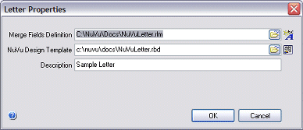

Clicking either the button in the top right-hand corner of the dialog window, or the CANCEL button will cancel any changes made to these properties and return the user to the letter designer without effecting any of these changes. Pressing 'ENTER' at any time (or clicking the OK button) while the dialog window is visible will accept all changes made to the letter properties and return the user to the letter designer with all changed settings being applied.

NuVu MergeField Definition

This setting stipulates which NuVu MergeField definition to associate with the current letter. You are able to manually advise the full pathname to this file, or alternatively click the associated 'browse' button located at the right-hand side of this field in order to browse the network for the NuVu Mergefield definition file.

This is a compulsory field.

You are able to invoke the NuVu MergeFields Designer directly from this screen by clicking on the associated button on the extreme right-hand side of this field. If a valid filename has been advised in this field, then the NuVu Mergfields designer will open this definition otherwise a 'file-picker' dialog window will be displayed, allowing you to select any pre-defined definition or else create a new one.

NuVu Design Template

This setting stipulates which NuVu report template will be used when clicking on the 'Preview' button while designing the letter. This report template is only normally used at design time, as the actual NuVu report template is optionally advised within the formatted xml data file at run-time in order to render the actual letters.

You are able to manually advise the full pathname to this file, or alternatively click the associated 'browse' button located at the right-hand side of this field in order to browse the network for the NuVu Mergefield definition file.

This is a compulsory field.

You are able to invoke the NuVu Report Designer directly from this screen by clicking on the associated button on the extreme right-hand side of this field. If a valid filename has been advised in this field, then the NuVu Designer will open this definition otherwise a 'file-picker' dialog window will be displayed, allowing you to select any pre-defined definition or else create a new one.

Description

This optional setting is used to describe this letter within the system.

Tutorial Notes

For purposes of the tutorial, look at but do not save any settings. If you wish to create your own version of the design, rather choose the ‘Save As’ option from the menu and save your own copy that you can expirement with until the desired results are achieved.

Step 3: Designing the Letter template

The final design step to producing letters using the NuVu Reporting Suite is to design the NuVu Report definition that will process the XML letter data and render the letters.

Click on the ‘NuVu Report Designer’ shortcut on the NuVu program group to invoke the NuVu Report Designer tool (if purchased), otherwise use the Windows Explorer to browse to your installation NuVu folder (normally ‘C:\NuVu’) and then double-click the ‘rbd_freedesigner.exe’ to invoke the free Report Designer tool.

If the free NuVu Report Designer is invoked, a welcome dialog window will be initially displayed, warning you that you are using the demonstration version of the Report Designer product. The demonstration version is limited to 2 triggers and 40 objects, but for most letter designs, these limitations should not be reached.

Once the Designer tool is loaded into memory, open the ‘NuVuLetter.rbd’ design that ships as part of the NuVu Reporting Suite. The design will be opened and shown similar to this:
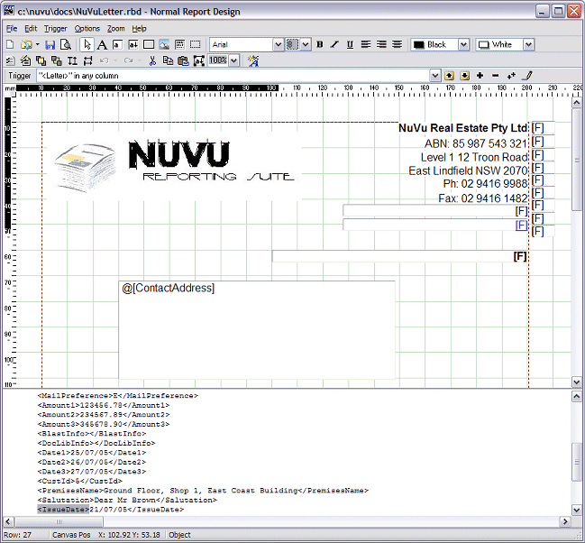
Use the normal features of the NuVu Report Designer to change logo, address and other information. Please refer to the comprehensive on-line help as well as the ‘Report Designer’ section of this User Reference for more details on how to edit the letter.

Tutorial Notes

For purposes of the tutorial, look at but do not save any settings. If you wish to create your own version of the design, rather choose the ‘Save As’ option from the menu and save your own copy that you can expirement with until the desired results are achieved.

Step 4: Preparing and Previewing the letters

Once the previous steps have all been performed, you are now ready to create a data source (the actual merge field data from your database, and then prepare this data source for use by the NuVu processing engine, that will then render the letters graphically and deliver them to the desired destination (email, fax, print, view, blast etc).

Creating a Data Source

In order to produce letters, a vital step is to extract the letter data out of your database.

Ultimately, the NuVu letter writer expects a standard XML file to be used to prepare the letters. Here is an example of a two letter XML file that would be processed by the NuVu Reporting Suite :
<?xml version="1.0" ?>
<NuVu.Prepared.Letter Version="4.3 - 24th December 2005">
<options>
<LetterDesc>Sample Letter</LetterDesc>
<LetterRbd>c:\nuvu\docs\NuVuLetter.rbd</LetterRbd>
<LetterRlm>C:\NuVu\Docs\NuVuLetter.rlm</LetterRlm>
</options>
<Letter>
<MyName>Sarah Cullem</MyName>
<MyPhone>(02) 9894 7373</MyPhone>
<MyMobile>0407 673 630</MyMobile>
<MyPosition>CREDIT CONTROLLER</MyPosition>
<EmailAddress>nuvu.test1@gmail.com</EmailAddress>
<FaxNumber>02 9416 1488</FaxNumber>
<MailPreference>E</MailPreference>
<Amount1>1234.56</Amount1>
<Amount2></Amount2>
<Amount3></Amount3>
<BlastInfo></BlastInfo>
<DocLibInfo>c:\nuvu\saved\arrears\Customer 4 - 20060105.pdf</DocLibInfo>
<Date1>25/07/05</Date1>
<Date2></Date2>
<Date3></Date3>
<CustId>4</CustId>
<PremisesName>Ground Floor, Shop 1, East Coast Building</PremisesName>
<Salutation>Dear Mr Brown</Salutation>
<IssueDate>21/07/05</IssueDate>
<ContactAddress>Mr Fred Brown\nUnit 3, 79 Crane Road\nCastle Hill\nNSW 2154</ContactAddress>
<Misc1></Misc1>
<Misc2></Misc2>
<Misc3></Misc3>
<BodyText>It is with great concern that we note that you have an outstanding rental due in the amount of $ @[Amount1] as at @[Date1].\n\nIn accordance with the terms and conditions of your lease with NuVu Real Estate Pty Ltd, all monies are due and payable on or before the 7th of each month.\n\nInterest will be charged on all outstanding balances, at the current CPI monthly percentage.\n\nIf you are unable to pay, or wish to discuss payment options, please contact me on @[MyPhone] or alternatively on my mobile @[MyMobile] at your earliest convenience.\n\nPlease treat this matter as URGENT to prevent any legal action from being taken on our part.\n\n\nYours Sincerely,\n\n\n@[MyName]\n@[MyPosition]\n</BodyText>
</Letter>
<Letter>
<MyName>Bobby Smith</MyName>
<MyPhone>(02) 9894 8383</MyPhone>
<MyMobile>0407 673 632</MyMobile>
<MyPosition>CREDIT MANAGER</MyPosition>
<EmailAddress>nuvu.test2@gmail.com</EmailAddress>
<FaxNumber>02 9416 1489</FaxNumber>
<MailPreference>F</MailPreference>
<Amount1>2345.67</Amount1>
<Amount2></Amount2>
<Amount3></Amount3>
<BlastInfo></BlastInfo>
<DocLibInfo>c:\nuvu\saved\arrears\Customer 9984 - 20060105.pdf</DocLibInfo>
<Date1>25/07/05</Date1>
<Date2></Date2>
<Date3></Date3>
<CustId>9984</CustId>
<PremisesName>First Floor, Shop 5, East Coast Building</PremisesName>
<Salutation>Dear Mr Stewart</Salutation>
<IssueDate>21/07/05</IssueDate>
<ContactAddress>Mr Sam Stewart\nUnit 5, 790 Terminus Street\nCastle Hill\nNSW 2154</ContactAddress>
<Misc1></Misc1>
<Misc2></Misc2>
<Misc3></Misc3>
<BodyText>It is with great concern that we note that you have an outstanding rental due in the amount of $ @[Amount1] as at @[Date1].\n\nIn accordance with the terms and conditions of your lease with NuVu Real Estate Pty Ltd, all monies are due and payable on or before the 7th of each month.\n\nInterest will be charged on all outstanding balances, at the current CPI monthly percentage.\n\nIf you are unable to pay, or wish to discuss payment options, please contact me on @[MyPhone] or alternatively on my mobile @[MyMobile] at your earliest convenience.\n\nPlease treat this matter as URGENT to prevent any legal action from being taken on our part.\n\n\nYours Sincerely,\n\n\n@[MyName]\n@[MyPosition]\n</BodyText>
</Letter>
</NuVu.Prepared.Letter>

This XML file produces the actual letters of which there is an example of at the start of this section of the User Reference.
Creating this XML is directly possible by writing code to create this from your database, but the task is less than trivial. To assist you, there is a supplied utility tool, called Engines\rld_prepare.exe that assists in creating this XML file from a standard text or csv (comma-separated value) file that is much easier to create by your development department (or via a SQL query for that matter).

Format 1 - CSV
Use a SQL query or write custom logic within your application to output the letter data in standard CSV (comma-separated values) format. The SQL tool supplied by Microsoft and available within the EXCEL spreadsheet program is ideal in performing this task. The first row of the CSV file will contain headings, each (normally) quoted and separated with comma’s. The second and subsequent lines contains the actual field data (also normally quoted) with comma’s separating them. The following example contains the same two letters that are shown in the detailed XML data source provided earlier in this reference manual :
MyName,MyPhone,MyMobile,MyPosition,EmailAddress,FaxNumber,MailPreference,Amount1,DocLibInfo,Date1,CustId,PremisesName,Salutation,IssueDate,ContactAddress
Sarah Cullem,(02) 9894 7373,0407 673 630,CREDIT CONTROLLER,nuvu.test1@gmail.com,02 9416 1488,E,1234.56,c:\nuvu\saved\arrears\Customer 4 - 20060105.pdf,25/07/05,4,"Ground Floor, Shop 1, East Coast Building",Dear Mr Brown,21/07/05,"Mr Fred Brown\nUnit 3, 79 Crane Road\nCastle Hill\nNSW 2154"
Bobby Smith,(02) 9894 8383,0407 673 632,CREDIT MANAGER,nuvu.test2@gmail.com,02 9416 1489,F,2345.67,c:\nuvu\saved\arrears\Customer 9984 - 20060105.pdf,25/07/05,9984,"First Floor, Shop 5, East Coast Building",Dear Mr Stewart,21/07/05,"Mr Sam Stewart\nUnit 5, 790 Terminus Street\nCastle Hill\nNSW 2154"
The ‘lettervalues.csv’ file supplied in the ‘samples’ folder of your NuVu installation contains this data. The first line (heading line) must contain the same fieldnames as contained within the NuVu MergeFields definition that will be used to produce the report.

Format 2 - Name/Value pairs
This format is much easier to read, but will require you to write custom logic within your application to output the letter data in this format. The file must comprise name/value pairs for each required MergeField. At the end of each letter, a blank row must be output in the file.

The following example contains the same two letters that are shown in the detailed XML data source provided earlier in this reference manual :
MyName=Sarah Cullem
MyPhone=(02) 9894 7373
MyMobile=0407 673 630
MyPosition=CREDIT CONTROLLER
EmailAddress=nuvu.test1@gmail.com
FaxNumber=02 9416 1488
MailPreference=E
Amount1=1234.56
DocLibInfo=c:\nuvu\saved\arrears\Customer 4 - 20060105.pdf
Date1=25/07/05
CustId=4
PremisesName=Ground Floor, Shop 1, East Coast Building
Salutation=Dear Mr Brown
IssueDate=21/07/05
ContactAddress=Mr Fred Brown\nUnit 3, 79 Crane Road\nCastle Hill\nNSW 2154

MyName=Bobby Smith
MyPhone=(02) 9894 8383
MyMobile=0407 673 632
MyPosition=CREDIT MANAGER
EmailAddress=nuvu.test2@gmail.com
FaxNumber=02 9416 1489
MailPreference=F
Amount1=2345.67
DocLibInfo=c:\nuvu\saved\arrears\Customer 9984 - 20060105.pdf
Date1=25/07/05
CustId=9984
PremisesName=First Floor, Shop 5, East Coast Building
Salutation=Dear Mr Stewart
IssueDate=21/07/05
ContactAddress=Mr Sam Stewart\nUnit 5, 790 Terminus Street\nCastle Hill\nNSW 2154

The ‘lettervalues.txt’ file supplied in the ‘samples’ folder of your NuVu installation contains this data. The Name portion of each line (ie : up to the first ‘=’ sign) must contain the same fieldnames as contained within the NuVu MergeFields definition that will be used to produce the report.

Preparing the XML data source

Now we have everything in place to produce our letters – the NuVu Letter Designer (in this case ‘NuVuLetter.rld’ in the ‘Docs’ folder of your NuVu install folder), the underlying NuVu Report Design (in this case ‘NuVuLetter.rbd’ in the ‘Docs’ folder of your NuVu install folder) and the extracted data source from your database – we will assume the Name/Value pairs example (in this case ‘LetterValues.txt’ supplied in the ‘samples’ folder of your NuVu install folder).

The Engines\rld_prepare.exe utility is a command-line tool that will automatically create the required format XML data source from the supplied lettervalues file. If the supplied lettervalues file has an extention of ‘.csv’, then the CSV format will be assumed, otherwise the Name/Value pairs format will be assumed.

The rld_prepare utility accepts 3 or 4 parameters :
- Your supplied ‘LetterValues’ file (either CSV or Name/Value pairs)
- The associated NuVu Letter Design you want to use (.rld)
- The output XML data source file (normally with an extention of .xml)
- Optionally, a copy of the associated NuVu Report Definition (.rbd) associated with this letter (determined by examining the contents of the .rld file)

For example, to create an XML data source using the samples provided with the NuVu Reporting Suite, invoke the following DOS command from the command-prompt (this is assuming that you have installed NuVu to ‘c:\NuVu’:
c:\nuvu\engines\rld_prepare.exe c:\nuvu\samples\lettervalues.txt c:\nuvu\docs\nuvuletter.rld c:\nuvu\saved\ourletter.xml c:\nuvu\saved\ourletter.rbd

This command must be executed on a single line, although it is shown wrapped to two lines in this document.

Use a text editor (NotePad for example) to view the contents of the created XML data source after invoking this utility (ie: c:\nuvu\saved\ourletter.xml – it should replicate the example given at the start of this section of the User Reference Manual.
You will also notice that the command line contained the optional 4th parameter, being the name of the file to copy the associated NuVu Report Definition to – we will use this in the next section of the manual, that deals with outputting the letters graphically.

Viewing the letters with the NuVu Preview tool

The last part of this tutorial is to actually produce the letters and view them graphically using the NuVu Report Previewer.

Firstly we need to prepare the NuVu report before invoking the NuVu processing engine. From the command prompt, advise the following statement, all on one line :
c:\nuvu\engines\rbd_prepare.exe c:\nuvu\saved\ourletter.xml c:\nuvu\saved\ourletter.rbd c:\nuvu\saved\ourletter.rbi D 1 0 0 0 N
This command creates a prepared NuVu report instance (c:\nuvu\saved\ourletter.rbi) that is set to output to the NuVu Viewer.

Lastly, all we need to do is now invoke the NuVu Processing Engine to process the prepared .rbi and render it to its destination, in this case the Viewer. To do that, advise the following command from the command prompt :
c:\nuvu\rbd_preview.exe c:\nuvu\saved\ourletter.rbi
After a second or so, the NuVu Viewer will open, and will be viewing the first of the two letters, as per the example below :
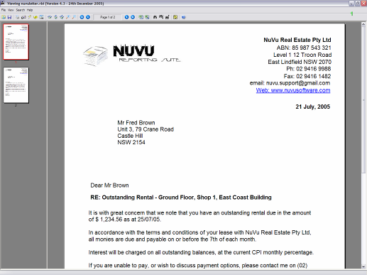.

Press PageUp/PageDown to view each one, comparing the differences. Also note that you can click on the ‘email’ and ‘web’ fields of the letter address to automatically invoke an email or the website (the NuVu website in this case).

Finishing Up

This concludes the tutorial on creating mail-merge letters using the NuVu Reporting Suite. Although the steps seem complicated at first, you will see that after creating your initial NuVu letter template and MergeFields definition – producing different letters is a breeze.

To demonstrate the production of the letters, there is a batch file called ‘nuvuletter.bat’ that is installed automatically into the ‘samples’ folder of your NuVu install. This batch file can be double-clicked from the Windows explorer, and will automatically prepare and process the two letters contained within the ‘lettervalues.txt’ file.

